Regional Growth Plan

Background Report

Authorised and published by the Victorian Government, 1 Treasury Place, Melbourne

Printed by Finsbury Green, Melbourne

If you would like to receive this publication in an accessible format, please telephone 1300 366 356.

This document is also available in Word format at [www.dtpli.vic.gov.au/regionalgrowthplans](http://www.dtpli.vic.gov.au/regionalgrowthplans)

Unless indicated otherwise, this work is made available under the terms of the Creative Commons Attribution 3.0 Australia licence.

To view a copy of the licence, visit creativecommons.org/licences/by/3.0/au

It is a condition of this Creative Commons Attribution 3.0 Licence that you must give credit to the original author who is the State of Victoria.

**Disclaimer**

This publication may be of assistance to you, but the State of Victoria and its employees do not guarantee that the publication is without flaw of any kind or is wholly appropriate for your particular purposes and therefore disclaims all liability for any error, loss or other consequence which may arise from you relying on any information in this publication.

**April 2014**

Table of contents

Executive summary i

1. Introduction and purpose 1

1.1 The Central Highlands Regional Strategic Plan 2

1.2 Purpose 2

1.3 Issues covered by this background report 3

1.4 Assumptions/limitations 4

2. Central Highlands snapshot 4

3. Population and settlement 5

3.1 Context 5

3.2 Preferred pattern of urban growth 18

3.3 Settlement network 22

3.4 Housing diversity and affordability 25

3.5 Liveability 27

3.6 Rural residential development and rural land use 29

3.7 Peri-urban relationships 30

4. Planning for communities 35

4.1 Context 35

4.2 Demographic change 37

4.3 Resilient communities 40

4.4 Education and skills 42

4.5 Health and wellbeing 46

4.6 Cultural heritage 50

5. Economic prosperity 53

5.1 Context 53

5.2 Agriculture and earth resources 55

5.3 Commercial development and tourism 65

5.4 Diversification of the regional economy 66

6. Transport and infrastructure 74

6.1 Context 74

6.2 Regional transport links 75

6.3 Freight transport 88

6.4 Services and infrastructure 92

7. Environment 97

7.1 Context 97

7.2 Natural environment 99

7.3 Water catchments 104

7.4 Natural hazards and risks 106

7.5 Landscape protection 112

8. Cross regional issues 116

8.1 Context 116

References 117

Appendix 1: Network of settlements table 120

Figures:

Figure 1: Central Highlands Regional Growth Plan area 1

Figure 2: Central Highlands town population changes 6

Figure 3: Change in estimated residential population by statistical local area 2006 to 2011 9

Figure 4: Inter-regional migration flows, Central Highlands region 2006 to 2011 12

Figure 5: Projected growth of Central Highlands municipalities 2011 to 2031 13

Figure 6: Change in population by age group, Central Highlands 2011 to 2031 14

Figure 7: Settlement role and function map – Grampians 17

Figure 8: Journeys from Central Highlands local government areas 2011 19

Figure 9: Ballarat West growth area 24

Figure 10: Median house prices 26

Figure 11: Where buyers come from (2010) 27

Figure 12: Peri-urban extent of Melbourne 31

Figure 13: Population by age cohort, 2011 and 2031 35

Figure 14: Relative socio-economic disadvantage 36

Figure 15: Proportion of older people by Central Highlands local government areas 38

Figure 16: Socio-economic indicators for Central Highlands region 42

Figure 17: Projected change in school enrolments 44

Figure 18: Some of the notable cultural heritage assets in the Central Highlands region 51

Figure 19: Employed people by industry sector 53

Figure 20: Industry output performance forecast by percentage share 2011 to 2031 55

Figure 21: Agricultural land quality in Moorabool Shire 58

Figure 22: Agricultural land quality in Hepburn Shire 59

Figure 23: Mining and extractive industries, tenements and licences 64

Figure 24: Energy in the future 70

Figure 25: Industrial land supply 71

Figure 26: Central Highlands transport network 74

Figure 27: Journeys to Melbourne from the Central Highlands by local government area 76

Figure 28: Estimated rail patronage (normal weekday) by station 2005 to 2011 77

Figure 29: Journeys from urban centres to destinations within the region and to Melbourne 2011 77

Figure 30: Annual average daily two-way traffic count by road transport corridor 82

Figure 31: Schematic public transport network 84

Figure 32: Work journeys from Ballarat 1996 to 2011 86

Figure 33: Work journeys to Ballarat 1996 to 2011 86

Figure 34: The Principal Freight Network - Road 89

Figure 35: The Principal Freight Network - Railways 90

Figure 36: Commodities and freight flows 92

Figure 37: Summary of water supply demand strategy outlooks for the Central Highlands region 94

Figure 38: Catchment management authority and regional growth plan boundaries 98

Figure 39: Native vegetation and habitat assets 100

Figure 40: Significant waterways of the region 101

Figure 41: Public land within the region 103

Figure 42: Declared water supply catchments in the region 105

Figure 43: Extent of the Bushfire Management Overlay 108

Figure 44: Extent of flood overlays 110

Figure 45: Significant landscapes 114

# Executive summary

This Central Highlands Regional Growth Plan background report has been prepared concurrently with the Central Highlands Regional Growth Plan. The background report has been developed from a draft issues paper prepared in June 2012. It provides a summary of research and evidence about existing conditions and trends in the Central Highlands region. It allows readers to further explore the basis of strategies contained in the plan.

In summary this background report covers the following issues:

**Chapter 1: Introduction and purpose**

**Chapter 2: Central Highlands snapshot**

* Providing a brief overview of the region’s key social, economic and environmental assets.

**Chapter 3: Population and settlement**

* Outlining key population and demographic attributes of the region.
* Identifying a preferred long-term future settlement pattern for the region to extend beyond existing planned growth.
* Understanding housing demand and supply of various housing types.
* Considering the implications of current trends relating to the development of housing in rural areas and identifying regional considerations related to rural residential development.
* Identifying significant attributes of towns that create a sense of place, or enhance liveability, and should be protected.
* Recognising the environmental, economic and settlement relationships between Melbourne and the peri-urban areas of the Central Highlands region.

**Chapter** 4**: Planning for communities**

* Understanding the spatial implications of demographic change, particularly the uneven population growth and ageing population, for provision of services and accommodation of new development.
* Seeking patterns of growth that support sustainable and resilient communities.
* Supporting education and skills development by planning for future education facilities in accordance with patterns of growth and change, and ensuring appropriate links are made to the regional university.
* Creating a healthy community by supporting appropriate infrastructure, developing healthy built environments and undertaking measures to address disadvantage.
* Considering the cultural heritage assets of the region.

**Chapter** 5**: Economic prosperity**

* Identifying overall strengths of the regional economy.
* Identifying strategic considerations related to agriculture and rural land use.
* Ensuring a sufficient supply of industrial land in strategic locations throughout the region.
* Protecting key tourism assets and ensuring these can be built on by complementary activities.
* Protecting and enhancing the region’s comparative economic advantages to assist in diversifying the regional economy, such as identifying preferred locations for renewable energy infrastructure.
* Identifying commercial and retail needs for the region.

**Chapter 6: Transport and infrastructure**

* Providing for improved regional and inter-regional connectivity to stimulate growth and provide access between communities.
* Considering the impacts of enhanced communications technology for future land use and settlement.
* Identifying infrastructure required to transport freight and maintain liveability.
* Setting out key infrastructure issues and needs related to the region’s economic and population growth.

**Chapter** 7**: Environment**

* Protecting significant environmental assets.
* Identifying key natural hazards.
* Identifying the impacts of a changing climate and how the region’s environmental, economic and settlement characteristics may need to change to take advantage of, or ameliorate the impacts of, a changing climate.
* Protecting regionally-significant landscapes.
* Ensuring growth in the region maintains the health of water catchments and can access a reliable water supply.

**Chapter** 8**: Cross-regional issues**

* Summarising the relationships between the Central Highlands and neighbouring regions.

1. Introduction and purpose

The Central Highlands Regional Growth Plan has been developed in partnership between local government and state government agencies and authorities. It provides regional land use planning responses to the strategic aspirations and directions identified in the Central Highlands Regional Strategic Plan 2010. The plan takes a 30-year strategic view of future planning for the region.

The Central Highlands region is located in the west of Victoria, comprising almost 13,900 square kilometres (Australian Bureau of Statistics 2006). It extends from Bacchus Marsh (Moorabool Shire Council) in the east to Pomonal (Ararat Rural City Council) in the north-west of the region (refer to Figure 1).

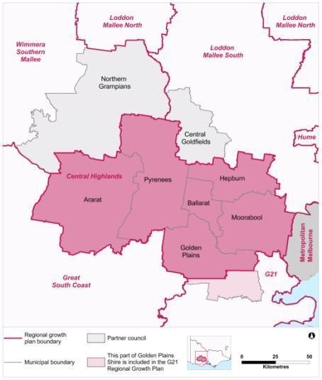Figure 1: Central Highlands Regional Growth Plan area

Source: Department of Transport, Planning and Local Infrastructure

For the purposes of the plan, the Central Highlands region includes the northern portion of Golden Plains and all of the Ararat, Ballarat, Hepburn, Moorabool and Pyrenees local government areas. The Central Goldfields and Northern Grampians local government areas have a strong relationship with the Central Highlands region. As such, issues from these neighbouring shires, particularly those relevant to the wider Central Highlands region, are also discussed in this background report. The southern portion of the Golden Plains local government area is included in the G21 Regional Growth Plan area. The Northern Grampians Shire is included in the Wimmera Southern Mallee Regional Growth Plan and the Central Goldfields Shire is included in the Loddon Mallee South Regional Growth Plan.

Strategic planning projects and development frameworks already undertaken by councils have contributed to the development of the plan. By building on and adapting existing local knowledge and applying it at a regional level, the plan informs short-term regional actions and articulates longer term direction for the region over the next 30 years.

The plan informs local strategic planning and future public and private investment. The plan is one of eight regional growth plans being prepared across the state to provide a whole-of regional Victoria view.

## The Central Highlands Regional Strategic Plan

The purpose of the regional growth plan is to provide land use planning responses to strategic directions established in the Central Highlands Regional Strategic Plan.

The overall goal of the Central Highlands Regional Strategic Plan is to position the region to provide a productive, sustainable and liveable region for its people to 2030 and beyond.

The Central Highlands Regional Strategic Plan was published in 2010 and sets out a framework to deliver on the collective aspirations of communities across the region. In 2012 the Central Highlands Regional Strategic Plan was updated as a shorter summary document. It identifies the following strategic directions for the region:

* Plan for growth.
* Improve transport infrastructure and services.
* Raise the region’s profile as a tourist and heritage destination.
* Utilise the region’s strength in information and communications technology to provide better services to business and communities.
* Improve access to health services and tackle health inequality.
* Provide better access to education and training.
* Continue to foster leadership capacity within the region.
* A productive and resilient landscape management.

The strategic directions have been used as the basis for developing the principles of the plan.

## Purpose

The purpose of this background report is to document:

* issues, opportunities and challenges facing the region
* issues in the Central Highlands Regional Strategic Plan that influence growth and land use
* local and state government policy directions
* drivers of change over coming decades.

The issues identified in this background report have formed the primary basis for the directions proposed by the plan.

## Issues covered by this background report

|  |  |
| --- | --- |
| **Chapter 1: Introduction and purpose** | |
| **Chapter 2: Central Highlands snapshot** | |
| **Chapter 3: Population and settlement** | |
| Preferred pattern of urban growth | Identifying the desired spatial configuration for growth |
| Settlement network | Settlement roles and relationships, small towns, managing growth and decline and land supply |
| Housing diversity and affordability | The mix and type of housing available including social housing |
| Liveability | Settlement character, identity and urban design |
| Rural settlement | Rural residential housing and subdivision |
| Peri-urban relationships | The interrelationship of the Central Highlands region with Melbourne |
| **Chapter 4: Planning for communities** | |
| Demographic change | Demographic trends including an ageing population and youth out-migration and the implications for services and settlement |
| Resilient communities | Access to services to retain viable communities. |
| Education and skills | Access to education and attracting skilled workers |
| Health and well being | Planning for health, Aboriginal[1] health, disadvantage and the social impacts of climate change |
| Cultural heritage | Key Aboriginal cultural heritage and historic heritage assets |
| **Chapter 5: Economic prosperity** | |
| Agriculture and earth resources | Key trends issues and opportunities related to the primary resource base of the region |
| Commercial development and tourism | Commercial land needs as well as opportunities for tourism |
| Diversification of the regional economy | The region’s comparative advantages, industrial land supply, the carbon economy, renewable energy and the importance of Ballarat as a regional economic hub |
| **Chapter 6: Transport and infrastructure** | |
| Regional transport links | Linking communities and accessing Melbourne and other parts of the state |
| Freight transport | Freight connections including road and rail, changing freight demand, and infrastructure |
| Services and infrastructure | Water, gas, sewer and telecommunications |
| **Chapter 7: Environment** | |
| Natural environment | Key environmental assets and potential for their enhancement and protection |
| Water catchments | Protecting a key regional asset |
| Natural hazards and risks | Bushfire, flood, salinity and climate change |
| Landscape protection | Protecting regionally-significant landscapes |
| **Chapter 8: Cross-regional issues** | |

## Assumptions/limitations

The population trends and growth rates identified in this background report are predominantly based on 2011 and earlier Census data and Victoria in Future 2012 data. Different geographic areas were used for the 2011 Census data and therefore population trends are not always informed by this most recent Census, as the data is not directly comparable. In such cases 2006 Census data has been used as a basis for comparison.

1. Central Highlands snapshot

The Central Highlands region has three distinct parts, each with its own particular issues and opportunities:

* Ballarat, which as the largest city, influences development and growth in its hinterland.
* The eastern area, which is within Melbourne’s peri-urban hinterland, has particular pressures around population growth in areas with significant landscapes, agricultural, waterway and other environmental assets. Many residents in this area commute to Melbourne for employment and to access higher order services.
* The western area, predominantly comprising rural areas and established settlements, with relatively low population growth.

The Western Highway, the Melbourne-Adelaide railway line and the Ararat-Melbourne railway line are key east-west transport assets providing links across the region to major centres.

The region contains highly productive agricultural and horticultural areas used for broadacre grazing and cropping, with some areas of intensive agriculture, including horticulture, viticulture and poultry.

The region’s goldmining and cultural heritage and diverse landscapes attract many visitors and residents. Environmental features of the region include the Grampians National Park at the western end of the region and forests along the Great Dividing Range that make up a large proportion of the north-east parts of the region. Regional natural resources support industries such as agriculture and nature based-tourism, supply urban water needs and provide important habitat for flora and fauna.

The estimated population of the Central Highlands region in 2011 was approximately 169,300 people (Victoria in Future 2012).

Ballarat is the dominant settlement and provides higher order services and employment to a wide hinterland area. There are also a number of larger towns which provide services to surrounding districts, including Ararat, Bacchus Marsh and Daylesford, and a range of smaller settlements. Bacchus Marsh also has strong links to Melbourne.

1. Population and settlement

## Context

The Central Highlands Regional Strategic Plan Discussion Paper (Parsons Brinckerhoff, 2010a) identified some of the key attributes of the region’s population and demographic profile, including:

* shifting populations from rural areas to Ballarat and Melbourne and to a lesser extent from rural areas to regional centres and community service hubs such as Ararat, Bannockburn, Stawell and Beaufort
* strong population growth in Ballarat and the peri-urban municipalities of Golden Plains and Moorabool associated with affordable living or lifestyle considerations in close proximity to Melbourne
* an ageing population in rural areas and in Ballarat
* loss of youth from rural areas to Ballarat and Melbourne for education, and often when tertiary study is complete, from Ballarat to Melbourne
* limited in-migration concentrating on urban areas, notably Ballarat.

The 2011 estimated resident population of the Central Highlands region (excluding Northern Grampians and Central Goldfields shires) was 169,300 people. Figure 2 shows how strongly this population is focused around the larger urban centres and how significant growth has been mostly focused in the region’s east. Notable growth includes settlements where there has been a large increase in population numbers, for example Bacchus Marsh and Ballarat, and those where there has been a large proportional increase in population, such as Smythesdale and Ballan. Both situations can put pressure on services and infrastructure. In contrast, many settlements in the western part of the region have had relatively stable or declining populations.

Figure 2: Central Highlands town population changes

**a) Population change 2001 – 2011**

**LGA – Ballarat**

* Town – Ballarat
* 2001 population – 72,280
* 2011 population – 85,314

**LGA – Moorabool**

* Town – Bacchus Marsh
* 2001 population – 12,152
* 2011 population – 14,779
* Town – Ballan
* 2001 population – 1766
* 2011 population – 2008
* Town – Gordon
* 2001 population – 407
* 2011 population – 378
* Town – Blackwood
* 2001 population – 300
* 2011 population – 295

**LGA – Ararat**

* Town – Ararat
* 2001 population – 7068
* 2011 population – 6906
* Town – Willaura
* 2001 population – 288
* 2011 population – 256

**LGA – Hepburn**

* Town – Daylesford
* 2001 population – 3382
* 2011 population – 3294
* Town – Creswick
* 2001 population – 2448
* 2011 population – 2582
* Town – Clunes
* 2001 population – 1091
* 2011 population – 1393
* Town – Trentham
* 2001 population – 697
* 2011 population – 682

**LGA – Pyrenees**

* Town – Beaufort
* 2001 population – 987
* 2011 population – 983
* Town – Avoca
* 2001 population – 957
* 2011 population – 945
* Town – Snake Valley
* 2001 population – 311
* 2011 population – 292

**LGA – Golden Plains**

* Town – Smythesdale
* 2001 population – 312
* 2011 population – 479
* Town – Linton
* 2001 population – 342
* 2011 population – 351
* Town – Meredith
* 2001 population – 308
* 2011 population – 369

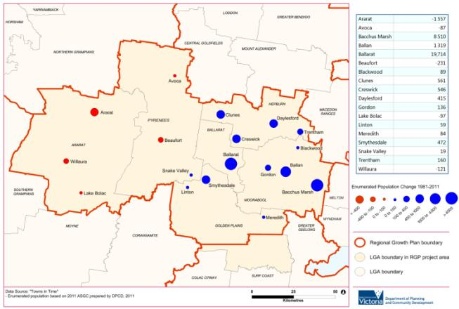**b) Population change 1981 - 2011**

Source: Australian Bureau of Statistics censuses and Department of Planning and Community Development Towns in Time[2]

Recent population estimates (Figure 3) shows that all of the Central Highlands local government areas have been growing, with the exception of Northern Grampians Shire. Nevertheless, the disparity in growth between west and east remains, with significant levels of growth recorded for Bacchus Marsh and Ballarat, in both absolute and proportional terms.

Figure 3: Change in estimated residential population by statistical local area 2006 to 2011

Ararat (RC)

* Estimated residential pop 2006 – 11,660
* Estimated residential pop 2011 – 12,070
* Change – 410
* Change percent – 3.52

Ballarat (C) - Central

* Estimated residential pop 2006 – 34,230
* Estimated residential pop 2011 – 36,036
* Change – 1806
* Change percent – 5.28

Ballarat (C) – Inner North

* Estimated residential pop 2006 – 29,981
* Estimated residential pop 2011 – 34,081
* Change – 4100
* Change percent – 13.68

Ballarat (C) – North

* Estimated residential pop 2006 – 1016
* Estimated residential pop 2011 – 1045
* Change – 29
* Change percent – 2.85

Ballarat (C) – South

* Estimated residential pop 2006 – 23,224
* Estimated residential pop 2011 – 26,648
* Change – 3424
* Change percent – 14.74

Golden Plains (S) - North-West

* Estimated residential pop 2006 – 7697
* Estimated residential pop 2011 – 8213
* Change – 516
* Change percent – 6.70

Hepburn (S) - East

* Estimated residential pop 2006 – 7486
* Estimated residential pop 2011 – 8016
* Change – 530
* Change percent – 7.08

Hepburn (S) - West

* Estimated residential pop 2006 – 6730
* Estimated residential pop 2011 – 7004
* Change – 274
* Change percent – 4.07

Moorabool (S) - Bacchus Marsh

* Estimated residential pop 2006 – 16,628
* Estimated residential pop 2011 – 18,953
* Change – 2325
* Change percent – 13.98

Moorabool (S) - Ballan

* Estimated residential pop 2006 – 6198
* Estimated residential pop 2011 – 6708
* Change – 510
* Change percent – 8.23

Moorabool (S) - West

* Estimated residential pop 2006 – 3628
* Estimated residential pop 2011 – 3748
* Change – 120
* Change percent – 3.31

Pyrenees (S) - North

* Estimated residential pop 2006 – 3401
* Estimated residential pop 2011 – 3477
* Change – 76
* Change percent – 2.23

Pyrenees (S) - South

* Estimated residential pop 2006 – 3385
* Estimated residential pop 2011 – 3446
* Change – 61
* Change percent – 1.80

C. Goldfields (S) - Maryborough

* Estimated residential pop 2006 – 7574
* Estimated residential pop 2011 – 7629
* Change – 55
* Change percent – 0.73

C. Goldfields (S) - Bal

* Estimated residential pop 2006 – 5118
* Estimated residential pop 2011 – 5163
* Change – 45
* Change percent – 0.88

N. Grampians (S) - St Arnaud

* Estimated residential pop 2006 – 3528
* Estimated residential pop 2011 – 3478
* Change – -50
* Change percent – -1.42

N. Grampians (S) - Stawell

* Estimated residential pop 2006 – 8819
* Estimated residential pop 2011 – 8718
* Change – -101
* Change percent – -1.15

Source: Department of Transport, Planning and Local Infrastructure

One of the reasons for the region’s recent population growth has been inter-regional migration flows to the Central Highlands from outside the region. These are illustrated in Figure 4, indicating positive growth coming from all other regions in the state, particularly from Melbourne and the Wimmera Southern Mallee.

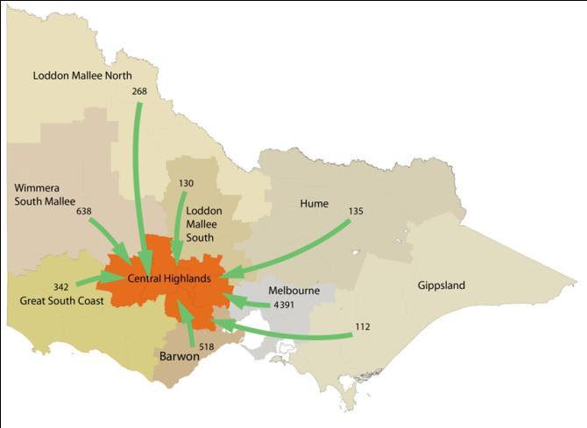Figure 4: Inter-regional migration flows, Central Highlands region 2006 to 2011

Source: Department of Transport, Planning and Local Infrastructure

It is expected the Central Highlands region[3] will grow by around 78,200 people and have an average annual growth rate of 1.6 per cent per annum between 2011 and 2041 (Victoria in Future 2012), although population growth will not occur evenly across the region.

Population projections show that this trend towards disparity in growth between west and east is likely to continue, with the municipalities of Moorabool and Ballarat growing faster than other parts of the Central Highlands (refer to Figure 5).

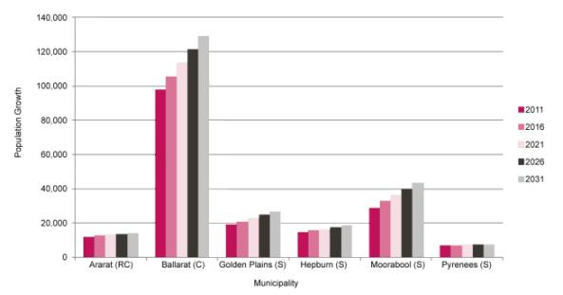Figure 5: Projected growth of Central Highlands municipalities 2011 to 2031

Source:Victoria in Future 2012

A key to understanding the uneven projected population growth across the region is the projected demographic changes to the population. As shown in Figure 6, older age groups (65+) are expected to grow at disproportionate levels up to 2031 across the Central Highlands. However, in some municipalities to the east (Moorabool, Ballarat and Golden Plains), this will be balanced to some extent by growth, albeit lower growth, in the number of children and middle-aged people.

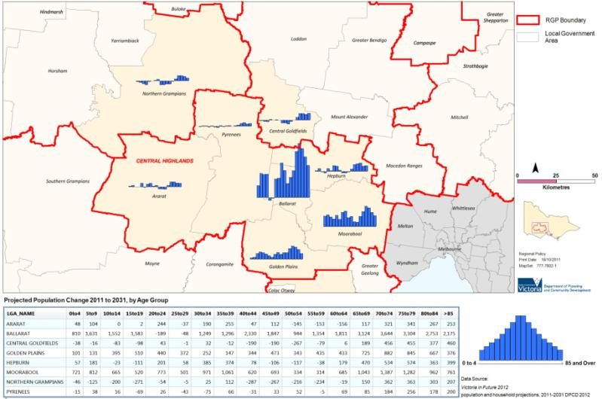Figure 6: Change in population by age group, Central Highlands 2011 to 2031

Source: Victoria in Future 2012

The settlement pattern of the Central Highlands is dominated by Ballarat which is over five times the size of any other centre in the region. Bacchus Marsh and Ararat are the next largest centres in the region, with Maryborough and Stawell also important centres close to the region. It is also important to recognise the influence of Melbourne and Geelong which are within close proximity to parts of the region and accessed for employment and lifestyle reasons. These cities, along with Ballarat, are significant enough to have their own hinterland (peri-urban) influence, with a network of towns that rely on them for employment and services.

Within the various municipalities making up the Central Highlands there are a diverse range of settlement patterns. For example, Golden Plains comprises a series of relatively small townships which are dependent on nearby municipalities for some services, whereas other municipalities have a single dominant centre such as Ballarat or Ararat.

Clause 11.05 of the State Planning Policy Framework outlines state planning policies relating to regional development and establishes the Victorian Settlement Framework. Within this framework Ballarat is identified as a major regional city, the highest order regional settlement. Ararat is identified as a regional centre, the second highest order regional settlement. Relevant strategies identified here include directing urban growth into major regional cities, including Ballarat, and supporting the sustainable development of regional centres including Ararat.

The Regional Mapping Project (Planisphere 2009) undertaken as part of the development of the Central Highlands Regional Strategic Plan, put forward a more detailed hierarchy of settlements for the Central Highlands region. The Central Highlands Regional Strategic Plan then identified the regional role and function of each centre, as outlined below.

|  |  |  |
| --- | --- | --- |
| **Provincial centre** | Role   * Highest levels of population and employment outside Melbourne * All utilities * Several substantial activity centres and a central business district * Highest order goods and services in regional Victoria * Head offices, regional universities, regional hospitals and medical facilities * Network of hinterland settlements | Settlement   * Ballarat |
| **District town** | Role   * Diverse population with moderate employment and good access to services * Sub-regional service function * Access to medical/hospital services and variety of education facilities * All utilities connected | Settlements   * Bacchus Marsh * Ararat * Daylesford * Maryborough (located in Central Goldfields) * Stawell (located in Northern Grampians) |
| **Town** | Role   * Diverse population and housing, often with commuters accessing larger nearby settlements * Water and sewer connected * Provide services to rural hinterland | Settlements   * Ballan * Trentham * Creswick * Clunes * Avoca * Beaufort * St Arnaud (located in Northern Grampians) * Bannockburn (located in the portion of Golden Plains outside of Central Highlands region) |

The role, function and network of settlements within the Central Highlands region has been further developed in consultation with local government stakeholders, given the need for greater recognition of the role of small and medium-sized towns in the plan. A table provided in Appendix 1 identifies each settlement in the region and its level of services and infrastructure, along with population data.

The need to consider the relationships between settlements, rather than simply considering settlements in isolation, has been recognised in consultation with stakeholders. The interrelationship between settlements in regional areas is often multi-faceted and may relate to matters such as access to social services, employment, retail services or recreational pursuits. Clusters of settlements should be considered when planning for growth within particular settlements. Figure 7 illustrates the settlement role and function of towns in the region.

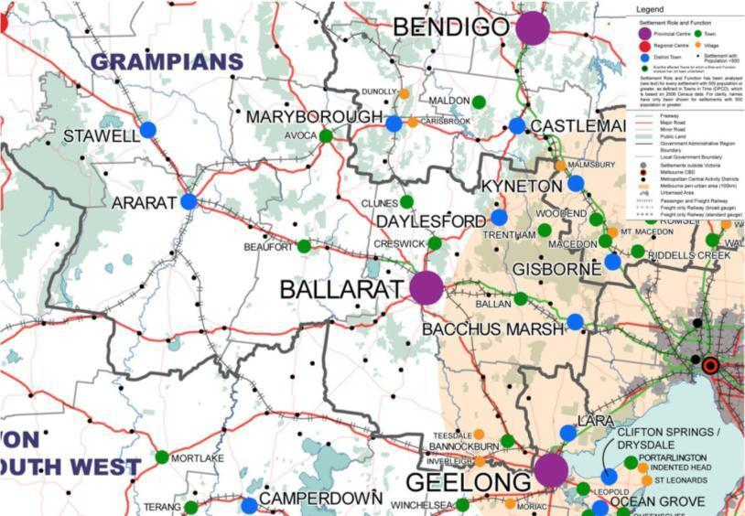Figure 7: Settlement role and function map – Grampians

Source: Regional Mapping Project Final Report, Grampians Region, Central Highlands

## Preferred pattern of urban growth

### Description and analysis

The significant growth forecast for the region presents the opportunity to consider the fundamental issue of how this growth should be distributed. However, it must be recognised the region is not starting with a ‘blank canvas’. Large amounts of future residential growth will be accommodated in the Ballarat West growth area which is currently being planned to accommodate around 30,000-40,000 people (Parsons Brinckerhoff, 2010a).

Bacchus Marsh also has significant land supply of around 1600 lots through development plans approved for the West Maddingley area. This figure could increase through other opportunities for development, such as rezoning in the Underbank area (under investigation).

Most growth pressure is likely to be in the eastern parts of the region in Ballarat or within the peri-urban influence of Ballarat, Geelong or Melbourne, with the settlement pattern in the western and northern parts of the region unlikely to change significantly.

The Central Highlands Regional Strategic Plan states the majority of urban growth in the region will occur in and around Ballarat and suggests this will take place in the following major areas:

* Ballarat West growth corridor
* inner area residential revitalisation in Ballarat
* along three major settlement and transport corridors, these being Creswick-Clunes, Gordon-Ballan and Smythesdale-Linton
* at Bacchus Marsh and Bannockburn, the latter being in the G21 Regional Growth Plan region which covers Geelong and surrounds.

The Central Highlands Regional Strategic Plan considers there are substantial opportunities to better utilise the existing network of small settlements. At a regional level, planning should recognise those locations that can connect to the regional transport network to ensure access to higher order facilities and services. As such, substantial opportunities exist to create a network of settlements clustered along key transport corridors. Settlements that would benefit from this approach include Meredith, Elaine, Buninyong, Gordon, Trentham, Clunes, Beaufort and Smythesdale.

Identifying a preferred pattern of settlement must also consider constraints such as:

* the need for appropriate infrastructure, particularly reticulated sewerage, in some towns
* the presence of high quality agricultural soils such as the Werribee River flats in Bacchus Marsh, wine growing regions and volcanic soils to the east of Ballarat
* declared water supply catchments for Melbourne, Ballarat, Bendigo and Geelong
* key landscapes and areas of biodiversity
* natural hazards such as flood and bushfire-prone land.

Options for settlement patterns are arguably the most important directions the plan can provide, as these will determine priorities for infrastructure investment, how services should be planned and distributed, and how the region wants to position itself as an economic and social entity.

Settlement pattern options include promoting the development of a diverse range of centres, focusing development in key centres, or even developing major new growth centres. In relation to the latter option, there would need to be significant evidence to show that existing settlements were not able to cater for growth, or that this option provided a net community benefit.

The Central Highlands Regional Strategic Plan strongly promotes the concept of developing existing settlement corridors. However, a regional growth pattern tied to transport corridors that essentially encourage commuting does have a number of consequences. As Buxton et. al. (2011) (page 103) note:

“High levels of commuting and increasing socio-economic linkages to the metropolis at once offer opportunities for services and employment, yet diminish identity and enforce interdependence … Spatial planning has an important role to play in envisaging and delivering a future where growing peri-urban communities retain physical identity as separate places, but also in providing for economic futures that assume continued services and employment…”

There are already high numbers of journeys to Melbourne from Moorabool Shire, including from Bacchus Marsh which functions in part as a commuter town. Figure 8 indicates there are fewer journeys from Ballarat to Melbourne and that Golden Plains residents travel in equal numbers to Geelong and Ballarat.

A transport corridor-based approach does not only have to pertain to Melbourne commuting. Within the Central Highlands region the opportunity exists to leverage the existing concentration of employment and services in Ballarat to create a network of settlements within this city’s peri-urban hinterland.

Figure 8: Journeys from Central Highlands local government areas 2011

Origin – Ballarat (C)

* Journeys to:
* Metropolitan Melbourne – 2099
* Ballarat (C) – 31,650
* Greater Bendigo (C) – 53
* GreaterGeelong (C) – 258

Origin – Ararat (RC)

* Journeys to:
* Metropolitan Melbourne – 69
* Ballarat (C) – 50
* Greater Bendigo (C) – 8
* GreaterGeelong (C) – 7

Origin – Golden Plains (S)

* Journeys to:
* Metropolitan Melbourne – 544
* Ballarat (C) – 2336
* Greater Bendigo (C) – 3
* GreaterGeelong (C) – 2337

Origin – Hepburn (S)

* Journeys to:
* Metropolitan Melbourne – 668
* Ballarat (C) – 1195
* Greater Bendigo (C) – 52
* GreaterGeelong (C) – 25

Origin – Moorabool (S)

* Journeys to:
* Metropolitan Melbourne – 5375
* Ballarat (C) – 1236
* Greater Bendigo (C) – 6
* GreaterGeelong (C) – 229

Origin – Pyrenees (S)

* Journeys to:
* Metropolitan Melbourne – 69
* Ballarat (C) – 490
* Greater Bendigo (C) – 12
* GreaterGeelong (C) – 9

Source: Australian Bureau of Statistics (2011)

Transport projects, such as passenger train services between Ararat and Ballarat and Maryborough and Ballarat, the possible enhancements to coach and train services between Geelong and Bendigo via Ballarat (Rail Revival Study) and duplication of the Western Highway to Stawell, mean enhanced connectivity along corridors to the south, north and west of Ballarat. In addition to the existing high quality transport infrastructure in the Ballarat-Bacchus Marsh-Melbourne corridor, these transport spines could provide the basis for towns in Pyrenees, Golden Plains, Moorabool, Central Goldfields and Hepburn to become more attractive to potential residents. The extent to which growth could be directed to towns such as Clunes, Creswick, Talbot, Meredith, Gordon and Beaufort, versus the traditionally larger centres in the relevant municipalities, is identified in the plan.

There is already ongoing work on settlement planning within the region that informs the plan. For example, in the Ballarat-Maryborough corridor, the Advancing Country Towns project is currently developing solutions to the challenges facing the three settlements of Clunes, Creswick and Talbot. This project is a significant government investment over a period of four years (2011 to 2015) and aims to combine local knowledge and government resources to create new opportunities for people living in these communities. The benefits of population growth in these settlements were identified in the early stages of the project.

Clunes, Creswick and Talbot are well located within the Ballarat-Maryborough-Bendigo corridor to benefit from a strategic corridor approach to future development and infrastructure investment. Projects that support tourism, economic development, transport and arts have been identified as part of the Advancing Country Towns project.

These benefits will be delivered through a number of strategic interventions, the following of which are of direct relevance to land use planning:

* facilitating the development of land for residential purposes
* increasing the supply of suitable industrial and commercial land, and facilitating development.

The Central Highlands region’s councils have also undertaken considerable strategic settlement planning work that has been used to inform the plan. For example, the Golden Plains Rural Land Use Strategy 2008 describes the shire’s settlement strategy including core elements such as designating priority service towns, like Smythesdale, for infrastructure provision and development, and encouraging growth based on the provision of infrastructure and commercial facilities.

### Land use planning response

The Central Highlands Regional Strategic Plan sets out where the majority of growth will occur in the region over the next 20 years. However, this background report gives further consideration to how growth can be best managed, balanced and planned.

In developing the regional growth plan, a number of growth concepts were developed which identify potential locations and types of growth that could absorb the balance of growth planned for the region. The following concepts were developed for discussion and informed the preparation of a proposed concept plan for regional growth which was subject to public consultation in August 2012. It should be noted that these concepts are not intended to be interpreted as discrete options:

* *Settlement corridors radiating from Ballarat:* The Central Highlands Regional Strategic Plan identifies three corridors in the hinterland of Ballarat that could potentially be suitable for growth (Creswick-Clunes, Gordon-Ballan and Smythesdale-Linton). In addition to these corridors, other potential corridors exist along major transport routes radiating from Ballarat, including along the Midland Highway/Ballarat-Geelong railway line to the south of Ballarat (to Meredith and Elaine) and along the Western Highway and Ararat railway line to the west of Ballarat (Beaufort). Growth within these small-to medium-sized settlements would support less populated municipalities and provide lifestyle choice for people who wish to live in close proximity to a major regional centre while enjoying the small town lifestyle. This may attract people to the Central Highlands that might otherwise not have relocated.
* Growth in district towns: There are a number of district towns within the Central Highlands region that have good access to services and infrastructure, although specific guidance for growth in these towns is not provided in the Central Highlands Regional Strategic Plan. Encouraging growth within Ararat, Bacchus Marsh and Maryborough would ensure these towns remained vibrant and continued to offer a wide range of services to surrounding rural areas.
* Rural residential development: the Central Highlands Regional Strategic Plan recognises rural residential development needs to be carefully managed through identification of, and planning for, a limited number of clearly defined rural residential areas. This may require consolidation of designated rural residential areas with consideration given to natural hazards such as bushfire which make some areas less suited to this form of development. Rural residential development is best located on the periphery of settlements where it can support the settlement, where good access can be provided to services and residents can enjoy the benefits of a rural lifestyle. The ability to offer a rural residential lifestyle choice in well-located areas will enable the Central Highlands to attract a wider range of residents including those seeking a ‘tree change’.
* Hinterland (peri-urban) development: Large parts of the Central Highlands region fall within the peri-urban region of Melbourne. The attractive rural landscapes of the peri-urban region are important for the liveability of the region and for Melbourne, although there are considerable development pressures facing these rural areas. Studies commissioned by the Peri-Urban Group of Rural Councils, including Moorabool and Golden Plains, identify that a business-as-usual approach will lead to ad hoc development in rural areas and a loss of highly valued and important rural landscapes. There is a need to carefully manage residential growth in these areas and direct it to small and medium sized settlements, including Bacchus Marsh and Bannockburn and a small number of designated rural residential areas in order to protect the rural landscape that attracts people to the region.

The plan has sought to integrate the most beneficial aspects of these concepts into the proposed regional settlement framework.

## Settlement network

### Description and analysis

The roles and relationships of towns and cities in the region are set out in the Central Highlands Regional Strategic Plan which identifies that:

* Ballarat is a major regional activity centre which drives much of the current regional economy and extends to communities beyond the region.
* Ararat and Stawell (the latter of which is located in the adjoining Wimmera Southern Mallee region) are two distinct centres, but are close in distance (27 kilometres) and have interlinked roles and functions. They have a combined population of around 15,000 people and together can play a strong regional role.
* Maryborough, located outside the region, has traditionally been a strong regional service centre, strengthened by the re-opening of the passenger rail service to Ballarat and its location within the goldfields.
* Bacchus Marsh has grown rapidly and is now the second largest urban area in the region. It acts as both a commuter town to Melbourne and as an established service centre.
* Towns in the overlap between the Melbourne, Ballarat or Geelong hinterlands, such as Bacchus March, will continue to deliver services to their surrounding area but are subject to substantial change and growth pressures.
* Towns such as St Arnaud (in Wimmera Southern Mallee region), Avoca, Ballan, Beaufort, Clunes, Creswick and Trentham play important community service roles for surrounding rural areas.
* Daylesford-Hepburn Springs, with its tourism and health and wellbeing role, has developed a national role and profile.

It is noted there are a range of smaller towns which are not of regional significance, but play an important local role and will continue to be managed and planned for by councils.

The network of centres in the Central Highlands and their relationships may change as development occurs, functions are assigned by way of new facilities, and services are progressively provided. The Central Highlands Regional Strategic Plan (page 24) suggests this is unlikely to happen in the short term but over time changes can be expected in the role that each centre plays. For example, Ballarat may alter its role relative to the region by growing:

“..its critical population mass so as to expand its comprehensive set of high order health, education, retail, business arts and cultural and recreational services. This in turn will improve the economic robustness and liveability of the whole region.”

The role and relationship between settlements is an important input for the plan. The future growth patterns of the region need to be informed by how people use the network of centres to access services, jobs and facilities. This will become particularly important in areas of the region more remote from the largest centres where populations are decreasing or changing. Ageing populations will create increased demand for existing and new services, as well as housing and types of transport. However, there is a significant challenge in providing such resources to every settlement. Sharing of resources, facilities and economic development initiatives at a regional or sub-regional level is one way to assist in maintaining the viability of small communities. The complementary role that could be played by Stawell and Ararat to generate the critical mass of a much larger regional centre is a good example.

In planning for the long-term development of the region, the plan aims to deliver growth in appropriate locations to support a preferred settlement network, having regard to services and employment distributions outlined above. Residential land supply information has informed the preferred settlement network, particularly for major centres and preferred growth areas, as has the identification of opportunities to reinvigorate small towns and settlements within the network.

Local planning schemes make various directions and commentary about this issue, generally:

* encouraging growth in their major centres, or in some cases, smaller towns where infrastructure upgrades will facilitate growth such as Smythesdale
* supporting 10-15 years supply of residential land
* seeking to support infill development ahead of urban expansion for many centres
* including strategic maps indicating preferred areas for additional development.

The Department of Transport, Planning and Local Infrastructure’s Regional Urban Development Program is a key source of land supply data. The Regional Urban Development Program is currently collecting further land supply data in the Central Highlands region, which will result in comparable data being available across each of the municipalities. This data will help to provide a region-wide picture of land supply and will inform regional level planning. A number of the region’s councils have undertaken land supply investigations, which are instructive in determining land supply and demand over time. For example, the Golden Plains Shire Council adopted its Residential Land Supply Review in 2009, which documented existing land supply and demand in each of the settlements in the municipality and identified priority actions for further growth planning. This review identifies growth areas for a number of towns within the Central Highlands region including Smythesdale and its surrounds.

There is a substantial long-term supply (30–40 years) of residential land already identified in the Ballarat West Growth Area (refer to Figure 9). This is further supplemented by residential development opportunities in other centres throughout the region, particularly Bacchus Marsh.

In addition to the significant levels of growth planned for Ballarat and to a lesser extent Bacchus Marsh, the plan also identifies where medium and limited growth is supported in a range of smaller settlements to achieve regional objectives.

The key considerations for identifying opportunities for growth and establishing the Central Highlands’ future settlement network are:

* understanding how settlements relate to each other with a view to ensuring that easy access to services underpins planning for a changing demographic
* understanding key environmental assets such as open potable water catchment areas and natural hazards such as bushfire and flood risk
* identifying where longer term options for substantial residential development exist
* the implications of demand and pressure for growth experienced by peri-urban municipalities within the region, such as Golden Plains and Moorabool
* providing for appropriate land supply in centres across the region
* ensuring growth centres are sustainable and have access to services and employment
* coordinating growth planning with the provision of infrastructure and utility services
* protecting the liveability of towns and key regional assets and attractors, such as heritage and landscape amenity
* managing land use, transport and economic planning to minimise the risk of regional exposure to increasing energy costs.

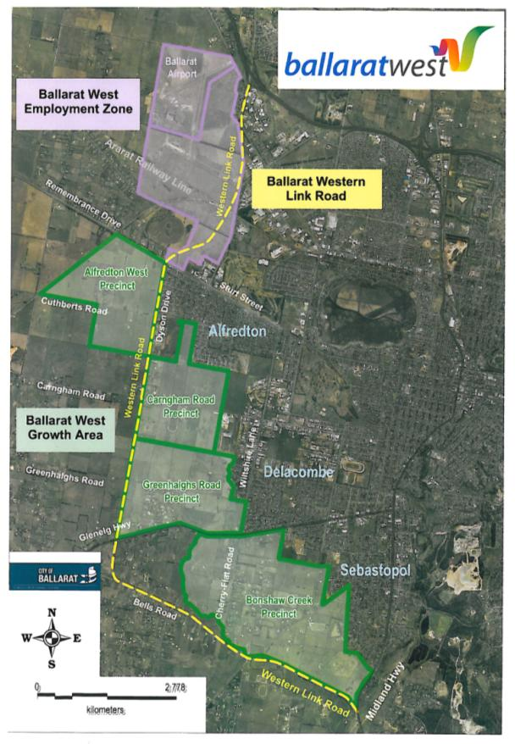Figure 9: Ballarat West growth area

Source: City of Ballarat

Kilometres

2778

0

### Land use planning response

The plan aims to ensure that appropriate levels of residential land are available throughout the region. A key attribute of the Central Highlands is its uneven distribution of growth, although centres such as Stawell-Ararat and Avoca, which are situated outside the areas of highest growth pressure, still play an important sub-regional role. Settlements such as these are identified in the plan to accommodate medium or limited levels of growth. Although growth will not be on the same scale as that planned for Ballarat and Bacchus Marsh, communities and economies in these settlements will experience significant benefits from the projected growth.

The plan recognises the important, and in many cases, mutually beneficial relationships that exist between settlements in the region and takes a regional perspective of the role and function of each settlement in providing services to local communities. The plan recognises the need to plan for growth and provision of services around groups of centres providing complementary facilities, housing or jobs for each other (local clusters).

## Housing diversity and affordability

### Description and analysis

There are significant differences in the supply of, and demand for, housing across the Central Highlands region. The supply of housing across the region should ideally reflect and anticipate the housing and service needs of new and existing residents and should consider access to employment, social infrastructure and transport. Recognising these dynamic needs can contribute to the understanding of internal and external migration and whether the housing markets adequately meet the needs of communities or workforces. For example, in Ballarat 29.4 per cent of private occupied dwellings were being rented, while in Golden Plains Shire, just 8.7 per cent of private occupied dwellings were being rented (Australian Bureau of Statistics, 2011). Diversity of housing can impact on the ability of some communities to attract skilled workers and thus affect service provision and the local economy. Given the ageing population, the mix of housing available is also an important issue.

There is a notable disparity in house prices between the east and west of the region, with Ballarat City and the Golden Plains, Hepburn and Moorabool shires tracking around or above the regional Victorian average (refer to Figure 10). Demand for housing in towns within commuting distance to Melbourne, Ballarat and Geelong has contributed to the rise. Median house prices in the Central Highlands have increased about two-fold, (around 115 per cent) since 2000.

Chart showing median house prices for the Central Highlands from 2000 to 2011Figure 10: Median house prices

Source: Department of Sustainability and Environment

The Central Highlands Regional Strategic Plan (page 13) expressed a view that the range of housing options across the region does not match the current and projected needs of many households as follows:

“Much of the type, form and location of residential areas and new housing being built in the region is working against the likely future needs of many households. Household sizes are getting smaller, single person households are increasing and households are often structured differently to traditional forms and sizes. These changes have implications for the supply of relevant forms of housing. New urban development and residential layouts across the region do not necessarily support the provision of cost effective and sustainable transport systems.”

In addition, the supply of appropriate housing must consider the housing needs created by the emergence of large construction and infrastructure projects such as the Western Highway development and the expansion of the Ararat and Langi Kal Kal prisons. Housing to address the needs of students migrating to regional universities and TAFE is also required.

Although the Central Highlands Regional Strategic Plan acknowledges the potential future gaps in housing needs, the strategic directions and actions component of that plan only focus on housing options within Ballarat and particularly the revitalisation of the central business district.

A wider understanding of housing needs across the region is important. According to the Department of Planning and Community Development’s report ‘Change and disadvantage in regional Victoria: an overview’ (2011), rising house prices result in some populations becoming concentrated in low service areas. Three groups will be affected, as follows:

* Residents who move into low service areas from high amenity areas, such as metropolitan areas, as house prices rise, particularly as amenity migration has generally not resulted in new houses being built (Barr, 2009).
* Existing residents in low service areas who are unable to move to more expensive serviced localities when their need for services increases due to age, disability or the need to access the labour market (Barr 2009). This includes social housing tenants who live in low serviced areas away from labour markets.
* Welfare recipients or underfunded retirees who move into low service areas because of the cheaper housing (Barr 2009). For example, in 2000 a net of 9500 welfare recipients moved to regional Victoria for housing (AHURI 2005). While housing is cheaper generally in regional Victoria (both rents and purchase), people will still be at risk of housing stress if their incomes do not keep pace with house prices or rent. This will include those on pensions, benefits and lower paid single workers.

One of the drivers behind the varying housing needs of the region is set out in Figure 11 which shows where buyers of property in the Central Highlands come from. The tree-change phenomenon is clearly a key factor in both Hepburn and Pyrenees shires where the largest cohort of home buyers are generally asset-rich households relocating from Melbourne. Moorabool and Golden Plains shires are attracting buyers from neighbouring municipalities, presumably people looking for value for money and lifestyle change from the larger adjoining cities. Smaller towns such as Daylesford, Hepburn and Trentham are towns that attract people looking to enjoy the different lifestyles available.

Conversely, the housing markets for the larger centres of Ararat and Ballarat would appear to be dominated by people moving within the municipality. There is some migration into the larger towns and centres from other parts of regional Victoria as people seek to take advantage of the services and opportunities on offer.

Figure 11: Where buyers come from (2010)

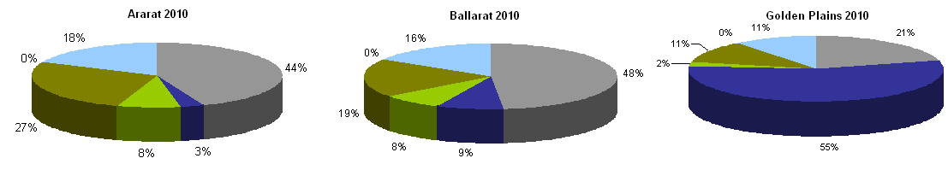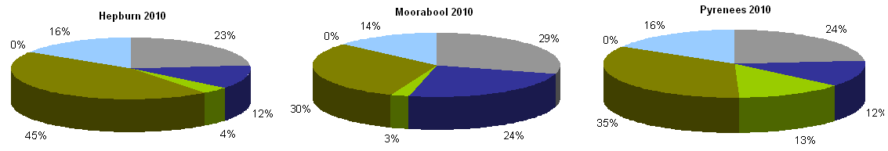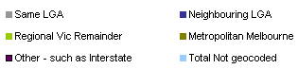

Source: Department of Sustainability and Environment

### Land use planning response

The plan identifies a need to develop a regional housing strategy to address issues such as appropriate housing choice, availability and affordability within the region. This strategy could identify locations where particular types of housing are most needed.

## Liveability

### Description and analysis

The Central Highlands Regional Strategic Plan specifically focuses on liveability. It acknowledges the sense of competitiveness within regional Victoria for regions to grow and present as an ‘attractive supportive place to live…’

The characteristics that contribute to the region’s liveability include:

* relative proximity and good access to Melbourne
* the location of a large, well serviced regional centre in terms of education and health
* strong regional road and rail capacity
* outstanding built and natural heritage, recreational opportunities, arts and cultural riches
* a wide variety of places to live, with the region’s network of small towns and villages linked to rapidly growing centres.

Some of the factors that contribute to liveability are explored in other parts of this background report, such as the services and transport links which make Ballarat an attractive alternative to Melbourne. The proximity to Melbourne is also a factor contributing to the attractiveness of peri-urban municipalities within the region. However, from a settlement planning perspective, there are a variety of other matters that are relevant to the liveability of communities and attracting people to the Central Highlands region, such as the protection of cultural heritage assets. While cultural heritage is often seen as a local issue, it can also have significant regional implications. As well as its intrinsic value to society on whole, a regional or state-significant cultural heritage asset can act as a drawcard for tourism. Likewise a town with attractive, intact heritage streetscapes can provide a selling point for lifestyle-related in-migration.

In Ballarat, for example, tourism makes a substantial contribution to the regional economy through attractions such as Sovereign Hill, major events, built heritage and the film industry. Ballarat is also a gateway to tourism opportunities in the Central Highlands such as health and wellbeing in Hepburn/Daylesford. Approximately 2200 new jobs are expected to be created in tourism-orientated industry sectors between 2006 and 2026 in cafes, restaurants and accommodation (SGS, 2010).

Planning schemes within the Central Highlands contain information about cultural heritage and urban character to a greater or lesser degree. Importantly, they all discuss the qualities and places that should be protected.

The plan has a role in ensuring the key qualities that make settlements liveable, attractive and unique are identified and protected. Growth and development should not compromise these qualities, particularly where they are of regional significance. For example, goldfields heritage, health and wellbeing tourism or significant landscape amenity can be intrinsically related to the appearance and character of towns. To ensure economic prosperity, spatial planning for growth must ensure that future development does not impact on the region’s cultural heritage assets.

Finally, there is a role for planning to create future liveable communities, both in the provision of services commensurate with levels of growth, and in providing good urban design and layouts for new residential precincts. This includes only supporting layouts that encourage safety and healthy living, such as ensuring walkable catchments for services and good connections to surrounding areas. For larger towns, liveability provisions could include supporting medium density housing in well-located parts of the town, close to the business and service centre. This will be particularly important for an ageing population and for supporting those moving from smaller settlements to take advantage of access to facilities and services.

### Land use planning response

The plan recognises the importance of retaining and enhancing the liveability of the region in a number of ways, supporting its notable heritage attributes, landscapes and accessibility to services and facilities. The plan does not discuss urban design principles as these remain in the realm of local planning schemes, as does a discussion of the town or parts of towns where character is a key asset to their liveability. Planning should seek to ensure the qualities that make places unique and liveable are retained in settlement planning.

## Rural residential development and rural land use

### Description and analysis

Local planning schemes provide some direction around rural residential development, although there are a variety of approaches to this issue. Municipalities such as the Hepburn and Golden Plains shires have identified concerns with existing high levels of low density residential development and seek to consolidate urban development within town boundaries, or defined areas. Other municipalities support the provision of rural residential development in appropriate areas, generally close to towns and provided it does not compromise high quality agricultural land. These councils include Central Goldfields, Moorabool, Ballarat, Ararat and Pyrenees.

The planning schemes of Golden Plains, Northern Grampians and Pyrenees (in part) specify larger minimum lot sizes for subdivision and dwellings than the default 40 hectares provided for by the Farming Zone. Moorabool Shire is also currently considering a long-term strategic approach as to how it will plan for small towns and rural settlements through its ongoing growth strategy work.

Clause 11.05-3 of the State Planning Policy Framework provides direction in relation to this issue, with strategies to:

* prevent inappropriately dispersed urban activities in rural areas
* limit new housing development in rural areas, including:
* directing housing growth into existing settlements
* discouraging development of isolated small lots in the rural zones from use for single dwellings, rural living or other incompatible uses.

The Improving Rural Land Use report prepared under the Future Farming Strategy (Rural Planning Group 2009) discusses rural living in relation to agriculture. It notes that:

* A clear distinction needs to be drawn between subdivision and approval of land for a dwelling, as small lots do not necessarily equate to less productive land.
* Rural lifestyle living should be contained within strategically identified locations away from farmland of strategic significance.
* There can be conflicts between agricultural production and sensitive land uses.

A report by Buxton et. al. (2011) about future planning for Melbourne’s peri-urban region identified significant long-term concerns with current trends around rural residential development and subdivision of rural land. It found that:

* The continuation of current development trends under present policy settings will fundamentally alter the appearance and functioning of the region.
* There are many small lots already in existence but which are undeveloped and currently used for agriculture. Progressive development of these lots will lead to dramatic changes in the landscape and threaten agricultural production. Critically affected areas will be around Melbourne, such as Moorabool Shire in the Bacchus Marsh area.

A number of measures that could be implemented to alter the business-as-usual scenario include:

* preventing increased fragmentation of land holdings and removing development expectations
* integrating environmental factors related to soils, vegetation and landscapes into planning
* providing effective urban alternatives to the price advantages of some peri-urban rural housing markets, including infrastructure, services and transport in peri-urban townships
* an improved housing mix in townships.

The Central Highlands Regional Strategic Plan provides guidance on this matter, by stating that high value agricultural areas and rural landscapes will be retained through the selection of a limited number of rural living opportunities, rather than allowing rural living to continue in an ad hoc manner (page 26).

In terms of zoned land, there are substantial areas in the region included in the Rural Living Zone, particularly around large centres. The most prominent areas of this type of zoned land include the north-west of Golden Plains, parts of Moorabool around Gordon and Lal Lal, areas around Beaufort in the Pyrenees, areas around Buninyong to the south of Ballarat, and land between Ararat and Stawell in Northern Grampians Shire.

### Land use planning response

The plan recognises that rural residential development is important for offering lifestyle choice to new and existing residents. The challenge for land use planning is to manage the demand for rural residential development to ensure it is directed to appropriate locations (rather than ad hoc) throughout rural areas considering important rural land uses, such as agriculture, environmental assets and infrastructure. The plan expresses the need to monitor supply and demand for rural residential land within the region.

The plan also recognises that detailed planning for rural residential development should be undertaken by councils. It identifies regionally significant environmental, landscape and agricultural assets with a view to ensuring these areas are protected from incompatible land use, including rural residential development. The plan also identifies a number of regional considerations that should be taken into account when considering locating rural residential development.

The plan notes that there are potential benefits to the region of rural residential development, in terms of providing housing and lifestyle choice, attracting residents to the region and supporting the viability of smaller settlements.

## Peri-urban relationships

### Description and analysis

Peri-urban issues

**‘**Peri-urban’ literally means the area around an urban settlement and has been applied in the plan to describe the eastern parts of the Central Highlands region that are within Melbourne’s peri-urban region (refer to Figure 12). Ballarat also has a peri-urban area containing a number of settlements located within easy commuting distance.

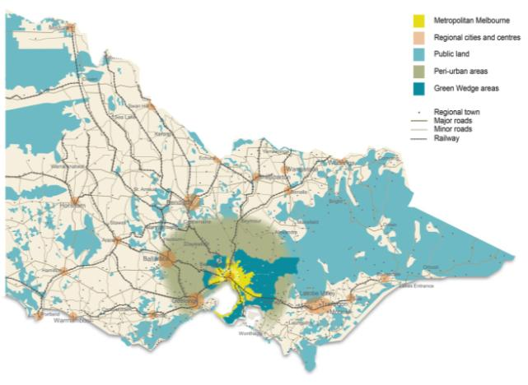Figure 12: Peri-urban extent of Melbourne

Source: Melbourne – Let’s talk about the future (2012).

One of the most important contextual factors affecting the Central Highlands is the region’s relationship to Melbourne. The area within 100 kilometres of central Melbourne is considered to be within the city’s peri-urban influence. For the Central Highlands region, this primarily includes Moorabool Shire and parts of the Golden Plains and Hepburn shires.

Protecting the values of peri-urban areas is a key challenge for land use planning around growing cities within Australia and internationally.

As Melbourne has grown so has the extent of its peri-urban area and the importance of the assets of this area in supporting the functioning of Melbourne. Continual investment in transport infrastructure has significantly improved access from Melbourne to regional centres and interstate, improving mobility within the peri-urban region, making it a more desirable area to live.

There are a number of ‘state significant’ land uses within Melbourne’s peri-urban region that may be regarded as assets to the functioning of metropolitan Melbourne and Victoria as a whole. These may be classified as resources, infrastructure, environment and cultural, and are identified in the following table.

State significant land uses

**Resources**

* Extractive
* Why these land uses are considered significant – The cost of transporting stone and sand products over long distances can account for a substantial proportion of product price at the construction site. Sourcing construction materials from local quarries within the peri-urban region enables cost efficiencies and energy savings.
* Forestry
* Why these land uses are considered significant – A number of state forest reserves are located in the peri-urban region. They provide for a variety of uses, including timber for sustainable forestry, biodiversity and landscape conservation, protection of water catchments and opportunities for recreation.
* Productive agriculture
* Why these land uses are considered significant – Prime agricultural land provides food and fibre to the Victorian community, and supports employment and businesses. It also supports associated rural industries, such as food processing, abattoirs, shearing, irrigation supplies and stock feed producers that contribute to Victoria’s economy.

**Infrastructure**

* Transport
* Why these land uses are considered significant – The peri-urban region is traversed by an extensive arterial road and rail transport network linking major centres of population and industry across Victoria. Progressive transport expansion and safety improvements continue to influence land use activities and are likely to further improve travel times, reducing the commuting time and improving access between peri-urban areas and Melbourne.
* Utilities
* Why these land uses are considered significant – Utilities infrastructure that require extensive landholdings or buffers, which are often unable to be provided within an urban area, are located within the peri-urban region and are critical to the functioning of urban areas. This includes water treatment plants, as well as electricity, gas and waste management facilities, pipelines and transmission corridors, and associated buffer areas.

**Environment**

* Biodiversity
* Why these land uses are considered significant – Strong natural systems with a diversity of natural habitats for native plant and animals are important for the health and wellbeing of people living in urban areas. Opportunities for close connections with the natural world have high social, economic and educational value.
* Landscapes
* Why these land uses are considered significant – Landscapes help define the areas in which we live and work, and provide a connection with place and culture. They also provide respite from urban living.
* Parks and reserves
* Why these land uses are considered significant – There are many parks and reserves in the peri-urban region surrounding Melbourne. These areas provide ecological, environmental, cultural heritage and aesthetic value and the opportunity for leisure and recreation.
* Water catchments/ wetlands and rivers
* Why these land uses are considered significant – Peri-urban catchments and storages remain essential to provide water for human and livestock consumption and for food production. The filtering action of the forested surrounds of many of our reservoirs avoids the need for expensive water treatment facilities. Careful management of land use within open potable water catchments is important to protect water quality and yield. Waterways and wetlands areas provide important habitat for flora and fauna and contribute to the landscape values of the peri-urban region.

**Cultural**

* Heritage
* Why these land uses are considered significant – There are various places, sites, structures, relics and flora of heritage significance in the peri-urban region. Cultural heritage assets generate social benefits, such as a sense of identity, direct user benefits through tourism, and the benefits stemming from the intrinsic value of preserving these assets for future generations to appreciate and enjoy.
* Tourism
* Why these land uses are considered significant – The peri-urban region provides key day and overnight trip destinations for residents and visitors from interstate and overseas. Attracting visitors to the peri-urban region also results in indirect employment and additional spend in ‘downstream’ industries such as retail suppliers, food production and construction.

The peri-urban area close to the edge of metropolitan Melbourne is subject to pressures associated with Melbourne’s growth, and is undergoing increasing demand for housing. This demand for housing is not limited to urban locations and also affects rural areas, where it can lead to ad hoc housing and subdivision, compromising the ability for landscapes to provide natural resources. Risks from natural hazards such as bushfire and flooding affect some areas where development pressures exist, exposing more residents to these hazards if development proceeds.

Changing patterns of work, travel and lifestyle preferences, coupled with improvements to transport infrastructure, will enable people to live in the Central Highlands but access employment and services in Melbourne. Major regional centres such as Ballarat also provide an attractive alternative for housing and commerce.

A new metropolitan planning strategy, *Plan Melbourne* has been prepared and will help define Melbourne’s relationship to its surrounds. The regional growth considers the emerging directions of this important strategy. Key aspects of the relationship between the peri-urban parts of the Central Highlands and Melbourne may include:

* maintaining systems that support Melbourne’s growth and liveability
* helping to maintain the city’s adaptive capacity to climate change, natural hazards, food and energy security
* helping reduce Melbourne’s ecological footprint and transition to a more sustainable economy
* appropriate settlement locations and infrastructure to support a greater proportion of Victoria’s growth, while maintaining key resources and assets
* the degree to which the Central Highlands is self-sufficient or needs to rely on Melbourne to provide jobs and services
* the ability to provide some housing options which can be supported through the role of transport networks.

A discussion paper titled Melbourne, let’s talk about the future, was released in October 2012 by the Ministerial Advisory Committee for the Metropolitan Planning Strategy. This discussion paper recognises that Melbourne is the gateway to regional Victoria and the competitiveness of regional Victoria is dependent upon the successful management of Melbourne’s growth. The discussion paper identifies that the focus of Melbourne’s growth is likely to shift from the south-east of the city to the north and west. How the westward expansion of Melbourne is managed will have significant implications for the Central Highlands region.

Several principles for defining how Melbourne should be managed in the future are identified in the discussion paper. One of these is Principle 6: A polycentric city linked to regional cities. The benefits of better integrating Melbourne with a network of regional cities, within the concept of a ‘state of cities’, are identified. These include:

* increasing economic and social links to better integrate labour forces
* creating more choice for fast growing sectors such as remote and mobile workers
* making better use of existing infrastructure.

The opportunity to grow some small towns to support additional growth and enhance the roles of regional cities is identified, with the considerable growth potential of Ballarat and Bacchus Marsh specifically mentioned.

The discussion paper recognises that regional cities can play stronger roles in the fields of agri-business, manufacturing, education and tourism and can be cost-competitive, highly attractive places to live. Potential cost advantages in upgrading existing road and rail infrastructure connections with regional cities, and providing for greater development of these cities as opposed to further greenfield expansion of Melbourne, is also recognised.

### Land use planning response

The plan identifies a wide range of regionally significant land uses that occur within the peri-urban parts of the Central Highlands region and the important role land use planning plays in ensuring these uses are provided for into the future.

The plan has been prepared concurrently with the new metropolitan planning strategy, *Plan Melbourne*. The metropolitan planning strategy and the eight regional growth plans will together inform a vision for Victoria, which will build on the strengths of Melbourne and regional Victoria. These documents will provide a statewide blueprint for managing growth and development throughout Victoria.

*Plan Melbourne* places a strong emphasis on planning for Melbourne’s growth and change and on strengthening the linkages between Melbourne and regional Victoria. The [regional growth plans](http://www.dpcd.vic.gov.au/planning/plansandpolicies/ruralandregionalplanning) identify priorities for regions across Victoria, developing locally-driven plans for population and economic growth.

The Central Highlands Regional Growth Plan, consistent with current state policy, seeks to achieve the following outcomes within the peri-urban region:

* direct development to key settlements
* limit development in settlements subject to significant natural hazards, risk or where growth would detract from significant environmental and landscape assets
* maintain a green break with the Melbourne metropolitan area
* protect and enhance cultural heritage values
* protect visual landscape values
* protect environmental assets and values of state and national environmental significance
* embrace the benefits to the region of Melbourne’s western growth corridor
* use land efficiently and minimise the impact on productive resources, including minimising the impact of rural residential development on water supply catchments and agricultural uses.

1. Planning for communities

## Context

It is important to understand the region’s age structure to plan for the needs of key population groups.

The Central Highlands region is characterised by ‘strong population growth in the larger regional centre of Ballarat and the peri-urban areas of Moorabool and Golden Plains coupled with an outmigration of youth, particularly from the rural areas west of Ballarat (Parsons Brinckerhoff, 2010a).

While the Victorian population is projected to grow, the proportion of children will decrease steadily and the ageing trend is projected to continue at a higher rate. The changing distribution of the population to different age groups (age structure) is influenced by the larger number of people born between 1945 and 1971 (who are now aged 42 to 68 years).

The projected age structure for Central Highlands region can be seen in Figure 13. Demographic changes are not uniform across the region, as shown in the previous chapter (refer to Figure 6).

Figure 13: Population by age cohort, 2011 and 2031

Source: Victoria in Future 2012

Another contextual indicator for communities within the Central Highlands is the levels of disadvantage. The map at Figure 14 shows there are relatively high levels of disadvantage across the region, particularly within some towns and parts of Ballarat, which are among the 10 per cent most disadvantaged areas of Victoria.

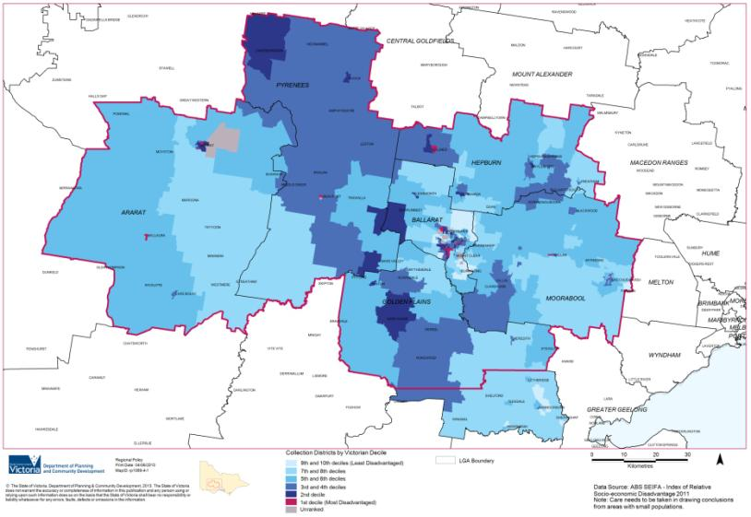Figure 14: Relative socio-economic disadvantage

Source: Australian Bureau of Statistics

## Demographic change

### Description and analysis

The population of the Central Highlands region is ageing, particularly in rural areas where the average age of farming communities is increasing. Younger people are migrating in search of improved economic prospects, with the migration rate of young women double that of young men and older people are retiring to regional Victoria from metropolitan areas (Department of Planning and Community Development, 2011).

The demographic changes experienced in the region are likely to differ across the region from the western parts of the region to the peri-urban context. For example, in Bacchus Marsh, growth from metropolitan Melbourne is occurring and this may result in young families moving into this part of the region.

Some high amenity areas are also experiencing a significant influx of ‘amenity migrants’ moving from Melbourne seeking a rural lifestyle (Barr 2009). Those people moving to regional Victoria can be grouped broadly as (Department of Planning and Community Development, 2011):

* weekenders, with some local government areas now having significant non-resident populations
* commuters and those that share their time between a city and a regional household
* downshifters (people seeking a balance between work and leisure)
* affluent retirees
* non-affluent retirees, welfare recipients and small numbers of new Australian migrants moving to areas where there is cheaper housing (Australian Housing and Urban Research Institute 2005; Barr 2009; Department of Human Services 2009).

A particular challenge will be providing centralised infrastructure and service provision for a critical mass, while meeting the needs of more isolated settlements.

Alongside the projected demand in Central Highlands for infrastructure and services, particularly in health, it is important to be able to attract and retain young families in the region to ensure a balanced community structure and appropriate labour force capacity to support an ageing population base (Parsons Brinckerhoff, 2010a).

Ageing populations

Understanding the demographic changes that will occur in the region is important as a significant amount of service provision relates to age. As the population ages there will be increased demand for specialist medical services and aged care facilities.

At a statewide level the first wave of ‘baby boomer’ retirement has commenced. The projected strong growth in retirement age groups over the next 20 years to 2031 will contribute to a more rapid increase in the proportions of older people in regional areas compared to Melbourne. Some ‘non-affluent’ retirees are also moving into regional areas of Victoria (Department of Planning and Community Development, 2011) possibly driven by rising cost of living and perceived lifestyle benefits.

In 2031 the Central Highlands (including Northern Grampians and Central Goldfields shires) is projected to have an additional 34,869 people aged 60+ years located in the region (refer to Figure 15). The largest concentration will be located in the City of Ballarat, although significant numbers will also be dispersed across the region in smaller settlements. The increase in people aged 60+ raises the issue of providing appropriate aged care services and more particularly ensuring access to services.

Figure 15: Proportion of older people by Central Highlands local government areas

Ararat

* 2011
* Over 60 – 3265
* Percentage over 60 – 27.05
* 2031
* Over 60 – 4419
* Percentage over 60 – 31.73
* Increase 2011-2031 – 1154

Ballarat

* 2011
* Over 60 – 19,846
* Percentage over 60 – 20.29
* 2031
* Over 60 – 36,609
* Percentage over 60 – 28.41
* Increase 2011-2031 – 16,763

Central Goldfields

* 2011
* Over 60 – 4126
* Percentage over 60 – 32.25
* 2031
* Over 60 – 6117
* Percentage over 60 – 43.73
* Increase 2011-2031 – 1991

Golden Plains

* 2011
* Over 60 – 3274
* Percentage over 60 – 17.22
* 2031
* Over 60 – 7195
* Percentage over 60 – 26.78
* Increase 2011-2031 – 3921

Hepburn

* 2011
* Over 60 – 3902
* Percentage over 60 – 25.98
* 2031
* Over 60 – 6445
* Percentage over 60 – 34.70
* Increase 2011-2031 – 2543

Moorabool

* 2011
* Over 60 – 5387
* Percentage over 60 – 18.32
* 2031
* Over 60 – 11,491
* Percentage over 60 – 26.45
* Increase 2011-2031 – 6104

Northern Grampians

* 2011
* Over 60 – 3333
* Percentage over 60 – 27.33
* 2031
* Over 60 – 4740
* Percentage over 60 – 39.03
* Increase 2011-2031 – 1407

Pyrenees

* 2011
* Over 60 – 2069
* Percentage over 60 – 29.89
* 2031
* Over 60 – 3055
* Percentage over 60 – 38.52
* Increase 2011-2031 – 986

Total

* 2011
* Over 60 – 45,202
* 2031
* Over 60 – 80,071
* Increase 2011-2031 – 34,869

Source: Victoria in Future 2012

Key directions to address this changing demographic, identified in the Central Highlands Regional Strategic Plan, revolve around coordinated land use and growth management planning in Ballarat and in the peri-urban areas, aligning infrastructure, service and land use priorities with the changing population base, retaining and attracting skilled young workers and migrants, and enhancing transport linkages with Melbourne and intra-regionally.

Youth out-migration

The Central Highlands Regional Strategic Plan Discussion Paper (Parsons Brinckerhoff, 2010) suggests that young people are leaving rural areas within the region for education in both Ballarat and Melbourne which impacts on the age balance within smaller settlements. It is also suggested that often once tertiary study is complete, young people move from Ballarat to Melbourne. This describes a loss of the 15-19 year-old cohort from rural areas and a loss of 21+ years from Ballarat through out-migration. This has social implications in terms of ensuring a balanced social structure and maintenance of community institutions, such as sporting clubs, and economic implications with regard to providing for a sufficient workforce.

### Land use planning response

Land use planning decisions can have significant influences on the demographics of a settlement, with growth likely to attract younger families. Planning can play a role in recognising the need to maintain and provide new facilities and infrastructure which attract young people and families to the region. Facilities and services planning should be integrated with land use planning to ensure that services and facilities are planned for areas where growth is to be directed. Land use planning can also ensure there is appropriately zoned land, employment opportunities and a mix of housing to support population and growth.

The plan provides a series of directions in relation to the need for the early identification and planning of social infrastructure provision in sequence with residential development.

Furthermore, residential areas should be well located and accessible to public transport services, employment, health care and educational opportunities.

## Resilient communities

### Description and analysis

In a general sense, the Central Highlands region’s existing planning policies support the idea of resilient communities by seeking to focus growth in existing centres, where community infrastructure and services are located. However, individual planning schemes provide variable levels of explicit policy around community development. Some, such as the Golden Plains Planning Scheme, identify quite specific needs, such as expanding the range of health services in Smythesdale to help create a more self-sufficient centre and to support its growth. Others such as the Hepburn Planning Scheme provide general policy support for improvements to community infrastructure and services.

An important strategic issue captured by the Moorabool Planning Scheme, but which is relevant to much of the region, is how small towns can be supported to maintain these places as viable communities:

‘Changing demographics and a reduction in the number of people working in farming around these small towns have resulted in a decrease in population in these small communities which threatens the viability of institutions such as sporting clubs and other community groups. Strategies are needed to achieve sustainable population sizes in these historically important small towns.’ (Clause 21.09)

As such, it is important the plan does not exclusively focus on the development of major centres to the exclusion of smaller communities.

The Central Highlands Regional Strategic Plan Discussion Paper (Parsons Brinckerhoff 2010a) identified two key dynamics that must be considered in terms of community planning for the Central Highlands. The first of these is the need to have regard to both the benefits and potential pitfalls of the dominance of Ballarat:

‘For most of the Central Highlands region, the relationship between Ballarat and the balance of localities must be two way. The region’s ability to capitalise on the strength of Ballarat in terms of services, education and employment will ensure the long term resilience of the region’s ‘capital’… The dynamics of population change in the Central Highlands will also necessitate greater emphasis on local community care and aged care, with Ballarat providing a hub for regional service delivery and coordination. As such, improved accessibility to existing and upgraded services and facilities in Ballarat will increasingly equate to improved service delivery for the region. Balancing this self-reinforcing trend with the needs of isolated rural communities will be imperative.’ (Parsons Brinckerhoff, 2010a, page 49).

Secondly, the dichotomy between population trends and differing needs of peri-urban growth areas and traditional rural communities must be considered:

‘… a strategic approach will be required to service planning and delivery, as population growth and demographic patterns take effect across the region. For instance, there is the potential for services to become redundant or underutilised in some relatively isolated geographic areas while in Ballarat and the peri-urban areas (e.g. Bacchus Marsh), demand might increasingly outpace supply.’ (Parsons Brinckerhoff, 2010a page 49).

The document makes the important point that:

‘Despite some strong regional identities and ongoing recognition by the state government as a convenient regional administrative unit the Central Highlands region does not form a single cohesive community ... The largely linear form and extent of the region reinforces that the binding element is ready connection to the transport corridor that forms a spine for much of the region’s economic roles and its social and community interaction.’ (Parsons Brinckerhoff, 2010a page viii).

The regional planning approach can ensure land use planning takes account of the varying needs of communities across the region and clusters of common interest, as well as the general relationships to major regional centres. Ultimately the ability to access services is a fundamental element of creating resilient communities and addressing disadvantage within the region. While the Central Highlands Regional Strategic Plan recognises the need for new models of service delivery, it is important that future planning mechanisms and processes also consider access to services.

Responses or considerations may be different for those populations experiencing growth and those experiencing decrease, such as giving consideration to the placement of infrastructure and facilities in relation to accessible transport, housing and employment centres. Other important aspects of resilience, including social inclusion are addressed through plans outside the regional growth planning process.

### Land use planning response

Land use planning can support the resilience of communities by promoting networks and patterns of regional growth that recognise the need to maintain the self-sufficiency and resilience of local communities through communities of common interest and access to enhanced services in growth areas. The continued growth of Ballarat will provide greater support for attracting major services, which will improve accessibility for all residents. Land use planning can also provide for sustainable population growth in smaller towns to help maintain local services.

## Education and skills

### Description and analysis

Increased participation in higher education and attainment rates has multiple benefits at an individual, family and community level. Those people who complete higher education are found to have a lower risk of unemployment, earn higher incomes, have better health outcomes, are more likely to engage in community activities, and have increased life choices than their non-graduate counterparts. Community-wide benefits of learning include a more skilled and healthy workforce and higher economic growth rates.

Figure 16 illustrates that the Central Highlands is characterised by below average levels of educational attainment and other socio-economic outcomes. Efforts should be made to increase educational attainment and skills development to address skills shortages and strengthen the economy of the Grampians region and Central Highlands more specifically. It is also important to improve the individual circumstances of more disadvantaged groups within the population.

Figure 16: Socio-economic indicators for Central Highlands region

Unskilled and semi-skilled workers

* Higher percentage than Victorian average in all 6 LGAs

Individual income under $400 per week

* Higher percentage than Victorian average in all 6 LGAs

Estimates of unemployment

* Higher percentage than Victorian average in 4 of 6 LGAs
* Pyrenees
* Ballarat
* Hepburn
* Ararat

Young people aged 15-19 not engaged in school, work or further education/training

* Higher percentage than Victorian average in 4 of 6 LGAs
* Pyrenees
* Hepburn
* Ballarat
* Ararat

People that experienced transport limitation in the last 12 months

* Higher percentage than Victorian average in 5 of 6 LGAs
* Hepburn
* Golden Plains
* Pyrenees
* Moorabool
* Ararat

Source: Change and Disadvantage in the Grampians region, Victoria 2011

Despite the above, Ballarat’s education and training network has been identified as a significant comparative advantage. The city offers a range of secondary education including four government and nine private secondary colleges. Furthermore, Federation University Australia (formerly the University of Ballarat) is a regional, multi-sector, comprehensive university with provision for secondary schooling, TAFE, higher education, further education and research students. It services communities in central and western Victoria, as well as other students nationally and internationally.

The university has 25,000 students including 7500 international students. It draws its 17,500 domestic students from a broad area of regional Victoria including Ballarat, Ararat, Stawell, Horsham, Nhill, Hamilton, Maryborough, Warrnambool, Portland, Bacchus Marsh, Bendigo, Mildura and Swan Hill. All of these communities have significantly lower participation rates in post-secondary education than the national average (Skills Victoria, 2009). As a dual-sector institution, Federation University Australia focuses on the transition of students from TAFE to higher education (Skills Victoria, 2009).

A study undertaken in 2007 (Western Research Institute, 2007a) found that the University of Ballarat’s economic contribution to Ballarat was just under $500 million and generated 2900 full-time equivalent jobs. The university accounts for more than 10.5 per cent of the whole Ballarat economy, an important regional asset not only as an employer but providing tertiary level education for regional students with flow-on effects to regional economies more generally. Another study indicated that 79 per cent of regionally-based students take up employment in regional areas following graduation (Western Research Institute, 2007b).

Although there has been some contention about the role of regional universities in terms of their effectiveness as an investment by government into regional development, the Grattan Institute’s report (2011) examining this issue notes the importance of the context of the university:

‘Having a local university is not enough in itself to retain residents locally through higher education and into employment. The host city also needs to be large enough to sustain an economic base that provides jobs for graduates outside the tertiary education sector.’

In Ballarat’s case the close links between the university and its adjoining technology park have helped create a focal point for information technology and telecommunications, and enhances the ability of the university to directly provide for the industry and skills needs of the region. The Central Highlands Regional Strategic Plan supports further enhancement of the university’s role by encouraging student housing and major new additions to higher education and vocational training capacity in Ballarat’s central business district.

A final key issue for education is the need to plan for population change. Figure 17 shows there will be a significant challenge in meeting education needs given the disparity in projected enrolment trends across the Central Highlands, ranging from a 40 per cent decline in Northern Grampians Shire at the region’s western edge, to a 25 per cent increase in Ballarat by 2026.

Figure 17: Projected change in school enrolments

Ararat (RC)

* Secondary
* 2006 – 624
* 2026 – 510
* Percentage change from 2006 – -18.3%
* Primary
* 2006 – 893
* 2026 – 763
* Percentage change from 2006 – -14.6%

Ballarat (C)

* Secondary
* 2006 – 4229
* 2026 – 5063
* Percentage change from 2006 – +19.7%
* Primary
* 2006 – 5429
* 2026 – 6801
* Percentage change from 2006 – +25.3%

Golden Plains (S)

* Secondary
* 2006 – 864
* 2026 – 1118
* Percentage change from 2006 – +29.4%
* Primary
* 2006 – 1630
* 2026 – 1863
* Percentage change from 2006 – +14.3%

Hepburn (S)

* Secondary
* 2006 – 830
* 2026 – 749
* Percentage change from 2006 – - 9.8%
* Primary
* 2006 – 957
* 2026 – 990
* Percentage change from 2006 – +3.4%

Moorabool (S)

* Secondary
* 2006 – 1306
* 2026 – 1357
* Percentage change from 2006 – +3.9%
* Primary
* 2006 – 2156
* 2026 – 2258
* Percentage change from 2006 – +4.7%

Northern Grampians (S)

* Secondary
* 2006 – 867
* 2026 – 497
* Percentage change from 2006 – - 42.7%
* Primary
* 2006 – 928
* 2026 – 554
* Percentage change from 2006 – - 40.3%

Pyrenees (S)

* Secondary
* 2006 – 376
* 2026 – 362
* Percentage change from 2006 – - 3.7%
* Primary
* 2006 – 572
* 2026 – 528
* Percentage change from 2006 – -7.7%

Source: Department of Education and Early Childhood Development

Education provision and access in the South Western Victoria Region of the Department of Education and Early Childhood Development, within which the Central Highlands region is located, comprises six core elements:

* universal access to quality kindergarten provision
* access to a comprehensive and contemporary range of learning programs regardless of location
* provision of school buildings that are fit-for-purpose
* access to flexible, blended learning opportunities
* integration of early childhood services and education through community hubs
* access to qualified and high quality teaching, care and leadership.

One particular issue of note is that Golden Plains, a shire experiencing sustained peri-urban growth, does not have a secondary school. Students within this municipality travel to schools in Geelong and Ballarat.

### Land use planning response

While education and skills are vital to the prosperity of the Central Highlands region, many aspects of this issue are not within the scope of a regional growth plan, and will be addressed by the Central Highlands Regional Strategic Plan and other initiatives. Nevertheless, the planning system has a role to play in delivering the Department of Education and Early Childhood Development’s provision and access goals as well as supporting the provision of a skilled workforce that is compatible with the employment needs of the region. There are clearly benefits to be gained from adopting an integrated approach to planning for education and strategic land use planning for population growth and change. The provision of key education facilities and infrastructure needs should be informed by land development priorities.

Land use responses might include:

* supporting a pattern of settlement that is compatible with making education facilities highly accessible
* identifying land required for the expansion of existing facilities or development of new infrastructure in growth areas
* encouraging the growth of settlements where education facilities are already provided to ensure their long-term sustainability
* supporting appropriate transport services and infrastructure to maximise accessibility
* ensuring there is an appropriate mix of housing and other facilities to attract highly skilled migrants
* supporting employment uses that link with employment and training programs provided in the area
* identifying gaps in key education infrastructure that are hindering growth and prosperity, or exacerbating disadvantage
* supporting the expansion of Federation University Australia and associated employment and education uses.

The plan expresses the need to protect the operation of existing and planned health and educational training facilities from conflicting land use.

## Health and wellbeing

### Description and analysis

Overview

The World Health Organisation (2003) states the social determinants of health can impact negatively or positively on health and addressing these can reduce health inequities and increase health status. Social determinants are defined as:

* the social gradient
* addiction
* early life/early childhood development
* food
* social exclusion
* transport
* employment and working conditions
* support networks
* unemployment/employment security.

Social and environmental factors affecting health and wellbeing include employment and housing, schools and education, social connections, conditions of work and leisure, the state of housing, neighbourhoods and the environment (Department of Health, 2011).

While life expectancy is increasing in the region, it is below the Victorian average and is lower for males than females. The region’s population has higher levels of overweight and obese people, asthma, unhealthy eating and people reporting a high or very high degree of psychological distress compared to the Victorian average (Department of Health, 2010). As the population ages, the chance of living long enough to experience age-related diseases and disability increases.

In 2009 the Central Highlands Primary Care Partnership identified some of the key health and wellbeing issues for the region. Of relevance to land use planning, key recommendations included:

* Ensure acceptable quality, affordable housing is available
* Promote healthy lifestyles to combat growing obesity trends
* Address public transport shortfalls in Golden Plains, Hepburn and Moorabool.

Planning for health

The built/physical, economic, social and natural environments are important dimensions of health. Local governments have a critical role to play in creating environments to support healthy people.

From 1981 to 2006 Central Highlands had an annual growth rate of 0.7 per cent (an additional 17,898 people) and this is projected to continue at even higher levels. Growing and decreasing populations in different parts of the region result in different types of pressure on infrastructure, including the need to create additional infrastructure where populations are increasing and maintain the viability of existing infrastructure where populations are in decline. A particular issue for the Central Highlands region is how to provide for sustained and relatively rapid increases in population at the eastern end of the region while maintaining services for ageing settlements towards the west of the region, with limited population growth or population decline.

Ballarat’s role as the major city within the Central Highlands region supports the development of high quality health services to support the entire regional catchment. An example of this is the current establishment of a new $55 million state-of-art regional cancer centre in Ballarat. In this sense there are benefits to supporting Ballarat’s ongoing growth, as this provides a critical mass for Central Highlands residents to access high quality health services within the region.

In addition to planning for issues around growth and provision of health services, the regional growth plan has a role in the broader health implications of land use planning. Planning and environmental design affects everyday life and influences the location and performance of buildings and homes, the location of health and community facilities and shopping centres, as well as the location of transport infrastructure and recreation space (Department of Health, 2011). An integrated planning approach to managing the environmental, social and health impacts of population growth will ensure socially, environmentally and economically sustainable communities (Department of Health, 2011).

A key consideration in creating supporting healthy environments is planning for sports and recreation activities and infrastructure. There are a number of regionally-significant sports and recreation issues in Central Highlands including:

* The potential development of a major sports and recreation precinct in North Ballarat. This could be developed to provide showcase arenas for the region to attract elite sport and provide infrastructure for local activities such as the University of Ballarat’s sports science education programs.
* An integrated recreation planning project is underway that aims to provide a framework for developing an integrated network of tracks and trails through the Ballarat, Hepburn, Central Goldfields and Macedon Ranges municipalities.
* Ongoing planning for the provision of appropriate levels of open space and active recreation infrastructure in the Ballarat West Growth Area.

The region would benefit from an integrated and cross-border approach to planning for sports and recreation given the changing population levels and age profile of communities, to ensure access to appropriate facilities and services.

The Victorian Public Health and Wellbeing Plan 2011-2015 (Department of Health, 2011) includes a focus on environmental health and identifies the following preventable environmental health issues:

* land use conflicts resulting from rapidly growing populations and emerging conflicts
* outdoor air quality from industry, motor vehicles, bushfires and wind-blown dust
* appropriate management of all water resources and preventing illness from inappropriate exposure to alternative water sources.

Opportunities to address the above issues include:

* **Ensure population health considerations are incorporated into policy, state, regional and community planning, including planning for major housing developments and other land use planning and design processes.**
* **Work with municipal public health and wellbeing planners and health services to adapt and reduce health impacts of heatwaves on vulnerable communities and implement requirements of relevant legislation.**

Disadvantage

Disadvantage occurs when an individual, family or community is deprived of resources that underpin social and economic wellbeing. Some population groups are consistently overrepresented in data related to disadvantage. The region has a number of areas with a relatively high level of socio-economic disadvantage, characterised by lower levels of income, lower educational attainment, high levels of unemployment, employment in unskilled occupations and dwellings without motor vehicles.

The Change and Disadvantage in the Grampians Region, Victoria (2011) report states that:

“..disadvantaged people and communities lack material resources (income, housing, services, and transport), skills/knowledge resources (education, health) or ‘social capital’ resources (social participation, inclusion, and strong governance).” (Department of Planning and Community Development, 2011)

The current context of economic and demographic change means “the purpose of many regional towns is changing” (Barr, 2009). For example, towns that once operated as a service centre to farming communities may no longer play this role (Department of Planning and Community Development, 2011). The changing role and purpose of towns will impact on whether they experience growth or decrease in population and “this will in turn impact on the viability and appropriateness of their services, business and industry” (Department of Planning and Community Development, 2011). Levels of disadvantage are impacted if some people find themselves ‘left behind’ in the change, whether through being ‘priced out’ of the housing market (buying or renting) or locked into a lower value market, unable to keep up with increasing cost of living or unable to access services.

Figure 14 illustrates that while there are significant discrepancies in relative socio-economic disadvantage across the region, areas of greatest relative disadvantage are generally concentrated in particular urban settlements. Many towns, including parts of Ballarat, Clunes, Bacchus Marsh, Ballan, Willaura, Ararat and Beaufort, have areas within the decile of greatest socio-economic disadvantage across Victoria.

Disadvantage may be reduced by increasing:

* provision and access to aged care and other community services
* access to public transport
* access to employment and training opportunities
* access to culturally appropriate services and economic development opportunities.

Addressing disadvantage in the region influences land use management to:

* provide equity in access to employment, education and services within the region
* support economic diversification and meet the skills requirements of emerging industries
* manage impacts on housing availability and affordability
* meet the demand for public, social and emergency housing
* integrate transport and land use planning.

Aboriginal health and wellbeing

The Grampians Indigenous Closing the Gap Health Plan (2009-2013) will implement initiatives to target specific health outcomes for Aboriginal peoples. Closing the gap in life expectancy between Aboriginal peoples and the wider community in the Central Highlands, which is part of the Grampians region, requires a substantial increase in resources, including investment in effective primary healthcare services and effecting change in the social determinants of health (Department of Health, 2009).

The Department of Health (2010b) has identified:

“As well as being a fundamental health indicator, studies have found life expectancy to be highly correlated with a range of other factors including employment, education and overall economic wellbeing. At the national level for 2005-2007, life expectancy at birth for Aboriginal males was estimated to be 67.2 years, 11.5 years less than life expectancy at birth for non-Aboriginal males (78.7 years). Life expectancy at birth for Aboriginal females was estimated to be 72.9 years, 9.7 years less than life expectancy at birth for non-Aboriginal females (82.6 years).”

Improvements in Aboriginal health and wellbeing status are an important aspect of the overall health and wellbeing challenge of the Central Highlands region. However, it should be noted that the health and wellbeing of the Aboriginal community is being addressed by the Grampians Indigenous Closing the Gap Health Plan (2009-2013), the Central Highlands Regional Strategic Plan and other initiatives.

Social impacts of a changing climate

The increased number of hot days expected in the future is likely to affect vulnerable members of the community differently from the broader population. As the average resident age increases, the number of potentially vulnerable people is forecast to increase too. For example, an increase in energy costs will particularly disadvantage vulnerable groups. The draft Energy Futures and Vulnerability in the Grampians Sub-project 2 (Earth Systems 2012) states that rising oil prices are expected to affect many different sectors in the Central Highlands region. Healthcare, agriculture, industry and residential sectors critically rely on oil and its products and are vulnerable to rising oil prices.

Towns such as Daylesford, Lake Bolac, Burrumbeet, Cape Clear, Landsborough, Linton, Dereel, Clunes, Blackwood, Amphitheatre, Avoca and Moonambel are estimated to spend the largest proportion of income on energy, owing to their reliance on liquid fuels. As energy prices rise, many communities are expected to become ‘fuel poor’. Fuel poverty is the condition in which a household spends over 10 per cent of its income on household energy. The average household in the statistical local areas of Pyrenees North and Hepburn East are predicted to become ‘fuel poor’ by 2020 (Earth Systems 2012).

Resultant changes in farming practices, such as larger farm sizes, could also lead to smaller workforces and challenge rural communities.

### Land use planning response

Land use planning can play a role in community planning by recognising areas of disadvantage and seeking to undertake positive measures to improve infrastructure, employment and housing in these areas.

Planning can also support improved accessibility to services and facilities in disadvantaged locations. The plan promotes the benefits of planning around clusters of settlements which can share facilities and help improve access to services for those in small or isolated communities.

A regional approach to planning for sport and recreation facilities would be beneficial, with recognition of changing needs due to population and demographic shifts. Planning can also encourage development types and land use patterns that seek to mitigate costs, such as energy and transport costs, and help ensure accessibility to jobs and facilities. Infill development opportunities should be investigated as a means to encourage affordability and provide good access to existing services, transport and facilities. Economic initiatives could be undertaken around key regional strengths, such as accessibility to Melbourne and markets, tourism opportunities associated with gold rush heritage, and renewable energy industries.

The plan acknowledges the need for an investigation into the social infrastructure needs for the region and target facilities to particular settlements or where the need is greatest or planning identifies a strategic direction to grow/maintain the settlement. Furthermore, councils should prepare development contribution plans to fund infrastructure.

## Cultural heritage

### Description and analysis

The Central Highlands region is home to considerable cultural heritage assets. Aboriginal peoples have lived in the Central Highlands region for more than 40,000 years. European and Chinese cultural heritage assets include those associated with the gold rush of the 1850s, which led to significant population increases in mining towns such as Ballarat and Ararat.

The presence of Aboriginal communities in Victoria is expressed through stories about the creation and evolution of features in the landscape, place names, and the physical evidence of occupation including culturally scarred trees, artefact scatters, earth mounds and burial places. Aboriginal people continue to have strong relationships, custodianship and decision-making roles about these heritage values. This is evidenced through the recognition of two groups of Traditional Owners (the Wotjobaluk, Jaadwa, Jadawadjali, Wergaia and Japagulk Peoples and the Dja Dja Wurrung Peoples) and three Registered Aboriginal Parties in the region (the Dja Dja Wurrung Clans Aboriginal Corporation, Wathaurung Aboriginal Corporation and the Wurundjeri Tribe Land and Compensation Cultural Heritage Council). Heritage places and objects are community assets. Therefore conservation, management and interpretation of these assets are an important part of integrated land use planning.

Some of the most significant cultural heritage assets in the region have been identified by the Office of Aboriginal Affairs Victoria and Heritage Victoria and are mapped in Figure 18. It is acknowledged this list is not exhaustive and many other more places of significance occur throughout the region.

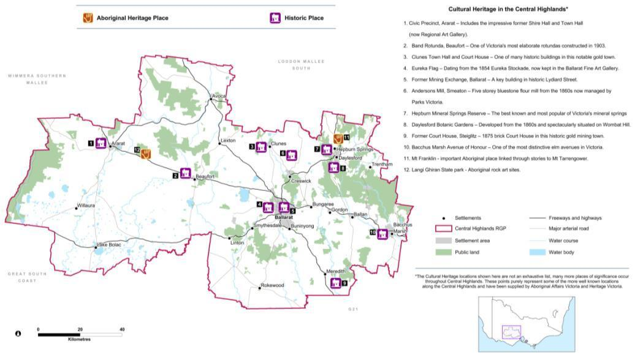Figure 18: Some of the notable cultural heritage assets in the Central Highlands region

Source: Office of Aboriginal Affairs Victoria and Heritage Victoria

In addition to these individual sites, the whole region has a strong goldfields heritage that underpins the fabric of many regional towns and is visible in relics dotted throughout the landscape. There are a diverse range of heritage tourism opportunities within the region, particularly around its goldfields heritage.

Councils in the Central Highlands and the neighbouring Loddon Mallee South region are developing a joint initiative to create worldwide awareness of the area as Australia’s premier heritage region, and to obtain World Heritage listing for the Castlemaine Diggings National Heritage Park. The initiative, Goldfields – Australia’s Premier Heritage Region, looks to promote heritage-based tourism opportunities throughout both regions. Heritage tourism is viewed by these regions as a key driver for economic diversification and development, population growth and improved quality of life.

The Central Highlands region already attracts many domestic and international day visitors for its cultural heritage values, through Sovereign Hill in Ballarat. There are opportunities to encourage visitors to stay longer in the region and explore heritage tourism beyond Sovereign Hill, through overnight and multi-night experiences. This would include improving access to surviving gold rush heritage sites, for example at Smythesdale and Linton. A further unique goldfields attraction is the Gum San Heritage Centre in Ararat which captures insights into the role of Chinese immigrants in the gold rush. The Grampians (Gariwerd) also attracts many tourists through its combination of Aboriginal cultural heritage and environmental assets.

Cultural heritage is protected by the *Aboriginal Heritage Act 2006* and the *Heritage Act 1995*. The *Planning and Environment Act 1987* requires that state and local government planning take cultural heritage and its management into account.

### Land use planning response

The plan recognises the important role land use planning plays in protecting the cultural heritage of the region by ensuring growth and new development is complementary to heritage values. Land use planning should seek to encourage the expansion of cultural heritage tourism within the region, in consultation with Traditional Owners, Registered Aboriginal Parties and others.

Cultural heritage is recognised as an important asset for the region, in community, economic and social terms. The plan acknowledges the significant opportunities that exist as a result of the region’s unique cultural heritage, including positioning the goldfields as Australia’s premier heritage region.

1. Economic prosperity

## Context

An analysis of the region’s economic prosperity undertaken by Regional Development Victoria in 2013[4] found that over the past decade the region has grown at a similar rate to the rest of Victoria, with Ballarat driving economic growth within the region. In addition to population growth, the region has also experienced productivity growth and labour utilisation growth over the last decade. The Central Highlands features a relatively diverse economy, particularly for a regional area, which has helped it to adapt to changing economic conditions.

The key features of the Central Highlands’ economy are as follows:

* Manufacturing, healthcare and construction contributed around 35 per cent of the gross regional product in 2011.
* The region’s manufacturing industry has strong links to the agriculture sector. In 2011, 32 per cent of the regional manufacturing sector’s output was from the food product manufacturing sub-sector, the highest among all manufacturing sub-sectors.
* Transport equipment manufacturing was the second biggest manufacturing sub-sector in the region.
* Population-driven sectors such as healthcare, construction, education and retail trade are also significant sectors of the regional economy.

The Central Highlands region is well represented in the following employment sectors: manufacturing, construction, retail trade, education and training, and healthcare and social assistance (refer to Figure 19).

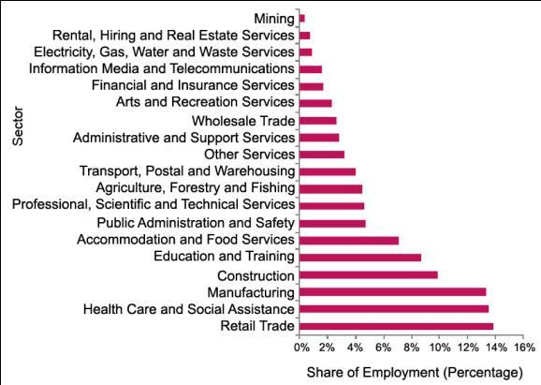Figure 19: Employed people by industry sector

Source: Regional Development Victoria, 2013

However, the economic profile across the region is diverse and not captured by region-wide statistics. For example, in 2011 agriculture accounted for 63 and 36 per cent respectively of the exports from Pyrenees and Hepburn, while manufacturing was the top export sector for Moorabool, Ararat and Ballarat. Most of the region’s exports in 2011 came from Ballarat (76 per cent). Ararat and Moorabool accounted for nine per cent and seven per cent of the region’s total 2011 exports, respectively.

It is projected that the shift in the economy toward service sectors[5] will continue over the next decade. The largest sectors in terms of output (by 2031) will be healthcare, manufacturing, professional services, construction and education (Figure 20). These sectors are projected to account for 51 per cent of the gross regional product by 2031. Of these high value sectors, the highest growth is projected to be in the healthcare and professional services sectors.

Other high growth sectors include accommodation, administrative and support services, and other services.

Manufacturing is projected to decline at an annual average rate of -0.3 per cent. However, manufacturing will still remain important to the regional economy. Agriculture is projected to grow at a relatively faster rate of two per cent over the same 10-year time period.

High-performing employment sectors will be mostly those that are services orientated.

In terms of growth factors, the region benefits from high levels of amenity and transport links to Melbourne which drive population growth. The agglomeration of economic activity around Ballarat is reflected in its high levels of growth and productivity. The region faces challenges in terms of human capital, future workforce size and innovative capacity.

Although population growth has been the main driver of economic growth, a strong and resilient economy in the region will not result from population growth alone. Jain and Courvisanos (2009) describe the factors such as investment in innovation, education and public infrastructure, which help to develop the strength of a region.

Regional Development Victoria (2013) identified the region’s competitive strengths as:

* education infrastructure, institutions and delivery model of post-secondary school education (university and vocational education and training) provided by the University of Ballarat
* built heritage including goldfields heritage
* the health and wellbeing sector in Daylesford-Hepburn, and goldfields tourism drawcards such as Sovereign Hill and the Eureka Centre
* information technology sector capabilities
* manufacturing sector capabilities
* strong forecast growth in knowledge intensive sectors such as professional, scientific and technical services, and financial and insurance services
* proximity to Melbourne.

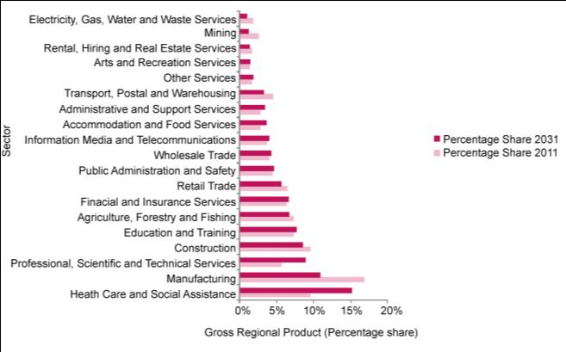Figure 20: Industry output performance forecast by percentage share 2011 to 2031

Source: Regional Development Victoria, 2013

## Agriculture and earth resources

### Description and analysis

Agriculture

The Central Highlands region has infrastructure that is well connected to Melbourne and Geelong and highly productive agricultural land which supports strong horticulture and livestock sectors In 2008–09 the gross value of agriculture production in the Central Highlands region was $495 million, which represents around five per cent of the total state agricultural Gross Victorian Product.

In addition to the agricultural production within the region there are significant quantities of agricultural products moving through the region towards distribution centres and ports. The Central Victorian Livestock Exchange (Ballarat saleyards) manages the exchange of stock from within and outside the region and has a 10-year throughput average in excess of 1.3 million sheep and 56,000 cattle (Central Victorian Livestock Exchange, 2013).

Agricultural production consists mainly of livestock (predominantly sheep), cropping, vegetables, (particularly potatoes) and timber. Other industries include a growing organic industry as well as pig and poultry production (Department of Primary Industries, 2013).

Major agricultural industries

The type and volume of industry varies throughout the region, largely dependent on climate (high rainfall) and mixed soil types. Cropping, livestock and horticulture comprise the major primary industries, with potato production particularly important around Ballarat. Intensive livestock industries also contribute significantly to the economy, mainly poultry for meat and egg production, and pig production.

Commercial forestry is a major industry in the Central Highlands and looks set to continue through the establishment of native hardwood and softwood plantations, rather than through reliance on harvesting native forests.

Some of Australia’s leading food manufacturing companies are located in Ballarat including Mars Confectionary, McCain Foods and Japanese noodle processing company, Hakubaku.

Diversification and value-adding

In recent years many Central Highlands landholders have diversified into alternative enterprises such as private forestry, prime lambs and high value crops, including intensive horticulture such as Asian vegetables. Any significant changes in agricultural production will have various implications for freight transport and other related land uses.

There is a need for planning to support opportunities for agricultural diversification and productivity growth to provide for a productive and sustainable agricultural base that contributes to the growth of the region’s economy. This will include maximising opportunities and allowing the flexibility necessary to assist the development and adoption of sustainable, diverse and innovative farming practices.

Sustainability and vulnerability of agriculture

The Ballarat Rural Land Use Strategy (Parsons Brinckerhoff, 2010b) noted the dairy and beef industries are expanding output and intensifying their activities. A shift towards large farm consolidation has been observed throughout Victoria (Barr, 2009).

There is a need to consider and plan for the impacts of climate change on the region. These impacts are likely to impact on the sustainability and vulnerability of some agricultural activities. Identification of the opportunities presented by changing climatic conditions will also assist adaptation. This might include supporting the agricultural mix in parts of the region to transition to a new mix.An area of particular vulnerability may be the intensively farmed river flats at Bacchus Marsh which rely on irrigation water from the Lerderderg and Werribee Rivers.

Opportunities for intensive agriculture

The region’s planning schemes, while supporting diversification of rural industry, generally take a reactive approach, that is, ensuring intensive agriculture is located where it will minimise negative externalities.

Community acceptance of some of these more intense forms of agriculture, potential land use conflicts and protection of the environment can present challenges. These factors could make it more difficult to establish and expand intensive agriculture in some parts of the region. The plan seeks to balance these concerns by developing an appropriate policy response consistent with the State Planning Policy Framework, which seeks to encourage the establishment and expansion of intensive agricultural activities in appropriate locations.

The plan broadly identifies preferred areas for some forms of intensive agriculture, including for types of specialist agricultural functions that may have the potential for off-site amenity impacts, in the Pyrenees and Golden Plains shires. There is already some support for intensive agriculture in the Golden Plains Shire Rural Strategy 2008 and local policy in that shire’s planning scheme. However, the need for site-specific assessments, and the application of relevant codes of practice, will continue to guide detailed decision-making regarding the siting of intensive agricultural operations.

The plan provides an opportunity to approach this issue on a more strategic basis and thereby support the diversification of the regional economy. The close proximity of much of the Central Highlands to Melbourne and Geelong makes it well placed to support intensive agricultural production.

Land capability

Agricultural practices must be informed by land capability to ensure long-term sustainability and avoid land degradation. Land capability studies have been undertaken for some areas within the Central Highlands region, including the Land Suitability Analysis of the Shire of Moorabool (former Department of Primary Industries, 2006) and the Review of Agricultural Land and Rural Land Use in Hepburn Shire (EnPlan Partners, 2007).

The former report provides a detailed analysis of the relative suitability of land within Moorabool Shire for a wide range of agricultural activities and has been designed to inform existing and prospective farmers as to suitable practices for specific parts of the municipality (refer to Figure 21). This study identified the versatility of agricultural land across the shire, in terms of the range of crops that could potentially be grown commercially. The Hepburn Shire report identifies the relative quality of agricultural land across the municipality (refer to Figure 22).

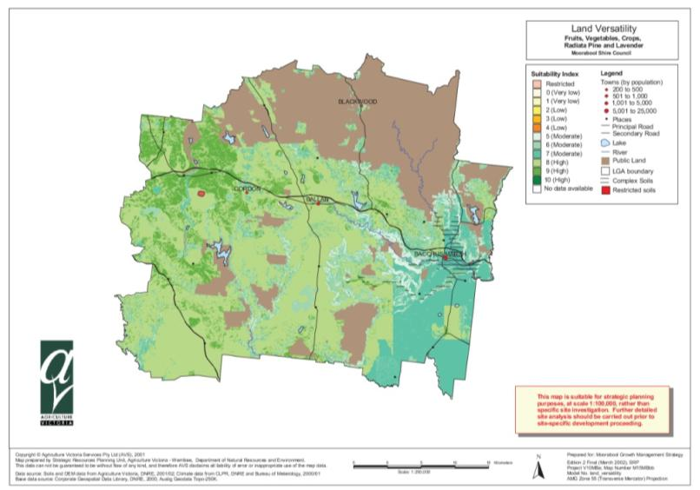Figure 21: Agricultural land quality in Moorabool Shire

Source: Department of Primary Industries, 2006

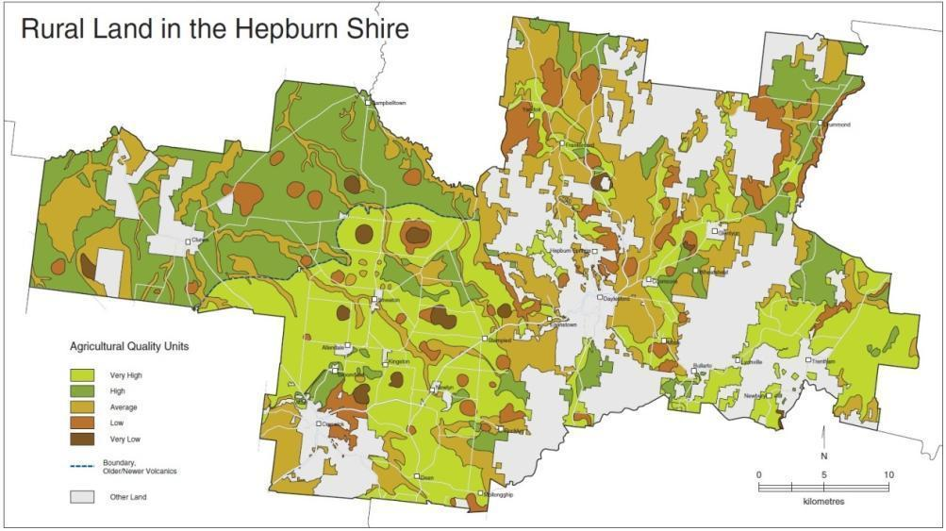Figure 22: Agricultural land quality in Hepburn Shire

Source: EnPlan Partners, 2007

Land capability assessments are a useful tool for profiling land and informing agricultural production decisions and practices although they are not a comprehensive marker for identifying the productive capacity or suitability of land for alternative agricultural land uses.

Land capability assessments may provide the basis for further strategic analysis and assessment to introduce, where necessary, an appropriate planning scheme overlay to minimise the potential for further land degradation from certain practices.

The impacts of climate change are likely to lead to changes in the capacity of land to support different types of agriculture as weather patterns change. This will need to be considered in land use planning for the region, in particular in terms of the flow-on implications to supporting industries, including food processing industries.

Maintaining productive rural land

Agriculture in some parts of the Central Highlands region, particularly in the eastern most parts of the region which form part of Melbourne’s peri-urban area, are vulnerable to fragmentation for residential uses and subject to potential land use conflict between residential use and agriculture. Locations where pressure has existed for urban growth include the highly fertile river flats that adjoin the township of Bacchus Marsh.

In order to protect the region’s productive agricultural base, there is a need to reduce the potential for land use conflict between urban and residential uses and agricultural activities by providing clear direction as to locations where highly productive agricultural land is to be protected from encroachment by such uses. In addition, productive rural land can be supported by ensuring it remains viable and supports investment. This can be achieved by providing the flexibility necessary to enable opportunities for agricultural diversification, development and productivity growth including intensification where appropriate, to sustain a robust agricultural base for the region.

The plan defines some of the regionally significant agricultural assets and identifies them at a regional scale. The productive potential of land for agriculture is influenced by a variety of factors, of which land capability is an important component but does not provide the whole picture.

Alternative forms of agriculture, such as intensive animal industries and greenhouse production systems, also contribute significantly to agricultural and food production as they can generate large outputs on small areas of land and are not dependent on high quality soils as the driver for location. Other criteria, such as access to roads, power, water, processing and feed supply can be important indicators or drivers for identifying the productive potential of farmland.

In agricultural areas where broadacre cropping and grazing are the predominant uses, lots are often already smaller than would support a self-sufficient broad acre agricultural enterprise. The fragmentation of lots in these areas could further undermine the viability of agricultural enterprises, particularly if land values reflect rural–residential purposes rather than the ability to support agriculture.

A number of councils have noted the issues associated with the diversity of lots sizes and predominance of small lots in some areas. Moorabool Shire’s Rural Growth Policy Statement (2012) identifies that small lots are a notable characteristic of the shire’s rural areas and that policy should be tailored to recognise this pattern. To this end, the shire supports protecting agricultural land from permanent loss, such as through supporting investment in small-scale, more intensive agricultural enterprises.

The Golden Plains Rural Land Use Strategy (Parsons Brinckerhoff, 2008b) recognises the need to prevent fragmentation of rural lots and retain large lot sizes to support broadacre agricultural enterprises in productive agricultural areas. The Rural Activity Zone has been applied to areas within the Golden Plains Shire based on the recommendations of the rural strategy. This approach ensures a wider range of rural uses are provided for in appropriate locations away from those areas where broadacre farming is the main focus. However, from a regional perspective, such zoning changes mean a disparity in rural land use approaches across regional boundaries that may require further consideration.

The Stawell-Ararat-Halls Gap Rural Zones Review (2012) has been prepared to develop policy settings across an area between the settlements of Stawell, Halls Gap, Moyston, Pomonal, Great Western, Armstrong and Ararat. This study area includes land in both the Ararat and Northern Grampians local government areas and it identifies the potential for consistent approaches to land use controls across the two planning schemes. The study area has been identified as a major tourist, agricultural/viticultural and rural residential area. The study recommends protecting the agricultural base of the region by focusing development in settlements, whilst allowing for some diversification of land use to support tourism which is a major economic driver of the region.

Impacts of changing agricultural practices on regional settlements

The sustainability of smaller rural settlements can be impacted significantly by changing agricultural practices. In some parts of the region a change from broadacre cropping and grazing to agroforestry may have contributed to reduced support for nearby service centres. Decline in smaller townships may also be caused by reduced labour inputs on larger consolidated farms.

Earth resources

While the Central Highlands has a long and continuing history of mining activity, this sector is neither currently, nor expected in the future, to become a major employer. Mineral resources within the region include copper deposits in the vicinity of Ararat and west of Lake Bolac, gold in Ballarat and the significant coal resources currently being explored in the vicinity of Bacchus Marsh.

The Maddingley No.2 open cut coal mine, south of Bacchus Marsh, provides coal of a lesser grade than the Latrobe Valley coal but is suitable as an industrial fuel. The coal seam is the third largest known in Victoria, after the Latrobe Valley area and Anglesea deposits. Any potential expansion of coal mining within proximity to Bacchus Marsh will present some challenges in terms of existing agricultural and residential land uses. State planning policy encourages the exploration and extraction of natural resources in accordance with acceptable environmental standards, and provides for the long-term protection of these resources, consistent with the relevant legislation.

Coal seam gas is another form of natural gas trapped by water pressure in coal seams. There is currently no coal seam gas production in Victoria, however some exploration licences have been granted to examine the feasibility of extraction, including in the Central Highlands region.

The planning and regulation of the coal seam gas industry is overseen by state and federal governments. At a national level, the Standing Council on Energy and Resources has endorsed a National Harmonised Regulatory Framework for Natural Gas from Coal Seams (May 2013). The Framework delivers on a commitment by Australian governments to put in place leading practice principles, to provide guidance to regulators in the management of natural gas from coals seams, and to ensure that regulatory regimes are robust, consistent and transparent across all Australian jurisdictions. The Victorian Government has endorsed the outcomes of the National Framework and will ensure that state legislation is consistent with its findings.

While the primary purpose of the Framework is to be a guidance document to governments, it will benefit communities, farmers, other land users and industry by providing increased levels of consistency, certainty and transparency in the management of natural gas from coal seams in Australia.

Coal seam gas exploration and production in Victoria is regulated under the *Mineral Resources (Sustainable Development) Act 1990*. The Act and supporting Regulation stipulates that the community must be kept informed and provides strict requirements for licensing and approval. Licensees are subject to regulator monitoring and companies must adhere to licence conditions or be subject to a range of enforcement actions up to and including, loss of licence.

In order to undertake exploration activities, a company must apply for an exploration licence. Exploration activities are predominantly desk-based, reviewing existing data and information, collecting and analysing rock samples or airborne geotechnical surveys. While exploration licences allow for low impact activities, ground intrusive works such as drilling, trenching or costeaning are subject to further approvals and conditions. The Department of State Development, Business and Industry is the regulatory authority for the issuing of licences and for enforcing compliance with licence conditions. Conditions are specific to each licence and are statutorily referred to other relevant agencies such as Department of Environment and Primary Industries, the Environmental Protection Authority and water corporations for input prior to being finalised.

The mining licence application process and the planning process provide for detailed environmental investigation and further opportunities for public input and comment.

There are significant stone resources within the region that are critical for the construction industry. Locations where stone resources are particularly important include to the north of Bacchus Marsh in Darley and the kaolin deposits at Pittong.

In May 2012, the Economic Development and Infrastructure Committee of the Parliament of Victoria tabled the results of its inquiry into the benefits and drivers of, and possible barriers to, greenfields[6] mineral exploration and project developments in Victoria. The Victorian Government’s response to the Inquiry was released in May 2013, supporting all recommendations. Key aspects of the response include:

* establish Minerals Development Victoria as a single point of entry for investors dealing with Government on their projects
* actions to reduce regulatory burden imposed in legislation
* actions to build community confidence through greater engagement and clearer communication of information
* additional funding for geosciences research and greater investment attraction
* steps to improve mechanisms to maintain appropriate access to extractive resources while supporting ongoing development and optimum land use.

While it is important to acknowledge these and other aspects of the response, it is beyond the scope of the regional growth plans to deal with the majority of the commitments and they will need to be addressed through other suitable government initiatives. The response did include a commitment to incorporate existing extractive industry interest areas into regional growth plans. The plan recognises these areas accordingly.

Current minerals and extractive industry activities, along with the extractive industry interest areas and other potential resources that occur within the region are shown in Figure 23.

### Land use planning response

The plan identifies strategically important agricultural assets that should be protected from non-agricultural uses including urban encroachment. It also recognises the need for land use planning to provide the flexibility to support investment in agriculture, revitalise this important sector of the economy, and enable diversification of agricultural related industries. The plan identifies where intensive animal or agricultural production is to be supported and protected from incompatible land uses. The plan encourages further investigations into the region’s strategic agricultural land assets and recognises that rural areas make an important contribution to the landscape values of the region.

The plan also provides for improved resilience under changing climate conditions. Measures the plan considers include assisting in diversifying agricultural practices, allowing for technological change and changing management practices.

The plan recognises the importance of earth resources for the region’s growth, infrastructure provision and economic diversity. It aims to maintain access to these resources and encourages growth to be steered away from areas that would reduce the capacity for valued earth resources to be capitalised on.

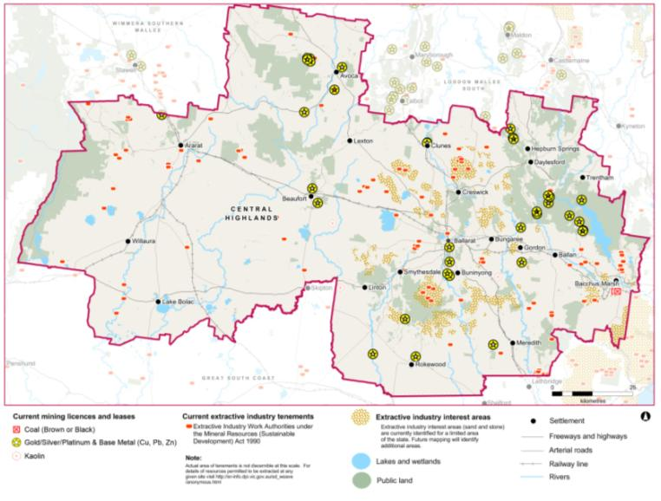Figure 23: Mining and extractive industries, tenements and licences

Source: Department of Environment and Primary Industries

## Commercial development and tourism

### Description and analysis

Commercial development and activity centres

The largest commercial centre within the Central Highlands region is Ballarat’s central business district. Most local planning schemes within the Central Highlands provide limited direction about commercial development, beyond stating that the provision of services and business is encouraged. The City of Ballarat has adopted an activities centre strategy (Hill PDA and Hansen, 2011) that establishes a hierarchy for activity centres within the municipality. The strategy identifies that the catchment for the municipality’s largest activity centres extends well into surrounding municipalities, particularly to the west.

Smaller towns within the Central Highlands perform a local role by providing retail, office and commercial services to their local catchments. The western half of the region functions quite differently to the eastern half which falls within Melbourne’s peri-urban region. The Municipal Strategic Statement of the Moorabool Planning Scheme identifies that towns in the eastern half of the region, such as Bacchus Marsh, while providing retail and commercial services to local residents, are subject to significant trade leakage to Melbourne, with many residents commuting to metropolitan Melbourne for employment.

In the western half of the region, Ballarat provides higher order commercial services for the range of smaller towns in its surrounds. Economic strategies such as the Growing Moorabool Economic Development Strategy (SGS, 2006) recognise that Ballarat is the preferred location for Moorabool Shire residents for comparative shopping and for entertainment, recreation and leisure, despite Moorabool Shire’s proximity to activity centres within metropolitan Melbourne. This is likely to be reflected in other local government areas within the Central Highlands. The regional cities of Geelong and Bendigo are also likely to draw some expenditure from the southern and north-eastern peripheries of the region respectively.

Department stores are located in Ballarat while medium-sized rural towns such as Maryborough, Ararat and Bacchus Marsh have discount department stores. Towns in the region have generally been successful in containing prime retailing to their central cores, with the Commercial 1 Zone applied to designated retail centres.

Activity centre planning to date has been undertaken at a municipal level, with no coordinated regional approach to the demand and supply of business zoned land and the relationship between different commercial centres. However, studies have been developed or are in the process of being undertaken in the areas of highest population growth including Ballarat and Bacchus Marsh.

Given the low rate of growth or decline of smaller towns in the western half of the region the lack of commercial land supply and demand information is unlikely to be a significant issue. However, it is essential to have a strong evidence base for the eastern half of the region for growing centres such as Ballarat and Bacchus Marsh to ensure these settlements are able to provide for office and retail investment as required. Meeting retail needs is an important factor in maintaining the liveability of the region, providing for economic self-sufficiency and providing a basis to attract in-migration.

Tourism

Tourism forms an important part of the economy of the Central Highlands. International tourism currently reflects less than three per cent of visits to Victoria but represents a longer-term opportunity, along with local tourism, for the Central Highlands region. Capturing a greater share of international tourism presents a significant opportunity given that the average number of nights stay and average spending is greater for international visitors than domestic travellers.

The economic importance of tourism to the spa country, in the Hepburn local government area, was 14.3 per cent of total regional output[7], which placed this region in the top 20 tourism regions by economic importance of tourism in Australia (Australian Government Department of Resources, Energy and Tourism, 2011).

The Central Highlands region supports almost 3500 tourism businesses, of which just over half are classified as non-employing businesses or owner-operated. Micro businesses (1-4 employees) account for around 900 and small businesses (5-19 employees) another 525. Only 222 businesses employ 20 or more employees. The bulk of these (165) are in the City of Ballarat (Australian Government Department of Resources, Energy and Tourism, 2008).

There are a number of key tourism assets and opportunities within the region:

* Natural assets such as the Grampians National Park, Brisbane Ranges Enfield State Park and Lerderderg State Park. Opportunities to expand eco-tourism ventures within the Central Highlands should be explored given the natural assets of the region, including forests and mountains and the high level of accessibility to Melbourne.
* The cultural heritage values of the Central Highlands are a key attraction for visitors to the region, such as the icons of Sovereign Hill and the Museum of Australian Democracy at Eureka. To reinforce this opportunity, the Central Highlands Regional Strategic Plan seeks to develop a coordinated approach to identify this as ‘Goldfields – Australia’s Premier Heritage Region’. Land use planning plays a key role in ensuring cultural heritage assets are protected from threats such as inappropriate development and that other tourism opportunities can develop to take advantage of the heritage offer.
* The Pyrenees and other wine-producing regions are significant tourism attractors for the northern and western parts of the region and are recognised in the plan. Opportunities for these wine-producing regions to further develop their tourism offering should be considered, including within serviced towns such as Avoca. The 2012 rezoning of land in Moonambel to Rural Activity Zone will enable the establishment of tourism-related uses in the Mountain Creek area which will build on the wine tourism offer of the local area. A similar rezoning has taken place in the Moorabool Valley to facilitate tourism and other complementary rural uses.

### Land use planning response

The plan recognises the need to support commercial development in keeping with the role and function of each settlement and which is well located to support town centres. The need for settlements in the eastern part of the region to reduce trade leakage to Melbourne is identified.

Regionally important tourism precincts and locations are identified in the plan along with the need to encourage tourism development that is consistent with the cultural heritage and environmental values of the region. Infrastructure investment decisions should factor in the potential benefits of particular infrastructure proposals for the tourism sector.

## Diversification of the regional economy

### Description and analysis

Comparative advantages

The regional economic outlook for the region varies significantly between its sub-regions. Ballarat and the peri-urban parts of the region are growing roughly in line with the state average, whilst the western parts of the region are lagging behind. If Ballarat is able to continue to integrate itself with the broader employment market in Melbourne while maintaining its regional character, then it will attract an expanding ‘tree changer’ population interested in continued employment, but at a slightly slower pace.

This outcome would see Ballarat holding its own in the longer run, offsetting the broader demographic weakness associated with an over-representation of older people that is likely to continue to characterise smaller settlements within the region. It would also broaden the employment base of the region, due both to the expanding population and the broader skills base that new workers are likely to bring. Building on the existing comparative advantage in education and information technology, the region must seek to expand its services base to ensure growth and reduce the risks that stem from a narrow economic base.

The comparative advantages of the region from an economic perspective include:

* sustained population growth of one per cent per annum
* located on the east-west transport corridor connecting Melbourne, western Victoria and Adelaide
* large areas within Melbourne’s peri-urban influence and network
* adjoining the western metropolitan area, the site of major current and future infrastructure investment and much of Melbourne’s population growth
* the major concentration of Australia’s gold mining heritage
* Victoria’s best developed and integrated regional higher education and training network
* regional Victoria’s strongest concentration of information technology and computing services and capacity
* some of Victoria’s most productive soils and quality horticultural growing conditions
* a restructuring economy embracing new opportunities in such areas as information technology, advanced manufacturing, education and tourism
* Ballarat, Victoria’s third largest urban area.

Sustaining Ballarat as an economic hub for the region

Manufacturing provides 12.8 per cent of employment in the Ballarat economy (Essential Economics, 2011), and is responsible for 34.3 per cent (REMPLAN, 2010) of the output of the economy. Clearly it is an important generator of wealth and employment for the regional economy.

Ballarat is one of regional Victoria’s success stories. People are attracted to the region for its vibrant community, lifestyle and economy. It is for these very reasons that the population of Ballarat is expected to increase by just under 25,000 people over the next 15 years, representing an average annual growth rate of 1.4 per cent per year (Essential Economics, 2011).

This rate of growth is on average around 0.15 per cent (Essential Economics, 2011) higher than expected for regional Victoria as a whole, making Ballarat one of Victoria’s fastest growing regional settlements. If the expected increase in Ballarat’s population eventuates this will be the continuation of a decade of population growth.

The Ballarat economy currently provides enough local employment to meet demand from its local workforce. However, there is emerging evidence that a decline in the competitiveness of industry and other business sectors in the Ballarat regional economy is limiting job creation capacity. This is particularly the case for the low value-add manufacturing sector, which was forced to cut hundreds of jobs during the 2008–09 economic downturn (SED Consulting, 2010). This in turn could undermine the sustainability of the expected increase in the population of Ballarat.

Of particular concern is the number of manufacturing jobs available in Ballarat, which is forecast to fall over the next 15 years despite the fact that the labour force will need to grow by 16,450 over the same period (Essential Economics, 2011). If transformation of the manufacturing sector is not achieved, or jobs are not created in other sectors, growth in employment will not match population growth. This is a substantial and long-term challenge, which if not met, could result in higher unemployment in Ballarat, and threaten the liveability of the region as people are forced to travel long distances to Melbourne and other regional economies to work.

The factors contributing to that decline in competitiveness must be addressed now if Ballarat is to provide the employment opportunities needed both now and over the coming 15 to 20 years. The current structure of the Ballarat regional economy may need to change if greater wealth and employment is to be created. One third of the manufacturing industry in Ballarat is in decline, and is exposed to the global economic forces that are undermining simple manufacturing enterprises in the majority of the developed world (SED Consulting, 2010).

Hopkins Correctional Centre expansion

Hopkins Correctional Centre is located approximately 200 kilometres west of Melbourne in Ararat. It is currently a 382-bed medium security protection prison.

The redevelopment will increase the number of beds within the prison to 740. Key features of the redevelopment include a new secure perimeter, new prisoner accommodation, new visits centre, store, medical and education centres, new and existing industries, multi-faith chapel and Koori resource centre.

The prison redevelopment will ensure the state's correctional and rehabilitation systems meet increased demand. During the construction phase up to 500 contractors may be operating on the site. The prison expansion will result in an additional 150 positions once commissioned in late 2014.

Renewable energy

There is potential for renewable energy to contribute to Victoria’s future economic prosperity. Growth in the renewable energy sector will create new industries across the state that will stimulate local economies and generate skilled jobs. The main sources of renewable energy that could be harnessed to create electricity in Victoria are solar, wind, hydroelectricity and bioenergy. Wind, bioenergy and hydroelectricity account for over 93 per cent of renewable energy in Victoria compared with seven per cent for solar (Sustainability Victoria, 2012).

Large parts of the region have been identified as having excellent wind resources, as shown in Figure 24. The Central Highlands is home to a number of wind farms including 128 turbines, at Waubra, and a community-owned facility at Leonards Hill of two turbines. The other operating wind farm in the Central Highlands region is Challicum Hills, east of Ararat, which generates 52.5 megawatts from 35 turbines, powering up to 25,000 houses and saving 170,000 tonnes of greenhouse gas each year. There are another eight wind farms that have been approved within the Central Highlands region but are not currently operational. Many of these approved wind farms, which are yet to be constructed or are under construction, are located in the local government areas of Ararat, Moorabool and Pyrenees.

Although other wind farms are in the planning stages, the region is at a competitive disadvantage when compared to less populated regional areas in terms of attracting new wind farm development due to the presence of dwellings in rural areas. This may make obtaining approvals more difficult for wind farm proponents. Most notably, any application that would result in a turbine being located within two kilometres of an existing dwelling is required to be accompanied by written consent from the owner of the dwelling, otherwise it is not permissible. This requirement recognises the potential amenity impacts that may be caused to residents located in close proximity to wind farms.

Opposition to wind farms resulting from their perceived impact on rural landscapes and potential amenity impacts has been significant in the Central Highlands and needs to be recognised when considering further wind farm developments.

There is potential for growth in solar power in Victoria, although the best solar resources are far from population centres and at the margins of existing transmission infrastructure. Work conducted to date has identified potential sites for solar installations that align with available infrastructure capacity. In the Central Highlands region the Central Victoria Solar Cities Ballarat Solar Park consists of more than 1850 solar panels at Ballarat University and was one of the first examples in Australia of integrated solar panels.

Organic matter, or biomass, can be converted into bioenergy (heat, electricity and biofuels) using a variety of technologies. Bioenergy generators tend to be small-scale and are best suited for local applications such as municipal waste facilities or for on-farm applications. Through the Victorian Local Sustainability Accord, Pyrenees Shire was recognised as the lead council for the Bioenergy Project. This project has received $600,000 of funding from the state government with the overall aim of developing bioenergy potential in the region.

One of the region’s biggest employers, McCain Foods, produces 10 per cent of its energy by turning food waste into biogas. Berrybank Farm in the Learmonth/Windermere district has installed a ‘biodigestor’ to process piggery manure, producing electricity for its own operation and selling power to the grid. The residue is worked back into crops and used to blend with pine bark to create quality compost and soil conditioners. All City of Ballarat trucks, graders, mowers, utes and garbage compactors are running on biodiesel. The City of Ballarat’s landfill at Smythesdale has gas capture and an electricity generation plant which sells clean electricity to the grid.

A biodiesel trial is also underway at the Ararat Rural City Council whereby algae ponds are used to produce oil, which is then transformed into biodiesel. This could lead to the establishment of a local biodiesel plant. The aim of the trial is to determine which species of algae produces the best oil.

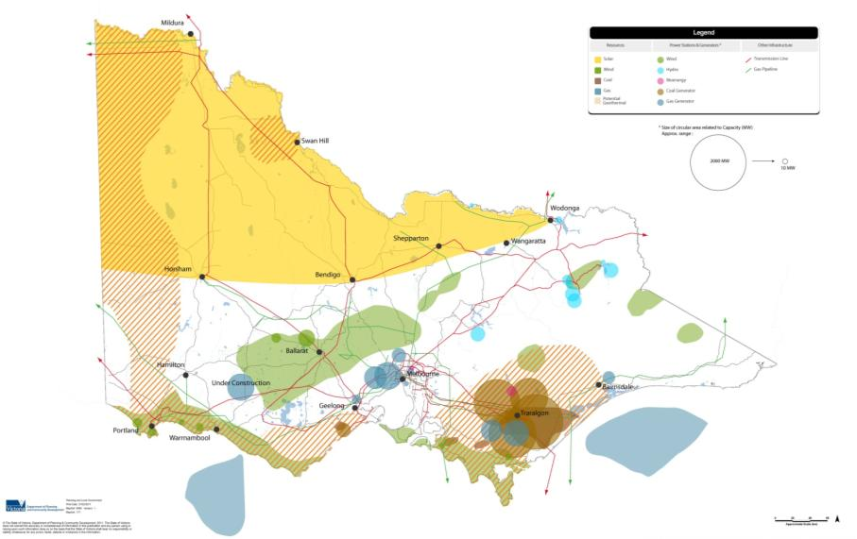Figure 24: Energy in the future

Source: Department of Environment and Primary Industries

Carbon economy

Carbon trading is still quite new and accordingly there are only limited projects identified around the carbon economy. As broadacre farming is the major rural land use in the region, work to identify possible opportunities and threats is underway through collaboration between the state government and regional primary producers. Some smaller industries have started to align their operations to take advantage of a less carbon intensive economy.

The Carbon Farming Initiative will enable farmers to enter the carbon market, and be paid to provide carbon offsets. This could be through soil carbon storage or through the planting of vegetation. Landholders, including small landholders, could choose to establish plantations on their property to capture carbon. This could have significant implications for future rural land use in a similar way to the widespread establishment of plantations in Victoria’s south-west, which have replaced livestock. This may also have implications for bushfire risk.

Industrial land supply and opportunities

There is a need to ensure sufficient land supply for industrial and commercial uses to support expansion of local industry and help diversify the local economy. A lack of industrial or commercial land supply could place constraints on the establishment or expansion of industry. There are varying levels of information available in the region about industrial land requirements.

The most recent, systematic collection of industrial land supply across the region was undertaken in 2007 as part of the Urban Development Program which is managed by the Department of Transport, Planning and Local Infrastructure. The audit of industrial land in provincial Victoria identified total industrial zoned land and how much of this is occupied or vacant.

Figure 25 shows the vacancy rates of industrial land are above the regional Victorian average of 33 per cent in all local government areas, except for Ararat and Moorabool.

Figure 25: Industrial land supply

Ararat

* Total hectares – 186
* Occupied hectares – 147
* Vacant hectares – 39
* Vacancy rate by total area – 21%
* Occupancy rate by total area – 79%

Ballarat

* Total hectares – 1103
* Occupied hectares – 623
* Vacant hectares – 480
* Vacancy rate by total area – 44%
* Occupancy rate by total area – 56%

Golden Plains

* Total hectares – 18
* Occupied hectares – 7
* Vacant hectares – 11
* Vacancy rate by total area – 61%
* Occupancy rate by total area – 18%

Hepburn

* Total hectares – 68
* Occupied hectares – 40
* Vacant hectares – 28
* Vacancy rate by total area – 41%
* Occupancy rate by total area – 59%

Moorabool

* Total hectares – 339
* Occupied hectares – 255
* Vacant hectares – 84
* Vacancy rate by total area – 25%
* Occupancy rate by total area – 75%

Pyrenees

* Total hectares – 64
* Occupied hectares – 28
* Vacant hectares – 36
* Vacancy rate by total area – 56%
* Occupancy rate by total area – 44%

Source: Audit of industrial land in provincial Victoria (Parsons Brinckerhoff, 2008a)

Moorabool Shire’s economic development strategy (SGS, 2006) identified issues with regard to the characteristics of its industrial land. While the shire has a sufficient amount of industrial land to meet demand, much of this industrial land supply suffers from constraints such as inadequate infrastructure, or being unsuitable for large-scale industry.

Within the Pyrenees Shire, the Beaufort and Avoca industrial estates play an important role in generating local employment opportunities and providing industrial land that can support uses associated with servicing the local rural economy.

In Ballarat, a study prepared by CPG Australia (2009) found that without an increase in the supply of industrial land suitable for modern industry, the role of Ballarat as the economic hub for the western region of Victoria would be threatened.

The Ballarat West Employment Zone is now being developed as a key regional focus for employment growth which will generate up to 9000 jobs. It is located on 621 hectares of land adjacent to the Ballarat Airport and leverages off the advantages of the excellent road access, presented by the convergence of the Western Freeway, Sunraysia Highway and Midland Highway and the Melbourne-Ararat railway line. A masterplan has been prepared which sets out a 20-year development timeframe for development. Key industries to be accommodated include transport and logistics, construction services, food processing, machinery and equipment manufacturing and research and development.

Ararat also contains a number of regionally significant industries including engineering and machinery manufacturing businesses which provide products for national and international markets. However, the town’s industrial areas are dispersed and may need to be rationalised over time to provide a more suitable land use framework for the city.

Hepburn Shire has recognised the potential need for additional industrial land in key towns such as Creswick and Daylesford to provide appropriate locations for local business and minimise leakages to larger centres. It is seeking to undertake a study to further investigate opportunities for industrial land.

Other parts of the Central Highlands region have industrial areas too, predominantly providing for light industry to service local communities and agricultural industries. Consideration needs to be given at the regional level as to whether further investigations are necessary to plan for industrial land uses within these areas.

One cross-regional issue that will need to be considered is the proximity of Central Highlands to western Melbourne and the availability of well-serviced industrial land there which can be easily accessed by workers from the peri-urban parts of the Central Highlands (SGS, 2006).

### Land use planning response

The plan recognises that it is critical to plan for the provision of sufficient land for employment purposes, including industrial zoned land that is appropriate for a wide range of industries. The plan supports the creation and expansion of industries and recognises the need to retain buffers between industrial and sensitive land uses. The Ballarat West Employment Zone is recognised as the most significant planned employment growth area within the region.

The plan recognises the need to accommodate initiatives that support national and global action to reduce greenhouse gas emissions.

1. Transport and infrastructure

## Context

Existing transport infrastructure and services provide an important comparative advantage to the Central Highlands over other regional areas, with the region enjoying good access to Melbourne, Geelong, Bendigo, Portland and Adelaide (refer to Figure 26). Transport in the Central Highlands is heavily focused around the western corridor linking Melbourne and Adelaide. The Western Highway is the principal road link along this corridor and forms part of the National Land Transport Network. Rail corridors included in the National Land Transport Network include the Melbourne-Mildura railway, which links Geelong, Ballarat and Maryborough, and the Melbourne-Adelaide railway, which links Geelong and Ararat. The region has good access to airport facilities including those at Melbourne Airport, Avalon Airport and regional airports such as Ballarat, Ararat, Lethbridge and Bacchus Marsh.

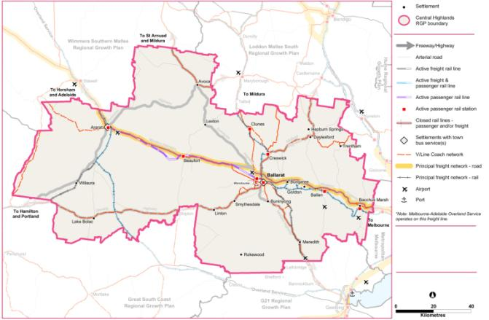Figure 26: Central Highlands transport network

Source: Department of Transport, Planning and Local Infrastructure

There are a number of key contextual factors that influence transport requirements for the Central Highlands:

* Ballarat is the major city in the Central Highlands region serving not only the community within its region but acting as an attractor to those living outside the region, particularly for employment, leisure and education.
* Central Highlands is developing a strong service-based economy with strengths in information technology, education, health services and tourism which account for approximately 72 per cent of employment.
* The region has a strong timber industry with establishment of hard and softwood plantations, as opposed to harvesting native forests.
* Agriculture, in particular cattle and sheep, along with potatoes, other vegetables, orchard fruits and associated food processing are also important to the region’s economy.

Rail and road networks service both freight and passenger requirements and are crucial to the local economy. Freight movements occur not only internally within the region but to the ports of Melbourne, Portland and Geelong for produce export. Passenger services provide links not only to Melbourne but to other parts of the region, notably the rail corridors to Ararat and Maryborough.

While the east-west transport corridors (the Western Highway and Adelaide-Melbourne railway) are an order of magnitude busier than other transport corridors in the region, there are also important north-south transport corridors, such as the Midland Highway, Sunraysia Highway and Geelong-Ballarat-Maryborough railway line. A Rail Revival Study has been undertaken by the Victorian Government to consider the long-term feasibility of returning passenger rail services between Geelong, Ballarat and Bendigo. The study recommends increases to coach services in the short-term with the return of rail services to form part of a longer-term plan for the region.

These enhanced transport services would further develop the importance of north-south transport within the region should they be realised.

## Regional transport links

### Description and analysis

Overview of travel patterns and trends

Ballarat is the main centre providing a number of high order services and facilities that relate in particular to medical services, health services and education. Federation University Australia attracts students from all over the region and the country and is internationally recognised. Ballarat is also home to a campus of the Australian Catholic University. Therefore, it is important to ensure transport links for passenger transport services are available, not only to Melbourne to ensure that people can access specialist services and facilities, but also to Ballarat so that students can access the universities.

Since the advent of the Regional Fast Rail project services on flagship trains have provided a commute time from Ballarat to Melbourne of just over one hour. Services run approximately every forty minutes in the AM and PM peaks and hourly after that. Rail at Ararat connects to Ballarat and then to Melbourne and likewise rail services from Maryborough connect with Ballarat and then Melbourne. The rail network in the region is entirely single track operating with regularly spaced passing loops.

Most of the region’s rail infrastructure is in reasonable to good condition having been extensively refurbished during the last decade as part of various freight and passenger rail projects (AECOM, 2011). The re-establishment of passenger rail services between Maryborough and Ballarat may also result in some changes to the orientation of Maryborough residents towards Ballarat for higher order services, where their regional catchment is located. Ballarat has an inter-regional role in providing services and facilities.

Enhancements to passenger rail services and infrastructure linking Melbourne and the Central Highlands have helped encourage a significant rise in the number of people using rail to travel to Melbourne, as shown in Figure 27 and Figure 28 although the absolute numbers of people using rail remains significantly less than those travelling by car. The number of people travelling from the Shire of Moorabool to metropolitan Melbourne, by both car and public transport, has also increased considerably, reflecting the strong commuter relationship between Bacchus Marsh and metropolitan Melbourne.

In terms of the numbers of weekday rail passengers using particular railway stations within the region, Ballarat railway station has by far the greatest patronage, with Bacchus Marsh also having significant patronage.

Figure 29 provides the number of journeys by car and by public transport from some of the larger settlements within the region. This figure demonstrates the strong commuter relationship between Bacchus Marsh and metropolitan Melbourne. It also shows travel is limited between places such as Ararat and Ballarat and Bacchus Marsh and Ballarat.

Figure 27: Journeys to Melbourne from the Central Highlands by local government area

Source: Department of Transport, Planning and Local Infrastructure

Figure 28: Estimated rail patronage (normal weekday) by station 2005 to 2011

Source: Public Transport Victoria

Constraints affecting Ballarat-Melbourne rail services in the western approaches to Melbourne are being addressed through the Regional Rail Link project which is currently under construction and is expected to be completed in early 2016. The resulting increase in capacity provided on the western railway lines approaching Melbourne may lead to reduced demand on roads, thereby improving access to the region from Melbourne.

Figure 29: Journeys from urban centres to destinations within the region and to Melbourne 2011

**Origin Ballarat (urban centre) - Journeys to....**

* Metropolitan Melbourne
* Using car – 848
* Using public transport – 646
* Ballarat
* Using car – 22,098
* Using public transport – 420
* Hepburn
* Using car – 417
* Using public transport – 6
* Moorabool
* Using car – 276
* Using public transport – 8
* Pyrenees
* Using car – 142
* Using public transport – 0
* Ararat
* Using car – 109
* Using public transport – 5
* Golden Plains
* Using car – 200
* Using public transport – 0

**Origin Bacchus Marsh (urban centre) - Journeys to....**

* Metropolitan Melbourne
* Using car – 2645
* Using public transport – 447
* Ballarat
* Using car – 92
* Using public transport – 8
* Hepburn
* Using car – 12
* Using public transport – 0
* Moorabool
* Using car – 1596
* Using public transport – 13
* Pyrenees
* Using car – 0
* Using public transport – 0
* Ararat
* Using car – 0
* Using public transport – 0
* Golden Plains
* Using car – 0
* Using public transport – 0

**Origin Ararat (urban centre) - Journeys to....**

* Metropolitan Melbourne
* Using car – 32
* Using public transport – 5
* Ballarat
* Using car – 32
* Using public transport – 7
* Hepburn
* Using car – 0
* Using public transport – 0
* Moorabool
* Using car – 4
* Using public transport – 0
* Pyrenees
* Using car – 6
* Using public transport – 0
* Ararat
* Using car – 1844
* Using public transport – 0
* Golden Plains
* Using car – 0
* Using public transport – 0

**Origin Ballan (urban centre) - Journeys to....**

* Metropolitan Melbourne
* Using car – 182
* Using public transport – 52
* Ballarat
* Using car – 86
* Using public transport – 7
* Hepburn
* Using car – 15
* Using public transport – 0
* Moorabool
* Using car – 179
* Using public transport – 3
* Pyrenees
* Using car – 0
* Using public transport – 0
* Ararat
* Using car – 0
* Using public transport – 0
* Golden Plains
* Using car – 0
* Using public transport – 0

**Origin Creswick (urban centre) - Journeys to....**

* Metropolitan Melbourne
* Using car – 34
* Using public transport – 17
* Ballarat
* Using car – 364
* Using public transport – 12
* Hepburn
* Using car – 192
* Using public transport – 0
* Moorabool
* Using car – 10
* Using public transport – 0
* Pyrenees
* Using car – 3
* Using public transport – 0
* Ararat
* Using car – 0
* Using public transport – 0
* Golden Plains
* Using car – 0
* Using public transport – 0

**Origin Daylesford – Hepburn Springs (urban centre) - Journeys to....**

* Metropolitan Melbourne
* Using car – 79
* Using public transport – 30
* Ballarat
* Using car – 91
* Using public transport – 3
* Hepburn
* Using car – 553
* Using public transport – 0
* Moorabool
* Using car – 13
* Using public transport – 0
* Pyrenees
* Using car – 0
* Using public transport – 0
* Ararat
* Using car – 0
* Using public transport – 0
* Golden Plains
* Using car – 0
* Using public transport – 0

**Origin Clunes (locality) - Journeys to....**

* Metropolitan Melbourne
* Using car – 10
* Using public transport – 3
* Ballarat
* Using car – 116
* Using public transport – 0
* Hepburn
* Using car – 81
* Using public transport – 0
* Moorabool
* Using car – 3
* Using public transport – 0
* Pyrenees
* Using car – 0
* Using public transport – 0
* Ararat
* Using car – 0
* Using public transport – 0
* Golden Plains
* Using car – 3
* Using public transport – 0

**Origin Beaufort (locality) - Journeys to....**

* Metropolitan Melbourne
* Using car – 3
* Using public transport – 4
* Ballarat
* Using car – 42
* Using public transport – 0
* Hepburn
* Using car – 0
* Using public transport – 0
* Moorabool
* Using car – 0
* Using public transport – 0
* Pyrenees
* Using car – 121
* Using public transport – 0
* Ararat
* Using car – 20
* Using public transport – 0
* Golden Plains
* Using car – 6
* Using public transport – 0

**Origin Avoca (locality) - Journeys to....**

* Metropolitan Melbourne
* Using car – 3
* Using public transport – 0
* Ballarat
* Using car – 11
* Using public transport – 0
* Hepburn
* Using car – 0
* Using public transport – 0
* Moorabool
* Using car – 0
* Using public transport – 0
* Pyrenees
* Using car – 118
* Using public transport – 0
* Ararat
* Using car – 10
* Using public transport – 0
* Golden Plains
* Using car – 0
* Using public transport – 0

Source: Department of Transport, Planning and Local Infrastructure

Road network

The region is currently served by a road network comprising the following primary links:

* the Western Freeway/Highway (M8/A8), which comprises an M standard four lane divided road between Melbourne and Burrumbeet and a two lane undivided road between Burrumbeet and the South Australian border with overtaking lanes
* the Midland Highway (A300), which connects Ballarat to Geelong and Bendigo
* the Glenelg Highway (B160), which connects Ballarat to Hamilton and south-west Victoria
* the Sunraysia Highway (B220), which connects Ballarat to Ouyen and north-west Victoria
* the Pyrenees Highway (B180), which connects Glenthompson to Maryborough and Castlemaine.

The Western Freeway is by far the busiest road transport corridor within the region, with the section between Ballarat and Melbourne carrying considerably more traffic than the section between Ballarat and Ararat, as shown in Figure 30.

Figure 30: Annual average daily two-way traffic count by road transport corridor

Source: VicRoads

A number of significant road upgrade projects are underway or have been recently completed in the region and were funded through federal and state programs. These include:

* the Anthony's Cutting realignment of the Western Freeway (improving road safety and travel times) between Bacchus Marsh and Melton
* the Western Highway Duplication project between Ballarat and Stawell. Works on the first eight kilometre section between Ballarat and Burrumbeet are due for completion in 2013 and works have commenced on the second section between Burrumbeet and Beaufort which is due for completion in 2014.

The Deer Park Bypass has also contributed to improved access to Melbourne.

Route improvement projects have also been completed on the Midland Highway between Geelong and Castlemaine.

The Ballarat Road Transport Strategy (Ratio, 2007) identified a future Western Link Road around the western fringe of Ballarat from the Sunraysia Highway to the Midland Highway. This first stage of this road will provide a north-south connection between the Ballarat West Growth Area and Ballarat West Employment Zone. Construction of the first stage from Sunraysia Highway to the intersection of Remembrance Drive and Dyson Drive will commence in 2013 and is due for completion in 2014.

Public transport network

The V/Line train service in the region carries almost three million passengers per year and the Ballarat town bus network carries just over two million people annually. However, on most rural public transport services patronage is less than 50,000 passengers per year (AECOM, 2011).

Other passenger transport services are primarily based around coach services. Coach services enable flexibility because of their ability to use the existing road network (see Figure 31). A strategic coach network for regional Victoria is under development.

In addition to connecting the major centres, it is important to consider the region’s rural and remote communities. Settlements with ageing populations may require more flexible and specialist transport services in the future. Most of the townships in the Central Highlands are covered by some form of passenger transport service.

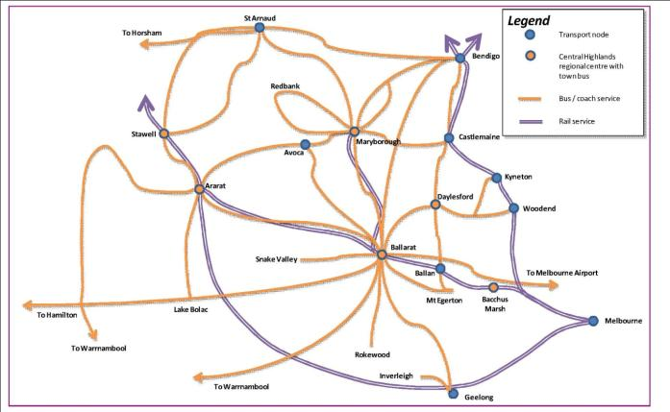Figure 31: Schematic public transport network

Source: AECOM (2011)

Central Highlands Regional Transport Strategy

The Central Highlands Regional Transport Strategy (AECOM, 2011) sets out the region’s aspirations for an effective, sustainable and efficient transport system that services businesses, service providers, employees, residents and visitors travelling to, from, within, and through the region. The strategy provides a response to the transport policy challenges identified in the Central Highlands Regional Strategic Plan which include:

* responding to population and employment change
* addressing the ageing population in rural areas
* managing the development of freight transport
* responding to the changing cost of transport
* developing the service economy.

The strategy identifies six objectives for the transport system’s response to these challenges, as follows:

1. Expand transport networks for growing areas.
2. Manage amenity impacts of freight.
3. Plan for a ‘networked region’ in transport and land use.
4. Provide efficient access to markets for the region’s production.
5. Support the needs of visitors to the region.
6. Increase the resilience of the transport system under changing circumstances.

A number of key directions are identified to achieve the objectives of the strategy, including one which links directly to growth planning as follows:

Direction Five: Explore land use opportunities on strategic network links.

This direction recognises the strategic advantage of directing growth to the orbital corridor linking Victoria’s largest regional centres of Geelong, Ballarat and Bendigo, which includes:

* existing road and, in parts, rail infrastructure for both freight and passenger movement
* good connectivity to large regional centres and to Melbourne
* established and emerging employment sectors
* ready access to water
* heritage, cultural and landscapes of national significance.

However, the strategy does recognise there are numerous constraints that affect land within this corridor including:

* water catchments for drinking and irrigation purposes
* limited options for wastewater treatment
* high value agricultural land
* sensitive natural values, including natural ecosystems (grasslands, woodlands etc.) and groundwater (mineral springs)
* steep topography
* competition from competing development options such as wind power generation.

The strategy recommends that a land use capability assessment is undertaken to identify a feasible long-term settlement structure in this corridor to shape the overall potential of the networked region concept.

The strategy recognises transport infrastructure investment should be prioritised on a regional basis, while having regard for preferred patterns of growth and development.

Integrating transport planning and the future role of Ballarat

Careful thought needs to be given to the role Ballarat will play into the future. Although it has good connections by road and rail to Melbourne, if it wants to attract specialist services and facilities equivalent to Melbourne, it needs to ensure people are easily able to travel to the city during the morning peak, rather than the current focus of providing services to transport people away from the city towards Melbourne.

At the time of writing the only morning peak train services to Ballarat from Melbourne arrive at approximately 8am and 9.30am. Figure 32 shows Ballarat currently remains a relatively self-sufficient community in terms of source of employment as the vast majority of work journeys generated from Ballarat are made locally. Work journeys to metropolitan Melbourne from Ballarat remain relatively low in overall numbers. Likewise journeys to Ballarat from metropolitan Melbourne remain relatively low and are shown in Figure 33.

Chart showing work journeys from Ballarat 1996 to 2011Figure 32: Work journeys from Ballarat 1996 to 2011

Source: Australian Bureau of Statistics, 2011

Chart showing work journeys to Ballarat 1996 to 2011Figure 33: Work journeys to Ballarat 1996 to 2011

Source: Australian Bureau of Statistics, 2011

The state government has investigated, through the Rail Revival Study, the re-establishment of passenger rail services between Geelong and Bendigo via Ballarat and Maryborough, an initiative that would make Ballarat one of the most accessible regional cities in Australia. The study’s proposals to enhance coach services in the short term and rail services in the longer term may strengthen links between Golden Plains residents and Ballarat.

The reopening of Talbot station in 2013 will also help to provide improved connections from communities within the Maryborough-Ballarat corridor to Ballarat.

Increasing pressures on the transport system are evident in Figure 33. The vast majority of work journeys to Ballarat occur within the same municipality and that number significantly increased between 1996 and 2011. Journeys into Ballarat from outside municipalities also increased, albeit in lesser numbers, with journeys from metropolitan Melbourne showing little change and a small absolute number.

Different transport considerations exist for the region’s growth areas, for example Ballarat West. In these areas demand management measures may be needed to ensure central Ballarat remains attractive and accessible. These measures may include park and ride facilities, with bus priority on roads, to reduce congestion in the city centre and enable access to the technology park, university and other large residential and employment areas. It would also negate the need for direct travel into the city centre and may help reduce additional parking requirements and improve traffic flows.

Ararat

Ararat would benefit from:

* strengthening links between Ararat, Stawell and the Grampians National Park
* ensuring employee and visitor access to the Hopkins Correctional Centre as this facility expands.

Therefore both train and coach services in and around the western corridor will need to be reviewed into the future to ensure the attractiveness and viability of Ararat. It is noted that Ararat has limited train connections to Melbourne and Adelaide. Both Ararat and Ballarat have town bus services. With future developments occurring, route reviews will need to be undertaken to ensure passenger access to services, facilities and employment is being met. Bus service reviews are conducted on a rolling basis.

Bacchus Marsh

Bacchus Marsh is subject to considerable growth, placing pressure on its road infrastructure and public transport network. A key strategic issue for the town is the need to provide north-south access on the link between Geelong and Gisborne, while minimising the impact of heavy vehicles travelling through the town centre. Moorabool Shire and VicRoads will be undertaking a transport study for Bacchus Marsh to look at options to cater for traffic growth and reduce the stresses on the current network. Alternative arrangements for north-south movements will also be examined. The town’s public transport network will become increasingly important as the population grows, given the partial role of the town as a commuter centre for metropolitan Melbourne.

Airports

Most movements within the region for passenger and freight occur on the road and rail freight network. Ballarat and other local airports are used for air ambulance and other medical air services as well as some freight carriage. Airport locations are shown at Figure 26.

During 2012 states and territories signed up to the National Airports Safeguarding Framework. This has resulted in the administration of airports being carried out in accordance with the framework, which aims to protect airports and their environs from a variety of potential encroachments.

The framework arose out of the Federal Government’s 2009 Aviation White Paper, which proposed the development of a national land use planning framework to:

* improve community amenity by minimising aircraft noise-sensitive developments near airports including through the use of additional noise metrics and improved noise-disclosure mechanisms
* improve safety outcomes by ensuring aviation safety requirements are recognised in land use planning decisions through guidelines being adopted by jurisdictions on various safety-related issues.

Developed by the National Airports Safeguarding Advisory Group in 2012, the National Airports Safeguarding Framework has a number of guidance notes including:

* the principles of the framework
* measures for managing impacts of aircraft noise
* managing the risk of building-generated windshear and turbulence at airports
* managing risk of wildlife strikes in the vicinity of airports
* managing the risk of wind turbines as physical obstacles to air navigation
* managing the risk of intrusions into the protected airspace of airports
* a national land use planning framework to ensure future airport operations and their economic viability are not constrained by incompatible residential development.

Each state government will implement the framework into its respective planning system.

### Land use planning response

Land use planning and transport planning need to be closely integrated to achieve desired outcomes in sustainability and accessibility, and to make the best use of infrastructure investment. The plan identifies the critical role of transport infrastructure in facilitating economic growth and identifies key transport infrastructure within the region. It recognises the need for transport infrastructure to be aligned with anticipated service demands, having improved connections within and beyond the region.

The plan also identifies how each of the identified future directions link to the objectives of the Central Highlands Regional Transport Strategy.

## Freight transport

### Description and analysis

The state government has prepared Victoria – The Freight State, the Victorian Freight and Logistics Plan which is closely coordinated with the regional growth plans. The freight plan examines long-term freight forecasts for Victoria up to the year 2050 and has used these forecasts to create and model a wide range of freight network scenarios that will inform decision-making for future projects and initiatives. The freight plan encompasses previously developed policy such as the Transport Solutions Framework and Growing Freight on Rail. The Victorian Freight and Logistics Plan provides important support for regional producers and industry.

The export of timber and livestock via the ports of Geelong and Portland ensures these are key destinations for produce from the region. The Central Victoria Livestock Exchange in Ballarat is a significant attractor of livestock from within and beyond the Central Highlands region. The movement of livestock to these saleyards and then onto abattoirs and farms within the region and to ports at Geelong and Portland for export is a significant freight transport task. The extractive industries to the north of Bacchus Marsh and landfill operations in the vicinity of Bacchus Marsh also generate significant heavy vehicle movements.

The main road links are via the Western Highway and Freeway to and from Melbourne, with this road forming part of the National Land Transport Network between Melbourne and Adelaide (refer to Figure 34). The Western Highway was also recognised as a component of the Principal Freight Network.This highway connection is proposed to be further enhanced by the duplication project which is underway.

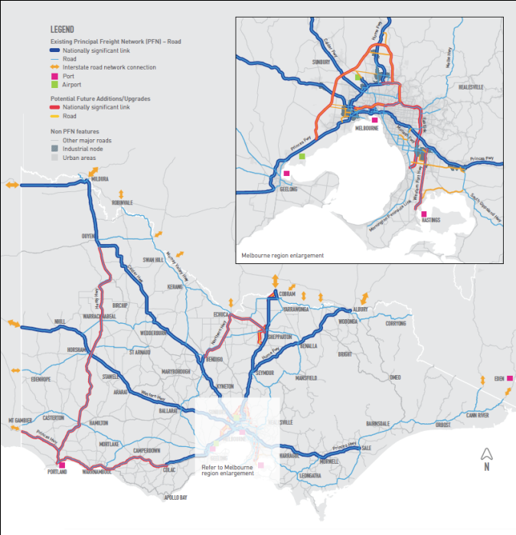Figure 34: The Principal Freight Network - Road

Source: Victoria The Freight State, Victorian Government (2013)

The movement of freight on rail is often more expensive than road freight transport over relatively short distances, such as between Melbourne and Ballarat. Another issue is that railways in the region are split between standard and broad gauge lines. Figure 35 shows Victoria’s rail freight network and opportunities for upgrades and additions.

Map showing the principal freight network – rail (with potential future additions). The map shows Victorian and a cut-out shows metropolitan Melbourne. The map shows exisiting Pricipal Freight Network (PFN) for rail and potential future PFN additions and upgrades such as standard/dual gauge, broad gauge and intermodal terminals.
Figure 35: The Principal Freight Network - Railways

Source: Victoria The Freight State, Victorian Government (2013)

For Ballarat, the imperative is to ensure access to Melbourne via the Western Freeway is as effective and efficient into the future as it can be. The Western Freeway and Highway is where the majority of heavy vehicle movements take place, carrying around 1500 to 2000 vehicles per day. Although the quality of the freeway to the east, and highway to the west, are currently fit-for-purpose, this will need to be assured into the future.

Road links to the ports of Geelong and Portland are good and there is capacity on the network into the future. Centres such as Bacchus Marsh, which grow fruits and vegetables and has state significant sand and stone quarries, require road transport to send their produce and resources quickly to market. The impact of truck movements associated with carrying produce and quarried materials is significant on the local road network and leads to an increased maintenance demand for local councils.

However, it is important to ensure these roads are well maintained as they form part of the freight network which supports a staple for the local economy. Equally, conflict between the agricultural base and a growing residential community may occur into the future. As the area develops and grows there is likely to be more competition for access to the road network and issues around amenity. This is already being seen in places like Bacchus Marsh, Beaufort and Ararat. Balancing these needs will be important to ensure the local economy does not suffer.

Freight is also carried around the region and may go through Ballarat, as shown in Figure 36. Demand management measures may need to be considered in order to reduce conflict between passenger and freight requirements. A long-term aspiration is to enhance north-south connectivity, particularly for freight movements. In part this is being implemented through the Ballarat West Link Road between the Western Freeway and Remembrance Drive.

Improved freight access and functioning of the town centre of Bacchus Marsh is also mooted for further investigation. This may impact in a positive way by providing quicker access to markets for local commodities and encouraging local employment. However, bypasses can contribute to a reduction in local economic vibrancy, such as passing trade, and so should be carefully considered. In the future there may need to be a balancing act between supporting the local economy, protecting amenity and facilitating the easy movement of goods and people.

### Land use planning response

The plan acknowledges that planning for employment growth, such as the Ballarat West Employment Zone, needs to be carefully coordinated with freight transport infrastructure planning to ensure required levels of access are achieved. It is important that supply chains between producers and markets are made as efficient as possible.

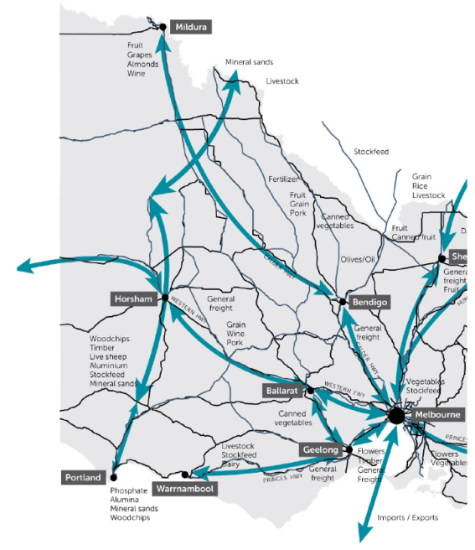Figure 36: Commodities and freight flows

Source: Victorian Government submission to Infrastructure Australia 2012

## Services and infrastructure

### Description and analysis

The Central Highlands Infrastructure Study (PGA, 2013) documents infrastructure assets for 45 settlements within the region. The study identifies the availability of services such as water, sewerage, gas, electricity, telecommunications, solid waste disposal and renewable energy infrastructure. It outlines the capacity of this infrastructure and the implications for capacity if growth was to occur. Infrastructure opportunities are also identified that could provide the region with a business advantage and assist in settlement growth. This study should be referred to for further information regarding the availability and capacity of services infrastructure within the region.

Water supply

Victoria has an integrated and adaptive water planning framework, which ensures urban water customers and the broader community have secure supplies of high quality water. These supplies support domestic and industry use and other needs such as recreational facilities, parks and gardens.

The State Government’s Living Victoria program was launched in April 2012 and has direct implications for water and urban planning across the state. Although the immediate focus of Living Victoria is on metropolitan Melbourne, its overarching directions are intended to apply more broadly across the state over time. As this occurs, the plans and strategies produced under this program will gradually supersede and replace existing strategies.

The Living Victoria program responds to the recognition that:

* water needs to be better integrated into urban landscapes
* the community needs to be better engaged in water planning
* improved evaluation frameworks capable of capturing a broader range of costs and benefits are needed to effectively assess the wide array of options for the provision of urban water services.

By implementing the Living Victoria program, the Office of Living Victoria will develop and coordinate new integrated urban and water planning frameworks and develop tools that will apply across the state, such as changes to the Victoria Planning Provisions.

Ballarat is also pursuing an integrated water cycle management model via the Living Ballarat project. This seeks to ensure augmentation of the supply is achieved through appropriate use of rainwater, stormwater and recycled water to help manage the impacts of growth and climate change.

At present, the key plans and strategies that guide urban water planning in regional Victoria are:

* water supply demand strategies, which will be superseded by integrated water cycle strategies
* regional sustainable water strategies
* drought response plans.

Water supply demand strategies were initially released in 2007. These strategies evaluated future water supply and demand scenarios, including under various climate change scenarios, and identified the mix of water supply and demand management measures needed to secure safe and reliable town water supplies, with a 50-year outlook. Urban water corporations released updated strategies in early 2012, which included new features to increase their alignment with the Living Victoria program including an Alternative Water Atlas and an annual Water Security Outlook.

Based on the water supply demand strategies across the Central Highlands, there is expected to be adequate water supply over most of the region for the next 30 years to meet demand. Some water supply districts may experience a shortage of water based on demand, depending on the emerging impacts of climate change as shown in Figure 37. Water corporations have already identified actions to address these potential shortages in supply, through improving efficiency of supply and supplementing supplies, for example increasing bulk water supply.

Figure 37: Summary of water supply demand strategy outlooks for the Central Highlands region

Grampians Wimmera Mallee Water

* Supply system: Pyrenees and Eastern Grampians Supply System
* May experience shortages in supply depending on the level of climate change

Central Highlands Water

* Supply system: Daylesford
* Adequate supply for 30+ years
* Supply system: Clunes
* Adequate supply for 50+ years
* Supply system: Blackwood
* Adequate supply for 30+ years
* Supply system: Beaufort
* Possible shortage towards the end of the 30 years, depending on climate change
* Supply system: Ballarat and district
* Adequate supply for 30+ years
* Supply system: Avoca
* Adequate supply for 30+ years
* Supply system: Amphitheatre
* Adequate supply for 30+ years

Western Water

* Supply system: Myrniong System
* Adequate supply to meet demand for 50+ years

Coliban Water

* Supply system: Coliban Southern System
* Possible shortages at year 2030, depending on climate change

Barwon Water

* Supply system: Greater Geelong Supply System and Moorabool River supply
* Adequate supply to 2050 (or longer)

Source: Northern Region, Western Region and Central Region Sustainable Water Strategy.

Integrated water cycle strategies will identify the best mix of measures to:

* maintain a balance between the demand for water and the supply of water in cities and towns
* facilitate efficient investment in all water cycle services, including recycling sewage or trade waste, stormwater capture and re-use, and demand management
* improve the resilience of water supply systems, including fit-for purpose, through scenario-based planning and adaptive management having regard to risk and uncertainty.

The integrated water cycle strategies to be prepared for the Central Highlands region will need to consider the direction regarding growth in the plan.

Regional sustainable water strategies take a long-term view of water resource planning, considering all sources of water and the needs of towns, industry, agriculture and the environment at a regional scale. They identify threats to reliability of water supply and quality of water, and ways to improve supply and quality of supply for existing and future consumptive users. These strategies also identify ways to improve, protect and increase environmental water reserves.

For the Central Highlands region:

* the Western Region Sustainable Water Strategy applies to some of the region and is still being implemented
* the Northern Region Sustainable Water Strategy has mostly been implemented and will now evolve as the Murray-Darling Basin Plan is implemented
* the Central Region Sustainable Water Strategy has now been superseded by the Living Victoria program.

Drought response plans manage temporary water shortages due to prolonged periods of below average rainfall or other causes such as poor water quality. They outline a range of options to balance supply and demand, which may include imposing water restrictions. The water restriction framework was reviewed in late 2011 to meet community expectations and to apply consistent restriction rules across the state.

Sewer

The Central Highlands region comes within the operating area of six different water corporations.

Sewerage services are provided by Central Highlands Water to most of the larger and medium sized settlements within the Central Highlands including Ballarat, Maryborough, Daylesford, Beaufort, Clunes and Ballan. Some of the smaller settlements within the Central Highlands, such as Learmonth, are also provided with sewer. The small townships of Gordon, Snake Valley, Waubra and Smythesdale are currently in the process of being sewered. Grampians Wimmera Mallee Water provides both water and sewer services to Ararat. Lake Bolac has also recently been sewered by Grampians Wimmera Mallee Water. Bacchus Marsh is serviced by Western Water, while Trentham is within the Coliban Water region.

The ability to provide sewer infrastructure may, in some locations, form a key determinant of the growth potential of towns. For example, the sewering of Gordon may facilitate the rezoning of the town and enable smaller lot subdivision to occur. In other cases the direction of future growth in an already sewered town may be determined by the location of existing infrastructure, such as in Creswick. Grampians Wimmera Mallee Water has advised that providing sewerage services to parts of Ararat is problematic, including to some areas identified for future growth.

The plan directs new development to locations with suitable infrastructure or where infrastructure upgrades are cost effective. It is noted that Talbot, which is presently unsewered, will shortly have its railway station reopened, therefore potentially providing an incentive to support additional development on the Maryborough-Ballarat corridor. The Loddon Mallee South Regional Growth Plan identifies sewering Talbot as a priority.

Gas

Reticulated gas supplies within the Central Highlands are provided by SP AusNet. Currently services are generally only provided to larger towns such as Ararat, Maryborough, Stawell, Ballarat, Daylesford and Bacchus Marsh as well as a few smaller towns including Ballan, Hepburn Springs and Creswick. The state government recently announced that Avoca will get access to natural gas under its Energy for the Regions program.

Information and communications technology

The development of the National Broadband Network will provide telecommunications infrastructure that is likely to improve the way people connect with one another, regardless of geography, for business, lifestyle, medical and education purposes. Varied coverage will be offered across the region.

Construction of the National Broadband Network in the Central Highlands is well underway, having commenced in 2011. Fibre connections are available or currently being rolled out in Ballarat, Bacchus Marsh and Creswick while fixed wireless connections are available or currently being rolled out to a wide hinterland area surrounding Ballarat which extends south as far as Rokewood, west as far as Trawalla, north as far as Smeaton and east as far as Mount Egerton.

Access to superfast broadband will give businesses the opportunity to increase productivity, save time and money and provide the ability to compete on a global scale.

The implications of the National Broadband Network for land use planning within the Central Highlands could be significant as it may result in fundamental changes to the way that certain activities are undertaken. Travel patterns may alter, with a reduced need to travel long distances to access certain services if they are able to be provided via a high speed internet connection. Opportunities are also presented by information and communications technology upgrades to enable rural businesses to operate more efficiently, such as the wine industry operating from areas like Moonambel which are some distance from larger centres.

There will be a need to monitor the impacts of improved communications technology on settlement and transport patterns over the longer term to ensure the plan’s settlement framework and assumptions about lifestyles and employment choices remain valid.

Waste management

Effective waste and resource recovery management is an essential service that protects environmental and public health. The Victorian waste management system includes waste generation, collection and transport, sorting and processing, recycling and reprocessing, export, reuse and disposal. The waste management system operates across all activities in the region such as household or municipal, commercial and industrial, and construction and demolition.

The state government is responsible for policy development and regulation around waste management, and for promoting environmental sustainability. Local governments are responsible for providing waste collection, transport and reprocessing, or disposal to landfill services.

Regional waste management groups are responsible for planning and coordinating the management of municipal solid waste for local governments within their regions, as well as helping them to reduce waste, maximise recovery and reduce environmental harm.

There are many industries existing and emerging in waste management, particularly in terms of recovery, reuse and recycling of waste. Energy generation from waste is an expanding industry across the state.

Victorian waste generation is expected to increase by around four per cent per annum. There is a need to plan for and manage the waste associated with population growth forecast for the region. As the recently released Victorian Waste and Resource Recovery Policy (Department of Sustainability and Environment, 2013) states:

As our cities grow, securing land for our waste management facilities is a challenge. As population increases our waste generation increases and as we strive for world’s best practice environmental standards, finding and securing land for waste management facilities is likely to become even more difficult. (page 16)

The potential for land use conflict from growth occurring in proximity to landfills needs to be carefully managed through the planning system. The plan recognises that regional landfills are located at Smythesdale and Stawell, which although outside the region, services Ararat and its surrounds.

There are opportunities to encourage and support investment into advanced technology that can convert waste into energy or fuel products. The plan recognises the need to encourage local energy generation from waste sources. The region could benefit from a regional plant that includes material recycling facilities, composting facilities for green waste, and bioenergy plants for processing food and animal production wastes. Any such facility would require suitable buffer zones to minimise conflict with areas of sensitive uses.

### Land use planning response

The plan has been prepared in collaboration with infrastructure service providers, ensuring growth is directed to locations where it makes best use of existing infrastructure and, that where additional infrastructure is required, it can be provided cost effectively. The plan supports the identification of regional priorities for improvements related to utilities, waste management, energy and telecommunications.

Consultation during development of the plan identified the need to provide appropriate waste disposal across the region for intensive industries. The need to investigate alternative waste treatment solutions for small towns was also noted, particularly those in declared water supply catchments.

1. Environment

## Context

The Great Dividing Range runs through the middle of the Central Highlands. As a result, the region is part of both the Murray Darling Basin as well as various catchments that drain to the Victorian coast. This means that environmentally, the Central Highlands region is closely linked to all of its surrounding regions. This is reflected by the fact that five catchment management authorities intersect in the Central Highlands region: the North Central, Wimmera, Glenelg Hopkins, Corangamite, and Port Phillip and Westernport catchment management authorities (refer to Figure 38).

Each catchment management authority prepares a regional catchment strategy, which becomes the principal strategic document setting regional priorities for maintenance of natural resources. The strategy is completed every five years by each catchment management authority, in consultation with the local community, and the Victorian and Australian governments.

Regional catchment strategies and their sub-strategies, such as regional waterway strategies, identify priorities for investment in protecting and enhancing high value environmental assets.

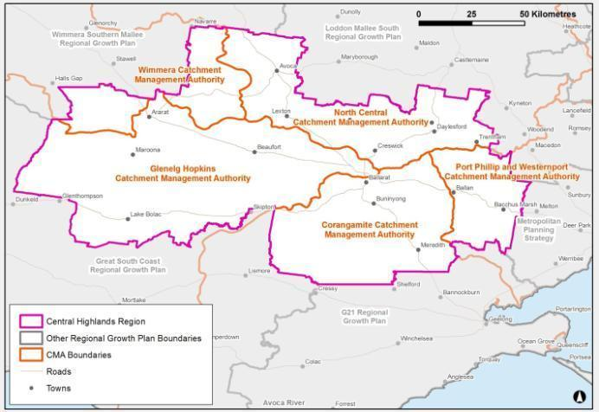Figure 38: Catchment management authority and regional growth plan boundaries

Source: Department of Transport, Planning and Local Infrastructure

The Central Highlands region contains many of the state’s significant environmental features, including, (wholly or in part):

* Grampians (Gariwerd) National Park
* St Arnaud Range National Park
* The Pyrenees Ranges (part of the Great Dividing Range)
* Lerderderg State Park
* Daylesford and Hepburn Springs
* The Castlemaine Diggings National Park
* Brisbane Ranges National Park
* Werribee Gorge State Park
* Enfield State Park
* Mount Cole
* Numerous significant rivers, wetlands and lakes

Landscape connectivity in the region is particularly strong around the ranges and areas of public land, and is poorer in agricultural areas.

The State Government has identified the need to protect areas of high biodiversity value (catchment assets) and to improve the vegetation corridors between them. The connections between natural habitats have been lost through land clearing and changed land uses. Most remaining examples of native forests, woodlands, grasslands and seasonal wetlands occur in parks and reserves or as isolated remnants within a matrix of farmland, urban land and other altered areas.

## Natural environment

The Central Highlands region’s natural environment is highly valued by its residents. It is a significant attraction for both residents and visitors. The protection of environmental assets is important not only for environmental reasons but also for liveability and productivity. Environmental assets such as forests and parks play a key role in protecting biodiversity and ecosystem resilience and provide a major contribution to the region’s social and economic wellbeing by contributing environmental services, such as clean air and water, carbon storage, timber products, pollination and climate regulation.

The benefits to the region from tourism, recreation and natural resource-based industries such as timber, apiculture and mining are significant. Environmental assets also provide important open spaces for recreation in urban areas and protect significant cultural values including Aboriginal and historic cultural heritage places.

### Description and analysis

Terrestrial habitat

Native vegetation and habitats (terrestrial habitat) are important as they provide a range of values, such as filtering nutrients, habitat regeneration and climate regulation, that underpin the health of land and water, flora and fauna, and natural communities. Native vegetation and habitats help provide clean water, carbon sequestration, timber, firewood and healthy soils. They also provide important spiritual and aesthetic values at various scales and are a key to many of the tourism values in the region.

Loss of habitat extent and quality through clearing of native vegetation, or from other threatening processes for urban and rural purposes, has been and continues to be a significant threat to native vegetation and habitats across Victoria.

Central Highlands catchment management authorities have identified the highest value native vegetation and habitat assets within each of their boundaries. Each catchment management authority has used a different method to identify their highest value native vegetation and habitat.

For consistency across the regional growth plans, the Department of Transport, Planning and Local Infrastructure has used the highest three levels of the Department of Environment and Primary Industries’ NaturePrint v2.0[8] mapping to identify significant clusters of vegetation across the state (refer to Figure 39). These align very closely to the terrestrial habitat assets identified by the catchment management authorities, such as the biodiversity assets identified by the North Central Catchment Management Authority. These areas include considerable areas of forested, grassy woodland and grassland communities.

Natural resource management activities within the region include actions to protect the high value habitat assets in the region, along with waterways, wetlands and soil assets. These activities will involve actions on both public and private land, but have limited strategic land use planning implications.

There will continue to be a focus on increasing the extent of native vegetation within the region by creating vegetation corridors in strategic areas. The preferred locations for these corridors may overlap with areas that may experience a future change in land use or a change in industry. Consideration needs to be given to potential changes in landscape-scale bushfire and flood risk when planning to increase the extent of native vegetation through the landscape.

There are emerging economic opportunities on private land centred on environmental values, such as in carbon markets, ecoMarkets and offset markets. There is the opportunity to coordinate planning of the preferred locations of these and other native vegetation planting activities to maximise the benefits gained from them.

While many of these activities sit outside the planning system, land use planning should be aware of them in order to ensure integrated decision-making. For example, careful consideration will need to be given to the preferred locations of vegetation corridors in light of land use planning strategies including regional growth plans. Such activities could, for example, lead to changes to the risk profiles of natural hazards which land use planning should take into account, such as vegetation corridors and bushfire risk. The potential to realise mutual benefits from these activities should be considered, for example, establishing vegetation corridors along key tourism routes.

There are numerous individual threatened species that occur in the region, although they are too many and their locations too specific to be considered and mapped for a regionally focused growth plan, particularly when localised planning assessments should consider threatened species. Threatened communities, such as the Natural Temperate Grassland of the Victorian Volcanic Plain, are generally captured by NaturePrint and this is considered an appropriate representation for a regional-scale plan.

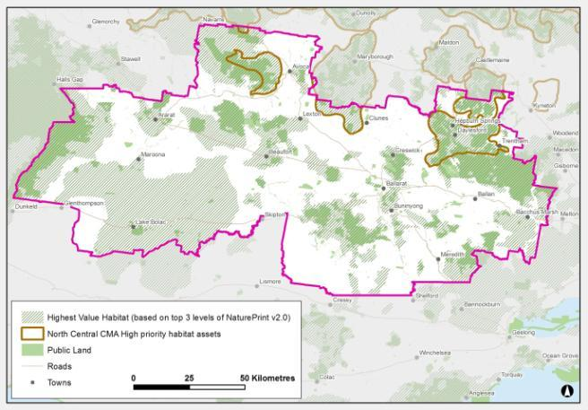Figure 39: Native vegetation and habitat assets

Source: Department of Transport, Planning and Local Infrastructure

Waterways (rivers and wetlands)

The Central Highlands region spans both sides of the Great Dividing Range and includes river catchments that drain to Victoria’s coast and to the Murray River. Parts of the Avoca, Barwon, Campaspe, Glenelg, Hopkins, Loddon, Maribyrnong, Moorabool, Werribee and Wimmera-Avon river catchments, and the Lake Corangamite catchment occur within the Central Highlands region (refer to Figure 40). Some of the region experiences large-scale flooding from these rivers, which can severely impact on both rural and urban areas.

There are numerous wetlands and wetland complexes throughout the region, including nationally important wetlands. The North Central Catchment Management Authority has also identified regionally significant wetland complexes as part of developing their regional catchment strategy. These are also illustrated in Figure 40. Waterways provide valuable habitat for fish, platypus, frogs, macro-invertebrates, birds and vegetation, as well as creating ecological connectivity and human recreation opportunities. Waterway strategies, the *Water Act 1989* and the *Planning and Environment Act 1987* can help to support these values through regulation, investment and land use planning. The Lerderderg River is recognised as a Victorian Heritage River.

Waterways (rivers, wetlands and floodplains) provide the region with its water supply. This water is critical for supporting the region’s towns, industry and agriculture, as well as the environmental values within and adjacent to rivers, wetlands and floodplains. Some of the wetlands in the region contain important cultural assets, while some lakes are important tourism assets, such as Lake Wendouree, Green Hill Lake, Lake Bolac, Lake Learmonth, Lake Burrumbeet and Lake Buninyong. Also of note are the mineral waters of Hepburn Shire that are a significant tourism asset for the state.

Map showing significant waterways of the Central Highlands 
regionFigure 40: Significant waterways of the region

Source: Department of Transport, Planning and Local Infrastructure

Land use change and development can have a wide range of impacts on environmental values. For example, development in proximity to waterways or wetlands can lead to impacts such as urban stormwater runoff, waste and wastewater and reduced wetland connectivity. Planning mechanisms are available, such as overlays, to detail specific considerations around regionally and locally important waterway assets. This is of particular relevance for wetlands, given the prominence of wetlands on private land.

Soils

The soils in the region vary depending on the geological and land formation history they have experienced. Each catchment management authority has described soil differently in their respective regional catchment strategies. The region contains areas of highly productive soils including the Werribee River flats at Bacchus Marsh, the Moorabool River valley near Bannockburn and the volcanic soils to the north and east of Ballarat. Land that is seen traditionally as holding less production value is of high value for some non-soil dependent intensive animal production industries in the south of the region.

Healthy and productive soils are essential for the continued economic success of Victoria, particularly for agricultural enterprises, as well as to continue to support most other environmental assets. However, soil can also pose a risk to other environmental assets (as discussed in section 7.4: Natural hazards and risks).

Soil, along with water, vegetation and fauna, is defined as an integral part of land under the *Catchment and Land Protection Act 1994*. Private landholders have primary day-to-day management responsibility for soil health on their properties and must take all reasonable steps to conserve soil and avoid doing anything that would cause or contribute to land degradation on someone else’s land. Governments can play a role where markets fail to encourage the long term preservation of soils and the values and services they provide (Department of Sustainability and Environment, 2012a).

Often at the heart of soil issues is a mismatch between land use and management, and the inherent capability of the soils (Department of Sustainability and Environment, 2012a). Land capability is a commonly used measure of the value of soil for agricultural production, although it is not the only indicator or driver of the productive capacity of land. Sometimes proximity or security of feed, roads, processors, power and water can be more important considerations.

Not all agriculture requires good soil or water to be productive for agricultural purposes. Therefore, land capability should not be the only indicator of potential of farmland, nor should soil capability be used to discriminate between different types of legitimate agricultural land uses in rural areas.

Continued development of information to support decision-making, such as regional soil plans and capability mapping, will be important to enable growth in productive agriculture and settlements into the future.

Soil health considerations, including erosion and salinity, are considered in section 7.4: Natural hazards and risks.

Public land

There is an extensive network of public land reserves in the Central Highlands region that protect numerous environmental, economic and social values. These values include conserving flora and fauna, protecting water catchments and water supply, providing timber for sustainable forestry, protecting landscapes, cultural landscapes and historic places, and providing recreational and educational opportunities. The public land in the region is illustrated in Figure 41. This figure shows that public land captures many of the significant natural values (habitat) of the region, but there are substantial areas of high natural value outside public land.

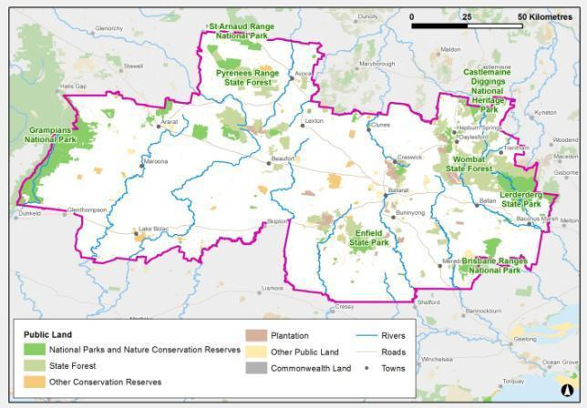Figure 41: Public land within the region

Source: Department of Transport, Planning and Local Infrastructure

There are significant, nationally recognised areas of public land in the Central Highlands region, such as the Grampians National Park and the Hepburn Springs/Daylesford area. These public land assets and their surrounding landscapes attract many visitors and provide significant income to the region. They are central to the tourism future of the region and for protecting its natural values.

Opportunities for tourism development associated with, or linked to, public land are encouraged in the plan. This is particularly relevant around the Hepburn Springs/Daylesford and Grampians areas. Within the Grampians there are plans to develop the Grampians Peak Trail, a long distance walking trail (linking Mount Zero to Dunkeld). This trail will require accommodation options along the route (away from townships) as well as tourism infrastructure to support walkers on their 12 to 14 day walking experience. This may create economic diversification opportunities for private landholders close to the Grampians. There are also tourism opportunities related to the ‘Goldfields – Australia’s Premier Heritage Region’ initiative and other nature-based tourism opportunities associated with public land.

### Land use planning response

The land use planning system plays an important role in protecting environmental assets on private land where new development is proposed. However, there are many other strategies and processes which manage environmental values beyond the land use planning system. For example:

* Waterway and wetlands health is managed by catchment management authorities, through their regional catchment strategies and relevant sub-strategies, including regional river health strategies and wetland management strategies.
* Water quality is managed by Environment Protection Authority Victoria and rural water authorities.
* Public land values are managed by Crown land managers, generally councils, Parks Victoria or the Department of Environment and Primary Industries.
* Threats to biodiversity values are managed through legislation such as the Victorian *Flora and Fauna Guarantee Act* *1988* and the Commonwealth *Environment Protection and Biodiversity Conservation Act 1999* as well as Department of Environment and Primary Industries action plans.
* Other catchment assets, such as soils, are managed by catchment management authorities through soil management plans and land and water management plans.

The planning directions set out in the regional growth plan are consistent with these existing strategies. The plan recognises the key environmental assets of the region and identifies the need to give primacy to their protection and enhancement.

While the plan identifies key environmental assets at the regional scale, detailed localised assessments are beyond the scope of a regional scale plan. As such, ‘ground-truthing’ of local environmental assets will be required for areas identified for future urban growth.

Consultation during development of the plan revealed the need to understand where the most valuable agricultural land is, particularly in the east of the region, to establish what needs to occur to protect those areas for future agricultural production. Land use planning can identify strategically important agricultural land and specify its protection for future agricultural production or to protect it from inappropriate development.

Land use planning can assist in the protection of the state’s soil resource by promoting that land use change does not disturb soils to a level that could result in deterioration of the soil assets within each region, or further contribute to pollution of waterways in any significant volume. One method could be to apply the Erosion Management Overlay.

## Water catchments

### Description and analysis

A significant proportion of the Central Highlands, including much of the shires of Hepburn and Moorabool, are located within declared water supply catchments, as shown in Figure 42. Many of these catchments are located in areas that are under significant demand for residential development. There are potential risks to water quality in these catchments that need to be managed appropriately.

The catchment areas within the region supply water for domestic, irrigation or other purposes and are protected under the *Catchment and Land Protection Act 1994*. These catchments have significant values as a source of water supply and much of the land within these catchments is privately owned and used for farming purposes. Within the Central Highlands region these catchment areas collect water for use in metropolitan Melbourne, for supply to important irrigation districts, and for supply to Ballarat, Bendigo, Geelong and many smaller settlements.

The land use planning system interacts with declared water supply catchments by recognising them in planning schemes, typically through an Environmental Significance Overlay such as in the Moorabool Planning Scheme, which triggers the need for a permit for land use or development that may impact on water quality. Water authorities are typically recognised as referral authorities for planning permit applications within the catchments that they manage. There is a need to consider how growth of settlements in the region will interact with objectives around protection of water catchments. Infrastructure upgrades to particular towns may assist in reducing the impact of existing septic systems and allow for further development.

In November 2012, the Minister for Water issued guidelines for planning permit applications in open, potable water supply catchment areas. The focus of these guidelines is to manage risks presented to catchments from pollution sources, primarily residential development and agriculture, which can impact on water quality due to contaminated runoff and wastes, nutrient contributions and sediment to waterways.

The guidelines address such issues as the density of dwellings within open, potable water catchment areas. In the absence of reticulated sewer, the guidelines state there should not be more than one dwelling per 40 hectares unless:

* a catchment policy has been prepared that provides for a greater density, or
* a domestic wastewater management plan has been prepared and a range of other requirements are satisfied.

Other issues addressed include the maintenance of septic tank systems and other on-site effluent disposal systems, encouragement of vegetated corridors and buffer zones along waterways and agricultural uses.

Special area plans have been prepared for some of the declared water supply catchments. These plans specify where, within these catchments, specific land uses may be undertaken and the conditions that apply to any such land uses. The purpose of these plans is to minimise any adverse effects on water-related values.

Domestic and stock water use continues to be an ‘as of right’ use if used for the purposes defined in the *Water Act 1989.* However, in 2009 the state introduced policies to improve the management of such uses (Department of Sustainability and Environment, 2011). Some of these measures aim to monitor interception activities and ultimately reduce the impact of small catchment dams on overall water availability. Domestic and stock use could undermine the reliability of supply for all water users, particularly as in dryer conditions these dams intercept a greater percentage of rainfall (Department of Sustainability and Environment, 2009).

There are some groundwater resources in the Central Highlands region, including small ones in the upper catchments of rivers that flow south. The largest one of these is in the Loddon River catchment. There is also a small resource around Bacchus Marsh.

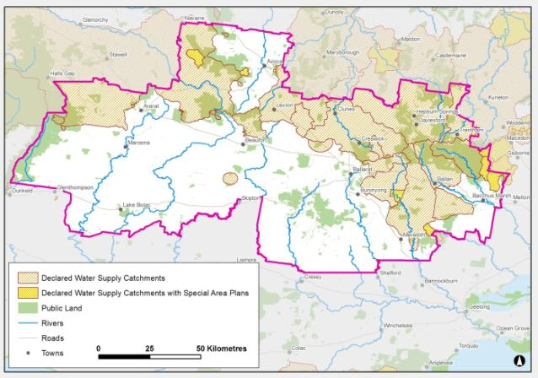Figure 42: Declared water supply catchments in the region

Source: Department of Transport, Planning and Local Infrastructure

### Land use planning response

The designation of land within a declared water supply catchment places constraints on development, particularly where land is not sewered, such as in rural residential areas, and can place limitations on agricultural activities such as highly intensive agriculture. The cumulative impacts of development within a catchment, such as rural residential development outside settlements, present risks to water quality that need to be carefully managed. The plan identifies the need to protect water catchments as regionally significant assets in local planning and policy development. Furthermore, ongoing infrastructure upgrades which achieve multiple benefits, such as sewering settlements in catchment areas, are supported in the plan.

The guidelines recently released by the Minister for Water provide further direction regarding land use and development within open, potable water supply catchments. The guidelines provide for the preparation of catchment policies and domestic wastewater management plans for specific catchments, which can set out the types of development and land use that will be supported. The regional growth plan emphasises the need for councils to review their domestic wastewater management plans particularly in areas subject to pressure for rural residential development.

The proliferation of farm dams for domestic and stock use in rural residential areas has impacts on the quantity of water able to be harvested from a catchment area. Water availability is a concern both for maintaining environmental water supplies and for use by people and industry. Land use planning needs to consider these cumulative impacts where planning approval is required for such dams.

Plantation timber is an expanding industry in the region, and is identified as a future opportunity for future economic diversification in the region. The implications of plantations on water supply in certain catchments may need to be investigated and land use regulated into the future, in line with the Western Region Sustainable Water Strategy.

## Natural hazards and risks

### Description and analysis

Climate change

The Central Highlands region has potential to be significantly affected by the consequences of a changing climate. Predictions of the climate in 30 years’ time indicate the region will experience less rainfall, have hotter days and be subject to more extreme weather events, such as storms, flooding and bushfires.

Natural systems such as wetlands, sectors such as agriculture and settlements in non-urban areas, could be particularly at risk of events such as drought and bushfire.

Identifying risks from climate change is an important step in preparing to minimise negative environmental, social and economic impacts in the region.

Projected changes in rainfall and higher rates of evaporation will result in less water for our dams and catchments. Most of the catchments in the Central Highlands region are estimated to experience a 30 per cent reduction in runoff by 2030, and by 2070, will be experiencing reductions in runoff of at least five per cent or up to 50 per cent (Department of Sustainability and Environment, 2008).

Although the implications of climate change on specific economic, environmental and social assets are hard to predict, it has been forecast that climatic changes will have long-term consequences for the Central Highlands region, including:

* implications on water supply and reliability
* altered agricultural commodities within the region, particularly in dry land farming areas
* damage to infrastructure, industries and agriculture from severe weather events and natural hazards
* pressures on natural ecosystems
* implications for communities, such as human health, energy use, housing needs and service provision (Department of Sustainability and Environment, 2013)
* an increasing likelihood of more extreme events such as heatwaves, bushfires and flooding (Department of Sustainability and Environment, 2013).

Climate change may also produce positive benefits for Victorian regions, such as enabling economic diversification into different commodities and industries.

The future water availability in the region is explored in the Western Region Sustainable Water Strategy, Northern Region Sustainable Water Strategy and the Central Region Sustainable Water Strategy, and in section 6.4 of this report.

The potential impacts of climate change raise various land use issues including:

* determining areas that are inappropriate for future urban growth, or areas that need specific controls, based on the future bushfire and flood hazard under climate change scenarios
* transitioning to the future agricultural and other industry mix in the region, based on climate change scenarios
* assessing the future carrying capacity of the region based on future water availability, by considering growth pressures, areas currently experiencing decline in population, climate change scenarios and the future industry potential for the region
* transitioning infrastructure to deal with the anticipated increase in the number of days with high temperatures, such as railway lines, hospital admissions, outdoor work and electricity demand.

Climate change will also have various impacts on soils into the future across Victoria. Impacts may include a decrease in soil carbon levels, increased soil erosion and nutrient loss due to reduced vegetation cover, and a shift in the suitability of land for farming.

Bushfire

The risks to life and property presented by bushfire are an important consideration in land use planning within the Central Highlands region. Many of the landscapes most attractive to residents and tourists in the region are at the highest risk from bushfire.

Pressure to develop in highly attractive areas in the region are likely to continue into the future and will present a significant, ongoing challenge for land use planning. These areas are also often the most attractive for tourism development.

Predictions indicate that as the climate changes there will be an increase in the number of extreme bushfire index days each year. Bushfire frequency and intensity is likely to increase as a result of climate change. The impacts of climate change on bushfire risk need to be considered when planning for future development.

Following the Victorian Bushfire Royal Commission, Amendment VC 83 was gazetted in November 2011 to incorporate new bushfire planning provisions into the Victoria Planning Provisions, and integrate with changes made earlier to building regulations.

Regional bushfire planning assessments provide extra information about areas (referred to as ‘identified areas’) where a range of land use planning matters intersect with a bushfire hazard to influence the level of risk to life and property from bushfire. This information should be addressed as part of strategic land use and settlement planning at the regional, municipal and local levels. The regional bushfire planning assessment maps identify where a significant bushfire hazard may affect land use planning, as well as features such as settlements, urban interfaces and single access roads. The maps aim to assist councils with their strategic planning such as when they are preparing a planning scheme amendment to support land use change or development.

Of major significance for land use planning is the requirement to prioritise the protection of human life over other policy considerations, reinforced by an explicit requirement to apply the precautionary principle in decision-making when assessing the risk to life, property and community infrastructure.

In line with 2009 Victorian Bushfires Royal Commission recommendations, new development should be substantially restricted in the areas of highest bushfire risk, while giving due consideration to biodiversity conservation[9]. Regional and settlement planning need to clearly demonstrate how bushfire risk has been considered and how a response to risk has informed that planning. Figure 43 illustrates the extent of the Bushfire Management Overlay in the region.

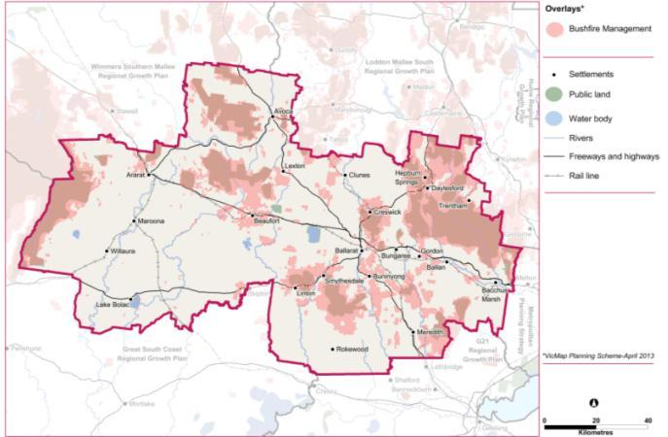Figure 43: Extent of the Bushfire Management Overlay

**Source: Department of Transport, Planning and Local Infrastructure**

Flooding

While flooding is usually a natural event, and one which is important to maintain biological diversity, it can be highly disruptive to the community and the economy. The Central Highlands region has a history of floods. The most recent floods in 2010–11 were the most extensive ever experienced in the region. Towns affected included Creswick, Skipton, Beaufort, Landsborough, Navarre and Burrumbeet Creek. The severe impact of these floods was clearly illustrated by the extensive damage caused to important infrastructure in the region.

Catchment management authorities develop, oversee and implement regional floodplain management strategies. These strategies integrate local floodplain management issues and prioritise the development of urban and rural floodplain management plans within the region.

Municipal councils in regional Victoria have historically had operational responsibility for most floodplain management activities occurring within their boundaries. This has occurred by controlling floodplain development through the municipal planning scheme and implementing local floodplain management plans.

Floodplain management is based on making trade-off decisions about the economic, social and environmental costs and benefits of allowing a broad range of activities to take place on floodplains.

The existing flood overlays are shown in Figure 44. Flood studies have been released for various areas of the region by the catchment management authorities although some will require updating in light of the most recent floods.

Catchment management authorities in the Central Highlands have advised that floodplains in the region could be improved by addressing inappropriate development and land use, among other factors. The Review of the 2010–11 Flood Warnings and Response (Comrie, 2011) (page 194) notes that the:

“North Central Catchment Management Authority advised ... that no towns within its catchment had adequate flood mapping, in particular, it noted that for Carisbrook and Creswick, two towns that flooded in the 2010–11 floods, only anecdotal mapping existed.”

Since that time a number of studies have been undertaken to improve the evidence base for flood management, mitigation and planning controls, including for Creswick. The Parliamentary Inquiry by the Environment and Natural Resources Committee into Flood Mitigation Infrastructure in Victoria (ENRC, 2012) found that the types and effectiveness of flood mitigation infrastructure varied across the state. It also found that further work was required to clarify the roles and responsibilities of the various government agencies involved in flood mitigation, monitoring and management.

At present the approach to flood management in the region’s planning schemes is highly inconsistent. A variety of different approaches and planning tools are in evidence. Settlements as large as Ararat have no flood controls at all. Further work is required to ensure the region’s settlements and rural areas are provided with appropriate planning controls to manage flood.

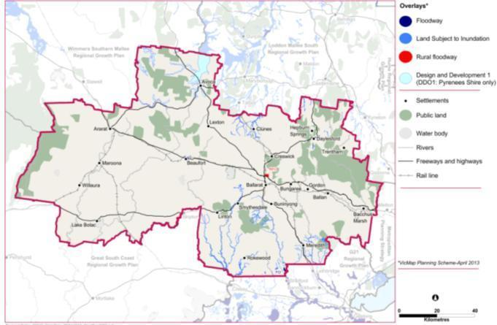Figure 44: Extent of flood overlays

**Source: Department of Transport, Planning and Local Infrastructure**

Climate change predictions indicate that more extreme flood events may occur in the future. Existing flood risk assessments do not take account of these likely increases in the intensity of storm and flood events. The potential increase in flood risk should be considered in future strategic planning.

Soil health

Healthy soil delivers a wide range of environmental benefits and is less likely to be acidic, saline, compacted, nutrient poor, or eroding. Soil erosion and land degradation have significant economic, social and environmental costs, both on site, such as loss of carbon storage, and on downstream assets, such as erosion entering rivers and reducing water quality.

There are areas within the Central Highlands region that are particularly susceptible to erosion and landslip. Factors which contribute to these risks include land use, whether the use is consistent with the land capability, vegetation cover, gradient and aspect.

Salinity is a significant soil health issue within some parts of the Central Highlands and has the potential to impact on urban water supply, infrastructure, agriculture and environmental values. Salinity issues in relation to rural areas are managed through land and water management planning activities of catchment management authorities.

Urban salinity is an emerging problem across Victoria, causing damage to many natural and built assets including buildings, bridges, pipelines, cemeteries, parks and gardens, lakes and waterways.

Salinity also affects private homes and gardens. Salinity in urban areas can cause significant damage to structures such as pavements, roads, bricks and mortar, and can corrode and damage underground pipes. It can also result in dying gardens, bare soils and soils that can only grow salt-tolerant species.

The impacts of salinity both in urban and rural areas decreased during the recent extended drought. However, the problem was only temporarily halted. The return to wetter years has seen a return of many salinity-related problems.

Potentially contaminated land

Contaminated sites include land, and often also groundwater, where chemical and metal concentrations exceed those specified in policies and regulations. The location and number of contaminated sites across Victoria is not accurately known. A desktop assessment in 1997 estimated there were around 10,000 contaminated sites in Victoria (Victorian Auditor-General, 2011).

Contaminated sites may pose immediate or longer-term risks to human health and the environment, depending on the type and extent of contamination and on how the site is used.

There are many areas that may contain contaminated land in the region, particularly due to its gold mining history. There are also many individual properties that may have contaminated land due to historic land use and management. Many of these areas could be subject to development pressures, either through infill or urban expansion, given the high occurrence of historic mining sites associated with existing settlements.

Potentially contaminated and known contaminated sites are regulated through a framework that encompasses the *Planning and Environment Act 1987*, the *Environment Protection Act 1970*, and a range of complementary regulatory instruments.

Acid sulfate soils

Acid sulfate soils are found naturally within the Central Highlands region, although they are not widespread. According to mapping available on the Australian Soil Resource Information System, there is a high probability of the presence of acid sulfate soils in certain locations within the Central Highlands region, predominantly associated with wetland sites.

These soils contain iron sulphides, which if disturbed and exposed to oxygen, produce sulphuric acid. This can lead to significant damage to infrastructure and the environment. Acid sulfate soils can be disturbed as a result of agricultural activities, infrastructure works and urban development. It is best practice to leave acid sulfate soils undisturbed, although this requires knowledge of their location, followed by protective action to ensure they are not disturbed. Investigations of areas subject to disturbance, such as urban growth areas will be necessary at a local level.

### Land use planning response

Bushfire

Bushfire risk is a critical consideration when planning for growth within the region. Planning must consider bushfire hazard in detail, with the assistance of planning tools, such as the Bushfire Management Overlay and Regional Bushfire Planning Assessments, as well as input from key stakeholders such as the Country Fire Authority.

The plan identifies where bushfire risk is a key consideration for growth of specific settlements. The growth of Daylesford has been identified as limited in part because of this risk. Bushfire risks to tourism and landscape values also need to be considered in rural areas.

Flooding

Land use planning is the most effective means of reducing future risks and damages from flooding. The catchment management authorities are currently undertaking flood studies for the areas that experienced severe flooding in 2010–11. This information will be used (where applicable) to update flood overlays in planning schemes. As further research and modelling is released over time it will better inform land use planning. The need to update planning controls such as overlays to accurately reflect information available on flooding was emphasised in the Review of the 2010–11 Flood Warnings and Response, which recognised that in the absence of such controls there are few restrictions to further development in flood prone areas.

Flood provisions in planning schemes should be used consistently across the region to avoid inappropriate development or redevelopment, or to require appropriate development responses, as well as apply design responses through the building code.

The plan recognises implications of floods on growth, particularly settlement growth. The plan identifies where flooding is a key consideration for growth of specific settlements. Flood is also an issue across the broader landscape and has implications for rural land use opportunities.

Climate change

Land use planning can play a role in improving the region’s resilience and ability to adapt to a changing climate, such as through facilitating changing agricultural practices and facilitating economic diversification. Examples of diversification include carbon farming, renewable energies or new industries. The need to plan for altered risk profiles associated with natural hazards such as bushfire and flood as a result of a changing climate should also be recognised in land use planning.

Soils and contaminated land

Land use planning addresses soil health issues through such mechanisms as the Erosion Management Overlay which has been used in some areas to identify land susceptible to erosion or landslip. However, this overlay has not been consistently applied between local government areas. The Salinity Management Overlay is likewise used in some areas to highlight salinity issues, such as areas subject to saline ground water discharge or high ground water recharge. However this overlay has also not been applied consistently.

Land use planning has a very important role to play in managing potentially contaminated land. Given that the location of all contaminated sites is not known, land use planning needs to take a precautionary approach and ensure that investigations are undertaken prior to residential development or other sensitive uses establishing where there is any possibility of contamination. The plan recognises that land contamination is an important issue when planning for growth.

Acid sulfate soils need to be likewise managed through a precautionary approach given the location of these soils is not generally known. Where development is proposed on land in proximity to a saline wetland/lake, investigations should be undertaken to determine the presence of these soils.

## Landscape protection

### Description and analysis

Landscapes may be deemed significant for a combination of cultural heritage, aesthetic, scientific, religious and social reasons and are often integral to the amenity of an area. There are many significant landscapes in the Central Highlands region. The South West Victoria Landscape Assessment Study (Department of Transport, Planning and Local Infrastructure and Planisphere, 2013) examined the character and significance of the landscapes of the region, to understand how they may be affected by future change; and to protect and manage those values that are most important, for future generations. The study covered the whole region, with the exception of the northern parts of the Pyrenees Shire which were outside the study area.

The study designated some landscapes as regionally significant and others as having state significance or higher. Figure 45 shows the levels of significance attributed to the landscapes across the study area, including the Central Highlands region, as well as significant viewing locations and viewing corridors.

Significant landscapes identified within the Central Highlands region include the Grampians (Gariwerd) and surrounds, the plateaus and gorges south of Ballan, the forested uplands around Blackwood, Daylesford, Creswick and Clunes, and the southern Pyrenees uplands.

Throughout the Central Highlands it is notable that the Significant Landscape Overlay is applied inconsistently, in some cases applying to areas on one side of a municipal border, but not the other. The South West Victoria Landscape Assessment Study will help identify tools in planning schemes, including the Significant Landscape Overlay, to protect and manage landscape into the future. The region may need to consider a regionally consistent way to apply suitable planning tools to recognise these significant landscapes.

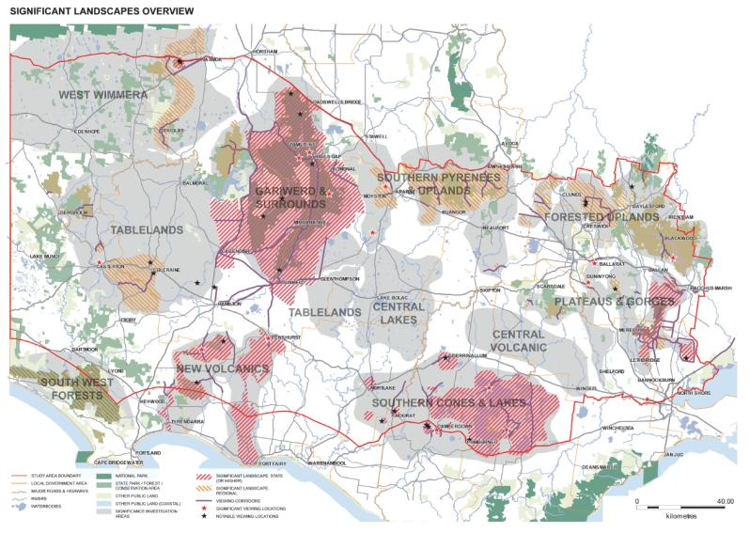Figure 45: Significant landscapes

Source: South West Victoria Landscape Assessment Study, 2013

Peri-urban impacts

The eastern half of the Central Highlands is located within Melbourne’s peri-urban region. Areas of high landscape value within the region often attract ‘tree changers’ who seek to live in reasonable proximity to Melbourne while enjoying high quality environmental settings. Buxton et. al. (2011) identified there are significant implications for continuing the current trends of rural living and subdivision of rural land in Melbourne’s peri-urban region. This report found continued housing development in rural areas would fundamentally alter the appearance and functioning of the region. Furthermore, significant changes to rural landscapes would occur if existing small lots were developed in rural areas, threatening continued agricultural production. Areas of the Moorabool Shire were identified as critically affected by this trend, including in the vicinity of Bacchus Marsh.

The development pressures within some highly valued landscapes need to be carefully managed to ensure they do not detract from the landscape values that have attracted people to these areas, along with other assets in these same areas, such as water supply catchments, public land and terrestrial habitat.

Consultation during the development of the plan identified land between Bacchus Marsh and Ballarat as an area where there is significant competition between land uses, particularly rural residential development, urban expansion and agriculture, which has the potential to permanently alienate high versatility land from agriculture and impact on significant landscape values. There will be a need for careful planning at a local level to ensure regionally significant assets are protected.

### Land use planning response

The plan recognises the importance of the region’s landscapes as an attractor of residents and visitors and as a key contributor to the region’s amenity. The South West Victoria Landscape Assessment Study identifies landscapes of regional and higher significance. The plan supports the implementation of the study’s findings.

The plan also seeks to direct settlement into designated locations and avoid ribbon development along transport corridors to help protect the region’s rural landscape character.

1. Cross regional issues

## Context

The Central Highlands region has strong connections and relationships with all of the surrounding regions. This section discusses some of these cross-regional issues.

Melbourne metropolitan area

As detailed throughout this background report, the eastern parts of the Central Highlands fall within Melbourne’s peri-urban region and are strongly influenced by Melbourne. The continued westward expansion of Melbourne presents opportunities and challenges for the Central Highlands. The new metropolitan planning strategy for Melbourne *Plan Melbourne* sets out future planning strategies for managing Melbourne’s growth.

Wimmera Southern Mallee

The Wimmera Southern Mallee region has a very close relationship with the Central Highlands region. At the interface between these two regions there is a particularly strong relationship between Ararat and Stawell, and visitors to the Grampians National Park travel through the Central Highlands when travelling from Melbourne. Ballarat provides higher order services to the residents of the Wimmera Southern Mallee.

Loddon Mallee

The Loddon Mallee region is divided into north and south sections, with the latter located to the immediate north of the Central Highlands. The Central Goldfields Shire is located within the Loddon Mallee South region and has a strong relationship with the Central Highlands through connections between Maryborough and Ballarat. Central Goldfields Shire issues, which are also of relevance to the Central Highlands, are identified and discussed in this background report. However, regional planning for the Central Goldfields Shire is covered by the Loddon Mallee South Regional Growth Plan. There are also important links between the eastern part of the region, such as around Trentham, and the Calder Highway corridor.

G21 Region

The G21 region, which surrounds Geelong and includes the southern part of the Golden Plains Shire, is located south of the Central Highlands. There are strong connections between this region and the southern parts of the Central Highlands, particularly from towns such as Meredith and Rokewood. Important infrastructure of cross-regional significance includes the Port of Geelong and Avalon Airport. The G21 Regional Growth Plan has been released and sets out a framework for developing a region of 500,000 people. This includes supporting the ongoing growth of Bannockburn as a district town and identifying areas for further investigation for potential development to the north and west of Geelong.

Great South Coast (Green Triangle)

The Great South Coast region is located to the south-west of the Central Highlands. This region is particularly important for freight movement given that agricultural produce is transported from the Central Highlands to the Port of Portland for export. There are also tourism links through the Grampians National Park towards Warrnambool and the coast. Skipton has close connections to other towns on the Glenelg Highway corridor which are largely within the Central Highlands.

### Land use planning response

The plan recognises the need to capitalise on its links to surrounding regions and cities and in particular identifies important cross-regional relationships, such as those referred to above.

# References

* Access Economics (2011) Victorian Regional Economic Outlook
* AECOM (2011) Central Highlands Regional Transport Strategy
* Australian Bureau of Statistics, Census of population and housing 2011, Australian Bureau of Statistics, Canberra
* Australian Government Department of Infrastructure and Transport (2009) Aviation White Paper
* Australian Government Department of Resources, Energy and Tourism (2011) The economic importance of tourism in Australia’s regions, Tourism Research Australia
* Australian Government Department of Resources, Energy and Tourism (2008) Tourism Profiles for Local government Areas in regional Australia, Tourism Research Australia
* Australian Housing and Urban Research Institute (2005) Why Low-income Households Move: The Search for Affordable Housing and employment
* Barr, N. (2009) The House on the Hill, Land and Water Australia
* Buxton, M. et al (2011) Scenario Planning for Melbourne’s Peri-urban Region, RMIT
* Central Victorian Livestock Exchange (2013) Website <http://www.cvlx.com.au/>
* Comrie, N. (2011) Review of the 2010-11 Flood Warnings and Response
* Corangamite Catchment Management Authority (2013) Corangamite Regional Catchment Strategy 2013-2019
* CPG Australia (2009) Ballarat Review of Future Industrial Areas
* Department of Health (2009) The Grampians Closing the Gap Health Plan (2009-2013)
* Department of Health (2009) Urban Design and Health: A Guide to Relevant Resources for Planning Department of Health (2010a) Local Government area statistical profiles: Grampians Region
* Department of Health (2010b) Victorian Aboriginal Hospital Data 2007-2008 to 2008-2009 Koori Health Counts
* Department of Health (2011) Victorian Public Health and Wellbeing Plan 2011-2015.
* Department of Health Services (2009) Local Government Area Statistical Profiles
* Department of Planning and Community Development (2013) Towns in Time
* Department of Planning and Community Development (2011) Change and Disadvantage in Regional Victoria: an overview May 2011
* Department of Planning and Community Development (2011) Change and Disadvantage in the Grampians Region, Victoria
* Department of Planning and Community Development (2012) Central Highlands Region Economic Profile and Outlook
* Department of Planning and Community Development (2012) Regional Bushfire Planning Assessments
* Department of Planning and Community Development (2012) The Metropolitan Planning Strategy – Melbourne – Let’s Talk About the Future.
* Department of Planning and Community Development (2012) Victoria in Future
* Department of Transport, Planning and Local Infrastructure and Planisphere (2013) South West Victoria Landscape Assessment Study
* Department of Primary Industries (2006) Land Suitability Analysis of the Shire of Moorabool
* Department of Primary Industries (2008) Improving Rural Land Use Report: Future Farming Strategy
* Department of Primary Industries (2013) Website - Central Highlands Region Overview <http://www.dpi.vic.gov.au/agriculture/investment-trade/region-overviews/central-highlands>
* Department of Sustainability and Environment (2013) Website - Understanding climate change
* Department of Sustainability and Environment (2006), Sustainable Water Strategy Central Region: Action to 2055
* Department of Sustainability and Environment (2008), Climate Change in Victoria: 2008 Summary
* Department of Sustainability and Environment (2009) Northern Region Sustainable Water Strategy
* Department of Sustainability and Environment (2011) Western Region Sustainable Water Strategy
* Department of Sustainability and Environment (2012a) Soil Health Strategy: Protecting Soil Health for Environmental Values on Public and Private Land
* Department of Sustainability and Environment (2013) Draft Victorian Waste and Resource Recovery Policy
* Earth Systems (2012) Energy Futures and Vulnerability in the Grampians
* EnPlan Partners (2007) The Review of Agricultural Land and Rural Land Use in Hepburn Shire
* ENRC (2012) Inquiry into Flood Mitigation Infrastructure in Victoria
* Essential Economics (2011) Ballarat West Employment Zone Economic Assessment
* Glenelg Hopkins Catchment Management Authority (2013) Glenelg Hopkins Regional Catchment Strategy
* Golden Plains Shire (2009) Golden Plains Residential Land Supply Review
* Graduates Of The University Of Ballarat, WRI Bathurst
* Grattan Institute (2011) Investing in regions: Making a Difference
* Hill PDA and Hansen (2011), Ballarat Activity Centres Strategy, Prepared for City of Ballarat
* Jain, A & Courvisanos, J (2009) Urban growth centres on the periphery: ad hoc policy vision and research neglect*, Australasian Journal of Regional Studies*, Vol. 15, No. 1,
* Moorabool Shire Council (2012) Rural Growth Policy Statement
* North Central Catchment Management Authority (2013) 2013-2019 Regional Catchment Strategy
* Paroissien Grant and Associates Pty Ltd (2012) Central Highlands Infrastructure Study
* Parsons Brinckerhoff (2008a), Audit of industrial land in provincial Victoria, Final Report
* Parsons Brinckerhoff (2008b). Golden Plains Rural Land Use Strategy
* Parsons Brinckerhoff (2010a). Central Highlands Regional Strategic Plan – Discussion Paper (19 February 2010)
* Parsons Brinckerhoff (2010b) Ballarat Rural Land Use Strategy
* Planisphere (2009) The Regional Mapping Project
* Port Phillip and Westernport Catchment Management Authority (2013) Draft Port Phillip and Westernport Regional Catchment Strategy
* Public Transport Victoria (2013) Rail Revival: Geelong-Ballarat-Bendigo – Project Feasibility Summary Report
* Ratio (2007) Ballarat Road Transport Strategy, Consultants Final Report
* Regional Development Victoria (2010) Central Highlands Regional Strategic Plan
* Regional Development Victoria (2013, unpublished), Regional Economic Profile – Central Highlands
* REMPLAN (2010) Ballarat Industry Workforce Development Strategy
* Rural Planning Group (2009) Future Farming: Improving Rural Land Use, Independent report to the Minister for Planning
* SED Consulting (2010) City of Ballarat, Ballarat Industry Workforce Development Strategy
* SGS (2006) Growing Moorabool Economic Development Strategy
* SGS (2010) Ballarat Economic Strategy 2010-2014, City of Ballarat
* Skills Victoria (2009) Report advising on the development of the Victorian Tertiary Education Plan Available: <http://www.skills.vic.gov.au/corporate/providers/universities/victorias-plan-for-tertiary-education>
* Sustainability Victoria (2012) Electricity from Renewable Energy in Victoria 2011
* Victorian Auditor-General (2011) Managing Contaminated Sites
* Victorian Government (2009) Northern Region Sustainable Water Strategy
* Victorian Government (2012) Securing Victoria’s Economy
* Victorian Government (2013) Victorian Climate Change Adaptation Plan
* Victorian Government (2013) Getting Full Value: the Victorian waste and resource recovery policy
* Victorian Government (2013) Victoria The Freight State: the Victorian Freight and Logistics Plan
* Western Research Institute (2007a) Economic Impact of the University of Ballarat, WRI Bathurst
* Western Research Institute (2007b) The Destination Of On-Campus Higher Education
* Wimmera Catchment Management Authority (2013) Wimmera Regional Catchment Strategy
* World Health Organisation. The social determinants of health. Available: www.who.int/social_determinants/en/

# 

# Appendix 1: Network of settlements table

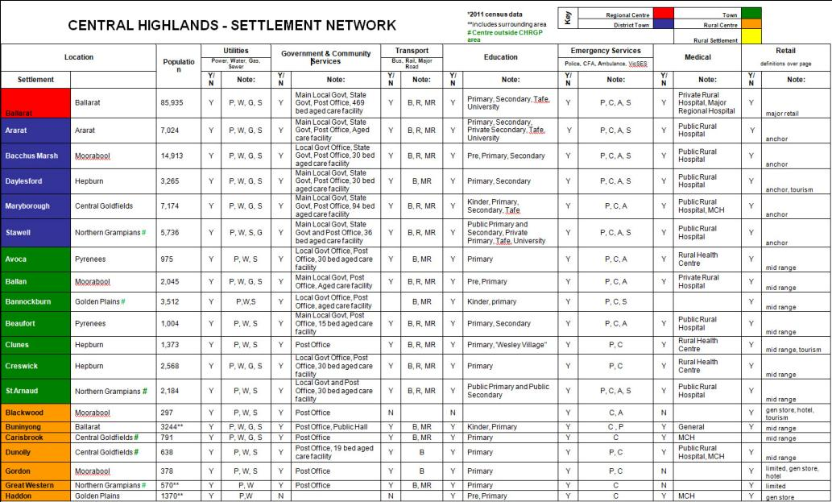

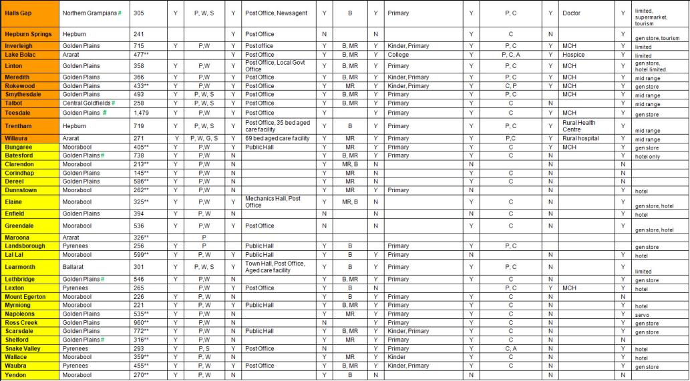

1. Throughout this document the term “Aboriginal” is used to refer to both Aboriginal and Torres Strait Islander people. Use of the terms “Koori”, “Koorie” and “Indigenous” are retained in the names of programs and initiatives, and, unless noted otherwise, are inclusive of both Aboriginal and Torres Strait Islander peoples.
2. It should be noted that town boundaries were modified between the 2006 and 2011 censuses and this may account for some of the increase or loss of population recorded over this period.
3. Does not include Northern Grampians and Central Goldfields shires and the Golden Plains Shire – south-east statistical local area.
4. Note this profile did not include Golden Plains Shire in the Central Highlands region
5. Regional Development Victoria analysis derived from Access Economics (2011) Regional Victoria Economic Outlook
6. Greenfields sites are those areas without known mineral deposits
7. The economic importance estimates rely on estimates of total regional output, the starting point which is Australian Bureau of Statistics data on total personal income.
8. NaturePrint v2.0 conveys information on relative habitat value for all areas in Victoria (excluding marine), not just those with native vegetation. In its most commonly used form, NaturePrint is illustrated as a map showing relative habitat value (Strategic Natural Values map) showing areas that most contribute to biodiversity conservation. Further information on NaturePrint can be found at <http://www.dse.vic.gov.au/conservation-and-environment/biodiversity/natureprint>
9. Recommendation 39 of the 2009 Victorian Bushfires Royal Commission