22nd March 2017

Sylvia Der
Department of Human Services
50 Lonsdale Street,
Melbourne,
Victoria 3000

RE: Bellbardia Estate, Heidelberg West– Tree Report

Brief
I was contacted by you and asked to provide an arboriculture assessment of the trees to this property, with the following brief:
‘The purpose of this survey is to create an inventory of the substantial trees on and adjacent to the subject site. The inventory will be used to assess the suitability of the trees for preservation in a general context and in relation to any longer-term changes to the subject site
Tree Identification – Identify species and common name;
Tree dimensions – Establish stem diameter, height, canopy size;
Tree Structure – Record formation of stem(s) and roots, determination of hazard potential;
Tree Health – Determine extent of deadwood, quantity and quality of foliage, presence of infection, assessment of vitality;
Hazards – Identify trees require work to minimise the hazard of or remove tree;
Tree Protection Zone – Establish Tree Protection Zone (TPZ) within which works should be controlled for the health of the tree
Tree Significance – Assess contribution to the landscape because of their botanical, horticultural, historical or local significance, to be considered in the project design;
Tree Treatments – Identify works required in the immediate and short term to promote tree health and safety.

Method
The trees were inspected visually; as per Australian standard 4970 – Protection of Trees on Development Sites (AS 4970), as required to facilitate this report. Heights and canopy spreads estimated, Diameter at Breast Height (DBH) and Diameter at Buttress (DAB) measured within subject site only, unless neighbouring trees are accessible; otherwise their DBH and DAB are estimated. No root excavations were carried out and images were taken as required.
Date Visited –16th November 2016
.

The Site
The site is a large housing estate, with a mix of double storey apartment blocks, and single storey semi-detached dwellings. There is minimal topographical change across the site, with Bell street to the south, and Bardia Street to the north. Generally, the trees to the site and in poor to average condition, with few worthy of long term retention. Weed species and dead trees should be removed, with hazardous trees removed immediately. Trees to the nature strips adjacent the property on Bell and Bardia street, should be inspected by council.

The Trees

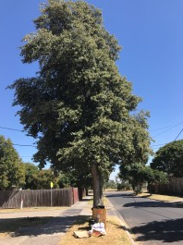

Tree 1 is a mature Norfolk Island Hibiscus to the nature strip of Bardia Street. It has good vigour and form with poor structure. It is bifurcated just above breast height and this is generating discoloured bark, indicating decay developing within. As it is a council tree it is their responsibility and should be assessed to check if it is suitable for retention.

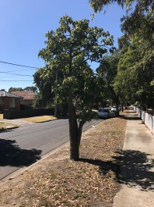

Tree 2 is a mature Illawarra Flame Tree to the nature strip of Bardia Street. It has poor form, vigour, and structure. Whilst it is likely to be a mature tree, it is in competition with Trees within the site. Whilst it is unlikely to fail in the near future it will not become a high value specimen. As it is a council tree it is their responsibility and should be assessed to check if it is suitable for retention.

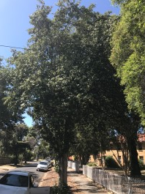
Tree 3 is a mature Norfolk Island Hibiscus to the nature strip of Bardia Street. It has average vigour and form with poor structure. It is bifurcated just above breast height and this is generating discoloured bark, indicating decay developing within. There is suckering growth to its base indicating it is under stress. As it is a council tree it is their responsibility and should be assessed to check if it is suitable for retention.

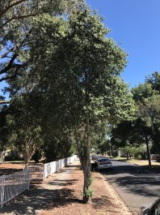
Tree 4 is a mature Norfolk Island Hibiscus to the nature strip of Bardia Street. It has poor vigour, form, and structure. It is trifurcated just above breast height and this is generating discoloured bark, indicating decay developing within. There is suckering growth to its base indicating it is under stress. As it is a council tree it is their responsibility and should be assessed to check if it is suitable for retention.

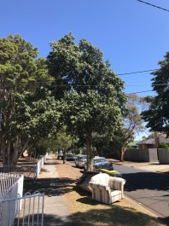

Tree 5 is a mature Norfolk Island Hibiscus to the nature strip of Bardia Street. It has average form and vigour with poor structure. It is trifurcated above breast height, with structural ridges and pockets of. There is suckering growth to its base indicating it is under stress. As it is a council tree it is their responsibility and should be assessed to check if it is suitable for retention.

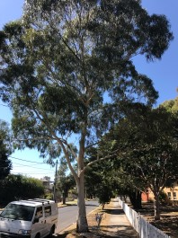

Tree 6 is a mature Wallangarra White Gum to the nature strip of Bardia Street. It has average form and structure with good vigour. Its branch unions are clear of included bark and have minimal reaction wood present, supporting and full and well-formed canopy. There are some old pruning wounds presents that have a exposed would present. As it is a council tree it is their responsibility and should be assessed to check if it is suitable for retention.

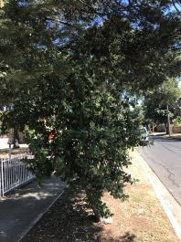

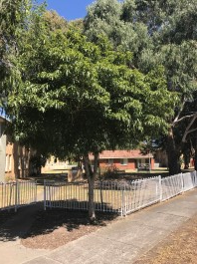
Tree 7 is a mature Norfolk Island Hibiscus to the nature strip of Bardia Street. It has poor form, vigour, and structure. It is old pruning wounds within its canopy. There is suckering growth to its base indicating it is under stress. As it is a council tree it is their responsibility and should be assessed to check if it is suitable for retention.

Tree 8 is a semi mature Sweet Pittosporum to the central gateway off Bardia Street. It has good form and vigour with average structure. It has been formatively pruned to create a well-rounded canopy, with the bifurcated branches clear of included bark. AS it is a weed species it is of a low retention value and should be removed.

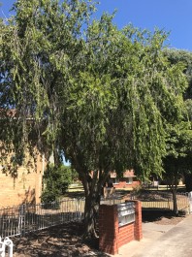

Tree 9 is a mature Weeping Bottle Brush to the central gateway off Bardia Street. It has good form and vigour with poor structure. It has a broad canopy supported by elongated branches radiating out form a multi-branches base. This maybe become hazardous over time. Considering its size it is of a moderate retention value but should have its canopy reduced to minimise the likelihood of a branch failing.

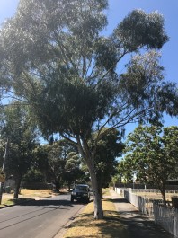

Tree 10 is a mature Wallangarra White Gum to the nature strip of Bardia Street. It has good vigour, average form poor structure. Its bifurcated with reaction wood and some included bark present. There is also a large open wound to the trunk and breast height. As it is a council tree it is their responsibility and should be assessed to check if it is suitable for retention
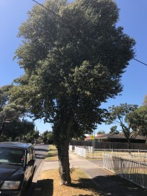

Tree 11 is a mature Norfolk Island Hibiscus to the nature strip of Bardia Street. It has good vigour, average form, and poor structure. It is bifurcated just above breast height and this is likely to generate decay over time. As it is a council tree it is their responsibility and should be assessed to check if it is suitable for retention.

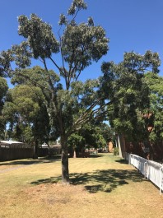

Tree 12 is a mature Claret Ash to the north east of the site. It has poor form, vigour, and structure. It has elongated branches supporting a sparse open canopy. Claret ash has a short ULE and it is starting to go into senescence. Over time its thin branches are likely to become increasingly hazardous, and it should be removed. It is of a low retention value.

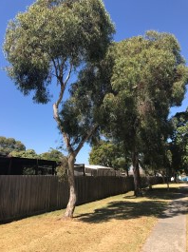

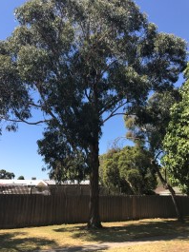
Tree 13 is a mature Yellow Gum to the eastern boundary. It has good vigour, average form, and poor structure. It has a full canopy with no significant dieback present. It is bifurcated and if possible the main bifurcation should be braced to reduce the likelihood of failure. If it were to fail it is unlikely to be hazardous due to its relatively small size and its positioning away from buildings and assets. It is of a moderate retention value

Tree 14 is a mature Blue Gum to the eastern boundary. It has good vigour with average form and structure. It has a well-formed canopy with no significant decay present. Its branches unions are well formed, and considering its location it is unlikely to be hazardous if it is to fail. Canopy reduction works should be carried out to reduce the risk of failure. It is of a moderate retention value.

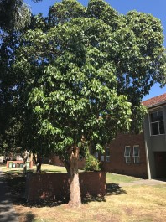

Tree 15 is a mature Brush Box to the eastern boundary adjacent to a walkway into the central eastern apartment block. It has good vigour with poor form and structure. There a several old pruning wounds, and new growth has suckered from these points to form and poorly shaped canopy. Overall it is canopy is full, but the decay present in the old pruning wounds is likely to shorten its ULE. It is of a moderate retention value.

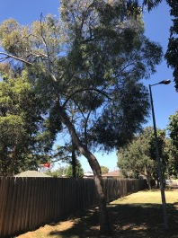

Tree 16 is a mature Yellow Gum to the eastern boundary of the site. It has average form with poor vigour and structure. It is being outcompeted by surrounding trees, resulting in a thin canopy that is poorly formed, with the trunk leaning away to open space, and neighbouring property. It is of a low retention value and should be removed.

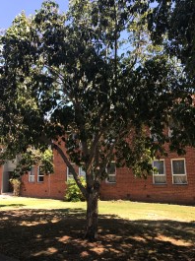

Tree 17 is a mature Brush Box to the eastern boundary adjacent to a walkway into the central eastern apartment block. It has average vigour and form, with structure. There is an old pruning wound, that has failed to heal, and is likely to allow damp and decay in over time. Its canopy is well formed but lacks the vigour of some specimens of this species observed on site. It is of a moderate retention value.

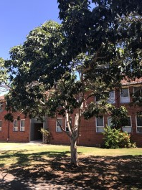

Tree 18 is a mature Brush Box to the eastern walk way of the site. It has average form and vigour with poor structure. It has an open canopy supported by four branches radiating out from just above breast height. The branch unions have some included bark present. Considering its small size and location it is unlikely to be hazardous if it was to fail. It is of a moderate retention value.

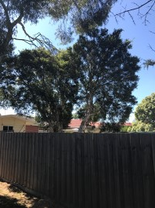

Tree 19 is a mature Prickly Tea Tree to the neighbouring side of the Eastern Boundary. It has poor form, vigour and structure. It has a main bifurcation, which appears to be failing, as is indicted by the wide angle between branches. Its canopy is thinning and it is likely it is in senescence. It is advised to removed it in negotiation with the tenant of the property.

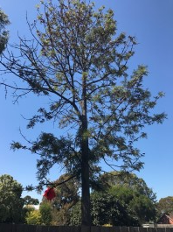
Tree 20 is an over mature Silky Oak to the neighbouring side of the eastern boundary. It has poor vigour form and structure. It appears to be in senescence, with a thin canopy and significant dieback present. Considering the height of the tree if this dead branches where to fall it may be hazardous. It is advised to removed it in negotiation with the tenant of the property.

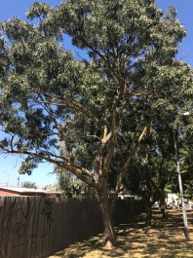

Tree 21 is a mature Claret Ash to the eastern boundary. It has average vigour and form with poor structure. It has an open, canopy with no significant dieback present. It has a bifurcation below breast height that is poorly formed with its branches generally elongated, with a high likelihood of failure in high wind events. It is of a moderate retention value but would require the canopy to be reduced to minimise the risk of branch failure. It is of a moderate retention value.

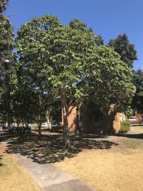

Tree 22 is a mature Brush Box to the eastern boundary. It has average form, vigour, and structure. It has a well-formed canopy with minimal dieback present. It is branches have well-formed unions, with a single pruning wound, that is clean and well healed with no visible defects that are likely to weaken them. It is of a moderate retention value.

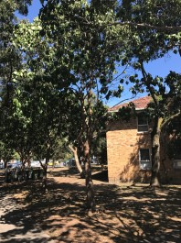
Tree 23 is a mature Brush Box to the eastern boundary. It has average form and vigour with poor structure. Has a galls present on its trunk, which are generating dead wood and cracks in its bark. Its canopy is well formed with no major die back present. It is of a moderate retention value.

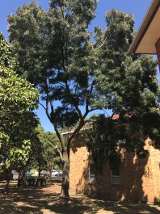

Tree 24 is a mature Claret Ash to the eastern boundary. It has average vigour and form with poor structure. It has an open canopy with minimal die back present supported by elongated branches. The branch unions are well formed with minor structural defects. It is of a moderate retention value, but will require its canopy to be reduced to reduce the hazard risk of a branch failing.

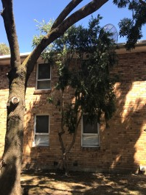

Tree 25 is a mature Weeping Bottle Brush to the eastern boundary. It has average vigour and form with poor structure. It has two elongated main branches which are joined by a poorly formed bifurcation. There is a high risk of one of its branches failing. It is of a low retention value and should be removed.

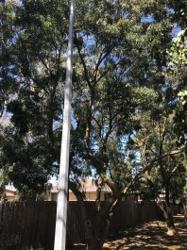
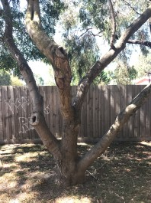
Tree 26 is a mature Claret Ash to the eastern boundary. It has average vigour and form with poor structure. It has a broad open canopy with minimal dieback present in the canopy. It has two poorly healed pruning wounds that are starting to decay. It has a significant area of decaying dead wood to one of its main branches which is hazardous. It’s of a low retention value and should be removed.

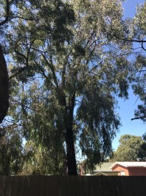

Tree 27 is a mature Red Iron Bark to the neighbouring side of the eastern boundary. It has good vigour and form with average structures. It has an open well-formed canopy with no obvious dieback present. It has a main bifurcation present approximately 4-5m above ground level that will need to be cabled as it matures. It is of a high retention value.

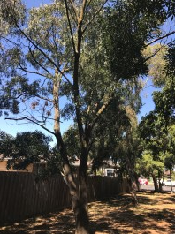

Tree 28 is a mature Claret Ash to the eastern boundary. It has poor vigour form and structure. It has an open canopy that is comparatively sparse. It has elongated branches, that have a high risk of failure. It is bifurcated approximately 1m above ground level. It is of a low retention value and should be removed.

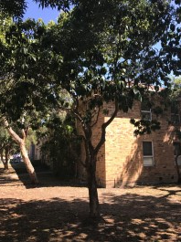

Tree 29 is a mature Brush Box to the eastern boundary. IT has average form and vigour with poor structures. It has an open canopy with two bifurcations shortly after each other just above breast height. These branch unions are poorly formed, and whilst currently not hazardous may cause problems long term. It is of a moderate retention value.

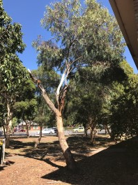

Tree 30 is a mature Yellow Gum to the eastern boundary. It has average vigour with poor form and structures. It has shed two of its three branches leaving it with an irregular canopy. The exposed wood is from the lost branches is likely to allow damp and decay in to its trunk. It is of a low retention value and should be removed.

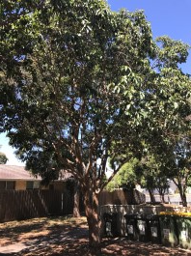

Tree 31 is a mature Brush box to the southern end of the eastern boundary. It has average form vigour and structures. It has a bifurcation below breast height with a further bifurcation just above. These branch unions are well formed with several small pruning wounds well-healed also present. It has an open canopy with no obvious dieback present. It is of a moderate retention value.

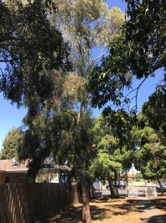
Tree 32 is a mature Yellow Gum to the south-eastern boundary. It has good vigour, with poor form and structure. It has a poorly formed central trunk which is has been damaged and is suckering from the area, approximately half way up its trunk. It has an open canopy with healthy growth throughout. As it is a smaller tree, growing away from buildings and footpaths it is unlikely to be hazardous if it was to fail. It is of a moderate retention value. If retained it will need to be formatively pruned to encourage a more balanced canopy form.

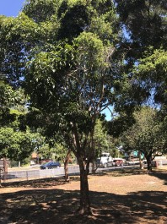

Tree 33 is a mature Brush Box to the south-eastern corner of the site. It has average vigour and form with poor structure. It has multiple branches radiating out at approximately 1m above ground level. These branches are poorly formed with Galls and included bark present. It has an open canopy with the current growth of a similar vigour to the other Brush Box found on site. It is of a moderate retention value. If retained its canopy should be formatively pruned.

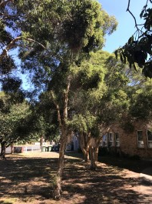
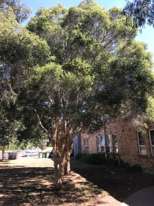
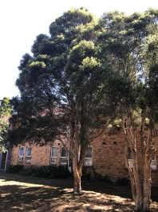

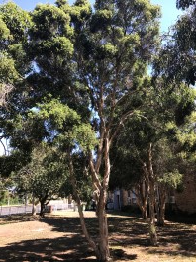
Tree 34, 35, 36 and 37 are all mature Prickly Tea Tree to the south-eastern corner of the site. They have average form and vigour with poor structure. All have multiple branch unions radiating out from below breast height, with the branch unions poorly formed, with included bark present. They have full canopies with some irregularities and dieback present. The group of trees collectively are of a moderate retention value, however all will need formative pruning and canopy reductions to encourage good form and reduce stress on branch unions.

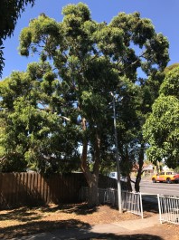

Tree 38 is a mature Smooth Barked Apple to the far south-eastern corner of the site.. It has good vigour and form with average structure. It has a well formed dense canopy with no visible die-back. It has a main bifurcation above breast height that is well formed with no included bark and minimal reaction wood present. It is of a high retention value but may require cabling in the future to strengthen the main bifurcated branch union.

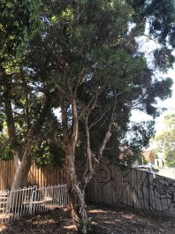

Tree 39 is an over mature Willow Bottle-Brush to the nature strip of Bell street. It has poor vigour form and structure. It has a main bifurcation that is showing signs of decay and is likely to fail. Its canopy is sparse with minimal new growth. Scale and sooty mould is present across the tree and is likely to increase the rate and which it declines. As it is on council land it is there responsibility and should be inspected to decided what actions are required.

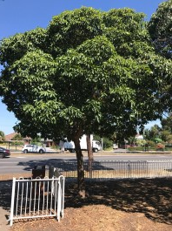

Tree 40 is a mature Brush box adjacent the eastern walkway entrance off Bell street. It has good form and vigour, with a dense well rounded canopy, with no die back visible. It has a clear central leader with no structural defects present. It is of a high retention value and should be retained.

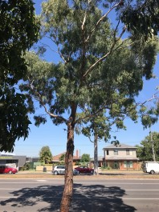

Tree 41 is a semi-mature Yellow Box to the nature strip of Bell street. It has good vigour and form with average structure. It has a open canopy with some branches elongated. There is no apparent structural defects or dieback, visible. As it is on council land it is there responsibility and should be inspected to decided what actions are required.

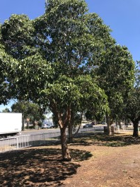

Tree 42 is a mature Brush Box to the south-east of the site. It has average from with poor vigour and structure. Its canopy is open and sparse with some dieback present. It has two separate bifurcations one below breast height and one above. These are poorly formed with included bark present. It is possible that it has poor vigour due to the time of year and lack of water. It is of a moderate retention value, but should have its canopy formatively pruned to reduce stress on its branch unions.

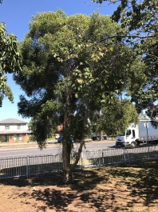

Tree 43 is a mature Prickly Tea-Tree to the south-east of the site. It has average vigour and form with poor structure. It has a well-formed dense canopy with some dieback present. It is trifurcated just above ground level with the outer branch towards Bell street, likely to fail soon. If this was to happen it may be hazardous. It is of a low retention value and should be removed.

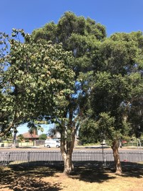
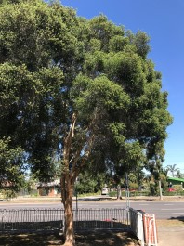
Trees 44 and 45 are mature Prickly Tea-Tree to the south-east of the site. They have average form and vigour with poor structure. Tree 44 is trifurcated with a broader canopy resulting in Tree 45 having a strong lean. Both have full canopies with no obvious dieback present. They are of a moderate retention value.

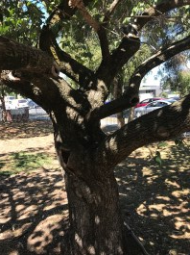
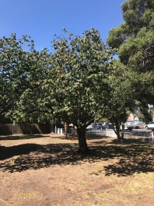

Tree 46 is an over mature English Elm to the south-east of the site. It has average form, with poor structure and vigour. It has a broad canopy with dieback throughout. There are several significant dead branch within its canopy, and large open and decaying wounds present. It has multiple and complex branch unions, all with a highly likelihood of failure. It is of a low retention value and should be removed.

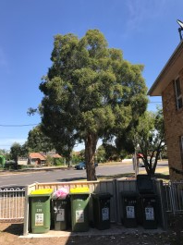

Tree 47 is a mature Prickly Tea-Tree to the south-east of the site. It has good form, with average vigour and poor structure. It has a well-formed dense canopy with no significant dieback. It has a bifurcated trunk bifurcated trunk that has an acute angle to it, increasing the amount of included bark, and likelihood of failure. It should be cabled If possible, and formatively pruned to reduce the weight of the canopy. It is of a moderate retention value.

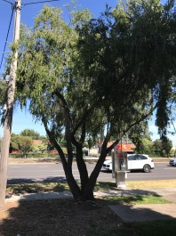
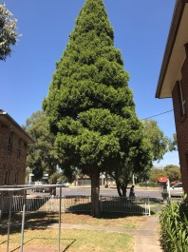

Tree 48 is a mature Weeping Bottle-Brush to the south-east of the site. It has good vigour and form with poor structure. It has an open broad canopy, showing the characteristic weeping habit of the species, with vigorous growth throughout. It is trifurcated to the base, with a high likelihood of its failing. Given the low height of its canopy it is unlikely to be hazardous. It should have its canopy formatively pruned to reduce stress on its branches. It is of a moderate retention value.

Tree 49 is a mature Cedar of Goa to the south-east of the site. It has good form and structure with average structure. It has a well-formed central leader supporting a dense, pyramidal canopy with no dieback present. It is of a high retention value and will not require any immediate remedial works.

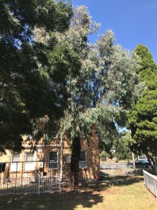

Tree 50 is a mature Red Iron Bark. It has good form and vigour with average structure. It has a dense canopy, with some elongated branches, likely a result of its vigorous growth. It has a well-structured central leader with no major structure defects present. As it has the potential to become a very large tree as with Tree 194, it should be formatively pruned to help prevent over elongation of its branches. It is of a high retention value.

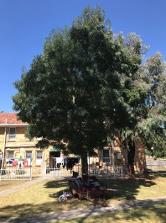
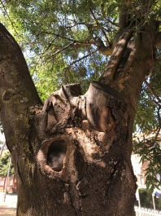
Tree 51 is a mature Claret Ash to the south-east of the site. It has average vigour and form with poor structure. It has a rounded dense canopy, with healthy growth throughout. It is a bifurcation at approximately 1.9m above ground level. Here there are multiple poorly healed pruning wounds with signs of decay present. These are position between the two existing bifurcations and greatly increase the hazard of either branch failing. It is of a low retention value and should be removed.

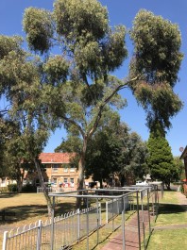
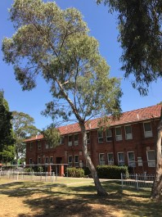
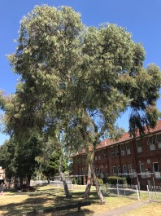

Tree 52, 53 and 54 are Yellow gums to the east of the site. They have good vigour with average form and poor structure. All have healthy growth across the canopy with no dieback present. Tree 52 and 54 are both leaning to one side with their canopy growing above the main leader. Tree 53 has two separate bifurcations radiating out on a wide angle. They are likely to fail if the tree is stressed and could be hazardous considering their height from ground level. Tree 53 should have its canopy reduced to minimise the stress on its branch unions. They are all of a moderate retention value.

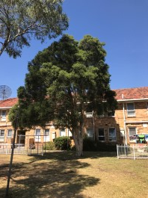

Tree 55 is a mature Prickly Tea-Tree to the east of the site. It has good vigour with average form and poor structure. It has a full canopy with no significant dieback present. It has a trifurcated trunk with the branches radiating out at acute angles. Given the angle of the branch unions there is likely to be significant included bark present which weakens the structure of the branches significantly. Given its height and weight of the canopy it would be hazardous if it was to fail. It is of a moderate retention value, but will require cabling and formative pruning to reduce the risk of a main branch failing.

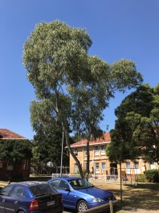

Tree 56 is a mature Yellow gum to the east of the site. It has good vigour, average form, and poor structure. It has healthy growth across its canopy, supported by two main bifurcated branches radiating out from ground level. It is of a moderate retention value and will require cabling to strengthen its main branches.

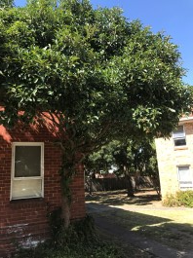

Tree 57 is a mature Photinia to the east of the site. It has average form vigour and structure. It has been pruned to create a dense well-formed canopy. Its central trunk has multiple old pruning wounds and sprouting growth along its extent. It is of a moderate retention value.

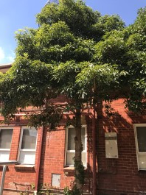

Tree 58 is a mature Sweet Pittosporum to the east of the site. It has average form, vigour, and structure. It has been pruned in a similar manner to tree 58 with several pruning wounds on its central trunk. It has a well-formed canopy dense canopy. As it is a weed species in Banyule Council it should be removed.

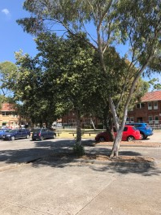
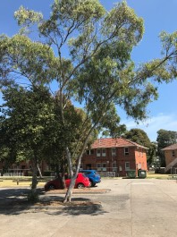

Tree 59 is a mature Norfolk Island Hibiscus to the east of the site. It has average form vigour and structure. It has a dense well rounded canopy with no visible dieback present. It has a central leader supporting the canopy that has no visible structural defects.

Tree 60 is a mature Yellow Box to the east of the site. It good vigour, with average form and poor structure. It has an open canopy supported by elongated branches. The main branches form a bifurcated union just above breast height. It is of a moderate retention value but should be formatively pruned to reduce the length of its branches and reduce the stress on its main branch union.

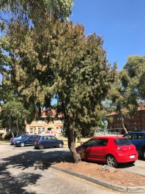

Tree 61 is a mature Rose She oak to the east of the site. It has good vigour and form with average structure. It has a dense canopy with no visible dieback. IT has a central leader supporting the canopy with no signs of structural defects. It has some irregularities with its form and should be formatively pruned to encourage a more uniform growth. It is of a high retention value.

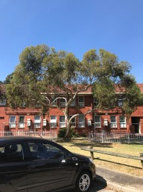

Tree 62 is a mature Yellow Gum to the east of the site. It has good vigour and form with poor structure. It has a broad open canopy with healthy growth throughout. Its branches are elongated with some branch unions poorly formed. Canopy reduction is recommended to reduce the stress on its branches. It is of a high retention value

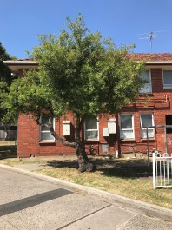
Tree 63 is a mature Willow Hakea to the north-east of the site. It has average vigour with poor form and structure. It has a bifurcation below breast height with the secondary branch elongated forming a smaller canopy separated from the main tree. It has a large lignotuber present to its base and galls bellow breast height. Whilst unsightly they are unlikely to cause structural issues. It is of a moderate retention value, and should have the secondary branch removed with the canopy formatively pruned.

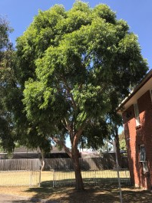

Tree 64 is a mature Smooth Bark Apple to the north-east of the site. It has good form and vigour with average structure. It has a dense canopy with healthy new growth throughout. It has fissures along its bark indicating periods of rapid growth with some minor irregularities in the formation of its branches. It is of a high retention value and would require no immediate remedial works.

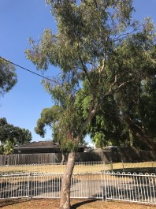
Tree 65 is a mature Yellow Gum to the north-east of the site. It has good vigour, average form, and poor structure. It has an open canopy of an irregular form with healthy new growth throughout. It has a central leader which is leaning towards the road with signs of torsional loading. Torsional loading is a process where a tree twists in relation to varying forces. As trees can’t move this twisting formation can lead to a precarious situation, where if the forces are to stop or reverse, the trunk ‘unravels’ and can fail. As the tree is small it is unlikely to be hazardous, however it will need some formative pruning to reduce stress on its trunk.

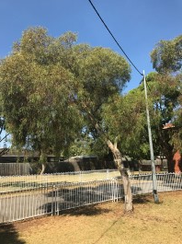

Tree 66 is a mature Yellow Gum to the north-east of the site. It has good vigour with poor form and structure. It has a healthy canopy well-formed canopy leaning over the entrance to a carpark. It has a central leader supporting this canopy, and is likely to be under stress due to the lean present and the uneven loading of the canopy on to it. It has a secondary small branch further down w

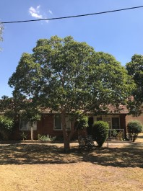

Tree 67 is a mature Brush Box to the north east of the site. It has average vigour, form and structure. It has a rounded open canopy with healthy foliage throughout. The main branch union is below breast height and has some included bark present. This may become hazardous over time, but due to the structure of branches in the canopy is a poor candidate for cabling. It is of a moderate retention value.

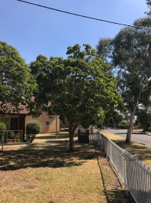

Tree 68 is a mature Brush Box to the north-east of the site. It has good vigour and form with average structure. It has a full and healthy canopy that has a rounded form. It has a bifurcation just above breast height that has some included bark, but lacks reaction wood. It is of a high retention value.

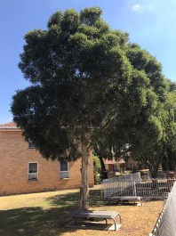
Tree 69 is a mature Prickly Tea-Tree to the north east of the site. It has good form and vigour with average structure. The central leader appears to have no major structural faults, with a bifurcation 3m above ground level, with some included bark present. It has a full well formed canopy with new growth throughout. It is of a high retention value

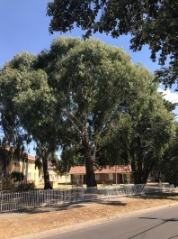
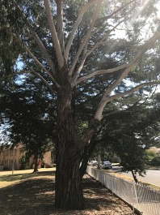
Tree 70 is a mature Candle Bark to the north of the site. It has Good form and vigour with poor structure. It has a full and healthy canopy with a rounded form. It has a main bifurcation 1.8m above ground level, with the secondary branch growing towards the street. Its main branch terminates at approximately 6m above ground level into multiple smaller branches. The secondary branch towards the street is hazardous, considering its weight, position, and height above ground level. It is of a high retention value but will need to have the secondary branch removed.

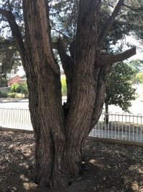
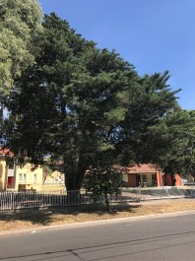
Tree 71 is a mature Leyland’s Cypress to the northern boundary. It has average vigour and form with poor structure. It has a well-formed canopy with minimal dieback present. It has 7 large branches radiating out from its base with a central pocket collecting debris and water. This is likely to result in damp entering its base and triggering decay. If any of its branches where to fail it could cause serious damage to property injury or worse. The upper sections of its branches have significant areas of exposed dead wood. It is hazardous now and should be removed immediately.

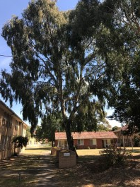
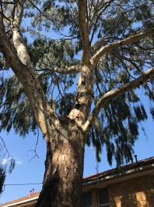
Tree 72 is a mature River Red Gum to the northern of the site. It has good vigour and form with average structure. It has an open canopy with healthy growth throughout. It has a main bifurcation which will require cabling to strengthen its structural integrity. It is of a high retention value.

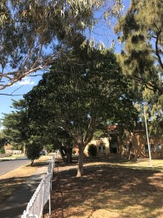

Tree 73 is a mature Brush Box to the northern boundary. It has good form and vigour with average structure. It has a well-formed canopy with healthy growth throughout. I have a multi-branched habit with branches radiating out from approximately 1.6m above ground height. There is some included bark present. Some formative pruning is recommended to open the canopy and reduce stress on the branch unions. It is of a high retention value.

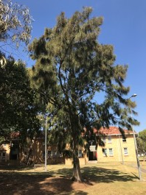
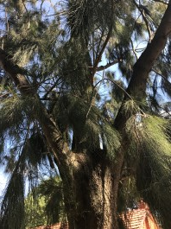
Tree 74 is a mature River Sheoak to the northern boundary. It has good form, average vigour, and poor structure. It has a dense canopy with healthy new growth throughout. It has a trifurcation m above ground level which is likely to become hazardous due to the significant amount of reaction wood present. It is of a moderate retention value but will require formative pruning.

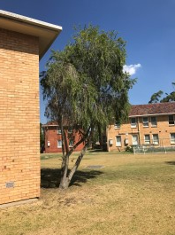

Tree 75 is a mature Weeping Bottle-Brush to the centre of the site. It has average form and vigour with poor structure. It has an open canopy with it thinning in some areas. It is trifurcated to the base with a secondary bifurcation below breast height. These branch unions are unevenly weighted as it is growing away from the nearby building. It is of a moderate retention value but will need its canopy formatively pruned and reduced to minimise stress on its branch unions.

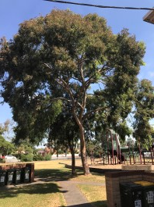

Tree 76 is a mature Smooth Barked Apple, to the south of the site. It has good form and vigour, with average structure. It has a well-formed canopy with healthy growth throughout. It has two bifurcations at 5 and 6m above ground level. There is some reaction wood present, however they lack included bark. It will require some formative pruning. It is of a high retention value.

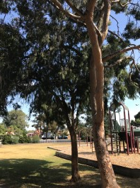

Tree 77 is a mature Rose Sheoak, to the south of the site. It has good vigour with average form and structure. It has a broad canopy with healthy growth throughout. Its branch unions are well formed and clear of included bark. It is of a high retention value.

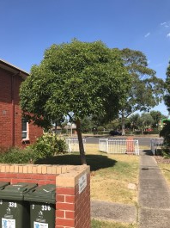
Tree 78 is a mature Brush Box to the south side of the site. It has good form and vigour, with average structure. It has a dense well rounded canopy, with no die back visible. It has a clear central leader with no structural defects present. It is of a high retention value and should be retained.

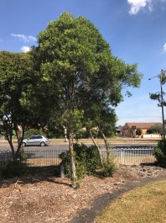
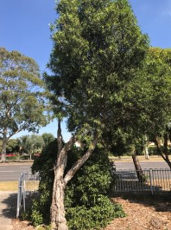
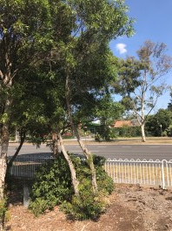
Tree 79, 81 and 82 is are mature Willow Bottle-Brushes to the southern boundary. They have average vigour with poor form and structure. All of them have poorly formed canopies that have scale and sooty mould present. Their branches are poorly structured with suckering growth from the base and damaged branches present.

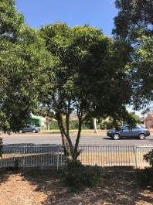

Tree 80 is a mature Sweet Pittosporum to the southern boundary. It has average form and vigour with poor structure. It has a round canopy with new growth throughout. It is bifurcated approximately 500mm above ground level, with the branches elongated and poorly structured. As it is a weed in Banyule it should be removed.

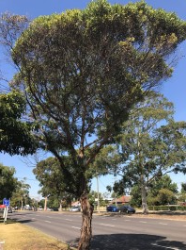

Tree 83 is a mature Coastal Moort to the nature strip of Bell Street. It has poor form vigour and structure. It has a sparse canopy with new growth only present to the top. It has decay present throughout its branches and its unions are poorly structured. As it is on council land it is there responsibility and should be inspected to decided what actions are required.

Tree 84 is a mature River She oak (Picture not shown) to the nature strip of Bell Street. It has average form, vigour, and structure. It has a well-formed canopy with no major structural faults. As it is on council land it is there responsibility and should be inspected to decided what actions are required.

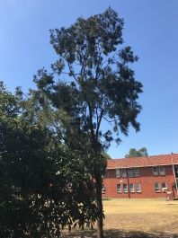

Tree 85 is a mature Rose Sheoak to the southern boundary. It has average form vigour and structure. It has an open canopy with healthy new growth throughout, with no decay present. It has elongated yet well-structured branches. It is of a moderate retention value.

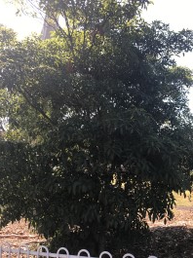
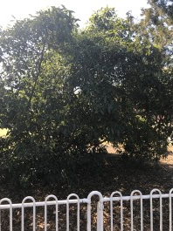
Tree 86, 87 and 88 are all Sweet Pittosporum to the southern boundary. They have average form and vigour with poor structure. They appear to be wood regrowth that germinated in the canopy of the larger tree which is now removed. As they are weed species in Banyule Council they should be removed.

Tree 89 (not pictured) is a mature Yellow Box to the nature strip of Bell Street. It has good vigour, average form and poor structure. It has a well-formed canopy with some structural defects. As it is on council land it is there responsibility and should be inspected to decided what actions are required.

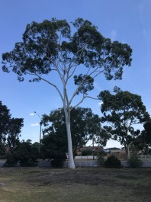

Tree 90 is a mature Lemon Scented Gum to the southern boundary. It has good vigour, average form, and poor structure. It has an open broad canopy that has no obvious signs of dieback. The canopy is supported by elongated weak branches that have a high risk of failure if this was to happen it would be hazardous, damaging property, injuring people or worse. As it is a large tree adding to the amenity of the area its retention is desirable, however due to its significant structural faults it is of a low retention value and should be removed.

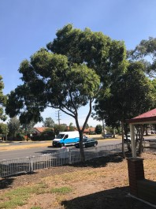

Tree 91 is a mature Smooth Bark Apple to the southern boundary. It has good form and vigour with average structure. It has a dense well-formed canopy with no dieback present. It has a main bifurcation above breast height that is clear of included bark and lacks reaction wood. It is of a moderate retention value, but should have its canopy reduced to reduced stress to its branches.

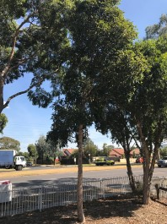
Tree 92 is a mature Red Flowering Gum to the southern boundary. It has average form vigour and structure. It has a full and dense canopy supported by a single slightly elongated leader. It is of a moderate retention value.

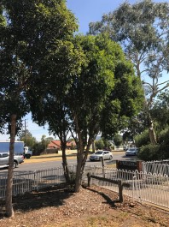
Tree 93 and 94 are two mature Willow Bottle-Brush to the southern boundary. They have average form and vigour with poor structure. They have stunted dense canopies that are full with healthy growth throughout. They have acute bifurcations with reaction bark present. As they are small if they were to fail they are unlikely to cause significant injury or damage. They are of moderate retention value and should have they main branches braced or bolted to prevent failure.

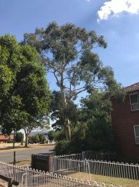

Tree 95 is a mature Brittle Gum the southern boundary of the site. It has good vigour and form with average structure. It has a full open canopy with healthy growth throughout. Its branch unions are well structured with no visible included bark and minimal reaction wood. It is of a high retention value.

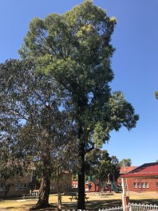
Tree 96 is a mature Red Iron Bark to the south of the site. It has good vigour and form with average structure. It has an even canopy with new growth throughout. It has no major structural faults, with some irregularities present in its branches. It is of a high retention value, but should have its canopy formatively pruned as a precautionary measure, due to the size and height of the tree.

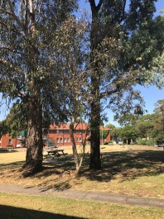

Tree 97 is a mature Yellow Gum to the south of the site. It has poor, form vigour and structure. It has a sparse canopy with new growth present reverting to its immature leaf form, indicating the tree is under stress. It has bifurcation to the base that is poorly formed. It is of a low retention value and should be removed.

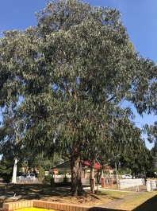

Tree 98 is a mature Blue Gum to the south of the site. It has good vigour and form with average structure. It has an even canopy with new growth throughout. It has no major structural faults, with some irregularities present in its branches. It is of a high retention value, but should have its canopy formatively pruned as a precautionary measure, due to the size and height of the tree.

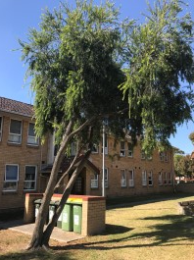

Tree 99 is a mature Weeping Bottle Brush to the south of the site. It has good vigour, with poor form and structure. It has an uneven canopy leaning heavily to one side, with healthy growth throughout. It has a main bifurcation to the base with a secondary bifurcation 1 meter above ground level. The branches are elongated and likely to fail. It is of a low retention value and should be removed.

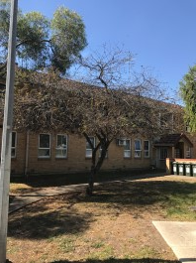

Tree 100 is an over mature Cherry Plum to the south of the site. It has poor vigour, form, and structure. It is in an advanced stage of senescence and should be removed immediately.

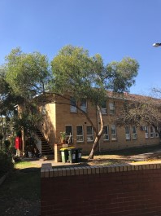

Tree 101 and 102 is a mature Yellow Gum to the south of the site. It has good vigour, average form, and poor structure. They have an open canopy with healthy new growth throughout. There canopies are supported by elongated branches that are bifurcated above (Tree 101) and below (Tree 102) breast height. The unions are well formed with minimal included bark and reaction wood present. Both should be cabled and have their canopies formatively pruned to reduce stress on there branches. They are of a moderate retention value.

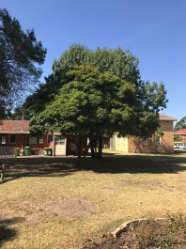
Tree 103 is a mature Sweet Pittosporum to the centre of the site. It has good vigour and form with average structure. It has a broad dense canopy with healthy growth throughout. Its bifurcated near ground level with the branch unions well structured. As it is a weed species it should be removed, however if council is will to allow for its retention it will continue to add to the amenity of the site. If retained it is of a high retention value.

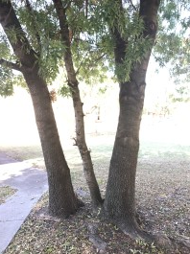
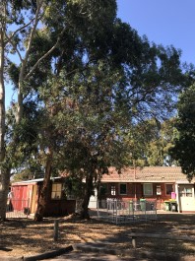
Trees 104, 105, 106 and 107 are young to over mature Desert ash to the centre of the site. They have irregular canopies with the health of the growth present reflective of the age of the tree. All having varying structural faults, which will become hazardous over time. As they are weed species in Banyule Council they should be removed.

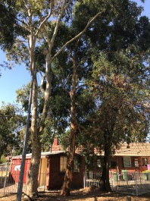

Tree 108 (highlighted in orange) is a mature Orange Gum to the to the centre of the site. It has good vigour and form with average structure. It has a full canopy with healthy growth throughout. It has a single central leader with no major defects present. It is of a high retention value.

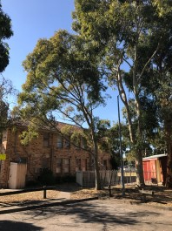
Tree 109 & 110 are mature Spotted Gums to the centre of the site. They have good vigour, with Tree 109 having average form and structure, and Tree 110 having poor form and structure. Tree 109 has a bifurcation 1.8m above ground level that will require cabling. Tree 110 has elongated branches radiating away from tree 109 and should have the lower two branches removed. Tree 109 is of a high retention value and Tree 110 is of a moderate retention value.

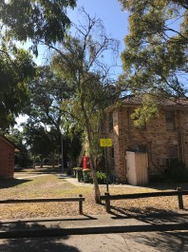

Tree 11 is a semi-mature Yellow Gum to the centre of the site. It has poor vigour form and structure. It has a patchy canopy with significant dieback throughout. It has poorly structured branches and is in a state of senescence. It is of a low retention value and should be removed.

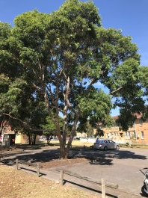

Tree 112 is a mature Smooth Bark able to the centre of the site. It has Good vigour and form with poor structure. It has a broad, full canopy with healthy growth throughout. It has two separate bifurcations below breast height supporting the canopy. There is some included bark and reaction wood present. Its canopy should be formatively pruned, with the main branches secured if possible. It is of a high retention value.

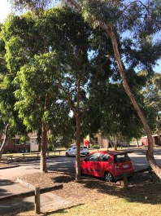
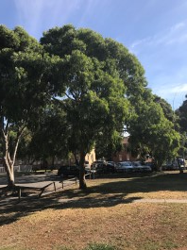
Trees 113, 114, 115 and 116 are mature Smooth Bark Apples to the centre of the site. They have good vigour and form, with trees 113, 115 and 116 having average structure and Tree 114 having poor structure. All have dense canopies with healthy new growth throughout. Tree 114 has two bifurcations to its trunk that are poorly structured, it will require cabling or canopy reduction to reduce the risk of failure. They are all high retention value.

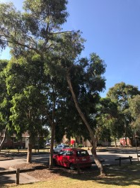

Tree 117 is a mature Yellow Gum to the centre of the site. It has good vigour with poor form and structure. It has an open canopy that has healthy growth throughout but is poorly formed. It has an elongated central leader, that is exhibiting torsional loading, making it structurally unstable. It is of a low retention value and should be removed.

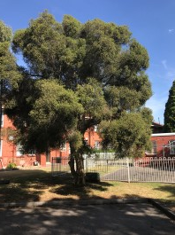

Tree 118 is a mature Prickly Tea Tree to the centre of the site. It has average form and vigour with poor structure. It has a well-formed canopy with healthy growth throughout, and some dieback present. It is trifurcated to its base with a large pruning would present on an outer branch. It is of a moderate retention value but should have its canopy formatively pruned to reduce stress on its branch unions.

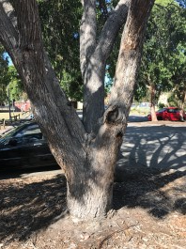
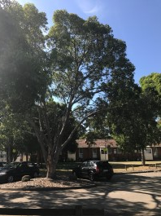
Tree 119 is a mature Red Flowering Gum to the centre of the site. It has good form and vigour with poor structure. It has a broad open canopy, with healthy growth throughout. It has four branches radiating out from its base, with reaction wood and included bark present. It has several pruning would that have signs of decay on its branches. Due to the structural faults it is of a low retention value and should be removed.

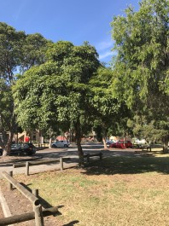

Tree 120 is a mature Sweet Pittosporum to the centre of the site. It has average form and vigour with poor structure. It has a well-rounded canopy with healthy growth throughout. It is trifurcated below breast height with branch unions poorly structured. It is a weed in Banyule Council and should be removed.

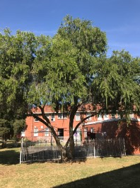

Tree 121 is a mature Weeping Bottle-Brush to the centre of the site. It has good vigour and form with poor structure. It has a broad dense canopy with healthy growth throughout. It has a trifurcated trunk, with the over elongated branches radiating out at wide angles. It is of a moderate retention value, but would require its main branches being cabled.

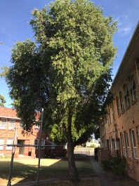

Tree 122 is a mature Weeping Bottle Brush to the centre of the site. It has good vigour and form with average structure. It has a broad dense canopy with healthy growth throughout. It has a well formed canopy with a more upright habit then Tree 121. It has a single central leader that is well structured. It is of a high retention value.

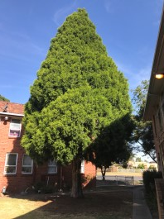

Tree 123 is a mature Cedar of Goa to the south of the site. It has a good form and vigour, with average structure. It has a well-formed central leader supporting a dense, pyramidal canopy with no dieback present. It is of a high retention value and will not require any immediate remedial works.

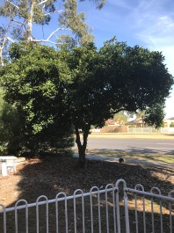

Tree 124 is a mature Photinia to the south of the site. It has average from and vigour with poor structure. It has a dense canopy with healthy growth throughout. It is bifurcated half a meter above ground level with the branch union poorly structured. It has significant decay present along its branches. It is of a low retention value and should be removed.

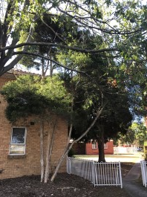

Tree 125 is a mature Prickly Tea Tree to the south of the site. It has average vigour, with poor form and structure. Its canopy is separated into clear areas, with each well-formed and with healthy growth throughout. It has 4 elongated branches radiating out from its base, with are likely to fail. It is of a low retention value and should be removed.

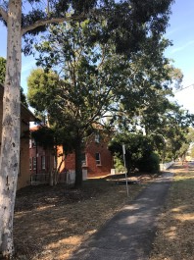

Tree 126 Is an over mature Pin Oak to the south of the site. It has poor form, vigour and structure. It has a sparse canopy with minimal coverage, and significant dieback. It has a single leader with signs of decay present. Considering its size, and poor vigour it is hazardous now, and should be removed

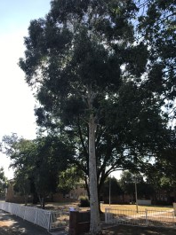
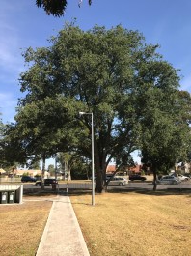

Tree 127 is a mature Brittle Gum to the south of the site. It has good form, vigour, and structure. It has we well-formed dense canopy with healthy foliage throughout. It has a well-structured central leader with no visible structural defects. It is of a high retention value and requires no immediate remedial works.

Tree 128 is a mature English Elm to the southern boundary. It has good form with average structure and vigour. It has a well-rounded canopy with healthy growth throughout and some areas of dieback. It has a main trunk, with a secondary branch radiating out from the base. There are signs of decay within its branches, and discoloration to its bark, indicating areas of damp. If it is likely to fail it would damage property and could injure someone or worse, given its location next to an internal footpath and the footpath running along Bell Street. If it is to be retained a Picus Tomograph, would be required to full understand any potential decay within, and the likelihood of it failing.

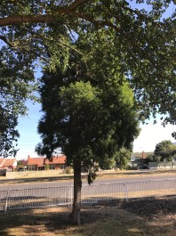

Tree 129 is a mature Cedar of Goa to the southern boundary. It has good vigour, form, and structure. It has a healthy well-formed canopy, supported by a well-structured central leader. It is of a high retention value.

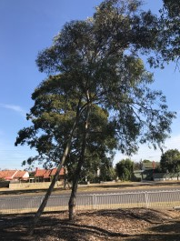

Tree 130 and 131 are mature Yellow Gum to the southern boundary. They have good vigour, average form, and poor structure. Both have open canopies that are well formed, yet leaning towards Bell Street. They both have a central leader that is elongated and poorly structured. They have moderate retention value, but will need there canopies formatively pruned to reduced stress on their main branch.

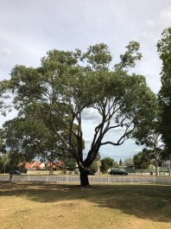
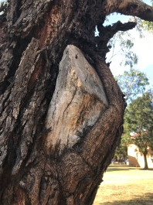
Tree 132 is a mature Southern Swamp Mahogany to the southern boundary. It has good vigour and form with poor structure. It has a broad open canopy with healthy growth throughout. Its limbs are elongated, with some branch unions poorly formed. Considering its location close to the foot path on Bell Street, and the poor structure of some of its branches, it is hazardous now and would require a significant reduction in its canopy to be made safe. It should be removed immediately.

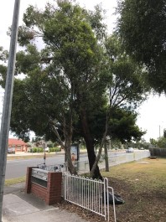

Tree 133 is a mature Willow Bottle-Brush to the southern boundary of the site. It has poor form, vigour, and structure. It has two elongated branches supported sparse canopies that are heavily affected by scale and sooty mould. It is of a low retention value and should be removed.

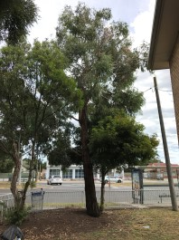

Tree 134 is a mature Red Iron Bark to the southern boundary of the site. It has good vigour, average form, and poor structure. It has a healthy canopy with new growth present throughout. It has an acute bifurcation leaning towards Bell street, which is likely to become increasingly hazardous over time. It is of moderate retention value, but would need its canopy reduced and formatively pruned to reduce the risk of it failing.

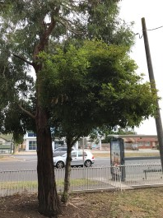

Tree 135 is a mature Sweet Pittosporum to the southern boundary. It has good vigour and form with average structure. It appears to have been formatively pruned to give it a clear single leader. It has a full well rounded canopy with healthy growth throughout. As it is a weed in Banyule City Council it should be removed.

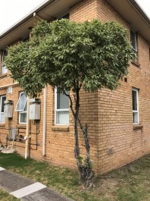

Tree 136 is a mature Variegated Lemonwood to the south-west of the site. It has good vigour, with average form and poor structure. It has been pruned to have a well-formed canopy approximately 3m above ground level. The canopy has healthy growth throughout. It has two elongated poorly structured branches supporting the canopy that are bifurcated to the base. Around the base are multiple pruning wounds that have signs of decay. It is of a low retention value and should be removed.

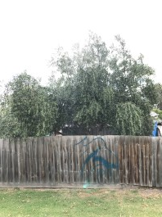

Tree 137 is a mature olive to the neighbouring side of the western boundary. It has good form, excellent vigour, and good structure. It has a broad canopy, with vigorous and healthy growth throughout. It has well-formed branches with no obvious structural defects. As it is neighbouring it would need to be protected if any development work was to take place.

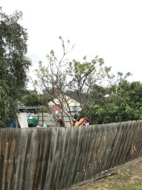

Definitions
As per Australian Standard 4970 – 2009 – Protection of Trees on Development Sites (AS 4970):
TPZ and SRZ Methodology
Determining the Tree Protection Zone (TPZ)
The radium of the TPZ is calculated for each tree by multiplying its DBH x 12. TPZ = DBH x 12
Where - DBH = trunk diameter measured at 1.4 metres above ground; radius is measured from the centre of the stem at ground level.
A TPZ should not be less than 2 metres and no greater than 15 metres except where crown protection is required. Some instances may require variations to the TPZ.
The TPZ of palms, other monocots, cycads and tree ferns should not be less than 1 metre outside the crown projection.
This area is an estimate of the space required to maintain the health of a tree long term. It is entirely possible to work inside this Zone providing due care is exercised according to AS 4970.

Determining the Structural Root Zone (SRZ)

The SRZ is the area required for tree stability. A larger area is required to maintain a viable tree. The SRZ only needs to be calculated when major encroachment into a TPZ is proposed.
There are many factors that affect the size of the SRZ; e.g. tree height, crown area, soil type, soil moisture etc. The SRZ may also be influenced by natural or built structures, such as rocks and footings. An indicative SRZ radius can be determined from the trunk diameter measured immediately above the root buttress using the following formula:
SRZ radius = (D x 50)0.42 x 0.64
Where - D = trunk diameter, in m, measured above the root buttress.
The SRZ for trees with trunk diameters less than 0.15m will be 1.5m.
It needs to be emphasised that this is an indicative calculation which generalizes all the conditions influencing the estimate. SRZ is often less than the indicated calculation. An Exploratory Root Excavation (ERE) or root investigation according to AS 4970 may provide more information on the extent of these roots.

TPZ and SRZ Encroachment
Any encroachment into TPZ should be advised and supervised by a qualified Arborist
AS 4970 says:
3.3.2 Minor encroachment
If the proposed encroachment is less than 10% of the area of the TPZ and is outside the SRZ detailed root investigations should not be required. The area lost to this encroachment should be compensated for elsewhere and contiguous with the TPZ.

AS 4970 also says:
3.3.4 TPZ encroachment considerations
When determining the potential impacts of encroachment into the TPZ, the project arborist should consider the following:
(a) Location and distribution of the roots to be determined through non-destructive investigation methods (pneumatic, hydraulic, hand digging or ground penetrating radar). Photographs should be taken and a root zone map prepared.
NOTE: Regardless of the method, roots must not be cut, bruised or frayed during the process.
It is imperative that exposed roots are kept moist and the excavation back filled as soon as possible.

(b) The potential loss of root mass resulting from the encroachment: number and size of roots.

(c) Tree species and tolerance to root disturbance.

(d) Age, vigour and size of the tree.

(e) Lean and stability of the tree.

NOTE: Roots on the tension side are likely to be most important for supporting the tree and are likely to extend for a greater distance.

(f) Soil characteristics and volume, topography and drainage.

(g) The presence of existing or past structures or obstacles affecting root growth.

(h) Design factors.

Tree sensitive construction measures such as pier and beam, suspended slabs, cantilevered building sections, screw piles and contiguous piling can minimize the impact of encroachment.
When siting a structure near to a tree, the future growth of the tree, both above and below ground should be taken into account. Precautions should be taken at the planning and design stage to minimize potential conflict between trees and new structures
When the root zone is reactive clay, techniques such as localized pier and beam (bridged), screw pile footings or root and soil moisture control barriers may be appropriate to minimize effects on structures.

NOTE: Collaboration may be required between the project arborist and the geotechnical or structural engineer.

Landscapes by Design believes it is vital to ensure that construction is strong enough to withstand any encroachment by the tree as it grows. Pro-active measure like root control barriers and moisture barriers before trees grow to maximum size may be considered.

Tree Protection Fencing

Tree Protection Fencing must be erected prior to any works of any nature commencing and before any machinery or materials are brought onto the site. Once erected this protective fencing must not be removed or altered until such time as all works associated with the construction are complete, unless approved and supervised by an Arborist.
Immediately following erection of the Tree Protection Fencing, the Tree Protection Zones are to be weeded and then mulched with 75 mm depth leaf mulch or similar, that has been aged for at least 12 weeks.
No trenching or excavation is to occur within this Tree Protection Zones. If underground services must be routed within the TPZ, they should be installed by directional drilling or in manually excavated trenches. The directional drilling bore should be at least 600 mm deep. The project arborist should assess the likely impacts of boring and bore pits on retained trees. An Exploratory Root Excavation (ERE) may assist in this case. See Later section.

The Tree Protection Fencing Zone should be secured to restrict access.
AS 4687 – Temporary Fencing and Hoardings specifies applicable fencing requirements. Shade cloth or similar should be attached to reduce the transport of dust, other particulate matter and liquids into the protected area.
Fence posts and supports should have a diameter greater than 20 mm and be located clear of roots.
Existing perimeter fencing and other structures may be suitable as part of the protective fencing.

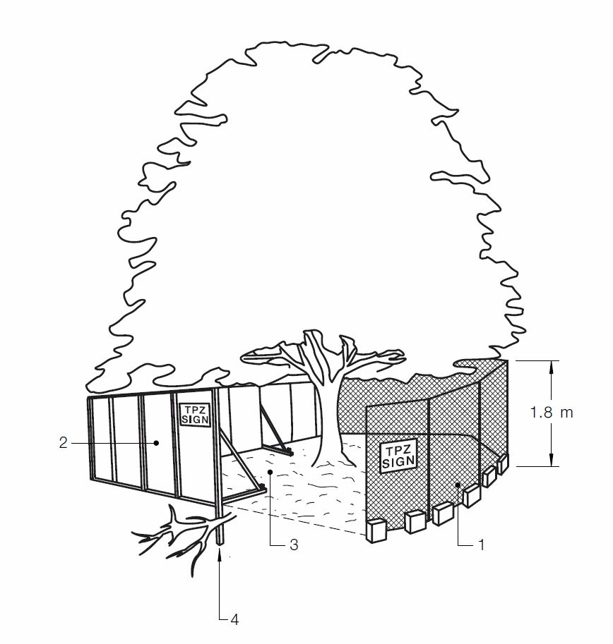
The image below on provides an example of suitable protective fencing:

Legend:

- Chain wire mesh panels with shade cloth (if required) attached, held in place with concrete feet.
- Alternative plywood or wooden paling fence panels. This fencing material also prevents building materials or soil entering the TPZ.
- Mulch installation across surface of TPZ (at the discretion of the project arborist). No excavation, construction activity, grade changes, surface treatment or storage of materials of any kind is permitted within the TPZ. Bracing is permissible within the TPZ. Installation of supports should avoid damaging roots.

If it is necessary to remove the Tree Protection Fencing to allow works to be carried out it must be reinstated on a daily basis immediately following completion of works. If works are carried out within the Tree Protection Zones this work must be supervised by an Arborist. During required work suitable planking should be laid within the Tree Protection Zone to protect against compaction to the roots of the tree / trees from workers and others. It is recommended that machinery does not enter the Tree Protection Zone (see 4.2 from AS 4970 below: “Activities generally excluded”), however rumble boards, plates, or sheets of heavy duty materials over mulch and an impervious membrane can be used if vehicles need to move through the zone. Excavation can be carried out by machine using skilled operators briefed by and observed by an Arborist. Mini-excavators should be used and if possible the vehicle located outside the zone with its tool arms moving within the site. In the case of an Exploratory Root Excavation (ERE) being conducted the workmen and their equipment are only in the area for a short time however extreme care must be taken to protect the trunk, canopy and roots of the tree/s.

Irrigation – during warmer periods the Tree Protection Zones should be irrigated with 1 litre of clean water for every 1 cm of trunk girth measured at the soil / trunk interface on a weekly basis.
No persons, vehicles or machinery are to enter the Tree Protection Zones unless authorised to do so, preferably with permission from the Determining Authority.
No fuel, oil dumps or chemicals are allowed to be used or stored within the Tree Protection Zones; the servicing and refuelling of equipment and vehicles must be carried out away from the TPZ; no storage of material or equipment is to take place within them; nothing whatsoever, including temporary services wires, nails, screws or any other fixing device, is to be attached to any tree.
4.2 ACTIVITIES RESTRICTED WITHIN THE TPZ
Activities generally excluded from the TPZ include but are not limited to—
(a) machine excavation including trenching;
(b) excavation for silt fencing;
(c) cultivation;
(d) storage;
(e) preparation of chemicals, including preparation of cement products;
(f) parking of vehicles and plant;
(g) refuelling;
(h) dumping of waste;
(i) wash down and cleaning of equipment;
(j) placement of fill;
(k) lighting of fires;
(l) soil level changes;
(m) temporary or permanent installation of utilities and signs, and
(n) physical damage to the tree.

Trunk and Branch Protection

Trees impacted upon by construction works should be protected as per the Sketch 1 below. It is suggested that suitable rubberised padding material be used under 75 by 50 hardwood timber which is strapped with galvanised tin strapping approximately 30 mm wide at 900 mm spacing from bottom of trunk upwards, and nailed or screwed to the hardwood timber with 25 mm long galvanised fasteners. The rubberised padding material should be perforated to allow air to the trunk, and not soak water into itself. No nails or screws are to enter the tree trunk or branches and care must be taken to ensure that no materials bite into the tree surface and scar or damage its surface in any way.

Ground Protection

The planking to the right in the sketch following is an example of the planking that could be used. If temporary access for machinery is required within the TPZ, ground protection measures will be required. The purpose of ground protection is to prevent root damage and soil compaction within the TPZ. Measures should include a permeable membrane such as
Geo-textile fabric beneath a layer of mulch or crushed rock, below rumble boards as per sketch 1. Rubber matting and packing plywood may also be used. Under this planking or sheeting within the TPZ, a 75 mm layer of leaf mulch or similar, aged for at least 12 weeks and proven to contain no toxic substances must be installed. These measures may also be applied to root zones beyond the TPZ. Rumble boards should be of a suitable thickness to prevent soil compaction and root damage.

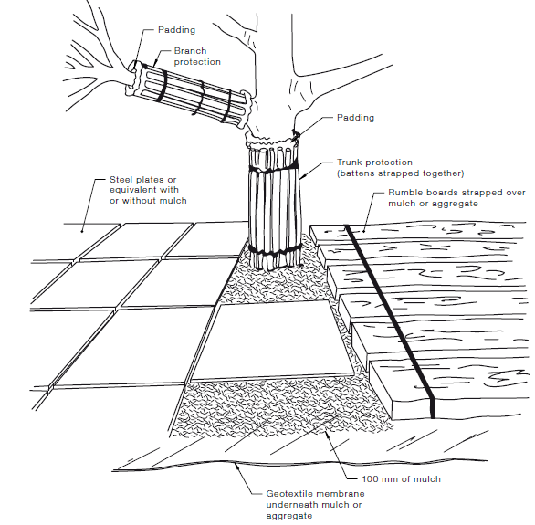
Exploratory Root Excavation

An Exploratory Root Excavation (ERE) or root investigation according to AS 4970 may be conducted to provide more information on the extent of a trees SRZ. The SRZ is an indicative measure and the actual positions and extent of the roots can only be determined by an investigation. A trench is carefully excavated along a pre-determined line (for example, the edge of a proposed slab or decking posts) to a depth of at least 650 mm and no more than 300mm wide. If roots are located they must be carefully exposed without any damage to the root. The position and size of any roots found can be photographed, recorded and mapped. If there are too many large roots or root mats found the Arborist may decide to move the trench further out from centre of trunk. An ERE may indicate that a building can or cannot be placed in the proposed location, or that piers/stumps can be placed between roots, or that roots are nor extending far enough to directly damage a building/path/pipe. The ERE map may lead to design and engineering changes to enable a building, extensions, or earthworks that encroach into the TPZ, to proceed or be moved. Where possible the trenching is done by hand but there are times when machinery or water pressure excavation can be used under the supervision of an Arborist.

Root Protection during Works within the TPZ

Some approved works within the TPZ, such as regrading, installation of piers or landscaping may have the potential to damage roots.
If the grade is to be raised the material should be coarser or more porous than the underlying material. Depth and compaction should be minimized.
Manual excavation is the preferred method and should be carried out under the supervision of an arborist to identify roots critical to tree stability and determine the actual extent of the SRZ. An ERE may be used with photographs and maps to serve as a guide for designers and workers. Relocation or redesign of construction works may be required. (See preceding section)
Where the project arborist identifies roots to be pruned within or at the outer edge of the TPZ, they should be pruned with a final cut back to undamaged wood. Pruning cuts should be made with sharp tools such as secateurs, pruners, handsaws or chainsaws. Pruning wounds should not be treated with dressings or paints. It is not acceptable for roots within the TPZ to be ‘pruned’ with machinery such as backhoes or excavators.
Where roots within the TPZ are exposed by excavation, temporary root protection should be installed to prevent them drying out. This may include jute mesh or hessian sheeting as multiple layers over exposed roots and excavated soil profile, extending to the full depth of the root zone. Root protection sheeting should be pegged in place and kept moist during the period that the root zone is exposed.
Other excavation works in proximity to trees, including landscape works such as paving, irrigation and planting can adversely affect root systems. The project arborist should be consulted and supervise any works.

TPZ Encroachment Over 10%

If the proposed building footprint encroaches into the TPZ more than 10%; either the building footprint will have to change to reduce the encroachment to 10% or an Exploratory Root Excavation (ERE) could be carried out by an Arborist to determine the exact location of any roots present. Prior to an ERE make certain to contact the Determining Authority to see if permission is required. If roots are discovered belonging to the tree that are under 40 mm diameter they could be cut by an arborist to allow either the entire building footprint to be accommodated, or if that is not possible, a smaller redesigned building footprint to be accommodated. If the TPZ is varied following an ERE (as per AS 4970) room must be allowed for the lost area to be compensated for elsewhere. Roots greater than 40 mm diameter and fibrous root mats or clumps greater than 50mm diameter should not be cut, but need to be worked around. A well-qualified arborist may cut a root greater than 40 mm diameter, but not greater than 50 mm diameter unless given permission to cut from the Determining Authority.
Alternatively, if an ERE shows it is impossible to vary the TPZ, alternative “tree friendly” construction methods could be employed, such as installing a building slab above grade, pier and beam methods, or building on stumps. Piers and stumps can be relocated to avoid damage to any significant roots discovered by the ERE. These alternative building methods should be specified by a suitably qualified person.

Installing Underground Services within TPZ

All services should be routed outside the TPZ. If underground services must be routed within the TPZ, they should be installed by directional drilling or in manually excavated trenches. The directional drilling bore should be at least 600 mm deep. The project arborist should assess the likely impacts of boring and bore pits on retained trees.
For manual excavation of trenches, the project arborist should advise on roots to be retained and should monitor the works. Manual excavation may include the use of pneumatic and hydraulic tools.

Crown protection

Tree crowns may be injured by machinery such as excavators, drilling rigs, cranes, trucks, hoarding installation and scaffolding. The TPZ may need to include additional protection of above ground parts of the tree. Where crown protection is required, it will usually be located at least one metre outside the perimeter of the crown (see Figure 2). The erection of scaffolding may require an additional setback from the edge of the crown. Crown protection may include pruning, tying-back of branches or other measures. If pruning is required, requirements are specified in AS 4373 and should be undertaken before the establishment of the TPF. NOTE: Pruning may require approval from the Determining Authority. See following section on Pruning and Removal of Trees

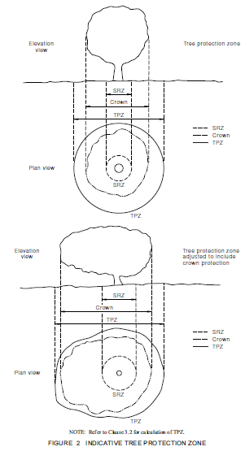
Pruning and Removal of Trees
If pruning is required, it should be carried out in accordance with Australian Standard 4373 - Pruning of Amenity Trees (AS4373) and any root pruning also as per AS 4973 – Specialist advice from a person with a minimum AQF Level 4 in Arboriculture should be sought before any root pruning occurs.
Prior to the pruning of or removal of any tree the Determining Authority, usually the local council must be consulted to be certain the pruning or removal is allowed by them and is lawful.
In any development seek approval for tree removal and encroachment into the TPZ of trees from the Determining Authority; before planning or building preparation and drawings are completed. This is to ensure that building or other drawings are not prepared on the basis of this report, when a relevant Determining Authority does not allow the trees nominated in our report to be removed, or their TPZ’s encroached into.

Scaffolding

Where scaffolding is required, it should be erected outside the TPZ. Where it is essential for scaffolding to be erected within the TPZ, branch removal should be minimized. This can be achieved by designing scaffolding to avoid branches or tying back branches. Where pruning is unavoidable it must be specified by the project arborist in accordance with AS 4970 and 4373.
NOTE: Pruning works may require approval by the determining authority.
Ground below the scaffolding should be protected by boarding (e.g. scaffold board or plywood sheeting) as shown in Trunk and Branch Protection earlier. Where access is required, a board walk or other surface material should be installed to minimize soil compaction. Boarding should be placed over a layer of mulch and impervious sheeting to prevent soil contamination. The boarding should be left in place until the scaffolding is removed.
There is a risk of materials falling off the scaffold decking and into the TPZ, damaging the tree. Care must be exercised and solid walls or mesh barriers be installed on any scaffolding over the TPZ.
Impervious membrane, mulch, boards or plywood must be used under the scaffold soleplates and no excavation is to be performed for the soleplates. It may be possible to erect secondary fencing inside the general TPZ fencing to further protect the tree from damage.

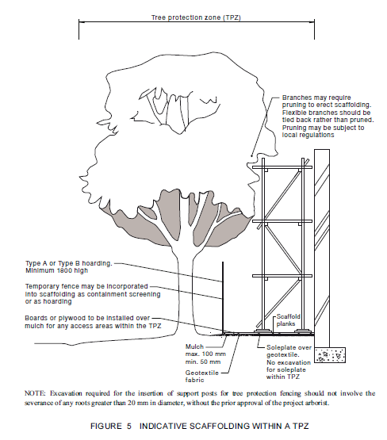

Parameters – Used as required:
Condition, Vigour, Structure and Form - Each has four parameters: Excellent, Good, Average and Poor.
ULE – Useful Life Expectancy - Has four parameters – Long (40 + years), Medium (16 to 39 years), Short (5 to 15 years) and Removal
Significance - Has five parameters – Most, Highly, Less, Least and Hazardous
Age – Has four parameters:
Young – Less than one third of expected life span
Semi Mature – Into second third of expected life span
Mature – Into last third of expected life span
Over Mature – Beyond normal life span or age related state of decline
Retention Value – has six parameters High, Moderate, Low, Weed, Neighbouring, Council and Hazardous when required following other parameter. Generally Neighbouring Trees must be retained and protected unless suitable arrangements can be made for their removal with the owner, and that removal is legal. Council trees to streets or neighbouring parks are that Council’s responsibility. After a tree report is submitted that includes Council trees, it is suggested that council should inspect their trees to ensure they are safe and worthy of retention.

Definitions - Terms:
Acute Branch Crotch – Angle on the inner side of the branch crotch is less than 90 degrees.
Apical Dominance - the main central stem of the plant is dominant over the other branches.
Branch Union – point where a branch originates from the trunk or another branch; may be referred to as a crotch.
Co-dominant Stems – ‘Co-dominant stems are two stems or trunks of equal size that develop from 2 apical buds at the tip of the same stem. Each co-dominant stem is a direct extension of the stem below its origin. There are no branch collars or trunk collars at the base of co-dominant stems’ (Dr Alex Shigo) – Similar to Bi-furcated meaning two and Tri-furcated meaning three.
Compartmentalise – (CODIT: Compartmentalization of Decay In Trees. Dr Alex Shigo) natural process of defence in trees by which they wall off decay in wood and heal wounds.
De-current – growth habit developing a more rounded form with multiple scaffold branches
Determining Authority – Usually refers to the Council responsible for the property being assessed but includes any government or semi-governmental authority that has control or liability under common law, and the role to encourage and enforce the developmental process including legislation relating to trees and plants.
Epicormic Shoots - An epicormic shoot is a shoot growing from an epicormic bud which lies underneath the bark of a trunk, stem, or branch of a plant. In older wood, epicormic shoots can result from severe defoliation or radical pruning.
Etoliation is a process in plants grown in partial or complete absence of light. It is characterized by long, weak stems; smaller, sparser leaves due to longer internodes; and a pale yellow colour (chlorosis).
Ex-current - growth habit with pyramidal crown and a central leader
Fall Zone – area under a tree or adjacent to it where if it failed it could impact upon.
Frass – Granular wood particles produced by borer insects that can be fine, medium or coarse depending on the type of insect.
Flush Cut - Pruning technique in which both branch and stem tissue are removed; generally considered poor practice. Flush cuts can allow decay to enter back into the main trunk or branch.
Gall - abnormal outgrowth of tissues and can be caused by various parasites, from fungi and bacteria, to insects and mites. Sometimes called a burl.
Hedges – Are not assessed as trees; therefore, a canopy dimension is represented in drawings not the TPZ.
Included Bark - bark that becomes embedded in a crotch between branch and trunk or Co-Dominant Stems and causes a weak structure.
Indigenous – a plant occurring naturally in the area or region of the subject site.
Obtuse Branch Crotch – where the angle on the inner side of the union is greater than 90 degrees.
Phototropism or Phototrophic Lean - is the phenomenon in which plants follow or grow towards a light source, most commonly the sun.
Reaction Wood - tree wood formed as a result of mechanical stress helping to provide strength to affected areas as in leaning trees, wind exposure, over weighting, compartmentalisation of decay etc.
Scaffold Branch – the permanent or structural branches of a tree
Senescence – the condition or process of growing old especially the condition resulting from the transitions and accumulations of the deleterious aging process.
Torsional Loading – When a tree generally by the wind has had part of its structure twisted as it grows.
?? – After a tree’s name means identity of species may not be exact.
Tree – As defined by AS 4970: A long lived woody perennial plant greater than (or usually greater than) 3 m in height with one or relatively few main stems or trunks (or as defined by the determining authority). Landscapes by Design believes that the definition is too loose and too general to include all the plants that we would include in the definition of a tree, however it serves to encompass most plants that we assess. We also assess where required, neighbouring plants other than trees.

Disclaimer etc
No examination of any sort has been carried out to the root systems of these trees. Given factors like environmental, vegetative and other overlays and local or other planning controls it is difficult to accommodate or satisfy all parties when assessing trees and other vegetation. It is very difficult to establish clear outcomes and impossible to determine that a tree can be deemed safe under all circumstances. No guarantee can be given that a tree is totally safe or will remain healthy given short term adverse weather conditions or long term climatic conditions or other environmental and physical factors. No guarantees can be given for any part of a trees current or future stability. The writer and Landscapes by Design Pty Ltd does not accept any responsibility for any tree or part of it assessed, with regard to its ongoing stability and safety, or its capacity to damage property, other assets or people. Any dead trees have not been included within this report but should be removed immediately.

Darrell Mcleod

