Planning and Environment Act 1987

GLEN EIRA PLANNING SCHEME

AMENDMENT CXXX

EXPLANATORY REPORT

Who is the planning authority?
The amendment has been prepared by the Minister for Planning, who is the planning authority for the amendment.
The amendment has been made at the request of the Level Crossing Removal Authority.

Land affected by the amendment
The amendment applies to the parcels of land at Newham Grove, North Road and Katandra Road, Ormond, as shown outlined in red on the map below:
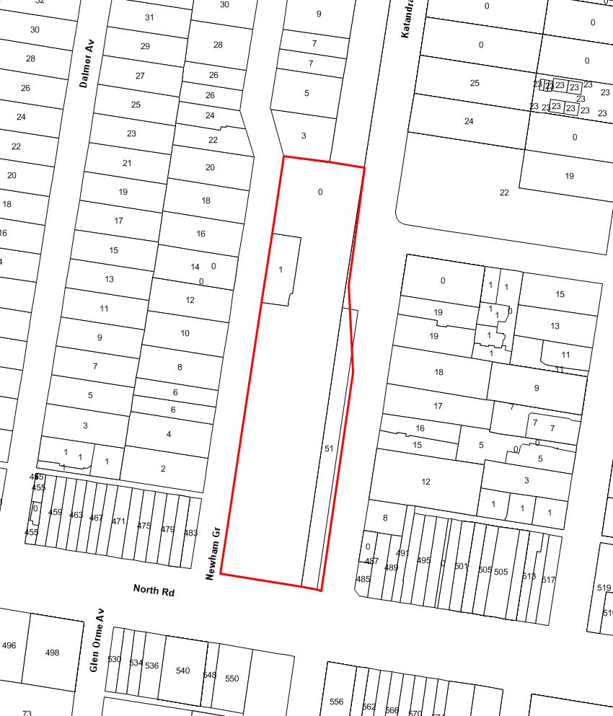

Note: The exact alignment of the boundary along Katandra Road will be finalised upon receipt of the as-built survey drawings for the core infrastructure works.

What the amendment does
The amendment seeks to rezone the subject land to facilitate urban renewal, made possible through the removal of the level crossing at North Road, Ormond and the associated station redevelopment.
The amendment will allow for the effective integration of transport and land use within the Ormond activity centre. It will operate in conjunction with the North Road Ormond Level Crossing Removal Project Incorporated Document permitting the level crossing removal, station redevelopment and associated works.
Specifically, the amendment seeks to make the following changes to the Glen Eira Planning Scheme:
- Insert the Comprehensive Development Zone at Clause 37.02.
- Insert Schedule 1 to the Comprehensive Development Zone after Clause 37.02.
- Rezone the bulk of the subject land which is currently within Public Use Zone - Schedule 4 and the remaining small portion of the subject land which is currently within the General Residential Zone to Comprehensive Development Zone - Schedule 1.
- Insert the North Road Ormond Comprehensive Development Plan into the Schedule to Clause 81.01 of the Glen Eira Planning Scheme.
- Amend the Schedule to Clause 61.01 of the Glen Eira Planning Scheme to make the Minister for Planning the responsible authority for the administration and enforcement of the Glen Eira Planning Scheme in respect of the subject land.
- Amends Clause 21.04 (Housing and Residential Development), 21.06 (Business), and 22.07 (Housing Diversity Area Policy) by inserting strategies, implementation and policy guidelines that encourage opportunity for landmark built form on strategic redevelopment sites made available through the removal of a level crossing.

Strategic assessment of the amendment

Why is the amendment required?
The amendment follows the introduction of Planning Scheme Amendment CG30 which introduced the "North Road Ormond Level Crossing Removal Project Incorporated Document, May 2015" in the Glen Eira Planning Scheme to facilitate the removal of the level crossing at North Road, Ormond, the demolition of the Ormond Railway Station and the construction of a new station with access located at the corner of Katandra Road and North Road.
The amendment is required to allow the development of the area above the new Ormond Railway Station with a range of residential, commercial and retail uses in line with the objectives of Plan Melbourne.
The amendment will facilitate an integrated development of the subject land with the new transport infrastructure works by setting out parameters for its future use and development through the application of the Comprehensive Development Zone and incorporation of the associated North Road Ormond Comprehensive Development Plan August 2016.
The Comprehensive Development Plan is a detailed and well thought out site responsive document comprising of a building envelope plan, a site access plan, objectives, design principles and application requirements. The building envelope plan in the Comprehensive Development Plan is broken down into three precincts with setback requirements and maximum heights.
The amendment will ensure the timely, efficient and appropriate development of the subject land into a vibrant transport hub by setting out a range of as of right uses (subject to meeting specified conditions and controls) and introducing exemptions from notice and third party review when development is generally consistent with the Comprehensive Development Plan .
Uses that do not meet the stated conditions, or any development not generally consistent with the Comprehensive Development Plan will be required to obtain a planning permit under a process that includes third party rights of participation and review.
How does the amendment implement the objectives of planning in Victoria?
The amendment implements the objectives of section 4 of the Planning and Environment Act 1987 by putting in place a suite of controls that facilitate the fair, orderly, economic and sustainable use and development of the land.
The amendment will allow for the more efficient use and development of under-utilised urban land which is strategically located above transport infrastructure and within an activity centre. The amendment will provide for a range of commercial, retail and residential uses in a manner which is fully integrated with the new railway station while at the same time respecting its land use context and nearby sensitive uses.
The amendment balances the present and future interests of the local and broader community by providing a pleasant and efficient working, living and recreational environment in association with improved public utilities, facilities and infrastructure.
How does the amendment address the environmental effects and any relevant social and economic effects?
The amendment is expected to have positive environmental, economic and social benefits. It will enable an urban renewal opportunity made available through the level crossing removal and station redevelopment works.
The amendment aims to ensure that future development will occur within a framework that specifically focuses on high quality urban design and architecture and on improved connection with the rest of the Ormond Activity Centre. It also allows a range of activities on the subject land that will meet the needs of those who live, work and visit the precinct.

Does the amendment address relevant bushfire risk?
The subject land is not within the Bushfire Management Overlay, nor is it within a designated Bushfire Prone Area.
Does the amendment comply with the requirements of any Minister’s Direction applicable to the amendment?
The amendment complies and is consistent with the Ministerial Direction on the Form and Content of Planning Schemes pursuant to section 7(5) of the Planning and Environment Act 1987. The amendment also complies and is consistent with the requirements of Ministerial Direction 11 on the Strategic Assessment of Planning Scheme Amendments.
Pursuant to section 12 of the Planning and Environment Act 1987, the amendment also complies with the Ministerial Direction No. 9 Strategy. In particular, in relation to Plan Melbourne it complies with:
Initiative 1.5.3 Support planning for activity centres - The amendment will allow improved access to the Ormond Activity Centre and will allow its growth by introducing additional uses and increased density.
Initiative 1.6.1 Identify new urban-renewal precincts and sites around the existing rail network based on transit-oriented development principles - The amendment will optimise the development opportunities of the land located above the relocated Ormond Railway Station which has been earmarked for additional residential, employment and mixed-use development
Direction 2.2 Reduce the cost of living by increasing housing supply near services and public transport - The amendment will increase density close to the Ormond Railway Station and will introduce new accommodation options in the Activity Centre.
Initiative 3.2.3 Facilitate development and drive investment through strategic removal of level crossings - The amendment optimizes the development opportunities arising out of the removal of the North Road Level Crossing Removal.
Initiative 4.1.1 Support a network of vibrant neighbourhood centres - The amendment provides for a range of uses on the site thus ensuring the Ormond Activity Centre is revitalised.
The amendment gives effect to Ministerial Direction No. 1 - Potentially Contaminated Land. An application requirement in the Comprehensive Development Zone is proposed, which is further outlined in the Comprehensive Development Plan. This requires an environmental site assessment to be undertaken in the event of any application to use the land for a sensitive use, or applications for buildings and works associated with a sensitive use.
The site assessment would advise whether an environmental audit is required, what level of remediation would be required in order for the sensitive use to occur
How does the amendment support or implement the State Planning Policy Framework?
The amendment is consistent with State Planning Policy Framework as it supports the regeneration of urban land within an existing activity centre, encourages the integration of land use and transport and promotes the use of existing infrastructure.
In particular the amendment will assist in implementing the following policies:
Clause 11 Settlement - The amendment will support the role and function of the Ormond Activity Centre by:
- providing increased housing density on urban land;
- providing diverse housing options close to jobs and services;
- activating a mixture of different and complementary land uses; and
- encouraging an improved connection to the Ormond Activity Centre.
Clause 15 - Built Environment and Heritage - The amendment will ensure future land use and development is of high urban design quality and architecture by creating a framework for a vibrant, functional and safe development. The amendment will provide for a different urban form than is currently in the nearby heritage overlay, however this is consistent with the Burra Charter.
Clause 16 - Housing - The amendment will enable the location of new housing in the Ormond Activity Centre on a strategic under-utilised urban site that offers good access to services and transport.
Clause 17 - Economic Development - The amendment provides for development that will meet the community's need for a range of services and activities while contributing a net community benefit in relation to accessibility and the efficient use of infrastructure. It facilitates and contributes to the enhancement and planning of a vibrant, functional, safe and integrated activity centre which services the commercial, employment and housing needs of the municipality.
Clause 18 - Transport - The amendment responds to this policy by allowing development above the Ormond Railway Station thus integrating land use and transport. The car parking provisions of the Comprehensive Development Zone Schedule 1 directly respond to the Transport policy objective by taking into account the location of public transport and existing road capacity. The Comprehensive Development Plan seeks to promote pedestrian movements.
Clause 19.03 – Design and Built Form - The amendment will facilitate the implementation of urban design, built form, and streetscape design principles. The amendment will incorporate planning provisions that will encourage and support enhanced liveability, and amenity within the municipality.

How does the amendment support or implement the Local Planning Policy Framework?

The amendment implements the Local Planning Policy Framework. The Municipal Strategic Statement recognises that the subject land is within the Ormond Activity Centre. As such, the land is within a designated housing diversity area intended to accommodate additional dwellings required to house Glen Eira's future population.

The amendment specifically implements the following policies:

Clause 21.04 Housing and Residential Development - The amendment encourages a mix of housing types and increased residential density. It also supports mixed use development on land located in a strategic location having excellent access to public transport, commercial, community, educational and recreational services.
The amendment inserts a strategy into Clause 21.04 that recognises the opportunity for landmark built form on strategic redevelopment sites made available through the removal of a level crossing.

Clause 21.06 Business - The amendment encourages development that will provide more local employment and attract more local spending. It will revitalise the Ormond Activity Centre by encouraging a mix of activities and increasing housing density.
The amendment inserts an implementation guideline into Clause 21.06 to enable a more flexible planning control on strategic redevelopment sites made available through the removal of a level crossing.

Clause 21.12-1 (Transport) Objectives - The amendment will enhance access to public transport and increase public transport patronage. It will ensure the adequate provision of car parking to serve the needs of residents and businesses and their customers.

Clause 22.07 (Housing Diversity Areas Policy) - The amendment, and the Comprehensive Development Plan in particular, ensures that the density, mass and scale of future development will respond to the location and the role of the Ormond Activity Centre. It promotes multi-unit development in proximity to the Ormond Railway Station while also taking into account the subject land's interface with existing residential development on adjoining sites.
The amendment inserts a policy guideline into Clause 22.07 that recognises the opportunity for landmark built form on strategic redevelopment sites made available through the removal of a level crossing.

Clause 22.12 (Public Open Space Contribution Policy) – The Comprehensive Development Plan identifies an opportunity for future publicly accessible spaces.

Does the amendment make proper use of the Victoria Planning Provisions?
The amendment makes proper use of the Victoria Planning Provisions. Importantly, the application of the Comprehensive Development Zone with accompanying schedule and associated Comprehensive Development Plan enables a tailored response to the site in a manner which is integrated with the rail infrastructure works permitted by the North Road Ormond Level Crossing Removal Project Incorporated Document.
Use of the Comprehensive Development Zone and schedule together with the associated Comprehensive Development Plan:
- provides flexibility in the mix of uses that may be permitted to occur on site within clearly defined parameters;
- maintains certainty as to the type of development that may occur in the circumstances where exhibition and the opportunity for third party participation in the decision making process is exempt;
- ensures that all planning permit applications must address the parameters, objectives, guidelines and application requirements contained in the Comprehensive Development Plan;
- requires that all applications be determined after considering the Comprehensive Development Plan and the North Road Ormond Level Crossing Removal Project Incorporated Document, as appropriate.

How does the amendment address the views of any relevant agency?
Relevant agencies will have an opportunity to provide submissions to the amendment, and to be part of the advisory committee process.

Does the amendment address relevant requirements of the Transport Integration Act 2010?
The amendment will have a positive impact on the transport system by providing for the effective integration of transport and land use. The co-location of access to public transport and urban renewal outcomes will facilitate access to social and economic opportunities and provide benefits all users of the site.
The amendment will particularly help achieve the objectives in section 11 of the Transport Integration Act 2010 by co-locating both employment opportunities and residential development on a site currently used exclusively for public transport. Residents of a development will have ready access to public transport and retail outlets, as well as a reduced need to rely on private motor vehicle transport. Retailers will benefit a close association with a public transport hub, as well the patronage from new residents living on-site. The public transport network is likely to have increased patronage from residents living on-site as well as people who use public transport to access nearby retailers.
The draft amendment will further other transport system objectives relating to social and economic inclusion, economic prosperity, efficiency coordination and reliability and safety and health and wellbeing. This well be achieved through contributing to the overall effectiveness of the Ormond Activity Centre and surrounding areas. The amendment will enable people to access social and economic opportunities and so support community and individual wellbeing. Furthermore, it will facilitate economic prosperity by enabling access to public transport services for existing and future residents, businesses and employment. The controls forming part of the amendment will ensure that transport system and land use decisions are aligned, complementary and supportive.

Resource and administrative costs

What impact will the new planning provisions have on the resource and administrative costs of the responsible authority?
The amendment will not place any unreasonable additional requirements on the resources of the Responsible Authority or result in significant additional administrative costs.

Where you may inspect this Amendment
The amendment can be inspected free of charge at the Department of Environment, Land, Water and Planning website at www.delwp.vic.gov.au/public-inspection.

