This version of Planning Advisory Note 71: Amendment VC148 has been prepared for use with screen reader software. The printed publication contains various design features that have been necessarily omitted from this version. In other respects, this document contains identical text to that in the PDF version of the document which is available at www.planning.vic.gov.au

Planning Advisory Note 71

Amendment VC148 - A New Planning Policy Framework
July 2018
Amendment VC148 is part of the Smart Planning program’s reforms to simplify and modernise Victoria’s planning policy and rules to make planning schemes more efficient, accessible and transparent.
There are two Advisory Notes for Amendment VC148. This Advisory Note provides information about the Planning Policy Framework (PPF) introduced by Amendment VC148.
Information about other changes made by this amendment is provided in Advisory Note 72 and in the explanatory report for the amendment, which is available on Planning Schemes Online.

What is the Planning Policy Framework?
The PPF is the policy content of planning schemes. It includes part of the Victoria Planning Provisions (VPP) in the form of state and regional planning policies and local content in the form of local planning policies.
The state, regional and local levels of policy are grouped by theme with directly relevant regional and local policies ’nested’ under the corresponding state planning policy.
The Amendment implements the first stage of the PPF replacing the State Planning Policy Framework (SPPF). In future the PPF will, in conjunction with the new Municipal Planning Strategy (MPS), also replace the Local Planning Policy Framework (LPPF) in each planning scheme. The PPF enables all policy content in planning schemes to be merged into a single policy source.

Why has the Planning Policy Framework been introduced?
The PPF has been introduced to improve the operation of planning policy in planning schemes.
Planning policy plays an important role in guiding decision makers and facilitating appropriate outcomes. Except for a modest restructure of the SPPF in 2010, the existing policy framework has largely operated in the same way for over 20 years. It has been the subject of a number of reviews over that time. These reviews have identified that while the VPP system with its policy foundation is widely supported, users seek greater clarity, certainty and improved usability.
The PPF will:
- strengthen planning policy
- enable the better alignment of state planning policy with local planning policy
- be easier to navigate and use than the currently separate state, regional and local policy frameworks
- ensure policy is consistent across state, regional and local tiers
- simplify the review and update of policy.

How does Amendment VC148 implement the Planning Policy Framework?
The Amendment implements the PPF by introducing various changes to the VPP, including:
- a new 3-tier integrated policy structure
- new and updated policies
- integration of regional policy.

A new 3-tier integrated policy structure
The new PPF (Clauses 10 to 19) replaces the SPPF (former Clauses 9 to 19). The PPF structure provides for three tiers of integrated planning policy: statewide, regional and local (see Figure 1).

Figure 1 - Planning Policy Framework Hierarchy
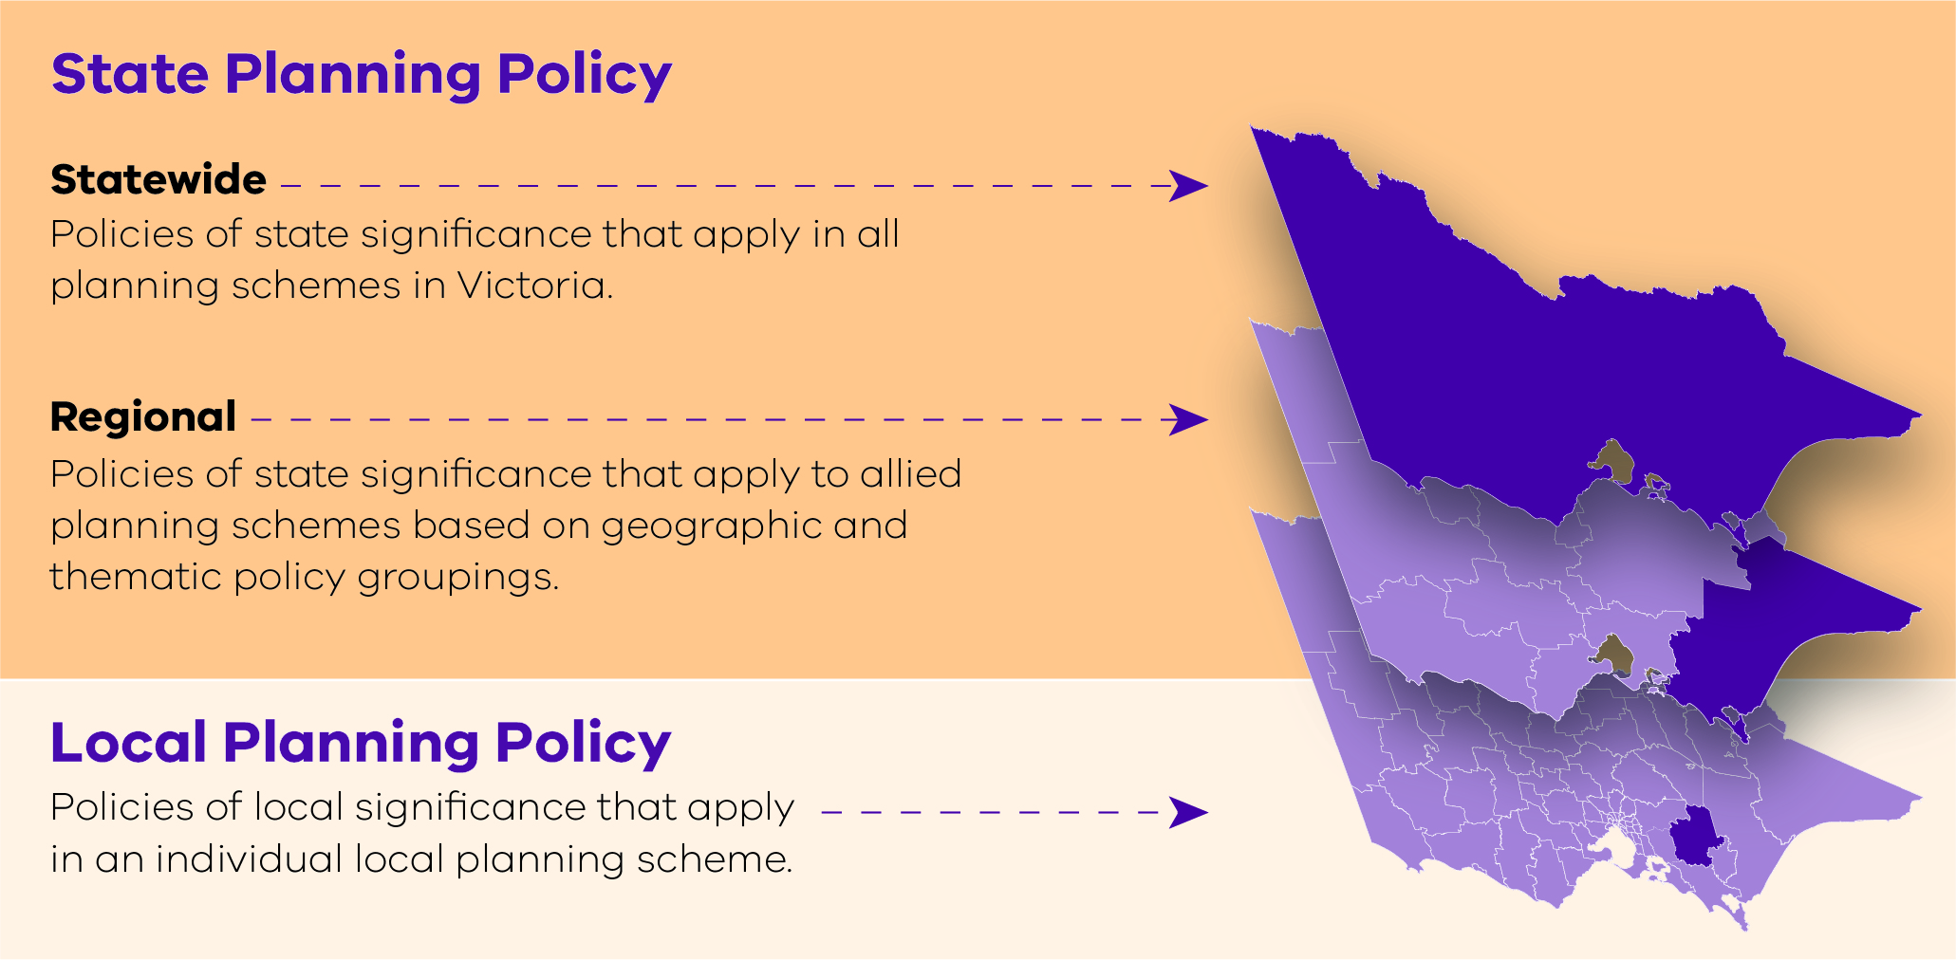
At this stage, local content has not been introduced into the PPF. The Department of Environment, Land, Water and Planning (DELWP) will shortly provide further information of how existing LPPF content will be translated into the PPF, completing the integration of all tiers of policy into a single PPF in each planning scheme. DELWP will work closely with local councils on the future integration of local content into the PPF.

New and updated policies
The PPF mostly uses SPPF policy themes as the basis for its structure. It changes the SPPF by:
- including new policy themes to allow for the integration of regional and local planning policies (for example, new Clause 17.01-1 - Diversified economy)
- repositioning some policies to make the thematic structure more logical and intuitive (particularly within Clause 11).
The PPF policy themes are shown in Attachment 1 at the end of this document.
Some SPPF policies have been updated (for example, Clause 15 - Built environment has been updated to be consistent with the Urban Design Guidelines for Victoria (DELWP, 2017)).

Integration of regional policy
Metropolitan and regional planning policies from SPPF Clauses 11.06 to 11.15 have been integrated into the PPF. Each planning scheme only includes relevant regional policies in its PPF. The allocation of regional policies to each planning scheme is specified in the Ministerial Direction - The Form and Content of Planning Schemes.
Some existing regional policies have been changed to statewide policies where there is a strategic basis derived from a state strategy document such as Plan Melbourne 2017-2050 or the regional growth plans and where:
- the policy applies across Victoria,
- replicates a state policy but provides clearer direction, or
- adds a strategy that helps support or clarify the state policy objective.
Some state policies that do not have statewide application have been changed to regional policies (for example, content on the Principal Public Transport Network now applies only in Metropolitan Melbourne planning schemes).

What is the Municipal Planning Strategy?
When a planning authority translates its LPPF into the new PPF, it will also be required to introduce a Municipal Planning Strategy (MPS) at Clause 02 of the planning scheme. The MPS supports but does not form part of the PPF. The PPF and MPS will work together to form the strategic basis of a planning scheme.
The MPS will be a succinct expression of the overarching strategic policy directions of a municipality. It will provide for the planning scheme’s policy foundation, based on the municipality’s location and regional context, history, assets, strengths, key attributes and influences. Planning schemes already have similar clauses in the MSS, however the new concise format will ensure a more focused and direct message about a council’s planning aspirations.
The form and content of the MPS is set out in the Ministerial Direction - The Form and Content of Planning Schemes.
DELWP will shortly provide further information on preparing an MPS as part of the broader changes associated with the PPF. DELWP will work closely with local councils on this process.

How does the Planning Policy Framework operate?
The operation of the PPF is set out in Clause 71.02. Responsible authorities are required to take into account and give effect to all planning policies in the PPF. This operation will also be applied to local planning policies when they are included in the PPF in the future.

What other Planning Policy Framework related changes are included in Amendment VC148?
A series of complementary changes are also included in Amendment VC148:
- a standard policy format
- expanded local schedule capacity
- clarification, corrections and reduced repetition.

A standard policy format
The format of policies in the PPF has been standardised. Each policy now includes ‘objectives’ and ‘strategies’ and where necessary, ‘policy guidelines’ and ‘policy documents’. A standardised format will also be applied to local planning policies when they are included in the PPF in the future.

Expanded local schedule capacity
To support the future integration of local content into the PPF, several zones, overlays and other provisions are amended to enable their schedules to specify additional matters including purposes, objectives, application requirements or decision guidelines. Enabling these matters to be specified in controls will consolidate related provisions and allows for some local policy content to be appropriately translated into these schedules. The Ministerial Direction - The Form and Content of Planning Schemes has been amended to provide for these added matters.

Clarification, corrections and reduced repetition
Repetitive policy content that was identified following the integration of statewide and regional policies has been removed. Some policies have been modified to make objectives and strategies clearer. Grammatical and administrative corrections have also been made to improve the readability of policies.
See Advisory Note 72 for more information on which provisions have been amended for this purpose.

Are transitional provisions included in Amendment VC148?
References to the SPPF and LPPF in the VPP (for example, in the zone and overlay purposes and decision guidelines) have been updated to refer to the MPS and PPF. To ensure continued operation of LPPFs before they are translated into the PPF (and other appropriate clauses) in future, transitional provisions are included in Clauses 23.01, 71.01-3 and 71.02-4.
References in local provisions of planning schemes (for example, in the LPPF and local schedules) have not been updated.

More information
To view Amendment VC148 go to Planning Schemes Online.

© The State of Victoria Department of Environment, Land, Water & Planning 2018
This work is licensed under a Creative Commons Attribution 4.0 International licence. You are free to re-use the work under that licence, on the condition that you credit the State of Victoria as author. The licence does not apply to any images, photographs or branding, including the Victorian Coat of Arms, the Victorian Government logo and the Department of Environment, Land, Water and Planning (DELWP) logo. To view a copy of this licence, visit http://creativecommons.org/licenses/by/4.0/
Disclaimer
This publication may be of assistance to you but the State of Victoria and its employees do not guarantee that the publication is without flaw of any kind or is wholly appropriate for your particular purposes and therefore disclaims all liability for any error, loss or other consequence which may arise from you relying on any information in this publication.
Accessibility
If you would like to receive this publication in an alternative format, please telephone the DELWP Customer Service Centre on 136186, email customer.service@delwp.vic.gov.au (or relevant address), or via the National Relay Service on 133 677 www.relayservice.com.au This document is also available on the internet at www.planning.vic.gov.au

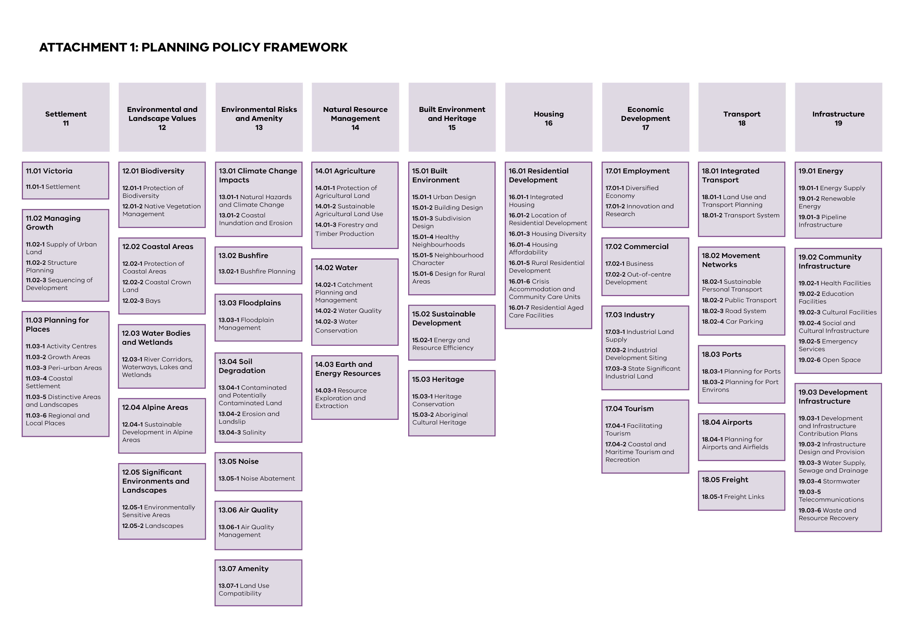

Attachment 1 is a diagram outling the themes of the Planning Policy Framework

