|  |
| --- |
| A Regional Career  Migration histories of professionals in Bendigo, Victoria Summary of survey findings  n histories of professionals in Bendigo, Victoria Summary of survey findings |

|  |
| --- |
|  |

|  |
| --- |
| A Regional Career  Migration histories of professionals working in Bendigo, Victoria.  Summary of survey findings.  Report prepared by Fiona McKenzie, Forward Policy and Research Branch, Department of Environment, Land, Water and Planning (DELWP), Melbourne, Victoria.  Logo© The State of Victoria Department of Environment, Land, Water and Planning 2016  This work is licensed under a [Creative Commons Attribution 4.0 International licence](http://creativecommons.org/licenses/by/4.0/). You are free to re-use the work under that licence, on the condition that you credit the State of Victoria as author. The licence does not apply to any images, photographs or branding, including the Victorian Coat of Arms, the Victorian Government logo and the Department of Environment, Land, Water and Planning (DELWP) logo. To view a copy of this licence, visit <http://creativecommons.org/licenses/by/4.0/>  Printed by Impact Digital, Brunswick.  ISBN 978-1-76047-167-5 (print) ISBN 978-1-76047-144-6 (pdf/online)  **Disclaimer**  This publication may be of assistance to you but the State of Victoria and its employees do not guarantee that the publication is without flaw of any kind or is wholly appropriate for your particular purposes and therefore disclaims all liability for any error, loss or other consequence which may arise from you relying on any information in this publication.  **Accessibility**  If you would like to receive this publication in an alternative format, please telephone DELWP Customer Service Centre 136 186, email [customer.service@delwp.vic.gov.au](mailto:customer.service@delwp.vic.gov.au), via the National Relay Service on 133 677 [www.relayservice.com.au](http://www.relayservice.com.au). This document is also available on the internet at [www.delwp.vic.gov.au](http://www.delwp.vic.gov.au) |

Contents

List of Figures iii

List of Tables iii

Summary of Key Findings iv

1 Introduction 1

2 The Bendigo Survey 3

2.1 The project 3

2.2 Research method 3

2.3 Sample characteristics 3

3 Survey Findings 5

3.1 Locational backgrounds of the respondents 5

3.2 Locational histories of the respondents 5

3.3 Workplace role and locational background 8

3.4 Reasons for moving to Bendigo 8

3.5 Reported advantages of living in Bendigo 10

3.6 Reported disadvantages of living in Bendigo 11

3.7 Future migration intentions 12

4 Policy Implications 15

References 16

Appendix: Detailed Survey Results 17

List of Figures

1 Age profile of respondents from survey samples (2015) and for the LGA of Bendigo (2011) 4

2 Locations of respondents at key life stages, combined Bendigo sample 6

3 Simplified migration histories, Bank, Hospital and Council samples 7

4 Location while obtaining highest educational qualification for those holding a   
management role, Bank, Hospital and Council samples 8

5 Reasons for moving to Bendigo by prior location, combined sample 9

6 Intention to leave Bendigo in next two years, respondents as a proportion of   
total Bank, Hospital and Council samples 12

7 Intention to leave Bendigo in next two years by age group, combined sample 13

List of Tables

1 Birthplace of respondents, Bank, Hospital and Council samples 5

2 Reasons for moving to Bendigo – Bank, Hospital, Council and combined samples 9

3 Advantages of living in Bendigo, as reported by respondents 10

4 Disadvantages of living in Bendigo, as reported by respondents 12

Summary of Key Findings

Young people have often seen moving to a capital city as a rite of passage, to expand their life experience, pursue educational and employment opportunities or simply to enjoy the attractions of living in a big city. However, regional Victoria offers an array of lifestyle and employment opportunities for people of all ages, cultures and backgrounds – and many are returning.

Around a third of young people who leave to work in a capital city like Melbourne will return to rural cities or regional areas before the age of 24 and many others in later years, recognising the importance of family ties and lifestyle benefits and attracted by growing employment opportunities and lifestyle benefits.

The exodus of young adults is concerning as their loss has critical implications for regional areas. Young adults are important – in economic terms they contribute skills and energy to a region and are an important part of the social fabric of any community. In population terms, they are a significant part of any community’s growth prospects as many will have children contributing to the next generation of that community.

There has been a lot of focus on population loss in regional areas but less research attention has been paid to the people who stay in, or move to, places like Bendigo. The research report *A Regional Career,* produced by the Department of Environment, Land, Water and Planning (DELWP) is an important first step in filling this information gap.

The report focuses on three groups of professional workers who call Bendigo home. The focus on this group is due to the fact that these people often *have* to leave regional areas to gain higher educational training in capital cities like Melbourne. The danger is though, they can be difficult to attract back to regional areas because of the depth of professional networks and career advancement opportunities that are offered in large cities. By better understanding the professional needs of these workers, government can determine the factors that create effective population strategies to attract and retain people to regional areas.

The findings presented in this report are the result of a survey of three different workplaces: Bendigo Bank; Bendigo Hospital, and the Greater Bendigo Council. More than 700 respondents took part in the survey, providing information on where they were born, where they were educated and the reasons why they chose to live and work in Bendigo.

Overall, two thirds of these respondents had been born in either Bendigo or other parts of regional Victoria. People who had moved to Bendigo from elsewhere generally did so for family reasons. In fact nearly 40 percent reported this as their reason for moving. This included those wanting to be closer to family members, having a good place to raise children, and those wanting to return to their place of birth. This highlights the importance of having a connection to a place when making a major decision like moving home. It also suggests that the most effective regional attraction policies should target those who have previously lived in regional areas.

The survey also showed that nearly 20 per cent of respondents had originated in Melbourne. What were their reasons for being attracted to a regional location like Bendigo?

A key factor was the job they currently held. Those based in Melbourne were less likely to move for general employment opportunities, but where a specific role matched their requirements, the move became more attractive. For regional employers, this suggests that targeted recruitment would be beneficial.

Importantly though, many of the Melbourne-born respondents had made the move to regional Victoria in the *later stages* of their career. It may be that younger professionals are attracted by the many career advancement opportunities in a major city like Melbourne, but workers in their 40s or 50s may be motivated by a range of other factors such as seeking a balance of lifestyle and career. This finding is useful in developing targeted attraction strategies towards those with a greater likelihood of making a regional move.

Interestingly, professional skills development is occurring effectively within regions and is not dependent on migration (temporarily or permanently) to a metropolitan area. Even respondents with senior management roles are well represented by people with regional backgrounds. The assumption that more senior roles require higher levels of education and experience may be true, but the degree to which these opportunities are only found metropolitan areas is challenged by the findings of this work.

The high proportion of senior employees at Bendigo Bank who had come from regional backgrounds showed that, even for globally-connected professions like financial services, a metropolitan education is not essential. Although Melbourne becomes more important as a location during the attainment of higher qualifications, it is not more prominent than Bendigo for any of the organisations. This suggests that the local education and training sectors are able to deliver a high standard of qualifications and skill development to the regional population.

In the case of the Bendigo Bank, the organisation itself played an important role in the professional development of their staff. Scholarships, internships and partnerships with local education providers forms an important part of the company’s culture. This benefits the bank, in terms of overcoming skills shortages, but it also benefits employees through sponsorship of their education locally; and local service providers through the purchase of education and training services within the regional city.

General accessibility, proximity to work and ease of travel are seen as some of the positive aspects of living in Bendigo. Many respondents highlighted the quality and availability of services and facilities as key advantages. Although amenity and lifestyle were not strong *drivers* of migration, they were listed by many as an *advantage*. This highlights an important point – drivers of migration, such as employment and family, are not the same as locational advantages such as physical amenity. Many attraction strategies focus on the physical amenity of regional areas but professional workers, especially younger ones, are more likely to be driven by job and career considerations.

Some of the disadvantages of living in Bendigo included lower pay in regional areas compared to metropolitan roles and limited local job opportunities in specialist fields. And although we tend to think of physical amenity as a major advantage of living in a regional location it seems that is only in the eye of the beholder – just over 10% of responses identified the natural environment of the region as a disadvantage, specifically issues related to water or, more accurately, the lack of it.

Around 85 percent of respondents had no intention to move away from Bendigo in the near future. Younger age groups are more likely to move from Bendigo in the coming few years and most of those were considering a move to Melbourne.

The study provides a valuable insight into the motivation behind skilled workers moving to regional Victoria and will be a great tool for those seeking to grow and develop those communities.

Chapter 1. Introduction

The retention and attraction of young adults to regional areas is central to the aspirations of many communities across Australia. However, information about the dynamics of skill creation and its relationship with migration is often lacking. In Victoria, as in other States, there is a long-standing population trend of young adults leaving non-metropolitan areas to seek educational and employment opportunities in capital cities (McKenzie 2010). This has raised concern because regional areas are seen as losing a key part of their population. Young adults are important economically, in terms of the skills they can contribute to an economy (human capital), and demographically, in terms of their age group being likely to have children thus creating the next generation.

The stages of higher education and early career development are significant in economic terms because they represent a key period of human capital accumulation for individuals. And hence, where those individuals end up in a spatial sense has implications for the economic gains of city and country areas. The movement of young adults is important for economic growth and regional development (Romer 1986; Barro 1992). The movement of this large, highly mobile population group therefore results in a transfer of skills, knowledge and labour. The spatial outcomes of population flows can lead to gains and losses for regions which, in turn, can affect levels of economic and population growth.

Net flows from rural and remote communities into metropolitan areas of Australia reinforces concentration of economic activity and a relatively young metropolitan labour force. At the same time, it has led to a gradual ageing of the population structure and an erosion of the local stock of human capital in many rural communities, placing constraints for local development (Hogan & Young 2013). To enhance their social fabric and economic performance, rural communities often seek to develop policies for improving the attraction and retention rates of young and educated populations (Corcoran et. al. 2010). A comprehensive understanding of the complex blend of forces underpinning the migration patterns of young adults and their change over time is therefore a critical component for regional policy development.

Although regional Victoria loses young adults, it nonetheless has net gains in other age groups. Some of the gain in people aged 25 years and over may be return migrants who trained or worked in Melbourne then returned to a non-metropolitan location. Or they may be people moving from the city to seek a regional lifestyle.

The lack of information about the human capital implications of migration between regional and metropolitan areas of Victoria led to this research being undertaken. The survey upon which this report is based was undertaken as part of a larger study – an Australian Research Council (ARC) Linkage Project[1] – which examined the spatial dimensions of educational and post-educational pathways. A combination of longitudinal and survey-based data sources was used to gain insights into migration pathways and potential return migration. The findings from this research are important for policy makers who deal with population and attraction strategies – either at local or state government level. These decisions makers form the audience for this report.

Chapter 2: The Bendigo Survey

2.1 The project

For many secondary school students in regional Australia, the decision to continue studies beyond Year 12 means making a decision about moving to a new location – either to a regional city or to a capital city. Analysis of the Longitudinal Survey of Australian Youth (LSAY) data suggests that, of those who moved to a metropolitan area after leaving school, 29 per cent had made a return move to a regional area by the age of 23. It is not clear whether such return migration continues for people through their twenties or thirties or whether it reflects a pattern of ‘early return or no return’.

Because it is difficult to track the movements of individuals beyond their early 20s, a retrospective approach was taken in order to understand the potential pathways of people with high levels of human capital – that is, those with accumulated education and training. In the regional city of Bendigo, three workplaces with high numbers of professional occupations were selected for survey: Bendigo Bank; Bendigo Health, and the City of Greater Bendigo. The survey enabled the pathways of those who end up living in regional areas to be tracked over a longer period. The significance of capital cities in human capital development for a regional workforce can also be explored.

2.2 Research method

A sample of professional workers in a regional location was sought for this survey. As Latrobe University Bendigo was represented on the ARC Linkage Research team, Bendigo was selected as the location for research with three organisations identified as potential sources for survey samples: the Bendigo Bank, Bendigo Health and the City of Greater Bendigo.

A total of 734 respondents took part in the surveys: 440 from Bendigo Bank; 119 from Bendigo Health (Hospital) and 175 from the City of Greater Bendigo (Council). The surveys were undertaken in June and September 2015 via a web-based survey tool.

The survey aimed to collect information about the spatial histories of people currently working in a regional location to see whether there were typical patterns of migration for education and employment between regional and metropolitan locations. The web-based survey was conducted at Bendigo Bank over two weeks in February 2015 and concurrently at the Hospital and Council in November 2015. Key questions included:

* Did workers originate from the local area?
* Did they train in the local area or did they train elsewhere and return?
* What have been the motivations for various migration decisions?

2.3 Sample characteristics

In the combined three samples(n=734), female respondents (62%) outnumbered male (38%). The age profile of the samples from each of the three organisations is shown in Figure 1 and compared to the profile for the Bendigo municipality as a whole. Compared to the wider working age population of Bendigo, the sample has fewer workers aged 55 plus and fewer younger than 25. The Bank sample has a younger profile than the Hospital or Council.

Figure 1: Age profile of respondents from survey samples (2015) and for the LGA of Bendigo (2011)

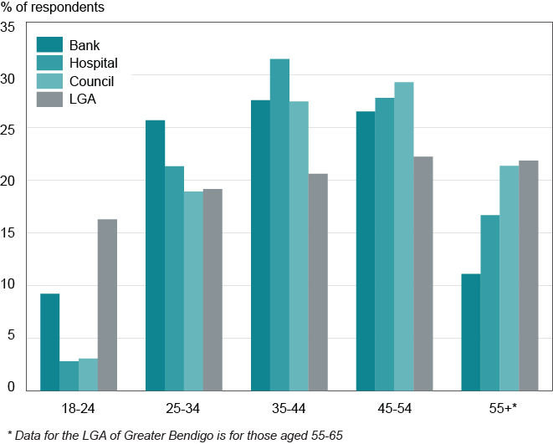

Sources: Bendigo Bank, Hospital and Council Surveys 2015

Chapter 3: Survey Findings

3.1 Locational backgrounds of the respondents

When the survey sample is considered as a whole, around a third of respondents were born in Bendigo (32.5%), a third in other parts of regional Victoria (32%) and 19 per cent in Melbourne. Other capital cities and interstate regional areas each accounted for less than 5 per cent of the sample while overseas born made up 8 per cent. All regional locations (Bendigo, Regional Victoria and Regional-Interstate) amounted to 69 per cent of the combined sample.

When the three organisations are compared, there is a notable dominance of the Bendigo-born at the Bank with 39 per cent of respondents being in this category compared to 26 per cent at the Council and only 19 per cent at the hospital (table 1). The Hospital shows a larger share originating from Melbourne (30%), however, it also has the highest proportion for those born in regional Victoria (38% compared to 31% at both the Bank and the Council).

Table 1: Birthplace of respondents, Bank, Hospital and Council samples

|  |  |  |  |
| --- | --- | --- | --- |
|  | **BANK** | **HOSPITAL** | **COUNCIL** |

|  |  |  |  |  |  |  |
| --- | --- | --- | --- | --- | --- | --- |
| **Where were you born?** | **No** | **%** | **No** | **%** | **No** | **%** |
| Bendigo | 171 | 39 | 22 | 19 | 45 | 26 |
| Melbourne | 70 | 16 | 35 | 30 | 34 | 19 |
| Capital City – Interstate | 11 | 2 | 5 | 4 | 14 | 8 |
| Regional Victoria (excl. Bendigo) | 134 | 31 | 45 | 38 | 54 | 31 |
| Regional – Interstate | 21 | 5 | 4 | 3 | 10 | 6 |
| Overseas | 32 | 7 | 7 | 6 | 18 | 10 |
| TOTAL | 439 | 100 | 118 | 100 | 175 | 100 |

Sources: Bendigo Bank, Hospital and Council Surveys 2015

3.2 Locational histories of the respondents

The survey gathered information on migration histories, not just birthplace. The key stages of life for which locational information was asked included:

* up until the age of 15;
* the period of secondary schooling; and,
* the period of post-school education and training.

A summary of findings is shown in figure 2. The chart shows the location of respondents at time of birth and at the three stages listed previously. Bendigo becomes increasingly represented as the location for employees as they moved through primary, secondary and tertiary schooling while regional Victoria becomes less prominent during post-school stages. This aligns with our understanding of aggregate migration moves of young people from rural areas to larger regional centres to access educational opportunities. The pattern holds for each of the organisations although the Bank starts with a higher base of Bendigo-born respondents and maintains a higher proportion of Bendigo-based respondents at each of the subsequent life stages. While overseas is a birthplace of some, there appears to be relatively little influence of overseas experience or training in any of the three organisations.

Figure 2: Locations of respondents at key life stages, combined Bendigo sample

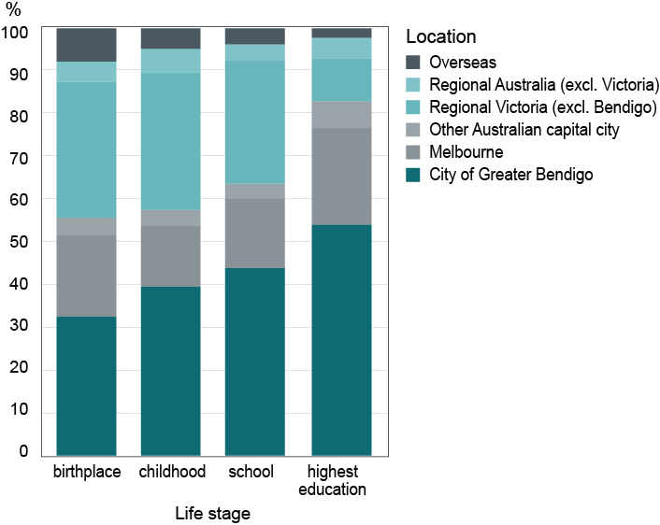

Sources: Bendigo Bank, Hospital and Council Surveys 2015

Although Melbourne becomes more important as a location during the attainment of higher qualifications, it is not of greater prominence than Bendigo for any of the organisations. This suggests that the local education and training sectors are playing an important role in delivering services to local businesses to facilitate human capital accumulation.

Where respondents answered all of the four locational questions, longitudinal locational patterns were able to be analysed. Sixty-five combinations were identified from a simplified location categorisation: Bendigo (B); other regional (R); metropolitan (M) and overseas (O). For example, a pattern of ‘MRBB’ would indicate a respondent who had been born in Melbourne, spent their childhood mostly in a regional location but secondary school and gaining post-school qualifications in Bendigo. A pattern of MMMM would be someone who had spent all of these points of time in Melbourne and was now in Bendigo as part of the organisation being surveyed. The most common migration history patterns are shown in figure 3. These nine patterns represent 71 per cent of the total sample of 639 useable responses.

Figure 3: Simplified migration histories, Bank, Hospital and Council samples

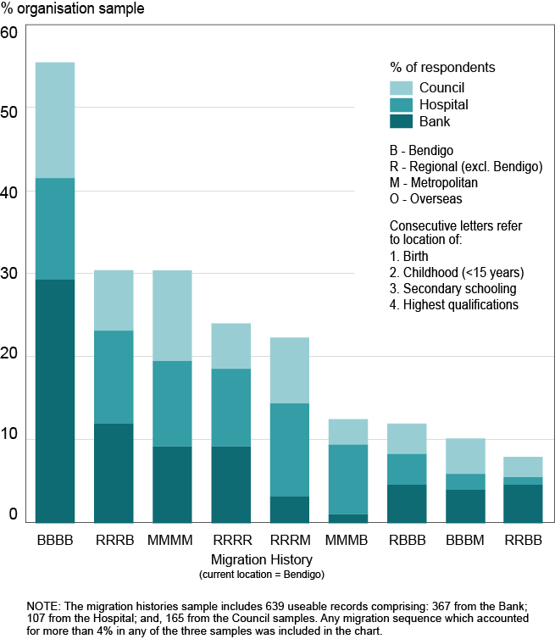

Sources: Bendigo Bank, Hospital and Council Surveys 2015

The dominance of the ‘Bendigo only’ pattern can be seen with 144 of the 639 usable responses being in this category. The Bank showed the highest proportion with this pattern (29.4%). A number of categories accounted for 10-14% of respondents in the three organisations. RRRB was relatively common in all organisations and accounted for 10.6% of the combined sample. This suggests that Bendigo is drawing from rural areas and other regional centres, mostly within Victoria. The appearance of MMMM (10% of total sample) and RRRR (8.3% of total sample) is of interest because, like the BBBB pattern, it suggests that non-migration is a common pattern. The anchors of family and friends are likely to be a reason for this.

Evidence of returnee migration can be seen in regional-metro-regional type patterns, for example the patterns of BBBM and RRRM. The latter pattern shows a return to the regional centre of Bendigo rather than a return to regional area of origin, a pattern noted earlier from previous qualitative research.

There is an important caveat to the data on these returnees. The survey questions asked respondents to state where they had attained their highest level of qualification. The 24 respondents showing the BBBM pattern had attained their highest qualification in Melbourne, however cross tabulation of their response with an earlier question ‘After the age of 15, have you lived outside the City of Greater Bendigo?’ reveals eight respondents who had not lived outside Bendigo after age 15 but had a post-school qualification from Melbourne, presumably through distance education or commuting.

3.3 Workplace role and locational background

Melbourne, like other metropolitan centres, provides an array of educational and employment opportunities, especially for specialist and professional training and senior management roles. For this reason it might be expected that regional centres would need to source highly skilled staff from larger cities. However, the survey data do not support this assumption.

In the combined sample, 44 per cent of those with management roles had gained their highest qualification in Bendigo. A further 19 per cent had gained their highest qualifications while in other regional locations and 35 per cent while in Melbourne or other capital cities. Thus 63 per cent of those in management roles had gained their highest qualification while living in a non-metropolitan location.

There is some variation between the three workforce samples with the Bank having a high proportion of managers who had trained in Bendigo (50%) and other regional (19%) areas (figure 4). The council sample had the highest proportion of managers who had been in metropolitan locations while gaining qualifications (52%) while the hospital had a relatively even representation between Bendigo (42%) and metropolitan (38%). The assumption that more senior roles require higher levels of education and experience may hold, but the degree to which these skills need to be acquired and utilised only in metropolitan areas is challenged by the findings.

Figure 4: Location while obtaining highest educational qualification for   
those holding a management role, Bank, Hospital and Council samples

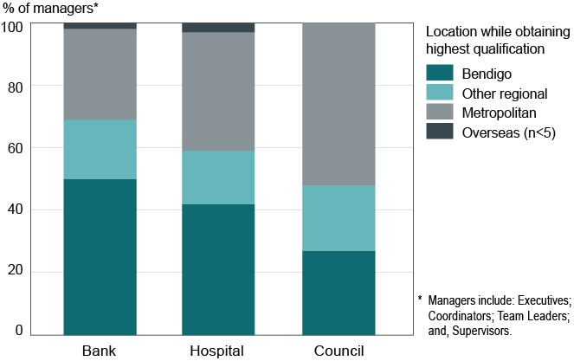

Sources: Bendigo Bank, Hospital and Council Surveys 2015

3.4 Reasons for moving to Bendigo

The respondents who had moved to Bendigo at some point in their lives were asked about their reasons for making the move – up to 3 reasons could be selected from a list of 8 options. A number of these options related to family and employment and have therefore been combined in table 2. The table reveals the dominance of family and employment reasons which account for 39 and 31 per cent of responses respectively in the combined sample. There is a large gap to education and training (12%) and amenity reasons (10%). Housing choice and affordability form only 5 per cent of all responses.

Table 2: Reasons for moving to Bendigo – Bank, Hospital, Council and combined samples

|  |  |  |  |  |  |  |  |  |
| --- | --- | --- | --- | --- | --- | --- | --- | --- |
|  | **BANK** | | **HOSPITAL** | | **COUNCIL** | | **TOTAL** | |
| **REASON FOR MOVING** | No | % | No | No | % | % | No | % |
| Family-related* | 103 | 44 | 42 | 34 | 60 | 35 | 205 | 39 |
| Employment-related** | 74 | 32 | 37 | 30 | 52 | 30 | 163 | 31 |
| Education / training | 37 | 16 | 10 | 8 | 14 | 8 | 61 | 12 |
| Amenity / lifestyle reasons | 9 | 4 | 20 | 16 | 22 | 13 | 51 | 10 |
| Housing choice / affordability | 1 | <1 | 10 | 8 | 15 | 9 | 26 | 5 |
| Other | 9 | 4 | 4 | 3 | 8 | 5 | 21 | 4 |
| TOTAL | 233 | 100 | 123 | 100 | 171 | 100 | 527 | 100 |

*\* includes: family reasons; follow spouse or partner; return to region of birth  
** includes: join current organisation; employment (other than current)*

Sources: Bendigo Bank, Hospital and Council Surveys 2015

An examination of responses based on the location prior to moving to Bendigo reveals the degree to which metropolitan and regional in-movers reported different reasons for moving. Figure 5 presents these data with the Metropolitan category comprising Melbourne and other capital cities and the Regional category including both regional Victoria and other regional Australia. Respondents who moved from overseas have been excluded due to small numbers.

Figure 5: Reasons for moving to Bendigo by prior location, combined sample

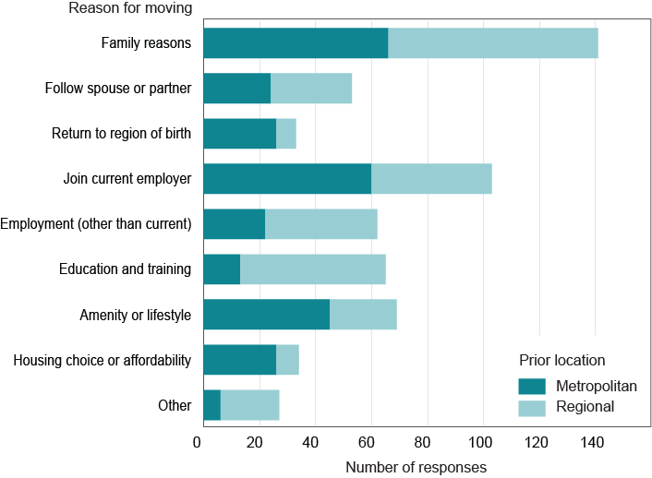

Sources: Bendigo Bank, Hospital and Council Surveys 2015

Family is a major reason for moving, irrespective of whether respondents came from regional or metropolitan backgrounds. Moving for the specific job was more significant for those moving from metropolitan areas, than regional areas. Many of those moving from regional areas had come to Bendigo seeking broader employment opportunities. This makes sense in terms of a regional centre like Bendigo offering a range of employment opportunities to people from smaller regional centres or rural areas. It also highlights the importance of specific job opportunities for metropolitan migrants. Those moving from metropolitan areas were also more likely to select ‘return to region of birth’, ‘amenity/lifestyle’ or ‘housing choice and affordability’ as reasons for moving than those from regional backgrounds.

3.5 Reported advantages of living in Bendigo

The survey offered open-ended questions about the advantages and disadvantages of living in Bendigo. Up to three items could be recorded and these were then grouped into broad categories for ease of analysis. Table 3 shows results for the combined sample in terms of reported advantages.

Table 3: Advantages of living in Bendigo, as reported by respondents

|  |  |  |  |
| --- | --- | --- | --- |
| **Theme** | **Examples** | **No. of responses** | **%** |
| Lifestyle | *Relaxed atmosphere; slower lifestyle.* | 229 | 14.1 |
| Less congestion/Good size | *Size of city makes it easy to commute; lack of traffic congestion compared to capital cities.* | 174 | 10.7 |
| Quality services/facilities | *High quality facilities - health care, education; sporting venues; arts; shops.* | 153 | 9.5 |
| Accessibility/Ease of travel | *Short drive to almost anything; ease of getting around; short distance between home and work.* | 151 | 9.3 |
| Affordability | *Cheaper housing costs; affordable acreage; cheaper cost of living.* | 139 | 8.6 |
| Close to family/friends | *Family here; close to my family/extended family.* | 126 | 7.8 |
| Access to Melbourne | *Accessible to Melbourne.* | 116 | 7.2 |
| Friendly community | *Community focus; community spirit.* | 103 | 6.4 |
| Employment | *Big enough city to provide good employment opportunities; Bank provides career opportunities.* | 95 | 5.9 |
| Access to services/activities | *Access to medical, sporting, education facilities.* | 85 | 5.3 |
| Location (not further defined) | *Central location in Victoria; central to Melbourne or the Murray River; central to most things.* | 69 | 4.3 |
| Natural amenity | *Pleasant place to live; bush; climate; landscape* | 63 | 3.9 |
| Good place to raise family | *Comfortable safe place to live and raise a family.* | 60 | 3.7 |
| Other |  | 35 | 2.2 |
| Built form | *Heritage buildings; parks and gardens.* | 21 | 1.3 |
| **TOTAL\*** |  | **1,619** | **100** |

*\* Up to 3 responses were allowed hence the number of responses is higher than the number of participants.*

Sources: Bendigo Bank, Hospital and Council Surveys 2015

The broad descriptor ‘lifestyle’ ranked highly in the frequency of responses (14%). This category included elements such as: work-life balance; less stress; slower pace; city lifestyle in a regional setting. Related to some of these themes was the second ranked-category, city-size, which accounted for 11% of responses. This included comments about the balance between being large enough to have city services, but small enough to avoid the negative aspects of large cities such as congestion, pollution and crime. Melbourne was often mentioned as having such problems. In contrast, Bendigo was regarded as ‘big enough to have its own identity but small enough to be welcoming’ (survey respondent). Generalaccessibility, proximity to work and ease of travel was a commonly reported advantage of Bendigo.

Affordability (in terms of both housing costs and general cost of living) and the accessibility and quality of services also ranked highly in respondents’ lists of advantages. There was general consistency of responses across the three organisations with most categories showing little variation.

It is interesting to note that the most important drivers of migration and the most often reported advantages of living in Bendigo were not the same. Whereas key drivers were found to be family and employment, these appear less often in the list of advantages, highlighting the differences between why people move to, and why people like, a particular location. For example, housing choice and affordability appears to have relatively little significance as a *driver* of migration, but was listed by many as an *advantage* of living in Bendigo. From a policy perspective it would seem to be important to distinguish between the drivers of migration and locational advantages. Just because a place has a key advantage (like affordable housing), it may not act as a driver to attract in-migration. In fact, affordable house prices are a very poor indicator of migration potential as some of the most expensive cities still attract in-migration. Appealing to former regional residents to return to a regional locational might prove to be a more effective strategy.

3.6 Reported disadvantages of living in Bendigo

The most commonly listed disadvantage of living in Bendigo was ‘infrastructure’ (18%) (table 4). This was particularly the case among Bank employees, 23% of whose responses included issues in this category, compared to only 10% in the Council sample. The main infrastructure issues were related to parking and public transport. The category of jobs/income was mentioned in 16% of the responses, mostly issues such as: limited career pathways outside the current organisation, and the discrepancy between regional and metropolitan incomes.

Environmental factors were mentioned in 136 (11%) of all responses. The vast majority of these related to water in some way, either in terms of the dryness and heat of the climate, the lack of recreational water nearby, and water supply issues. Fifty-five responses in this category referred specifically to the lack of a beach, an issue that would not seem to be amenable to policy intervention; likewise, the reality of hotness (20 responses) and dryness (10 responses) of the climate.

There is a greater level of variation between organisations regarding disadvantages compared to advantages. Issues relating to local ‘culture’ appeared more often in the Hospital and Council samples. This may reflect the timing of those surveys (November 2015) compared to the Bank (June 2015). A greater number of comments relating to multiculturalism in Bendigo (the ‘lack of’, or in a few cases, ‘problems with’), along with comments about intolerance and community conflict is likely to reflect the high level of media attention given to protests over a proposed mosque development in the latter part of 2015. The mosque issue itself was not mentioned, but comments such as: ‘negative discriminatory attitudes’ and ‘recent political climate means there is a lot of unrest’ is suggestive of the public controversy over this issue.

Table 4: Disadvantages of living in Bendigo, as reported by respondents

|  |  |  |  |
| --- | --- | --- | --- |
| **Theme** | **Examples** | **No of responses** | **%** |
| Infrastructure | *Lack of car parking; public transport.* | 212 | 17.7 |
| Jobs/Income | *Can be difficult to find work; limited employment opportunities for young adults; lower salaries; lack of senior professional roles.* | 194 | 16.2 |
| Environment | *No beach; no river/lake; too hot/dry.* | 136 | 11.3 |
| Services | *Limited choice of schools; lack of medical specialists; childcare expensive and hard to find.* | 121 | 10.1 |
| Location/Distance | *Distance to Melbourne.* | 120 | 10.0 |
| Culture | *Old boys clubs; small town mentality; anti multicultural attitude.* | 101 | 8.4 |
| Lack of activity | *Lack of shopping; don’t get big events; boredom.* | 98 | 8.2 |
| Council | *Hard to obtain approvals; rates too high; lack of funding for sport.* | 62 | 5.2 |
| Social issues | *Growing drug culture; crime.* | 43 | 3.6 |
| Cost of living | *Cost of living too high / rising.* | 36 | 3.0 |
| Congestion | *Traffic.* | 32 | 2.7 |
| None | *No disadvantages* | 27 | 2.2 |
| Other |  | 18 | 1.5 |
| **TOTAL\*** |  | 1,200 | 100.0 |

*\* Up to 3 responses were allowed hence the number of responses is higher than the number of participants.*

Sources: Bendigo Bank, Hospital and Council Surveys 2015

3.7 Future migration intentions

Most respondents (85%) had no intention to move away from Bendigo in the near future. The hospital had the highest proportion intending to leave within two years (20%) and Council had the lowest proportion (10%) (figure 6).

Figure 6: Intention to leave Bendigo in next two years, respondents as a proportion of total Bank, Hospital and Council samples

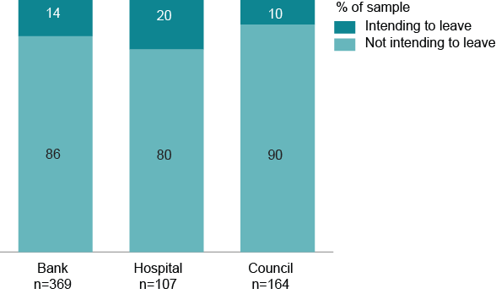

Sources: Bendigo Bank, Hospital and Council Surveys 2015

For those indicating an intention to leave, Melbourne was the most popular destination (33%) followed by regional Victoria (26%). Interstate locations accounted for 9 per cent (capital city) and 7 per cent (regional) while overseas accounted for 9 per cent of respondents’ intended destinations. Seventeen per cent remained unsure about their potential destination.

When age is factored in to the analysis the results show that those in younger age groups appear more likely to move from Bendigo in the near future (figure 7). Given that people in their early adult years are, on average, the most mobile age group in the population, this result is not surprising.

**Figure 7: Intention to leave Bendigo in next two years by age group, combined sample**

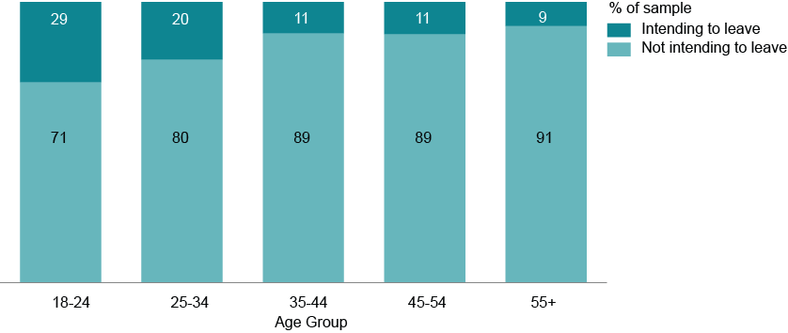

Sources: Bendigo Bank, Hospital and Council Surveys 2015

Chapter 4: Policy implications

Young adults gain skills and experience through school and post-school education and through entry into the workforce. The locational choices made by people as they accumulate human capital can ultimately favour different locations. With a long standing pattern of net loss of young adults from regional areas, the concern held by many policy makers is that areas of net loss of young people (such as regional Victoria) may lead to a net loss of the human capital needed to maintain and expand regional economies.

National-level data indicate that, by the age of 23, around a third of those who had left regional areas for education or employment had returned to a regional location. This presents a positive story for regions in terms of human capital accumulation as skills learnt and developed in places like Melbourne can be transferred to regional areas. There is also likely to be additional return migration after the age of 23 although existing longitudinal data does not provide comprehensive evidence of these pathway patterns.

In terms of human capital accumulation, another piece of positive evidence for regional areas comes from the Bendigo Bank survey results. Findings indicate that the development of professional skills can occur effectively within regions rather than being dependent on individuals moving (temporarily or permanently) to a metropolitan area for higher education. The high proportion of senior Bank employees who had come from regional backgrounds showed that, even for globally-connected professions like financial services, a metropolitan education is not essential. It should be noted that, in the case of Bendigo Bank, the organisation itself played an important role in the skills development of their staff. Scholarships, internships and partnerships with local education providers form an important part of the company’s culture. This benefits the bank, in terms of overcoming skills shortages, but it also benefits employees through sponsorship of their education locally, and local service providers through the purchase of education and training services within the regional city.

The Bendigo survey also highlighted the role of family factors in peoples’ migration decisions. Among the various components of this category are people moving to be closer to parents or other relatives and those who are returning to the region of their birth after leaving Bendigo at an earlier age. The significance of this for regional policy makers is that having a connection with a place (through family for example) makes moving there more likely. Given that social networks usually act as an anchor on migration, it is likely to be much more difficult for people who have lived their lives in a major city to consider living in a regional location. For policy makers interested in attracting people to a regional location, targeting people who grew up in such areas may be an effective strategy.

References

Barro R, 1992, 'Human capital and economic growth', in *Policies for long-run economic growth, a symposium sponsored by the Federal Reserve Bank of Kansas City*, Kansas.

Corcoran, J, Faggian, A and McCann, P 2010, 'Human capital in remote and rural Australia: The role of graduate migration', *Growth and Change*, vol. 41, no. 2, pp. 192-220.

Hogan, A and Young, M 2013, 'Visioning a future for rural and regional Australia', *Regions, Economy and Society* 6(2) 319-30.

McKenzie, F. 2010, ‘The influence of tertiary institutions on regional youth migration in Victoria’, in P. Dalziel (ed), *Innovation and Regions: Theory, Practice and Policy. Refereed Proceedings of the 34th Annual Conference of the Australia and New Zealand Regional Science Association International, 7-10 December 2010, Melbourne,* pp. 144-160. Published by AERU Research Unit, Lincoln University, New Zealand.

Romer, P 1986, 'Increasing returns and long-run growth', *Journal of Political Economy*, 94(5): 1002-1037.

Appendix: Detailed Survey Results







1. *ARC Linkage Project LP LP120100212 ‘Attraction and Retention: The role of mobility in educational pathways and human capital development’, involving a partnership between the Victorian Government, University of Queensland, Graduate Careers Australia and Latrobe University Bendigo.*