SCHEDULE 1 TO THE COMPREHENSIVE DEVELOPMENT ZONE
--/--/20--
C--
Shown on the planning scheme map as CDZ1
NORTH ROAD ORMOND COMPREHENSIVE DEVELOPMENT PLAN
Land
This clause applies to the land shown in Figure 1, which comprises the Ormond Railway Station and associated land.

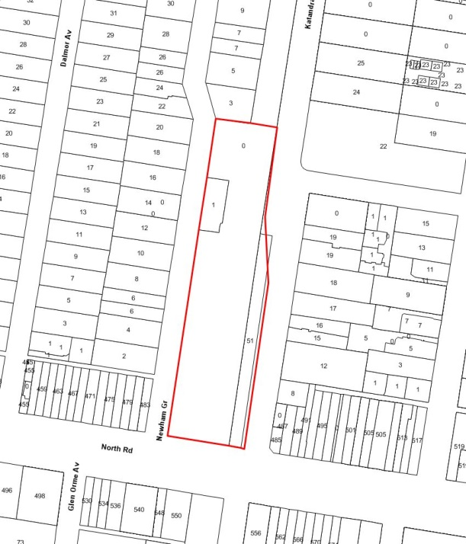
Figure 1
Note: The exact alignment of the boundary along Katandra Road will be finalised upon receipt of the as-built survey drawings for the core infrastructure works.

Purpose
- To realise the substantial urban renewal and development opportunities made available through the removal of the level crossing at North Road, Ormond.
- To give effect to the North Road Ormond Comprehensive Development Plan (August 2016).
- To ensure the successful integration of new development and the works permitted by the North Road Ormond Level Crossing Removal Project Incorporated Document (July 2015).
- Table of uses
--/--/20--
C--
Section 1 - Permit not required
Use | Condition
Accommodation (other than Corrective institution) | No dwellings at ground floor level in Precinct A as outlined in the North Road Ormond Comprehensive Development Plan.
Bus terminal
Car park
Display home
Food and Drink Premises (other than Hotel and Tavern) | Must be located within Precincts A or B as outlined in the North Road Ormond Comprehensive Development Plan.  The combined maximum leasable floor area for all Food and Drink Premises and Shop uses must not exceed 6,900 square metres
Home occupation
Minor utility installation
Office | Must be located within Precincts A or B as outlined in the North Road, Ormond Comprehensive Development Plan.  The combined leasable floor area for all office use on the land must not exceed 500 square metres.
Railway
Railway station
Restricted Recreation Facility | Must be located within Precincts A or B as outlined in the North Road, Ormond Comprehensive Development Plan.  The maximum leasable floor area must not exceed 500 square metres.
Shop (other than Adult sex bookshop) | The combined leasable floor area for all Shop uses and Food and Drink Premises must not exceed 6,900 square metres.
Telecommunications facility
Tramway
Any use in Clause 62.01 | Must meet the requirements of Clause 62.01

Section 2 - Permit required
Use | Condition
Child care centre
Education centre
Industry | Must not be a purpose listed in the table to Clause 52.10
Leisure and recreation facility (other than Restricted recreation facility)
Place of assembly
Retail premises (other than Shop, Food and drink premises and Take away food premises)
Utility installation (other than Minor utility installation and Telecommunications facility)

Warehouse | Must not be a purpose listed in the table to Clause 52.10
Any other use not in Section 1 or 3
Section 3 - Prohibited
Use
Adult sex bookshop
Brothel
Corrective institution

2.0 Use of land
--/--/20--
C--
A use must not detrimentally affect the amenity of the surrounding area, including through the:
- Transport of materials, goods or commodities to or from the land.
- Appearance of any building, works or materials.
- Emission of noise, artificial light, vibration, smell, fumes, smoke, vapour, steam, soot, ash, dust, waste water, waste products, grit or oil.
3.0 Subdivision
--/--/20--
C--
Exemption from notice and review
An application to subdivide land is exempt from the notice requirements of Section 52(1)(a), (b) and (d), the decision requirements of Section 64(1), (2) and (3) and the review rights of Section 82(1) of the Act.
4.0 Buildings and works
--/--/20--
C--
Permit requirement
A permit is not required to:
- Install an automatic teller machine.
- Alter an existing building façade provided:
  - The alteration does not include the installation of an external roller shutter.
  - At least 80 per cent of the building façade at ground floor level is maintained as an entry or window with clear glazing.
- Install an awning that projects over a road if it is authorised by the relevant public land manager.
- Undertake any buildings and works permitted by the North Road Ormond Level Crossing Removal Project Incorporated Document (July 2015).
- Undertake buildings and works for the purposes of railway operations, including signals (and related control buildings), new tracks, track-work and realignment, train stabling, overhead power lines, gantries, buildings and works related to railway power requirements and any works required under the Disability Discrimination Act – Disability Standards for Accessible Public Transport 2002.

Application requirements
An application to construct a building or construct or carry out works must be accompanied by the following information, as appropriate:
- A report and drawings that detail how the proposal responds to the Objectives, Design Principles and Application Requirements set out in the North Road Ormond Comprehensive Development Plan (July 2016).
- A Staging Plan outlining the proposed stages for delivery of the development.
- An Urban Context Report and Design Response to the satisfaction of the responsible authority that addresses the matters set out in the North Road Ormond Comprehensive Development Plan.
- An Integrated Transport Plan to the satisfaction of the responsible authority that addresses the matters set out in the North Road Ormond Comprehensive Development Plan.
- A Traffic, Loading, Parking and Access Management Plan to the satisfaction of the responsible authority that addresses the matters set out in the North Road Ormond Comprehensive Development Plan.
- A Waste Management Plan to the satisfaction of the responsible authority that addresses the matters set out in the North Road Ormond Comprehensive Development Plan.
- A Sustainability Management Plan to the satisfaction of the responsible authority that addresses the matters set out in the North Road Ormond Comprehensive Development Plan.
- A Landscape Plan to the satisfaction of the responsible authority that addresses the matters set out in the North Road Ormond Comprehensive Development Plan.
- An Acoustic and Vibration Report to the satisfaction of the responsible authority that addresses the matters set out in the North Road Ormond Comprehensive Development Plan.
- An Environmental Site Assessment to the satisfaction of the responsible authority that addresses the matters set out in the North Road Ormond Comprehensive Development Plan.
Before deciding on an application for buildings and works, the responsible authority may seek the views of VicTrack, VicRoads, and Public Transport Victoria, where relevant.
5.0 Decision Guidelines
--/--/20--
C--
Before deciding on an application, in addition to the decision guidelines in clause 65, the responsible authority must consider, as appropriate:
- The North Road Ormond Comprehensive Development Plan (July 2016).
- The North Road Ormond Level Crossing Removal Project Incorporated Document (July 2015).
6.0 Conditions and requirements for permits
--/--/20--
C--
Any planning permit issued must, where appropriate, include the following conditions:
- A Construction Management Plan must be prepared to the satisfaction of the responsible authority and in consultation with Public Transport Victoria and VicRoads, detailing how impacts associated with construction of the development will be managed, to include, as appropriate:
  - Staging of construction.
  - Management of public access and linkages around the site during construction, and consideration of public safety.
  - Site access, parking and traffic management.
  - Any works within the road reserves of surrounding streets.
  - Any impacts on public transport operations.
  - Hours of construction.
  - Control of noise, dust and soiling of roadways, including sediment control and site drainage.
  - Storage of construction materials.
  - Location of site offices, and cranes.
  - Collection and disposal of building and construction waste.
  - Methodology for responding to complaints associated with the construction works and provide site manager contact details.
A Construction Management Plan may be prepared for each stage of the development to the satisfaction of the responsible authority.
- An Emergency Evacuation Plan must be prepared to the satisfaction of the responsible authority in respect of the development and must include an Emergency Evacuation Plan for the railway station, prepared in consultation with Public Transport Victoria, VicRoads, VicTrack, Glen Eira City Council, Metro Trains Melbourne and relevant emergency services agencies.
- A condition detailing any identified public realm works and improvements (to be completed at the cost of the developer).
7.0 Bicycle Parking Provision
--/--/20--
C--
Unless with the consent of the responsible authority, 20 commuter bicycle parking spaces must be provided on the subject land.
Except with a permit, bicycle parking must be provided on the subject land in accordance with the rates set out in Table 1 to Clause 52.34-3.
If in calculating the number of bicycle facilities the result is not a whole number, the required number of bicycle facilities is the nearest whole number. If the fraction is one-half, the requirement is the next whole number.
Shower and change room facilities will be required for employees where five or more employee bicycle parking spaces are required. One shower with access to a change room will be required for the first five employee bicycle parking spaces, plus one shower with access to a change room to each 10 employee bicycle parking spaces thereafter.
A permit may be granted to vary bicycle facilities requirements.
In determining whether to approve a variation (including a reduction to zero) of the requirements for bicycle facilities, the responsible authority must consider the decision guidelines at Clause 52.34-2 and whether it is proposed to provide commuter bicycle parking.
Exemption from notice and review
An application to vary the number of bicycle parking rates or facilities required for a use is exempt from the notice requirements of Section 52(1)(a), (b) and (d), the decision requirements of Section 64(1), (2) and (3) and the review rights of Section 82(1) of the Act.
8.0 Car Parking Provision
--/--/20--
C--
Unless with the consent of the responsible authority, 120 commuter car parking spaces must be provided on the subject land.
Except with a permit, car parking must be provided on the subject land in accordance with the rates set out in column A of Table 1 of Clause 52.06-5
If in calculating the number of car parking spaces the result is not a whole number, the required number of car parking spaces is to be rounded down to the nearest whole number.
A permit may be granted to vary the number of car spaces required for a particular use.
In determining whether to approve a variation (including a reduction to zero) of the number of car parking spaces required for a use, the responsible authority must consider as appropriate:
- Whether it is proposed to provide commuter car parking spaces.
- The availability of public transport in the locality of the land.
- Any effect on vehicle and pedestrian movements in the area.
- Any empirical analysis which supports a variation in the number of car parking spaces that should be provided.
- The likelihood of multi-purpose trips within the locality which are likely to be combined with a trip to the land in connection with the proposed use.
- The variation of car parking demand likely to be generated by the proposed use over time.
- The short-term and long-term car parking demand likely to be generated by the proposed use.
- The anticipated car ownership rates of occupants (residents or employees) of the land.
- Whether design or other constraints warrant reducing the car parking requirement.
- Any other relevant consideration.
The car parking requirement specified above is inclusive of disabled car parking spaces. The proportion of spaces to be allocated as disabled spaces must be in accordance with the Building Code of Australia.
Exemption from notice and review
An application to vary the number of car parking spaces required for a use is exempt from the notice requirements of Section 52(1)(a), (b) and (d), the decision requirements of Section 64(1), (2) and (3) and the review rights of Section 82(1) of the Act.
9.0 Traffic mitigation works
--/--/20--
C--
Prior to a permit being granted under this schedule, the owner must enter into an agreement under section 173 of the Planning and Environment Act 1987 with the Responsible Authority and VicRoads for:
- the provision at the owner’s cost of traffic management measures generally in accordance with the North Road/Katandra/Cadby Avenue Signalised Intersection Concept Layout Plan, Drawing Number 16M1141000-02P1 dated 12 November 2015 prepared by GTA Consultants; or
- alternative traffic mitigation works to the satisfaction of the Responsible Authority and VicRoads.
The owner must pay all of the responsible authority’s reasonable legal costs and expenses for this agreement including its preparation, execution and registration on title.
10.0 Advertising signs
--/--/20--
C--
Advertising sign requirements are at Clause 52.05. This zone is in Category 1.
An application under Clause 52.05 is exempt from the notice requirements of Section 52(1)(a), (b) and (d), the decision requirements of Section 64(1), (2) and (3) and the review rights of Section 82(1) of the Act.
11.0 Licensed Premises
--/--/20--
C--
Clause 52.27 does not apply to an application for a BYO Permit Licence, Packaged Liquor Licence or Restaurant and Café License.
12.0 Other provisions of this scheme
--/--/20--
C--
Where any provision in this schedule is inconsistent with the North Road Ormond Level Crossing Removal Project Incorporated Document (July 2015), the North Road Ormond Level Crossing Removal Project Incorporated Document (July 2015) prevails to the extent of such inconsistency.
Subject to clause 10.0 and clause 11.0, other than clauses 52.01 (Public Open Space Contribution and Subdivision), 52.05 (Advertising Signs), 52.27 (Licensed Premises) and 52.28 (Gaming), no particular provision in this scheme applies to a development that is generally consistent with the North Road Ormond Comprehensive Development Plan (August 2016).

