
Guidance document


Clause 55 Two or more dwellings on a lot and residential buildings




Townhouse and Low-Rise
Code Guidelines
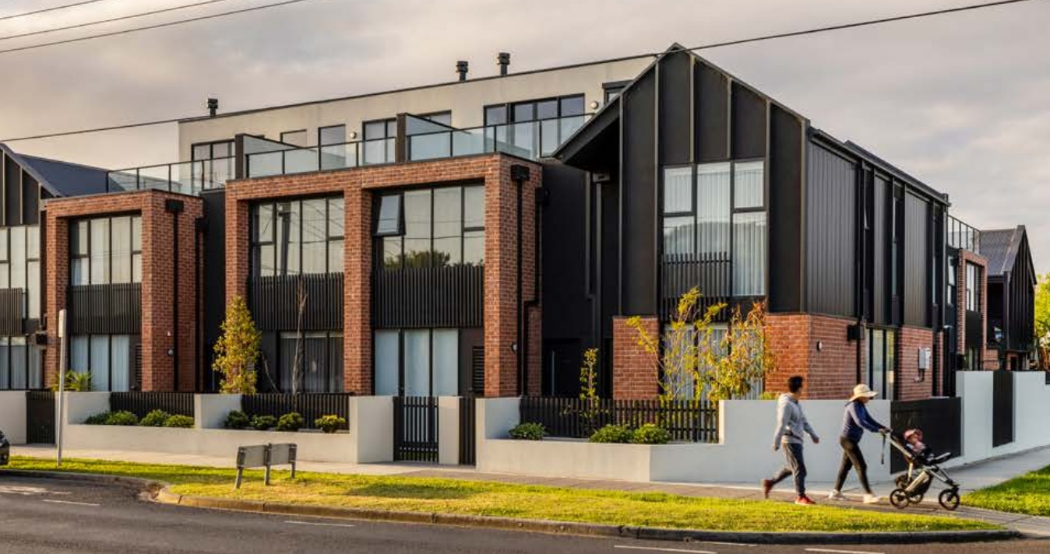
Version 2 – May 2025
Contents
UNDERSTANDING CLAUSE 55 STANDARDS 5
APPLICATION OF RESIDENTIAL DEVELOPMENT STANDARDS 6
CLAUSE 55 7
55.02 NEIGHBOURHOOD CHARACTER 6
Standard B2-1 Street setback 6
Standard B2-2 Building height 10
Standard B2-3 Side and rear setbacks 11
Standard B2-4 Walls on boundaries 15
Standard B2-5 Site coverage 19
Standard B2-6 Access 21
Standard B2-7 Tree canopy 23
Standard B2-8 Front fences 31
55.03 LIVEABILITY 32
Standard B3-1 Dwelling diversity 32
Standard B3-2 Parking location 34
Standard B3-3 Street integration 35
Standard B3-4 Entry 37
Standard B3-5 Private open space 39
Standard B3-6 Solar access to open space 43
Standard B3-7 Functional layout 45
Standard B3-8 Room depth 47
Standard B3-9 Daylight to new windows 49
Standard B3-10 Natural ventilation 51
Standard B3-11 Storage 54
55.04 EXTERNAL AMENITY 60
Standard B4-1 Daylight to existing windows 60
Standard B4-2 Existing north-facing windows 63
Standard B4-3 Overshadowing secluded open space objective 65
Standard B4-4 Overlooking 68
Standard B4-5 Internal views 72
55.05 SUSTAINABILITY 74
Standard B5-1 Permeability and stormwater management 74
Standard B5-2 Overshadowing domestic solar energy systems 77
Standard B5-3 Rooftop solar energy generation area 79
Standard B5-4 Solar protection to new north-facing windows 82
Standard B5-5 Waste and recycling 83
Standard B5-6 Noise impacts 87
Standard B5-7 Energy efficiency for apartment developments 88

Note.
This document is not a substitute for meeting the requirements of clause 55 in planning schemes.
This document incorporates the standards as approved by Amendment VC276.

UNDERSTANDING CLAUSE 55 STANDARDS
Meeting the requirements of clause 55
Clause 55 applies to an application to construct and extend of two or more dwellings on a lot, dwellings on common property and residential buildings specified in:
32.04-7, Mixed Use Zone,
32.05-8, Township Zone,
32.07-6, Residential Growth Zone,
32.08-7, General Residential Zone,
32.09-7, Neighbourhood Residential Zone,
32.10-5, Housing Choice and Transport Zone.
Clause 55 specifies objectives that must be met. The objective describes the outcome to be achieved in the completed development. A development must meet all of the applicable objectives of the clause before a permit can be issued.
Each objective contains a relevant standard. A standard contains the requirements to meet the corresponding objective.
If a development meets a standard:
- The corresponding objective is deemed to be met;
- The responsible authority is not required to consider the corresponding decision guidelines or other policies or decisions guidelines pertaining to that matter.
If a development does not meet a standard, the responsible authority must consider the applicable decision guidelines in determining whether the corresponding objective is met.
If a zone or an overlay specifies a requirement of a standard, different from a requirement set out in the clause, the requirement of the zone or overlay applies.
Clause 55 sets out matters that a responsible authority is exempt from and is not required to consider in determining applications to which clause 55 applies.
For detailed information on the operation of the objectives, standards and decision guidelines, refer to clause 55 of the planning scheme.

APPLICATION OF RESIDENTIAL DEVELOPMENT STANDARDS

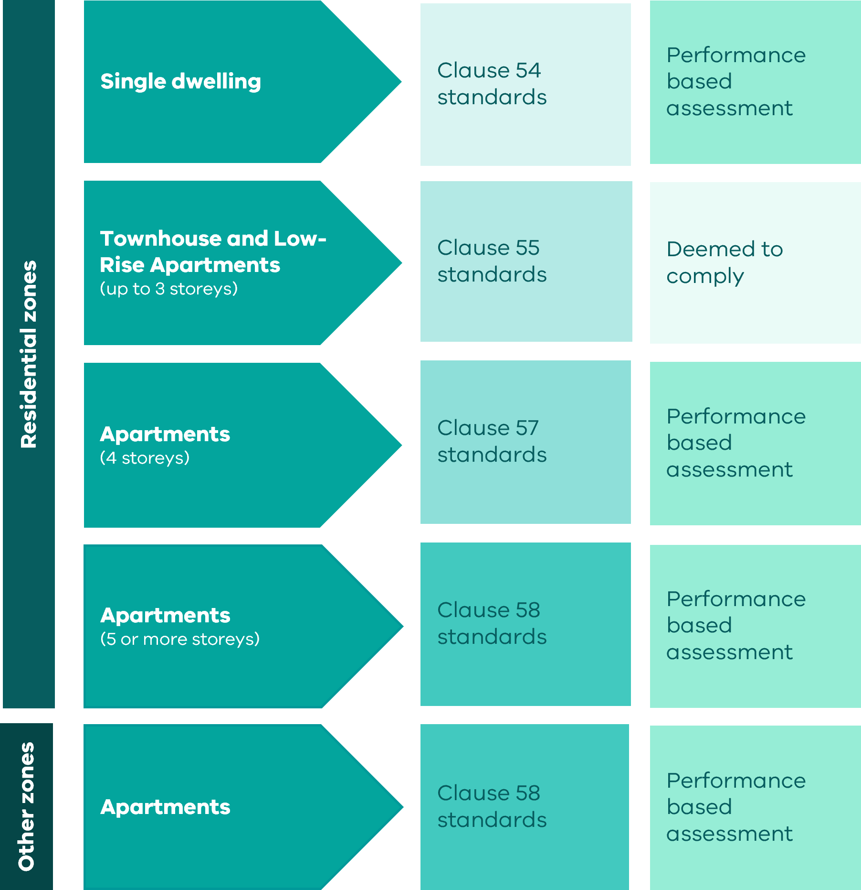

CLAUSE 55
Clause | Standard |  | Clause | Standard
55.01 Application requirements |  |  | 55.03-8 | B3-8 Room depth
55.01-1 Site description |  |  | 55.03-9 | B3-9 Daylight to new windows
55.01-2 Design response |  |  | 55.03-10 | B3-10 Natural ventilation
55.02 Neighbourhood Character |  |  | 55.03-11 | B3-11 Storage
55.02-1 | B2-1 Street setback |  | 55.03-12 | B3-12 Accessibility for apartment developments
55.02-2 | B2-2 Building height |  | 55.04 External Amenity
55.02-3 | B2-3 Side and rear setbacks |  | 55.04-1 | B4-1 Daylight to existing windows
55.02-4 | B2-4 Walls on boundaries |  | 55.04-2 | B4-2 Existing north-facing windows
55.02-5 | B2-5 Site coverage |  | 55.04-3 | B4-3 Overshadowing secluded open space
55.02-6 | B2-6 Access |  | 55.04-4 | B4-4 Overlooking
55.02-7 | B2-7 Tree canopy |  | 55.04-5 | B4-5 Internal views
55.02-8 | B2-8 Front fences |  | 55.05 Sustainability
55.03 Liveability |  |  | 55.05-1 | B5-1 Permeability and stormwater management
55.03-1 | B3-1 Dwelling diversity |  | 55.05-2 | B5-2 Overshadowing domestic solar energy systems
55.03-2 | B3-2 Parking location |  | 55.05-3 | B5-3 Rooftop solar energy generation area
55.03-3 | B3-3 Street integration |  | 55.05-4 | B5-4 Solar protection to new north-facing windows
55.03-4 | B3-4 Entry |  | 55.05-5 | B5-5 Waste and recycling
55.03-5 | B3-5 Private open space |  | 55.05-6 | B5-6 Noise impacts
55.03-6 | B3-6 Solar access to open space |  | 55.05-7 | B5-7 Energy efficiency for apartment developments
55.03-7 | B3-7 Functional layout |  | 55.05-7 | B5-7 Energy efficiency for apartment developments

CLAUSE 55 STANDARDS

55.02 NEIGHBOURHOOD CHARACTER

Standard B2-1 Street setback
Why is this important
The setback of buildings from the street defines the spatial relationship between buildings and the street and is a key determinant of neighbourhood character by contributing to the overall aesthetic, pedestrian experience, and sense of openness in the street.
Importantly, the street setbacks provide space for the planting and growth of canopy trees. This standard relates the front setback to neighbouring setbacks, so all new buildings respond to the street’s character and make efficient use of the site.

Street setback objective
To ensure that the setbacks of buildings from a street respond to the existing or preferred neighbourhood character and make efficient use of the site.

Standard B2-1
Walls of buildings are set back from streets:
- At least the distance specified in a schedule to the zone if the distance specified in the schedule is less than the distance specified in Table B2-1; or
- If no distance is specified in a schedule to the zone, the distance specified in Table B2-1.
Porches, pergolas and verandahs that are less than 3.6 metres high and eaves may encroach not more than 2.5 metres into the setbacks of this standard.
Table B2-1 Street setback
Development context | Minimum setback from front street | Minimum setback from a side street
There is an existing building on both the abutting allotments facing the same street, and the site is not on a corner. | The same distance as the lesser front wall setback of the existing buildings on the abutting allotments facing the front street or 6 metres, whichever is the lesser. | Not applicable
There is an existing building on one abutting allotment facing the same street and no existing building on the other abutting allotment facing the same street, and the site is not on a corner. | The same distance as the setback of the front wall of the existing building on the abutting allotment facing the front street or 6 metres, whichever is the lesser. | Not applicable
There is no existing building on either of the abutting allotments facing the same street, and the site is not on a corner. | 6 metres for streets in a Transport Zone 2 and 4 metres for other streets. | Not applicable
The site is on a corner. | If there is a building on the abutting allotment facing the front street, the same distance as the setback of the front wall of the existing building on the abutting allotment facing the front street or 6 metres, whichever is the lesser.  If there is no building on the abutting allotment facing the front street, 6 metres for streets in a Transport Zone 2 and 4 metres for other streets. | Front walls of new development fronting the side street of a corner site are setback at least the same distance as the setback of the front wall of any existing building on the abutting allotment facing the side street or 3 metres, whichever is the lesser.  Side walls of new development on a corner site are setback the same distance as the setback of the front wall of any existing building on the abutting allotment facing the side street or 2 metres, whichever is the lesser.

Decision Guidelines
Before deciding on an application, the responsible authority must consider:
- Any relevant neighbourhood character objective, policy or statement set out in this scheme.
- The design response.
- Whether the siting of the building is constrained by the shape, dimensions, slope or other conditions of the site.
- Whether a different setback would be more appropriate taking into account the prevailing setbacks of existing buildings on nearby lots.
- The visual impact of the building when viewed from the street and from adjoining properties.
- Whether a different setback affects the ability to retain or plant canopy trees.

Applying the standard
Existing buildings on both the abutting allotments/lesser setback  New buildings take their reference for front setback from the abutting dwellings or 6 metres, whichever is the lesser. |  | 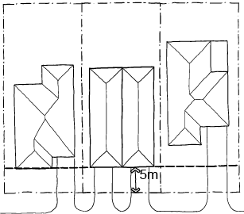
If the abutting building setback is less than 6 metres, the new building can have a minimum setback that is the same.

If the abutting dwelling setback is greater than 6 metres, the new dwelling can have a minimum setback of 6 metres. |  | 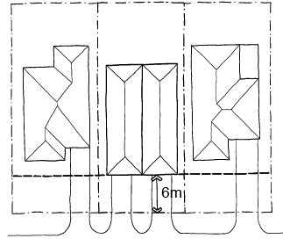
Front setback where there is only one existing abutting dwelling  A new dwelling takes its reference for front setback from the abutting dwelling or 6 metres, whichever is the lesser.  If the abutting dwelling setback is greater than 6 metres, the new dwelling can have a setback of 6 metres. |  | 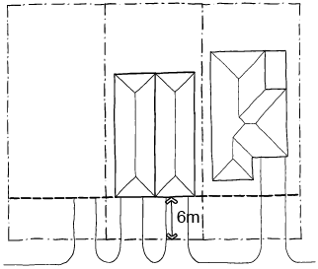
Setbacks on a corner lot  Either street frontage may be selected as the front setback on a corner lot.  Front street setback (A)  New dwellings are to be set back the same distance as the front setback of the abutting dwelling facing the same street or 6 metres, whichever is the lesser.  There is only one front street setback for the purposes of this standard.  If there is no building on the abutting allotment facing the front street, 6 metres for streets in a Transport Zone 2 and 4 metres for other streets | 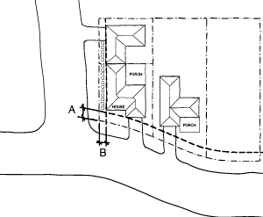
Side street setback (B)
New developments fronting a side street are set back:
- The same distance as an adjoining development facing the side street (if lesser) or 3 metres (if lesser)
New developments with a side wall to a side street are set back:
- The same distance as an adjoining development facing the side street (if lesser) or 2 metres (if lesser)

Allowable encroachments  Porches, pergolas, and verandahs can encroach up to 2.5 metres into the front setback, provided they are less than 3.6 metres high.  Eaves can also encroach up to 2.5 metres into the front setback. | 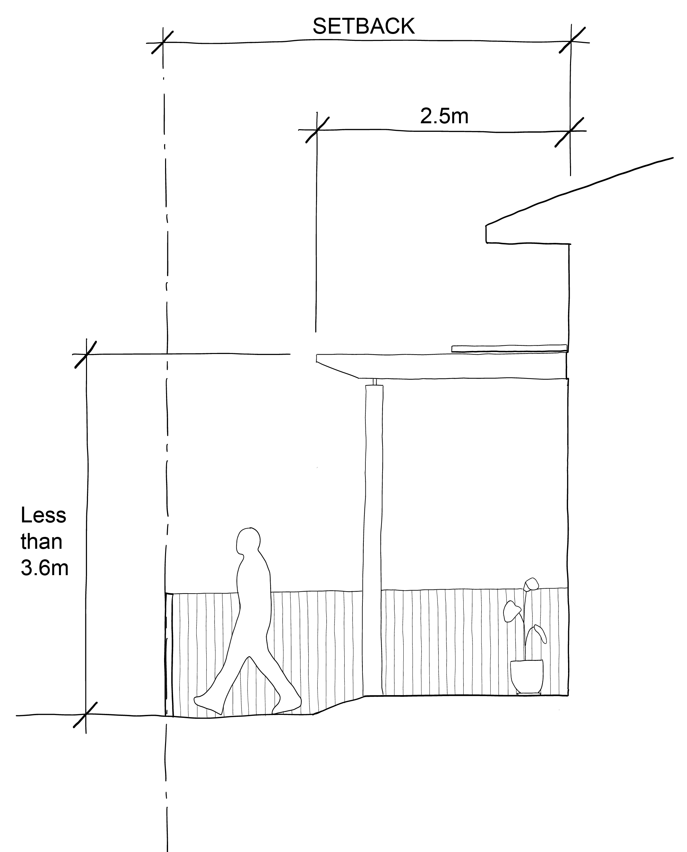

Standard B2-2 Building height
Why this is important
Building height is an important aspect of both character and amenity in residential areas. The standard protects the amenity of properties near new development and ensures that excessive building height does not diminish the character of neighbourhoods.
Building height objective
To ensure that the height of buildings respond to the existing or preferred neighbourhood character.
Standard B2-2
The maximum building height does not exceed the maximum height specified in the zone, schedule to the zone or an overlay that applies to the land.
If no maximum height is specified in the zone, schedule to the zone or an overlay, the maximum building height does not exceed 9 metres, unless the slope of the natural ground level at any cross section wider than 8 metres of the site of the building is 2.5 degrees or more, in which case the maximum building height does not exceed 10 metres.
Decision Guidelines
Before deciding on an application, the responsible authority must consider:
- Any relevant neighbourhood character objective, policy or statement set out in this scheme.
- Any maximum building height specified in the zone, a schedule to the zone or an overlay applying to the land.
- The design response
- The effect of the slope of the site on the height of the building.
- The relationship between the proposed building height and the height of existing adjacent buildings.
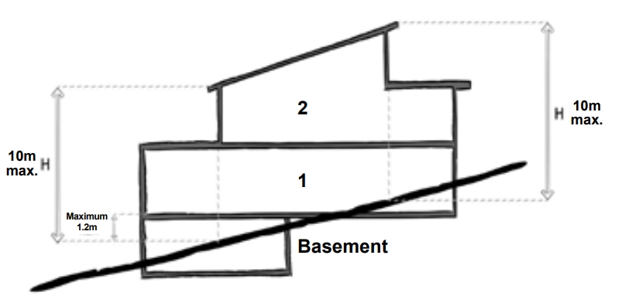
- The visual impact of the building when viewed from the street and from adjoining properties.

Applying the standard
The slope of land is measured through any cross section (greater than 8 metres) of the building.
If the slope of the land is greater than 2.5 degrees through the cross section, the maximum building height may be up to 10 metres.
Working out the slope of a building site
Where the slope of the ground is 2.5° or more across an 8 metre cross section of the building site, this is equal to a ratio of 1:23 or 350 mm (when expressed as a rise or fall over an 8 metre cross section).
Supporting documents
The natural ground level and maximum building height should be clearly shown on elevations and sections. The Australian Height Datum (AHD) of natural ground level and maximum building height should be clearly shown on plans.
Any area greater than 8 metres with a slope greater than 2.5 degrees should be clearly shown on the plans and sections as relevant.

Standard B2-3 Side and rear setbacks

Why this is important
This standard ensures adequate separation between dwellings and small second dwellings on adjacent lots, particularly above ground floor level. Adequate setbacks ensure privacy, sufficient daylight, and enhanced amenity.
Side and rear setbacks objective
To ensure that the height and setback of a building from a boundary responds to the existing or preferred neighbourhood character and limits the impact on the amenity of existing dwellings or small second dwellings.

Standard B2-3
A new building not on or within 200mm of a boundary is set back from side or rear boundaries in accordance with either B2-3.1 or B2-3.2.
Standard B2-3 is met if the building is set back in accordance with either B2-3.1 or B2-3.2, rather than needing to comply with both of these provisions:
- B2-3.1:
The building is set back at least 1 metre, plus 0.3 metres for every metre of height over 3.6 metres up to 6.9 metres, plus 1 metre for every metre of height over 6.9 metres.
- B2-3.2:
If the boundary is not to the south of the building, the building is set back at least 3 metres up to a height not exceeding 11 metres and at least 4.5 metres for a height over 11 metres.
If the boundary is to the south of the building, the building is set back at least 6 metres up to a height not exceeding 11 metres and at least 9 metres for a height over 11 metres between south 30 degrees west to south 30 degrees east.
Sunblinds, verandahs, porches, eaves, facias, gutters, masonry chimneys, flues, pipes, domestic fuel or water tanks, and heating or cooling equipment or other services may encroach not more than 0.5 metres into the side and rear setbacks.
Landings that have an area of not more than 2 square metres and less than 1 metre high, stairways, ramps, pergolas, shade sails and carports may encroach into the side and rear setbacks.

Diagram B2-3.1 Side and rear setbacks
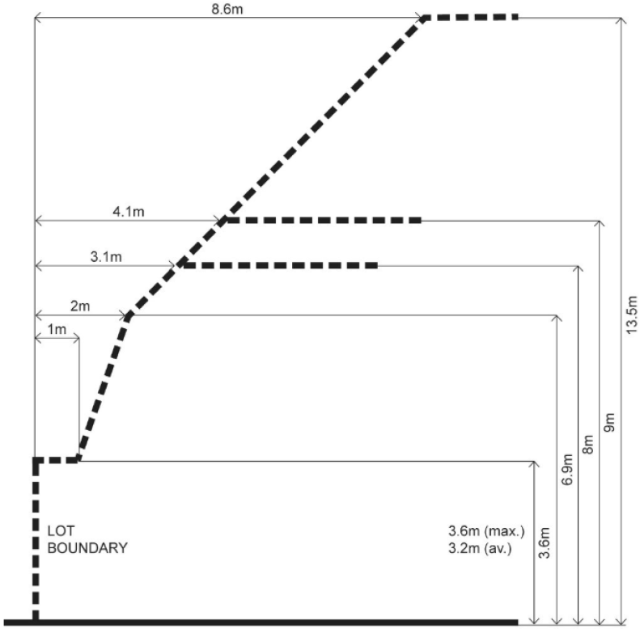

Diagram B2-3.2 Side and rear setbacks
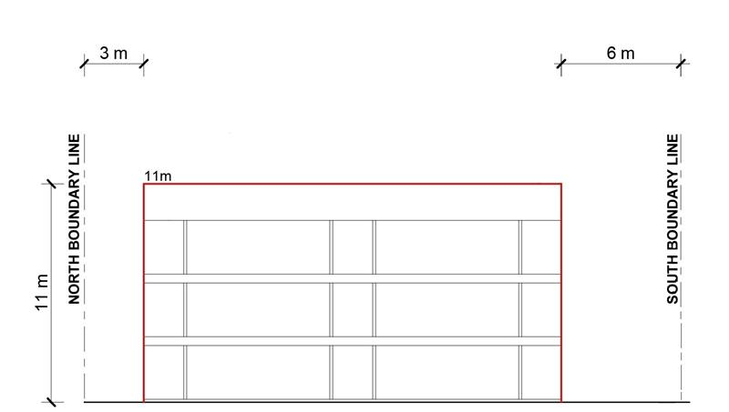

Decision guidelines
Before deciding on an application, the responsible authority must consider:
- Any relevant neighbourhood character objective, policy or statement set out in this scheme.
- The design response.
- The impact on the amenity of the habitable room windows and private open space of existing dwellings or small second dwellings.
- Whether the wall is opposite an existing or simultaneously constructed wall built to the boundary.
- Whether the wall abuts a side or rear lane.
- Whether a different setback in a rear yard affects the ability to retain or plant canopy trees.

Applying the standard
New buildings must be designed to meet either setback B2-3.1 or B2-3.2. A building cannot apply one setback requirement to one boundary, and the other setback requirement to other boundaries.

Standard B2-3.1
Where the wall height is between 3.6 metres and 6.9 metres, the formula for calculating side and rear setbacks is:
1m + [0.3m x (h – 3.6m)]
(h = wall height)
Where the wall height is greater than 6.9 metres, the formula is:
1m + [0.3m x (6.9m – 3.6m)] + [1m x (h – 6.9m)]
Using the above example, if the wall height is 6.9 metres, the required setback is calculated as follows:
1 m + [0.3 x (6.9 m – 3.6 m)]
- = 1 m + [0.3 x 3.3 m]
Allowable encroachments
= 1 m + 0.99 m
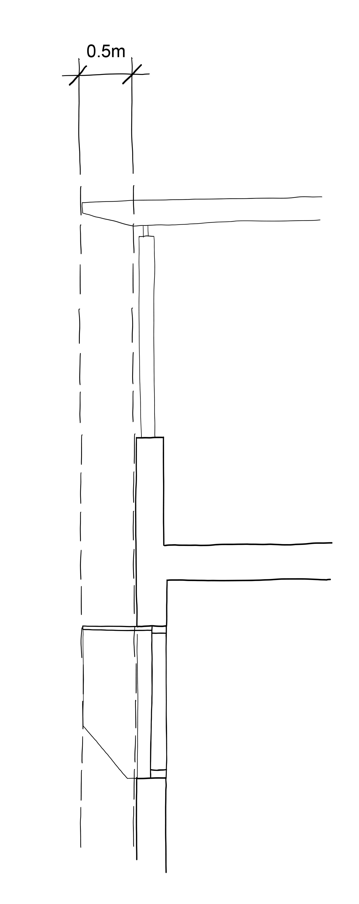
= 1.99 m (rounded up to 2 m) setback
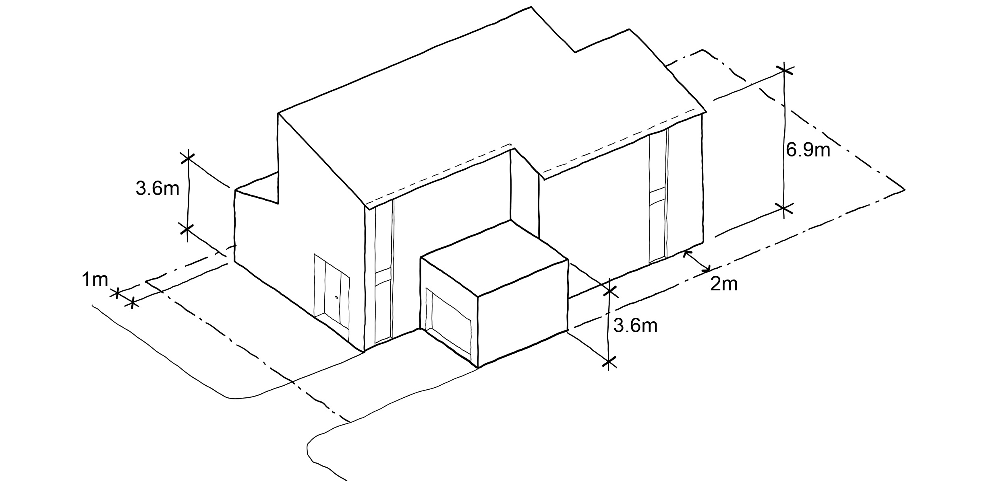

Standard B2-3.2

Boundary not to the South (e.g., North, East, or West)
For the north, east or west boundary, the building is set back at least 3 metres for heights up to 11 metres. If the building exceeds 11 metres, heights over 11 metres are stepped back to maintain a minimum 4.5 metre setback.
Example:
For a 13-metre-high building
- Up to 11 metres high the building is set back 3 metres from the boundary.
- From 11 – 13 metres high the building is set back 4.5 metres from the boundary.

Boundary to the South
For the southern boundary, stricter setbacks apply to minimise overshadowing. The building is set back at least 6 metres for heights up to 11 metres and at least 9 metres for heights over 11 metres between south 30 degrees west to south 30 degrees east.
Example:
- A 9-metre-high section is set back 6 metres from the southern boundary.
- A 12-metre-high section is set back 9 metres from the southern boundary.

Supporting documents
Side and rear setbacks (including the natural ground level at site boundary, setback distances, and wall heights) should be clearly shown on plans, elevations and sections.

Standard B2-4 Walls on boundaries
Why this is important
This standard limits the height and length of walls on lot boundaries, to reduce the amenity impact of housing on neighbouring properties. The length and height of walls on lot boundaries also impacts neighbourhood character.
Walls on boundaries objective
To ensure that the location, length and height of a wall on a boundary responds to the existing or preferred neighbourhood character and limits the impact on the amenity of existing dwellings and small second dwellings.

Standard B2-4
A new wall constructed on or within 200mm of a side or rear boundary of a lot or a carport constructed on or within 1 metre of a side or rear boundary of a lot does not abut the boundary for a length that exceeds the greater of the following distances:
- 10 metres plus 25 per cent of the remaining length of the boundary of an adjoining lot, or
- The length of existing or simultaneously constructed walls or carports abutting the boundary on an abutting lot.
A new wall or carport may fully abut a side or rear boundary where slope and retaining walls or fences would result in the effective height of the wall or carport being less than 2 metres on the abutting property boundary.
A building on a boundary includes a building set back up to 200mm from a boundary.
The height of a new wall constructed on or within 200mm of a side or rear boundary or a carport constructed on or within 1 metre of a side or rear boundary does not exceed an average of 3.2 metres with no part higher than 3.6 metres unless abutting a higher existing or simultaneously constructed wall.
Design Guidelines
Before deciding on an application, the responsible authority must consider:
- Any relevant neighbourhood character objective, policy or statement set out in this scheme.
- The design response.
- The extent to which walls on boundaries are part of the neighbourhood character.
- The impact on the amenity of existing dwellings or small second dwellings.
- The opportunity to minimise the length of walls on boundaries by aligning a new wall on a boundary with an existing wall on a lot of an adjoining property.
- The orientation of the boundary that the wall is being built on.
- The width of the lot.
- The extent to which the slope and retaining walls or fences reduce the effective height of the wall.
- Whether the wall abuts a side or rear lane.
- The need to increase the wall height to screen a box gutter.

Applying the standard
When applying the standard, ’new wall’ means the total length of any existing and proposed wall when calculating the length of a wall on a boundary.
Walls on boundaries where there is one adjoining lot  The formula for calculating walls on boundaries is:  10 m + [(length of boundary of an adjoining lot – 10 m) x 0.25]  This formula is separately applied to each boundary of the lot to determine the permissible walls on each boundary of the lot.  On a lot of 44 metres in length, the walls on boundaries along this boundary are calculated as follows:  10m + [(44m – 10m) x 0.25]  10m + [34m x 0.25]  10m + 8.5m  18.5m permissible wall on boundary  This example complies as it has less walls on boundaries than permissible under the standard. Other considerations such as neighbourhood character may be the reason for not using the maximum allowable walls on boundaries | 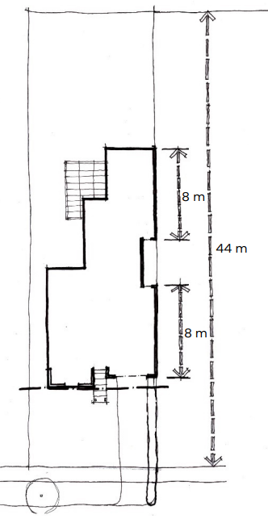
Walls on boundaries where there is more than one adjoining lot  Where there is more than one adjoining lot along a boundary, walls on the boundary may be constructed up to 10 metres plus 25 per cent of the remainder of the adjoining boundary abutting the lot, for each adjoining boundary.  The walls on boundaries permitted along the boundary are:  - 16.5 metres along the adjacent lot boundary A  - 8 metres along the adjacent lot boundary B.  As can be seen in this example, while the length of the boundary of the lot is the same as in the previous example (44 metres), a longer wall along this boundary is possible because of the abuttal to two properties.  The standard is applied to each adjacent lot boundary individually. | 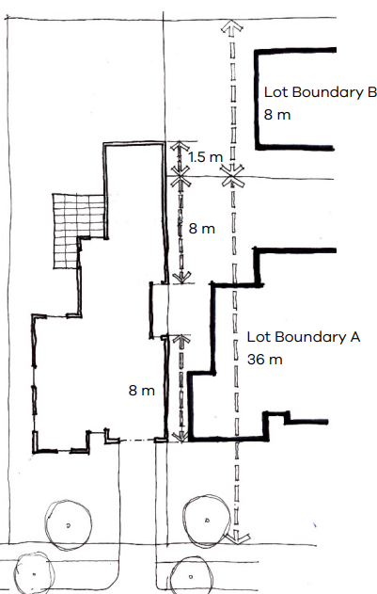
Walls on boundaries where there is an existing or simultaneously constructed wall on the boundary  Where there is an existing wall on the adjoining boundary, the length of the permissible wall on the boundary is able to exceed 10 metres plus 25 per cent of the remainder of the boundary provided that it is the same or a lesser length of the existing wall on the boundary.  To meet the standard, no part of the new wall on the boundary can be built to extend beyond the extent of the existing wall on the boundary, even though the new wall may be the same length as the existing wall on the boundary.  To meet the standard, simultaneously constructed walls on the boundary must be the same length and cannot be staggered. | 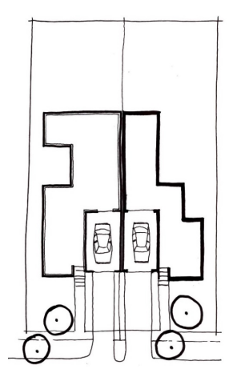
Walls on boundaries where there is a small second dwelling.  Where there is a small second dwelling (SSD) on a lot, the same walls on boundaries calculations are applied and the small second dwelling is included in the total walls on boundary calculation. | 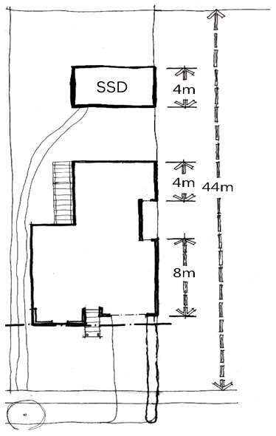
Effective wall height  Effective wall height means the height of the wall from the top of the wall to the ground measured on the boundary from the adjoining property.  In this example, cutting and filling of the cross slope has resulted in an effective wall height of less than 2 metres on the boundary for the wall constructed on the boundary.  Where the effective wall height is less than 2 metres on the boundary, the building may abut the full length of the boundary. | 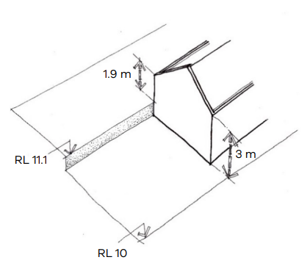
Height of wall on boundary  When calculating the average height of a wall on a boundary the formula is:  Average height = Area of wall divided by Length of wall  It is important to include all aspects of the wall on the boundary in the calculation, including the wall above and below the internal floor and ceiling heights of the wall. | 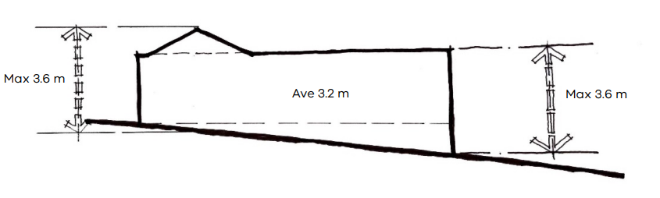

Supporting documents
Walls on boundary dimensions (including the natural ground level at site boundary, wall heights, lengths and average heights) should be clearly shown on plans, elevations and sections.

Standard B2-5 Site coverage
Why this is important
The standard limits the proportion of any lot that can be built on, to provide outdoor space for residents and to protect the amenity and character of neighbourhoods.
Site coverage objective
To ensure that the site coverage responds to the existing or preferred neighbourhood character and responds to the features of the site.
Standard B2-5
The site area covered by buildings does not exceed:
- The maximum site coverage specified in a schedule to the zone; or
- If no maximum site coverage is specified in a schedule to the zone, the percentage specified in Table B2-5.
If the maximum site coverage is specified in a schedule to a zone, it must be greater than the percentage specified in Table B2-5.
Table B2-5 Site coverage
Zone | Area
Neighbourhood Residential Zone  Township Zone | 60 per cent
General Residential Zone | 65 per cent
Residential Growth Zone  Mixed Use Zone  Housing Choice and Transport Zone | 70 per cent
Decision guidelines
Before deciding on an application, the responsible authority must consider:
- Any relevant neighbourhood character objective, policy or statement set out in this scheme.
- The design response.
- The existing site coverage and any constraints imposed by existing development or the features of the site.
- The site coverage of adjacent properties.
- The effect of the visual bulk of the building and whether this is acceptable in the neighbourhood.
- Whether a different area of site coverage affects the ability to retain or plant canopy trees.

Applying the standard

Site coverage (%) = Total building area multiplied by 100 divided by Total site area.
The definition of a building includes a dwelling, a small second dwelling, a garage or carport, a verandah and any other roofed building such as a garden shed. When calculating site coverage, if the upper storey projects over the ground floor, that part of the upper storey is also added onto the ground floor area. This does not include an underground basement that is constructed wholly underground.
Outdoor paving, driveways, pathway or building eaves are not included when calculating the amount of site coverage.
When calculating site coverage, the total building area includes both dwellings, both garages and the garden shed for the second dwelling. Where there are two or more dwellings on a lot, the total site area for all the dwellings is included when calculating site coverage.
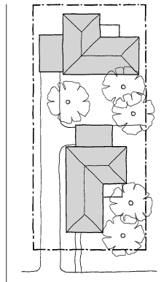
The new development must meet the garden area requirements specified in a residential zone as required.

Supporting documents
Site area and coverage should be clearly identified on plans.

Standard B2-6 Access
Why this is important
This standard regulates the width of accessways for vehicles entering and exiting a site to protect trees, allow for landscaping, enhance pedestrian safety and minimise the loss of on-street parking.
Access objective
To ensure the number and design of vehicle crossovers responds to the neighbourhood character.
Standard B2-6
The width of accessways or car spaces (other than to a rear lane) does not exceed:
- 33 per cent of the street frontage; or
- 40 per cent of the street frontage if the width of the street frontage is less than 20 metres.
The number of access points to a road in a Transport Zone 2 or a Transport Zone 3 is not increased.
The location of a vehicle crossover or accessway does not encroach the tree protection zone of an existing tree, that is proposed to be retained in a road by more than 10 per cent.
Decision guidelines
Before deciding on an application, the responsible authority must consider:
- Any relevant neighbourhood character objective, policy or statement set out in this scheme.
- The design response.
- The reduction of on-street car parking spaces.
- Whether a different accessway width, number of access points or encroachment of an existing tree affects the ability to retain or plant canopy trees on the site or footpath.

Applying the standard
Example Townhouse Development on a 15-Metre-Wide Lot
A proposed three-townhouse development is planned on a 15-metre-wide site to the street frontage. To comply with the accessway width requirements:
- The maximum allowable accessway width is 40% of 15 metres = 6 metres (since the frontage is less than 20 metres).
- A shared 5.5-metre-wide driveway is proposed for access to all three townhouses, less than the 6-metre limit.
- Only one crossover is used, avoiding an increase in access points to the road.
To protect an existing street tree with a tree protection zone of 3 metres, the crossover is positioned at least 2.7 metres from the tree, ensuring that encroachment does not exceed 10% of the TPZ.
Example Apartment Development on a 24-Metre-Wide Lot
A medium-density apartment building is proposed on a 24-metre-wide site with underground parking. To comply with the accessway width requirements:
- The maximum allowable accessway width is 33% of 24 metres = 7.92 metres.
- A 7-metre-wide basement entry driveway is proposed.
- No additional access points are created on a Transport Zone 2 road.
- The crossover is positioned outside the 4 metre tree protection zone of a protected tree, ensuring encroachment does not exceed 10% (0.4 metres).
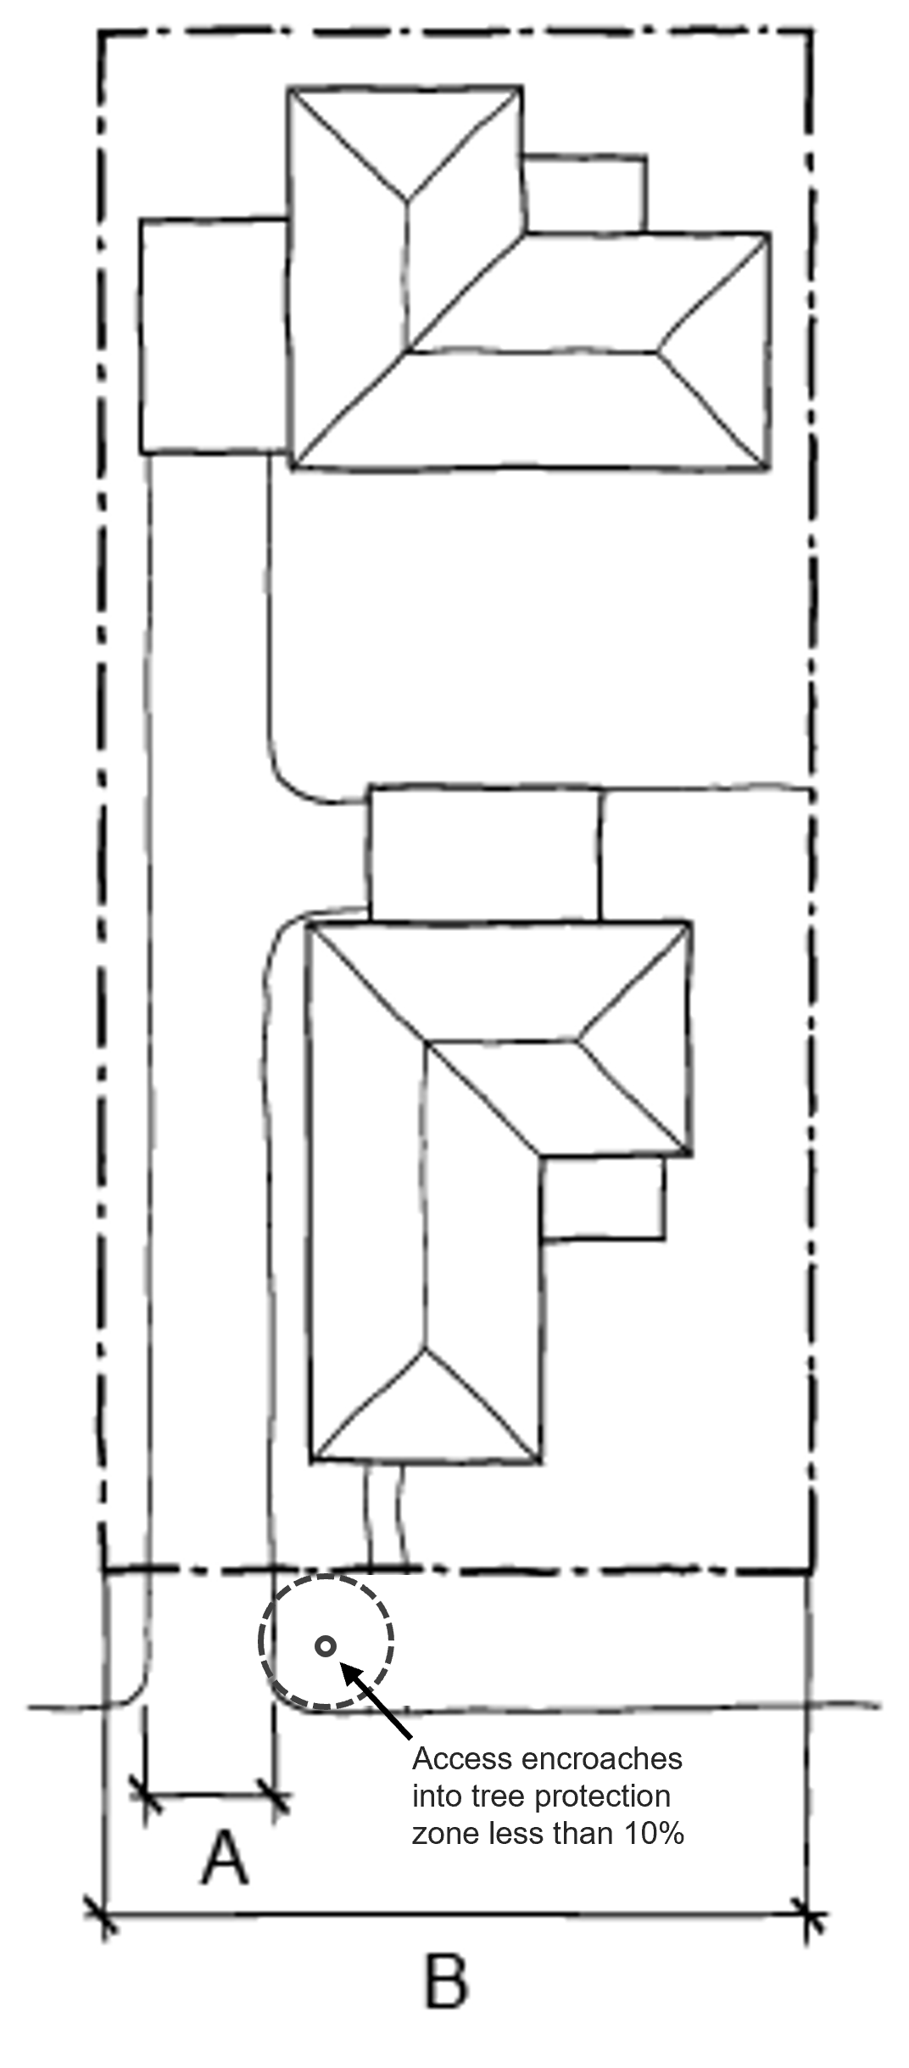
By limiting accessway widths, using shared driveways, and protecting existing trees, these example developments comply with the standard, maintain the streetscape character, enhance pedestrian safety, and increase the availability of on-street parking.

Driveway width (A) | Frontage width (B)
33 per cent of street frontage | < 20 metres
40 per cent of street frontage | > 20 metres

Supporting documents
Side and rear setbacks (including the natural ground level at site boundary, setback distances, and wall heights) should be clearly shown on plans, elevations and sections.

Standard B2-7 Tree canopy
Why this is important
This standard encourages canopy cover in residential areas to enhance quality of life. Tree canopies provide shade, reduce the urban heat island effect, and improve the streetscape by creating an attractive environment that complements neighbourhood character.
Tree canopy objectives
To provide tree canopy that responds to the neighbourhood character of the area and reduces the visual impact of buildings on the streetscape.
To preserve existing canopy cover and support the provision of new canopy cover.
To ensure new canopy trees are climate responsive, support biodiversity, wellbeing and amenity, and help reduce urban heat.
Standard B2-7
Provide a minimum canopy cover as specified in Table B2-7.1.
Table B2-7.1 Canopy cover
Site area | Canopy cover
1000 square metres or less | 10% of site area
More than 1000 square metres | 20% of site area
Existing trees to be retained meet all of the following:
- Has a height of at least 5 metres,
- Has a trunk circumference of 0.5 metres or greater at 1.4 metres above ground level,
- Has a trunk that is located at least 4 metres from proposed buildings.
- The minimum canopy cover is met using any combination of trees specified in Table B2-7.2.
- Existing trees that are retained can be used in calculating canopy cover.
Table B2-7.2 Tree type, canopy cover, deep soil and planter requirements
Tree type | Minimum canopy diameter at maturity | Minimum height at maturity | Minimum mature canopy cover | Tree in deep soil  Area of deep soil | Tree in planter  Volume of planter | Minimum depth of planter soil
A | 4 metres | 6 metres | 12.6 sqm | 12 square metres  (min. plan dimension 2.5 metres) | 12 cubic metres  (min. plan dimension 2.5 metres) | 0.8 metre
B | 8 metres | 8 metres | 50.3 sqm | 49 square metres  (min. plan dimension 4.5 metres) | 28 cubic metres  (min. plan dimension 4.5 metres) | 1 metre
C | 12 metres | 12 metres | 113.1 sqm | 121 square metres  (min. plan dimension 6.5 metres) | 64 cubic metres  (min. plan dimension 6.5 metres) | 1.5 metre
Provide at least one new or retained tree in the front setback and the rear setback.
Trees are located in either:
- An area of deep soil as specified in Table B2-7.2; or
- A planter as specified in Table B2-7.2.
Any tree required to be planted under this standard must be of species to the satisfaction of the responsible authority, having regard to the location and relevant geographic factors.

Decision guidelines
Before deciding on an application, the responsible authority must consider:
- Any relevant neighbourhood character objective, policy or statement set out in this scheme.
- The site context and design response.
- The extent to which the existing and proposed canopy trees contribute to a greener environment and reduce urban heat.
- Whether the growth characteristics of existing trees and proposed canopy trees will provide the required canopy cover.
- The suitability of the planting location, deep soil areas and planter soil volume for proposed canopy trees.
- Whether the species of canopy tree is suited to the soil conditions of the site.

Applying the standard
Provision of tree canopy should be an integral part of a development’s design and planning phase, rather than an after-thought when space for landscaping and solar access is constrained.
New trees are approved species, considering local climate and geography. To determine the typical tree size category at maturity for the chosen species, refer to tree planting guidance issued by relevant local council or use the authoritative online guide: Which Plant Where website at www.whichplantwhere.com.au.
At least one new or retained tree is to be provided in the front setback of the lot boundary and the rear setback of the lot boundary, not to each dwelling.
Table A details what ‘canopy cover’ includes and does not include.

Example: 860 square metre site with 10% tree canopy  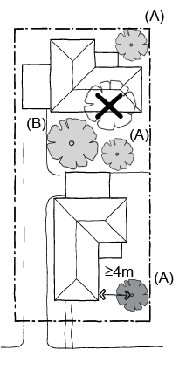  10% tree canopy is met through:  - One retained Type A tree with a trunk located more than 4 metres from the development  - One new Type B tree  - Two new Type A trees  An existing tree located less than 4 metres from the development will be removed. | Example: 1600 square metre site with 20% tree canopy  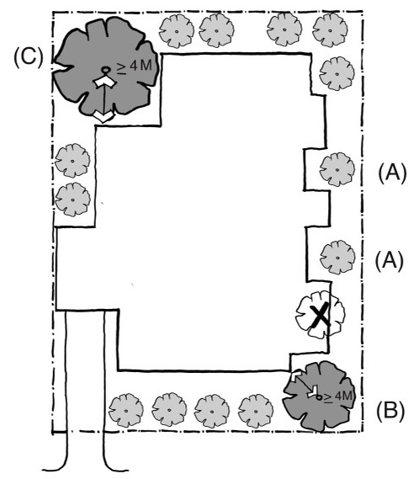  20% tree canopy is met through:  - One retained Type B tree with a trunk located more than 4 metres from the development  - One retained Type C tree with a trunk located more than 4 metres from the development  - 13 new Type A trees  An existing trees located less than 4 metres from the development will be removed.

The following is a suggested method to meet the standard.
Step | Method
1 | Identify existing trees that will be retained on-site and locations for any new tree.
2 | The space requirements for canopy trees and deep soil can be calculated using the steps below.
2 | Step | Example
2 | a) Determine the site area | The example site is 1,501 square metres
2 | b) Calculate the square metreage of canopy cover required (Table B2-7.1) | The site requires 300.2 square metres of canopy cover (20% of 1,501 square metres)
2 | c) Determine the canopy tree requirements (Table B2-7.2) | To meet the required canopy cover (300.2 sqm) the proposal could provide a range of tree types (A, B and C) that meet the minimum canopy diameter at maturity and minimum height at maturity specified in Table B2-7.2, columns 2 & 3. Table B2-7.2, column 4 provides the mature canopy cover (sqm) for each tree type.
2 | d) Determine the canopy tree plan dimensions | The image below shows the dimensions diagrammatically  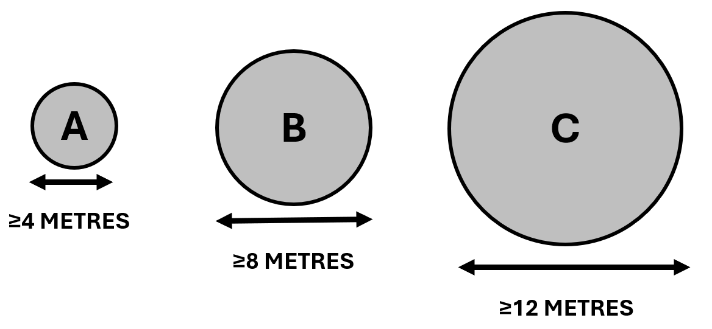
2 | e) Determine the size of canopy trees needed to achieve the required canopy cover  If trees are located close together, any area of canopy overlap must be counted only once when calculating canopy cover | 300.2 square metres of canopy cover is required.  Six Type B canopy trees of 8 metres will provide at least 50.3 x 6 = 301.8 square metres mature canopy cover area (using Table B2-7.2)

Table A: Canopy cover inclusions and exclusions
Canopy cover includes | Canopy cover does not include
The area of the canopy of an existing retained tree on the site  The area of the mature canopy of a new canopy tree to be planted within the title boundary of the site  The area of the mature canopy of a new canopy tree planted in a raised planter | Built structures (such as roofs, eaves, awnings and roofed or textile-covered shade structures)  Ground covers, shrubs and climbing plants on vertical surfaces including green walls or green façades  A tree planted outside the title boundary of the subject site including on public land  Any area of canopy cover below a cantilevered or overhanging built form or structure  Any area of canopy cover that overlaps with the canopy of another tree that has already been included in the calculation of canopy cover
Note: Areas of canopy cover provided by mature canopy trees are described in Table B below.

Table B: Deep soil area requirements for canopy trees
Tree Size | Mature canopy diameter1 | Mature canopy cover area | Minimum deep soil area required | Minimum soil plan dimension
TYPE A | 4–4.9 metres | 12.6–19.6 square metres | 12 square metres | 2.5 metres
TYPE A | 5–5.9 metres | 19.7–28.2 square metres | 16 square metres | 3 metres
TYPE A | 6–6.9 metres | 28.3–38.4 square metres | 25 square metres | 3.5 metres
TYPE A | 7–7.9 metres | 38.5–50.2 square metres | 36 square metres | 4 metres
TYPE B | 8–8.9 metres | 50.3–63.5 square metres | 49 square metres | 4.5 metres
TYPE B | 9–9.9 metres | 63.6–78.4 square metres | 64 square metres | 5 metres
TYPE B | 10–10.9 metres | 78.5–94.9 square metres | 81 square metres | 5.5 metres
TYPE B | 11–11.9 metres | 95.0–113.0 square metres | 100 square metres | 6 metres
TYPE C | 12–12.9 metres | 113.1–132.6 square metres | 121 square metres | 6.5 metres
TYPE C | 13–13.9 metres | 132.7–153.8 square metres | 136 square metres | 7 metres
TYPE C | 14 metres and greater | Above 153.9 square metres | 144 square metres | 7.5 metres
Note
- If using the radius rather than the diameter to calculate the mature canopy cover area, use the formula area = 3.14*r2: the radius is half the diameter. For example, for a diameter of 4 metres, use area = 3.14*2*2 = 12.56.

Table C: Planter soil volume requirements for canopy trees
Tree Size | Mature canopy diameter | Minimum required planter soil volume1 | Minimum soil plan dimension | Minimum planter soil depth2
TYPE A | 4m–4.9 metres | 7.54 cubic metres | 2.5 metres | 0.8 metres
TYPE A | 5m–5.9 metres | 11.78 cubic metres | 3 metres | 0.8 metres
TYPE A | 6m–6.9 metres | 16.96 cubic metres | 3.5 metres | 0.8 metres
TYPE A | 7m–7.9 metres | 23.09 cubic metres | 4 metres | 0.8 metres
TYPE B | 8m–8.9 metres | 30.16 cubic metres | 4.5 metres | 1.0 metres
TYPE B | 9 metres–9.9 metres | 38.17 cubic metres | 5 metres | 1.0 metres
TYPE B | 10m–10.9 metres | 47.12 cubic metres | 5.5 metres | 1.0 metres
TYPE B | 11m–11.9 metres | 57.02 cubic metres | 6 metres | 1.0 metres
TYPE C | 12m–12.9 metres | 67.86 cubic metres | 6.5 metres | 1.5 metres
TYPE C | 13m–13.9 metres | 79.64 cubic metres | 7 metres | 1.5 metres
TYPE C | 14m and greater | 92.36 cubic metres | 7.5 metres | 1.5 metres
Notes
- To calculate the required soil volume for a planter, use the formula Soil required in cubic metres = Canopy cover area. For example, for a canopy tree with a mature diameter of 7 metres, soil required = (from Table B column 3) 38.5*.6 = 23.1 cubic metres.
- The minimum planter soil depth excludes any drainage layers provided within the planter structure.

Table D: Reduction in soil areas for clusters of trees
No. of trees | % soil reduction | Example
1 | 0% | There are two Type B canopy trees and one Type A clustered in an area of deep soil.  These trees need 100 square metres, 64 square metres & 36 square metres of deep soil respectively (using Table B) for a total soil requirement of 200 square metres  Three trees means a 10% reduction = 20 square metre reduction, so the total required soil area is 180 square metres  The largest tree is 11-metre canopy, so the minimum soil plan dimension is 6 metres (using Table B)
2 | 5%
3 | 10%
4 | 15%
5 | 20%
6 or more | 25%

Supporting documentation
Architectural and tree canopy drawings
Architectural and tree canopy drawings should be consistent and demonstrate compliance with the standard.
The architectural drawings need to show how the structure will accommodate the tree canopy.
What should be shown on the drawings
Architectural drawings should include:
- A site plan that indicates:
  - the required canopy tree(s) including retained and proposed canopy trees and their size in diameter.
  - the location of existing trees 5 metres in height or greater, with a trunk circumference of 0.5 metres or greater at 1.4 metres above ground level, on the site to be retained (as required by the Site description)
  - deep soil areas and planters
  - sections indicating the location and dimensions of the required canopy trees, deep soil areas and planters
- A development summary table which includes:
  - the site area
  - the required canopy cover for the site
  - the number of canopy trees on the site and their size in diameter and the total amount of canopy cover provided for the site
  - the required deep soil area for the site, the amount provided and/or the planter soil volumes provided.
  - the tree species selected having regard to the location and relevant geographic factors.
Design response landscape plan
In addition to this standard, the design response requires preparation of a landscape plan that details the proposed:
- Retention and planting of canopy trees,
- Planting of other vegetation including location, species, number and size at maturity of vegetation,
- Where required, areas of deep soil and root barriers,
- Irrigation system to support existing and planted vegetation including details of any alternative water supply sources,
- Selection of vegetation that responds to the site’s environment and geographic factors,
- A plan showing the location of site services, clothes drying and storage.

When preparing the design response and landscape plan consider:
- Locating canopy trees;
  - where they will receive solar access (as they will perform better)
  - within deep soil areas (as they will have access to groundwater and nutrients)
- Plan the form of the development around the location of these canopy trees, as well as any requirements for setbacks from boundaries and allocations for communal or private open space.
- If deep soil areas are not available, use constructed planters.

Example site plans
Canopy trees located in deep soil in a suburban context achieve the required canopy cover
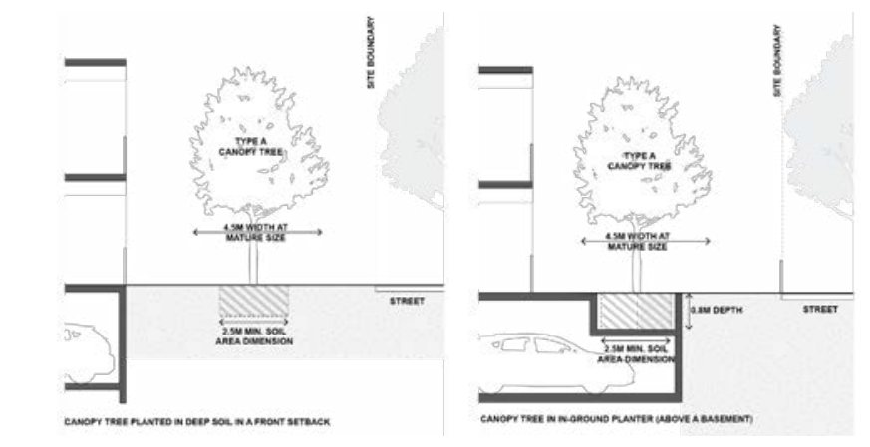

Standard B2-8 Front fences
Why this is important
This standard provides for front fences to be lower than other fences, so that houses and vegetation can be seen from the street and contribute to the streetscape.
Front fences objective
To encourage front fence design that responds to the existing or preferred neighbourhood character.
Standard B2-8
- A front fence within 3 metres of a street is:
- The maximum height specified in a schedule to the zone, or
- If no maximum height is specified in a schedule to the zone, the maximum height specified in Table B2-8.
Table B2-8 Maximum front fence height
Street context | Maximum front fence height
Streets in a Transport Zone 2 | 2 metres
Other streets | 1.5 metres
Decision guidelines
Before deciding on an application, the responsible authority must consider:
- Any relevant neighbourhood character objective, policy or statement set out in this scheme.
- The design response.
- The setback, height and appearance of front fences on adjacent properties.
- The extent to which slope and retaining walls reduce the effective height of the front fence.
- Whether the fence is needed to minimise noise intrusion.

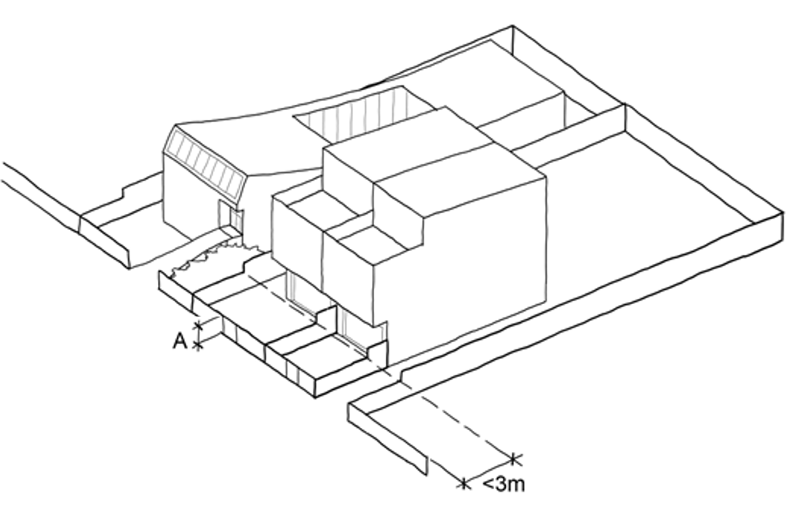
Applying the standard
A front fence includes any fence within 3 metres of the street. The fence height (A) should not exceed the maximum fence height specified in Table B2-8.

Supporting documents
Fence heights must be clearly shown on elevations.

55.03 LIVEABILITY

Standard B3-1 Dwelling diversity
Why this is important
This standard promotes a variety of dwelling sizes and types to accommodate the diverse needs of households. The standard promotes inclusivity by providing housing choices for individuals and families at different stages of life to create a vibrant, mixed community.
Dwelling diversity objective
To encourage a range of dwelling sizes and types in developments of ten or more dwellings.
Standard B3-1
Developments include at least:
- One dwelling that contains a kitchen, bath or shower, bedroom and a toilet and wash basin at ground floor level for every 10 dwellings.
- One dwelling that includes no more and no less than 2 bedrooms for every 10 dwellings.
- One dwelling that includes no more and no less than 3 bedrooms for every 10 dwellings.
Decision guidelines
Before deciding on an application, the responsible authority must consider whether the development provides a range of dwelling sizes and types to meet diverse household needs.

Applying the standard
The number of diverse dwellings required is calculated in multiples of 10.
For example:
A residential development consisting of 32 dwellings needs to include:
- 3 dwellings with a kitchen, bath or shower, bedroom, toilet, and wash basin at ground floor level (1 per 10 dwellings).
- 3 dwellings with 2 bedrooms (1 per 10 dwellings).
- 3 dwellings with 3 bedrooms (1 per 10 dwellings).
A residential development consisting of 39 dwellings needs to include:
- 3 dwellings with a kitchen, bath or shower, bedroom, toilet, and wash basin at ground floor level (1 per 10 dwellings).
- 3 dwellings with 2 bedrooms (1 per 10 dwellings).
- 3 dwellings with 3 bedrooms (1 per 10 dwellings).

A residential development consisting of 42 dwellings needs to include:
- 4 dwellings with a kitchen, bath or shower, bedroom, toilet, and wash basin at ground floor level (1 per 10 dwellings).
- 4 dwellings with 2 bedrooms (1 per 10 dwellings).
- 4 dwellings with 3 bedrooms (1 per 10 dwellings).
There is no requirement on the number and configuration of the remaining dwellings in the proposed development in each of the examples.

Supporting documentation
The location of dwellings must be shown on plans. The dwelling types (including number of bedrooms) must be documented in a development summary.

Standard B3-2 Parking location
Why this is important
This standard seeks to reduce the impact of vehicular noise and overall amenity impact on residents within developments.
Parking location objective
To minimise the impact of vehicular noise within developments on residents.
Standard B3-2
Habitable room windows with sill heights of less than 3 metres above ground level are setback from accessways and car parks by at least:
- 1.5 metres; or
- If there is a solid fence with a height of at least 1.5 metres between the accessway or car park and the window, 1 metre; or
- 1 metre where window sills are at least 1.5 metres above ground level.
This standard is met if an accessway or relevant car parking space is used exclusively by the resident of the building with the habitable room.
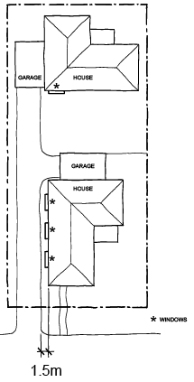
Decision guidelines
Before deciding on an application, the responsible authority must consider the design response.

Applying the standard
Plans should dimension the distance between car parks and habitable room windows and window sill heights from Natural Ground Level.
If the car park and accessway are exclusively used by the resident of the habitable room, and for example are within 1 metre, the standard is met, and no additional setback or solid fence is required.

Supporting documents
Dimensions between habitable room windows and accessways and car parks must be identified on plans and elevations.

Standard B3-3 Street integration
Why this is important
This standard promotes innovative, high-quality design outcomes that enhance safety and the amenity of residents. The standard encourages passive surveillance and external lighting, while ensuring that site services do not dominate the development's frontage.
Street integration objective
To integrate the layout of development with the street to support the safety and amenity of residents.
Standard B3-3
Where a development fronts a street, a vehicle accessway or abuts public open space:
- Passive surveillance is provided by a direct view from a balcony or a habitable room window to each street, vehicle accessway and public open space.
- The total cumulative width of all site services to be located within 3 metres of a street, do not take up more than 20 per cent of the width of the frontage and are screened from view from the street or located behind a fence. Screens or fences are to provide no more than 25 per cent transparency.
Lighting is provided to all external accessways and paths.
Mailboxes are provided for each dwelling and can be communally located.
Decision guidelines
Before deciding on an application, the responsible authority must consider:
- Any relevant neighbourhood character objective, policy or statement set out in this scheme.
- The design response.

Applying the standard
Any adjoining streets, vehicle accessways and public open space should be clearly visible from adjoining balconies or habitable room windows.
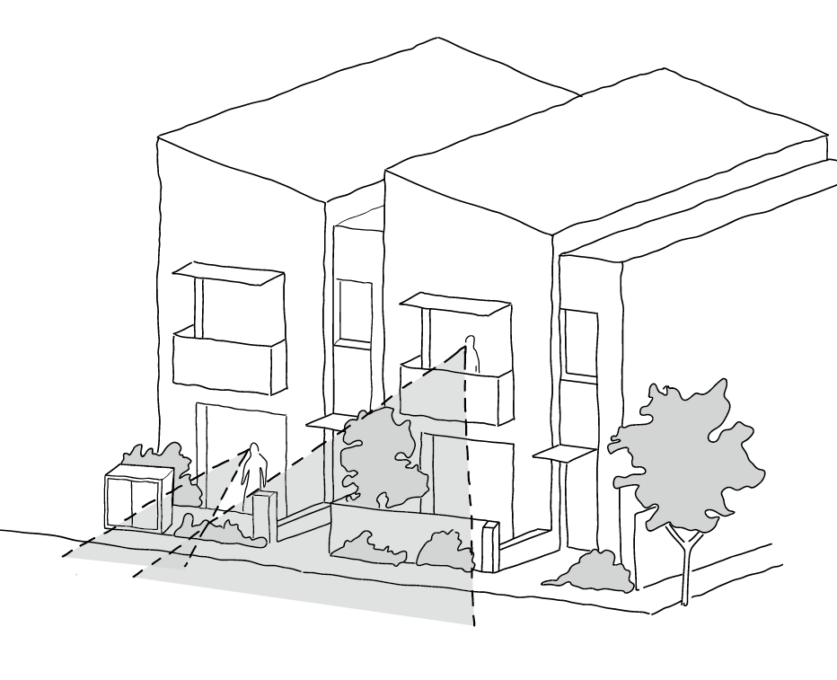

Locate and arrange utility service installations to minimise their impact on the building’s frontage.
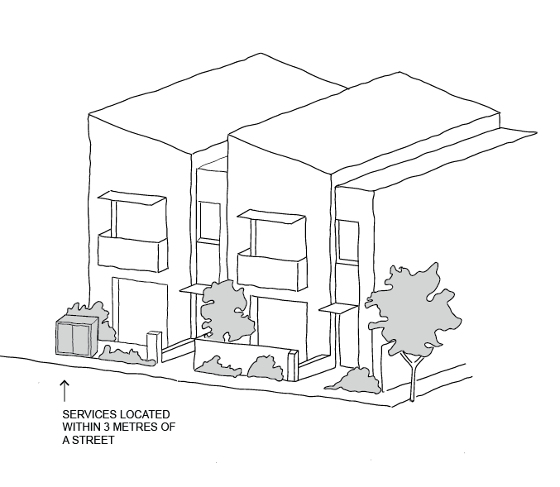

Supporting documents
The location of windows, balconies, site services, lighting, footpaths and mailboxes must be shown on plans and elevations.

Standard B3-4 Entry
Why this is important
This standard ensures each dwelling’s entrance is identifiable, sheltered and provides a sense of address and a transitional space around the entry for accessibility and usability.
Entry objectives
To provide each dwelling, apartment development or residential building with its own sense of identity.
To provide entries with weather protection, safe design, natural light and ventilation.

Standard B3-4
Dwellings (other than a dwelling in or forming part of an apartment development) and residential buildings

Each dwelling and each residential building has a ground level entry door that:
- Has a direct line of sight from a street, accessway or shared walkway.
- Is not accessed through a garage.
- Has an external covered area of at least 1.44 square metres with a minimum dimension of least 1.2 metres over the entry door.
Apartment development and residential building with a shared entry
An apartment development and each residential building has:
- A ground level entry door, gate or walkway with a direct line of sight from a street, accessway or shared walkway.
- An external covered area of at least 1.44 square metres with a minimum dimension of least 1.2 metres over the entry door to the building.
- Shared corridors and common areas have at least one source of natural light and natural ventilation.

Decision guidelines
- Before deciding on an application, the responsible authority must consider:
- Whether the entry is visible and easily identifiable from streets and other public areas.
- Whether the entry provides shelter, a sense of address and a transitional space around the entry.

Applying the standard
- Locate the main pedestrian entry to provide a sense of address by being clearly visible and accessible from the street.
- Building entrances help visitors orient themselves. Entries and foyers should be comfortable, sheltered, safe, convenient and visible during the day and night.
- Emphasise residential entry lobbies with prominent design features, signage or landscape treatments.
- Provide a sense of identity to individual dwellings with an internal entry that can be easily recognised.
- Provide clear sightlines from the foyer to the street so people can see both in and out when entering or leaving the building.
- Where ground floor dwellings face the street, individual entrances can assist in promoting a sense of personal address and activate the street.
- Where ground level units are raised above street level, achieve level access via the main apartment entry door off the circulation corridor.
- Separate the pedestrian and vehicle entries to the buildings.
- Separating vehicle entries from pedestrian entries enhances pedestrian safety.
- Vehicle entries that are designed to be less prominent or recessive improve the streetscape.

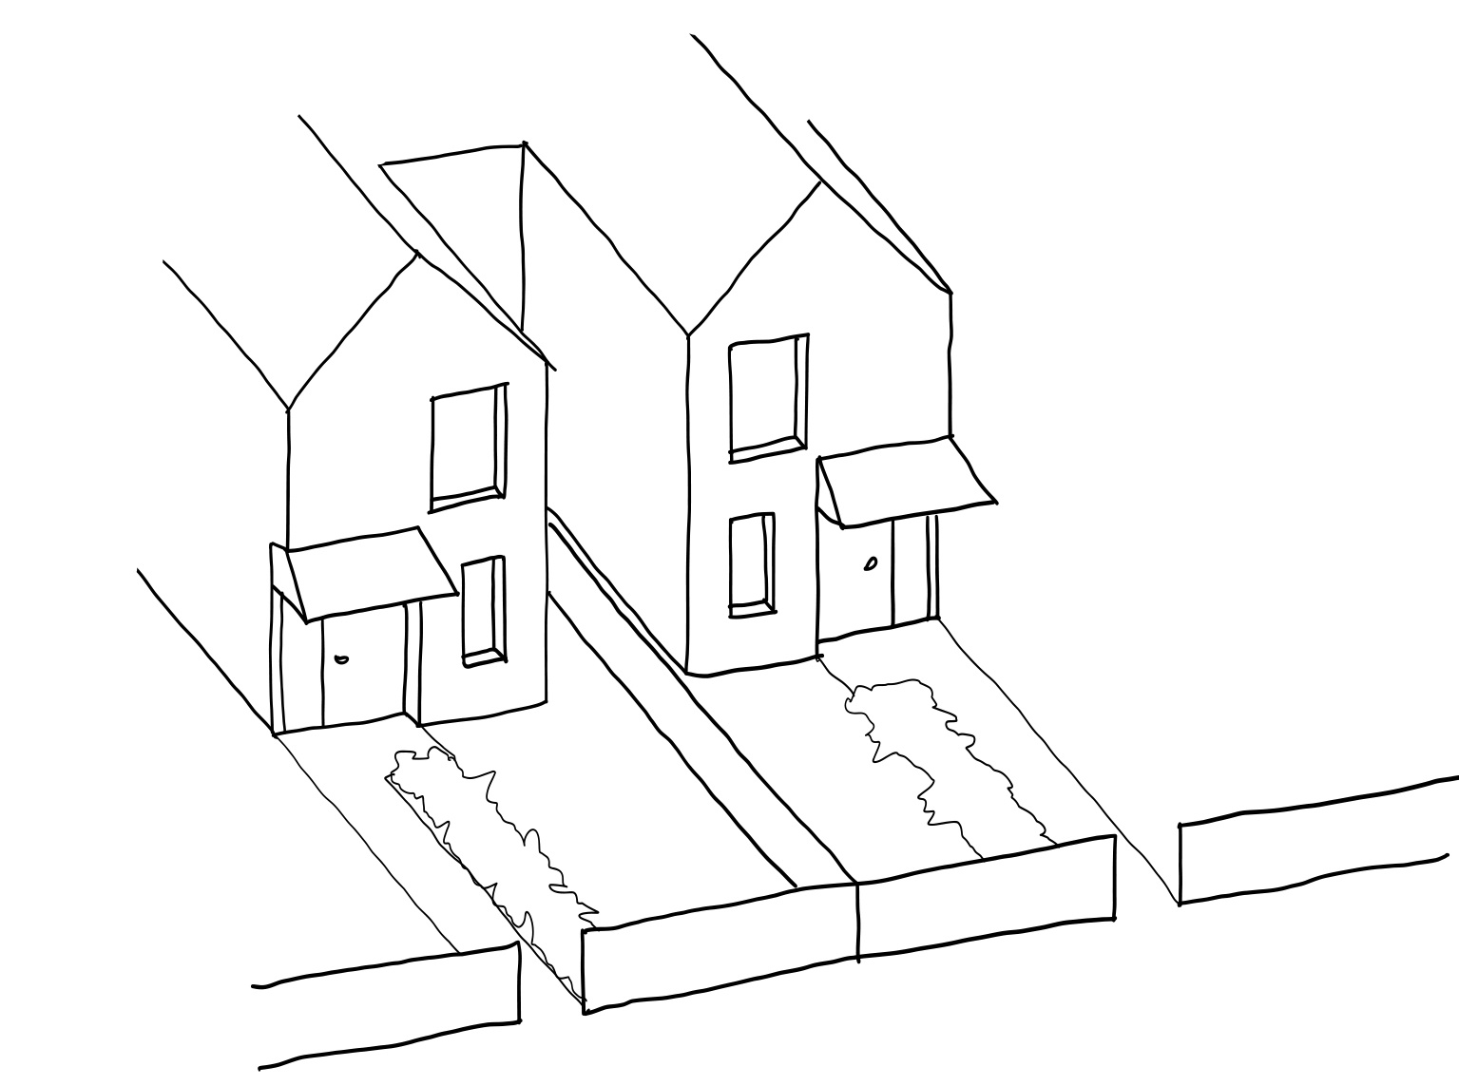

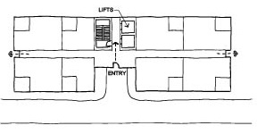

Supporting documentation
Identify building entrances on plans and elevations.

Standard B3-5 Private open space
Why this is important
This standard ensures that all residents of new dwellings have usable and adequate private open space accessible from living areas. Private open space offers residents an exclusive area for relaxation and recreation, enhancing the overall functionality and liveability of a dwelling and contributes to the character of residential areas.
Private open space objectives
To provide adequate private open space for the reasonable recreation and service needs of residents.
Standard B3-5
A dwelling or residential building has private open space of an area and dimensions specified in a schedule to the zone.
If no area or dimension is specified in a schedule to the zone, a dwelling or residential building has private open space with direct access from a living area, dining area or kitchen consisting of:
- An area of 25 square metres of secluded private open space, with a minimum dimension of 3
metres width; or
- A balcony with at least the area and dimensions specified in Table B3-5; or
- An area on a podium or similar of at least 15 square metres, with a minimum dimension of 3
metres width; or
- An area on a roof of at least 10 square metres, with a minimum dimension of 2 metres width.
If the area and dimensions of the private open space or secluded private open space is specified in a schedule to the zone;
- The area and dimensions specified in the schedule must be 25 square metres or less; and
- The area and dimensions specified for a podium, balcony or an area on a roof must be less than the area and dimensions specified in this standard.
If a cooling or heating unit is located in the secluded private open space or private open space the required area is increased by 1.5 square metres.
Where ground level private open space is provided an area for clothes drying is provided.
Table B3-5 Private open space for a balcony
Orientation of dwelling | Dwelling type | Minimum area | Minimum dimension
North (between north 20 degrees west to north 30 degrees east) | All | 8 square metres | 1.7 metres
South (between south 30 degrees west to south 20 degrees east) | All | 8 square metres | 1.2 metres
Any other orientation | Studio or 1 bedroom dwelling | 8 square metres | 1.8 metres
Any other orientation | 2 bedroom dwelling | 8 square metres | 2 metres
Any other orientation | 3 bedroom dwellings | 12 square metres | 2.4 metres
Decision guidelines
Before deciding on an application, the responsible authority must consider:
- The design response.
- The useability of the private open space, including its size and accessibility.
- The availability of and access to public or communal open space.
- The orientation of the lot to the street and the sun.

Applying the standard
Private open space areas with direct access from a living area, dining area or kitchen consisting of:
- An area of 25 square metres of secluded private open space, with a minimum dimension of 3 metres width; or | 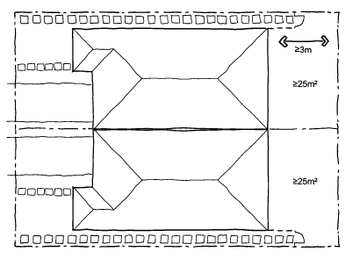
- A balcony with at least the area and dimensions specified in Table B3-5; or | 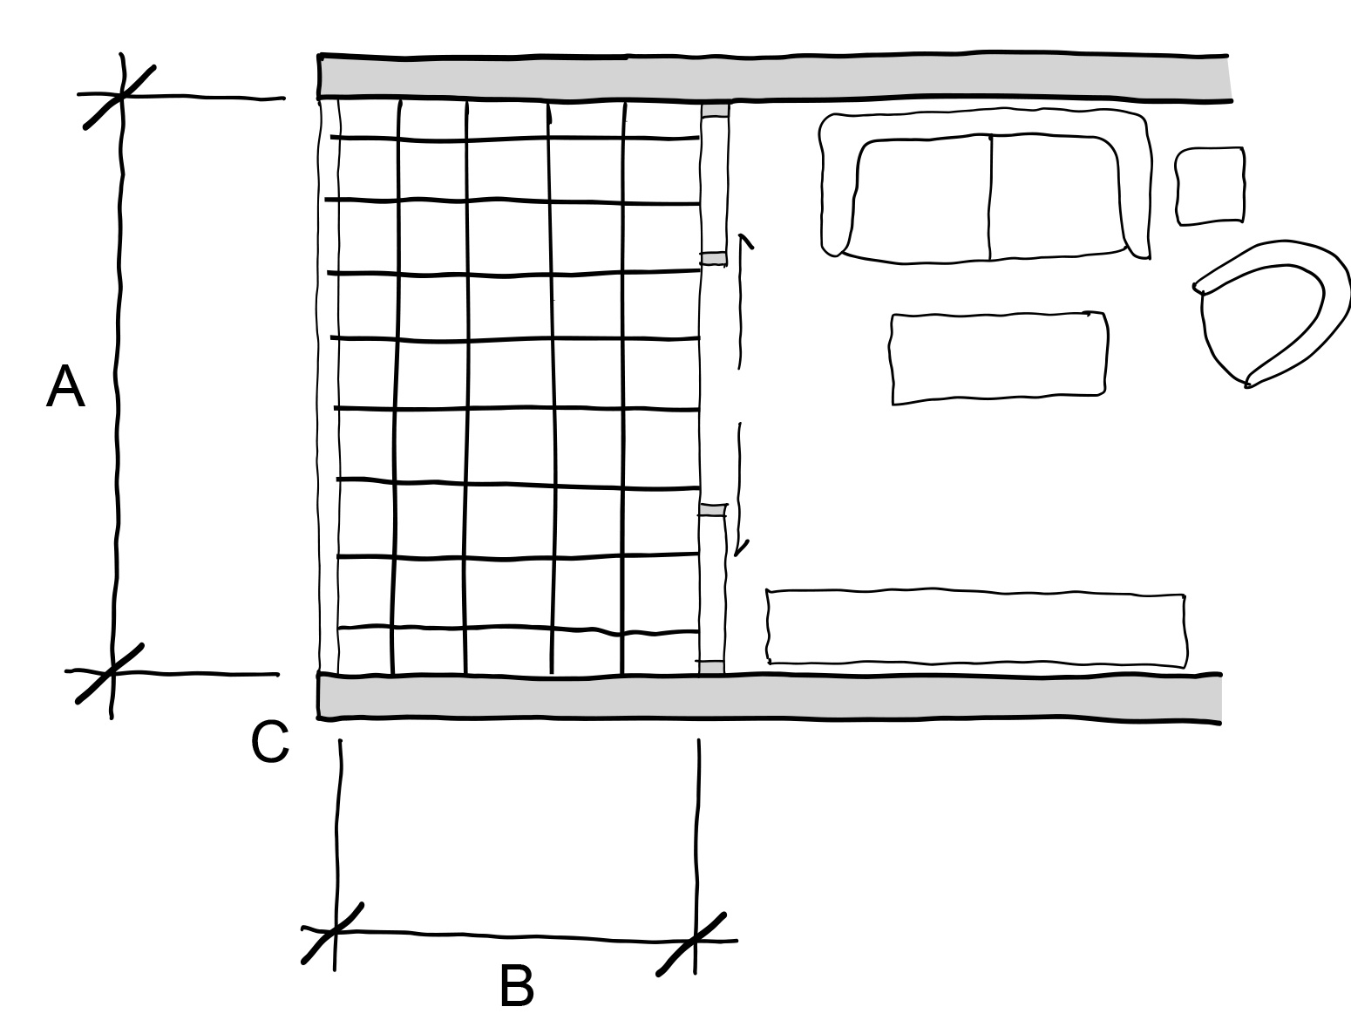
- An area on a podium or similar of at least 15 square metres, with a minimum dimension of 3 metres width; or | 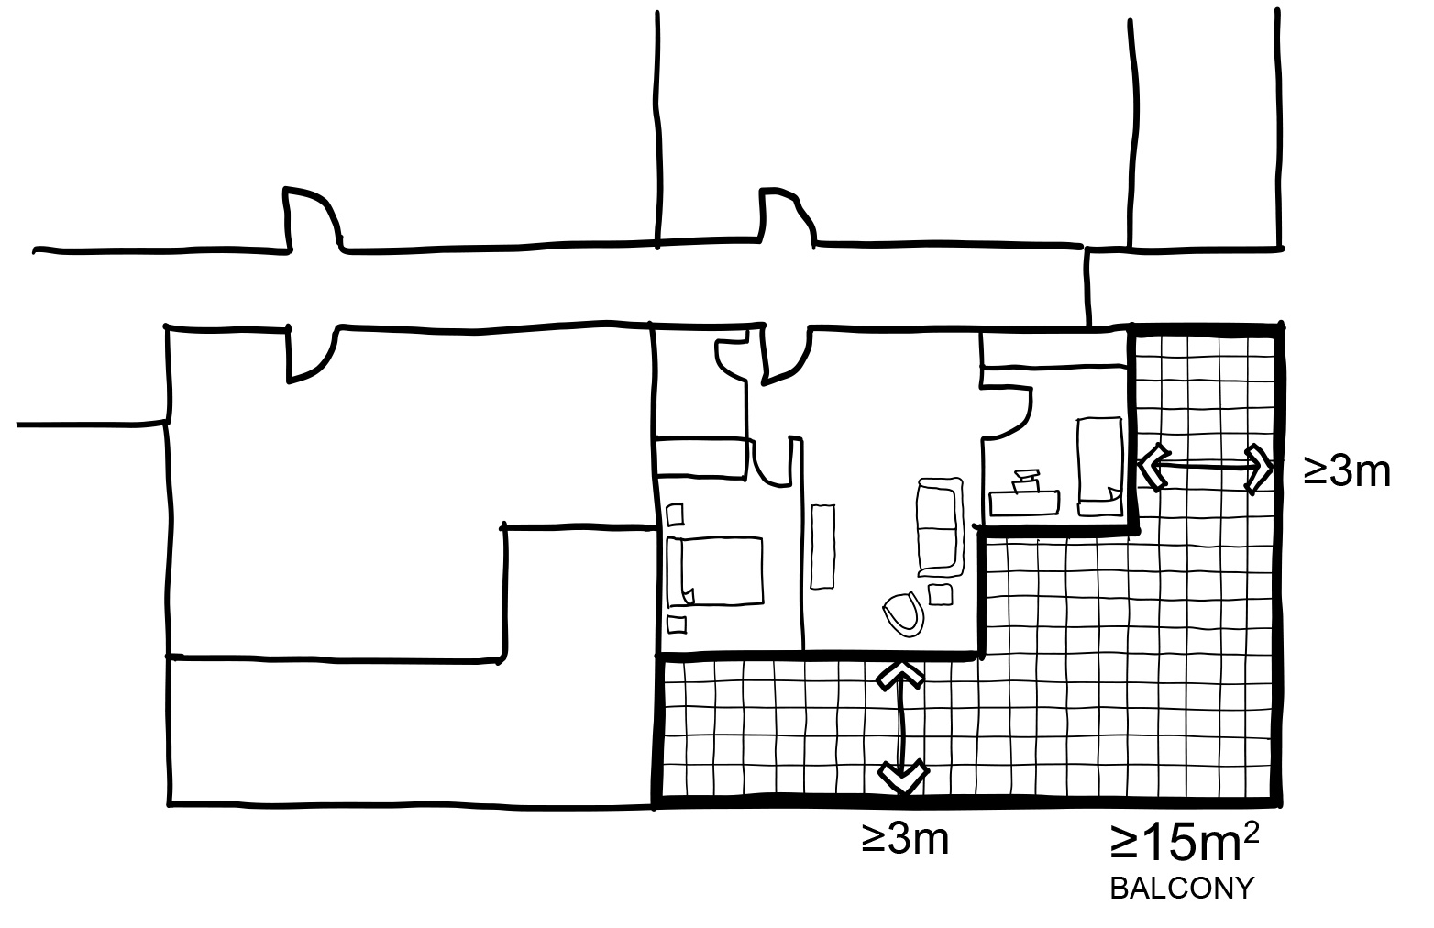
- An area on a roof of at least 10 square metres, with a minimum dimension of 2 metres width. | 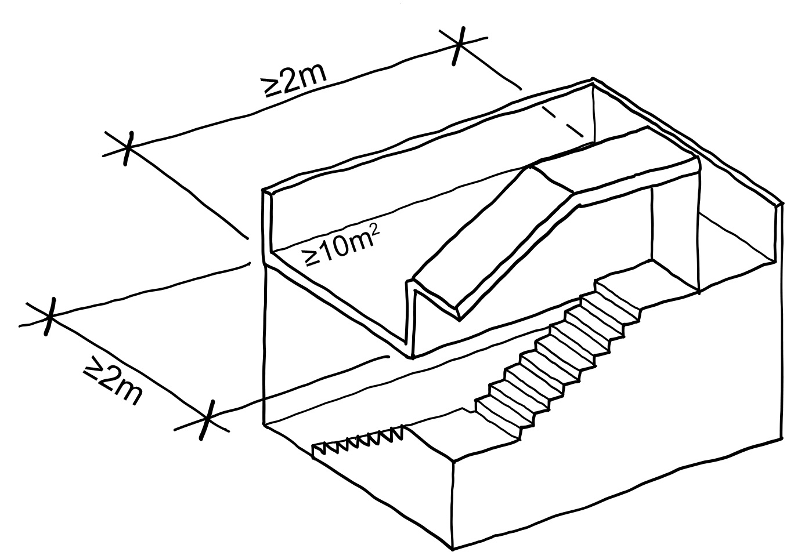

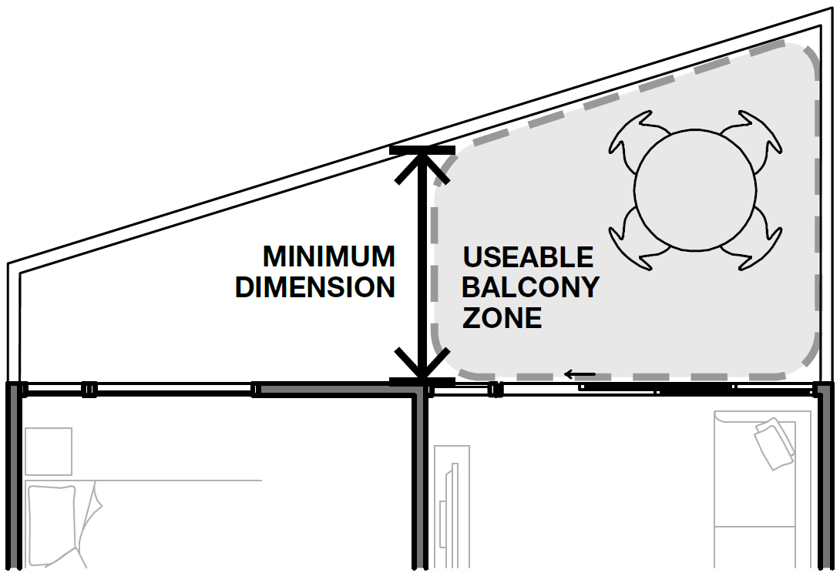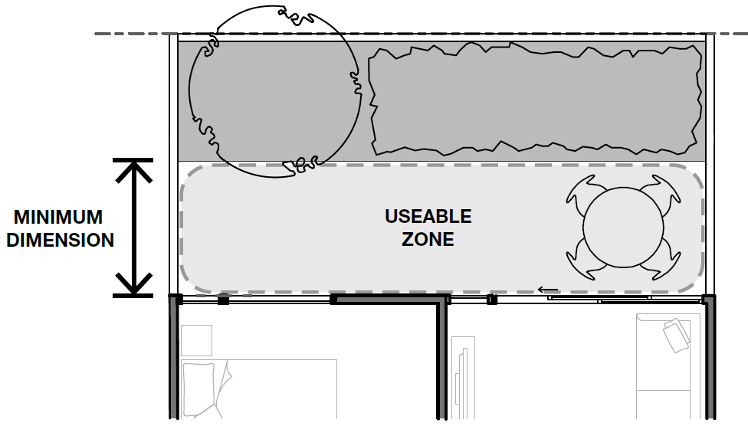

Where planting areas are included in ground floor, podium or rooftop private open spaces, provide a clear usable space which meets the minimum dimensions and areas included in Table B3-5.
The minimum area must be provided in a single usable space. Other balcony areas may be provided in addition.
The additional area for an air conditioning unit does not need to meet the minimum balcony dimension.
Storage integrated into balcony design is not included in the minimum area requirements.
Where irregular shaped balconies are proposed, only the portion of the balcony which meets the minimum dimension will be calculated towards the minimum area.

Design solutions include:
- Continuous overhanging balconies to shade windows from direct summer sun.
- Inset balconies to allow living rooms to be located at the building edge increasing daylight to the room.
- Limiting the depth of south facing balconies where they are located to the front of living spaces.
- Inset or semi screened balconies, rather than projecting balconies, to provide greater wind protection.
- Locate balconies to avoid exposure to noise sources.

Supporting documentation
Provide minimum dimensions and areas to all private open spaces

Standard B3-6 Solar access to open space
Why this is important
This standard is a key amenity requirement that ensures all secluded private open spaces receive adequate sunlight, enhancing their usability throughout the day. Solar access improves overall amenity and supports healthy outdoor living environments.
Solar access to open space objective
To allow solar access into the secluded private open space of new dwellings and residential buildings.
Standard B3-6
The southern boundary of secluded private open space is set back from any wall on the north of the space at least (2 + 0.9h) metres, where ‘h’ is the height of the wall.
Diagram B3-6 Solar access to open space
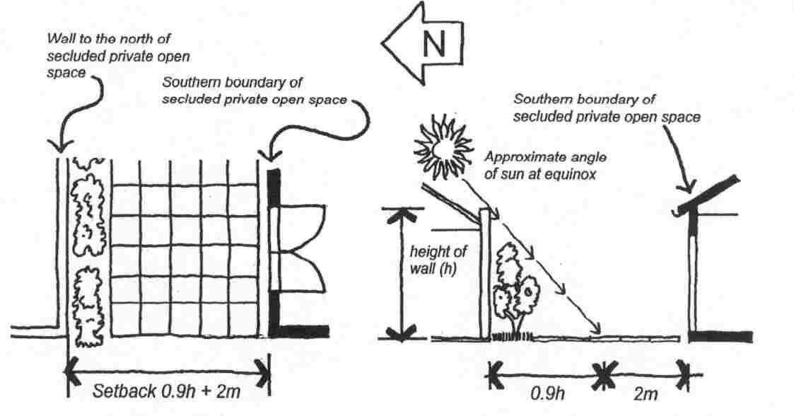

Decision guidelines
Before deciding on an application, the responsible authority must consider:
- The design response.
- The useability and amenity of the secluded private open space based on the sunlight it will receive.

Applying the standard

The standard requires the southern boundary of the secluded private open space (SPOS) to be set back at least 2m+0.9m(h) metres from any wall on the north, where h is the height of the wall.
Formula: 2m+0.9m(h)

Where the height of the wall on the north is 6.5m (h) this is the formula:

Required setback = 2m+0.9m(6.5m)

= 2m+(0.9m×6.5m)

=2m+5.85m

=7.85 metres

If a dwelling has its SPOS located directly south of a 6.5m tall northern wall, the southern boundary of this space must be at least 7.85 metres away from the northern wall to comply with the standard.

Supporting documentation
Identify wall heights and setbacks on plans, elevations and setbacks.

Standard B3-7 Functional layout
Why this is important
This standard promotes adaptable layouts that accommodate future household changes, ensuring the longevity of the housing stock. A diverse range of housing types is essential to meet the long-term needs of the community, catering to people of various ages, backgrounds, and requirements.
Functional layout objective
To ensure dwellings provide functional areas that meet the needs of residents.
Standard B3-7
Bedrooms:
- Meet the minimum internal room dimensions specified in Table B3-7.1; and
- Provide an additional area of at least 0.8 square metres to accommodate a wardrobe.
  - Table B3-7.1 Bedroom dimensions
Bedroom type | Minimum width | Minimum depth
Main bedroom | 3 metres | 3.4 metres
All other bedrooms | 3 metres | 3 metres
Living areas (excluding dining and kitchen areas) meet the minimum internal room dimensions specified in Table B3-7.2.
  - Table B3-7.2 Living area dimensions
Dwelling type | Minimum width | Minimum area
Studio and 1 bedroom dwelling | 3.3 metres | 10 square metres
2 or more-bedroom dwelling | 3.6 metres | 12 square metres
Decision guidelines
Before deciding on an application, the responsible authority must consider:
- The design response.
- The useability and amenity of habitable rooms.

Applying the standard
There is no restriction on how the width and depth dimensions are applied to a bedroom layout.
Demonstrate usability and functionality of room configurations by including furniture layouts with realistically scaled furniture and adequate circulation space.
Arrange rooms with efficient circulation and appropriate privacy between spaces.
Provide kitchen layouts with sufficient space for cooking, cleaning, food preparation and storage. Where dining is included within a kitchen, adequate bench space should be provided.
Apartment layouts which propose irregularly shaped or atypical spaces, need to demonstrate functionality and usability of the design with realistically scaled furniture and circulation.
Use standard bed sizes and allow for a functional circulation path.
Demonstrate that areas for dining provide for functional seating arrangements appropriate to the apartment size and number of bedrooms.

Supporting documentation
Provide dimensioned plans showing minimum depth, width and area outline of bedrooms and the living room.

Standard B3-8 Room depth
Why this is important
This standard emphasises the importance of adequate quality of daylight into single-aspect habitable rooms, based on room depth and height. Quality daylight minimises the need for artificial lighting, enhancing energy efficiency and creating a more comfortable living environment.
Room depth objective
To allow adequate daylight into single aspect habitable rooms.
Standard B3-8
The depth of a single aspect habitable room does not exceed 2.5 times the ceiling height measured from the external surface of the habitable room window to the rear wall of the room.
The depth of a single aspect, open plan, habitable room may be increased to 9 metres if all the following requirements are met:
- The room combines the living area, dining area and kitchen; and
- The kitchen is located furthest from the window; and
- The ceiling height is at least 2.7 metres measured from finished floor level to finished ceiling level, this excludes where services are provided above the kitchen; and
- An overhang extends no more than 2m beyond the window of the single aspect habitable room.
In Clause 55.03-8 a single aspect habitable room is a habitable room with windows on only one wall.
Decision guidelines
Before deciding on an application, the responsible authority must consider:
- The design response.
- The extent to which the habitable room is provided with reasonable daylight access through the number, size, location and orientation of windows.
- The useability, functionality and amenity of the dwelling based on the layout, siting, size and orientation of habitable rooms.
- Any overhang above habitable room windows that limits daylight access.

Applying the standard
Depth is measured at the deepest point of the room where a room has an irregular shape.
The depth of cupboards should be included within the room depth dimension.
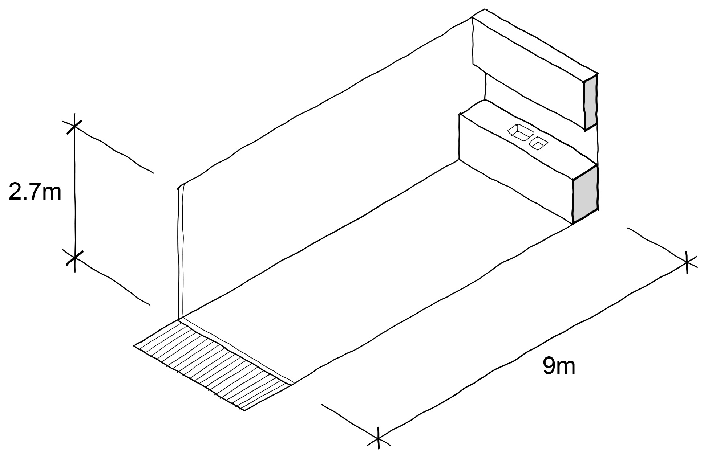
Where a habitable room is an open plan layout (combined living area, dining area and kitchen) with a ceiling height of 2.7m, the room depth can be extended to 9m as described in the standard above.
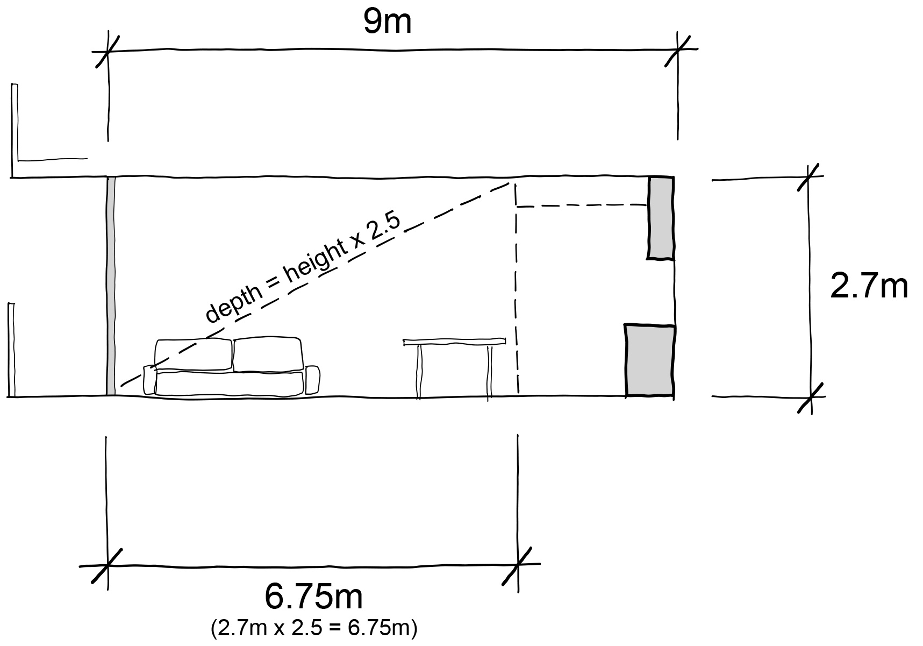
Where habitable rooms have a ceiling height of 2.4m the maximum room depth is 6m (2.5 x 2.4m).
Where habitable rooms have a ceiling height of 2.7m the maximum room depth is 6.75m (2.5 x 2.7m).
Increase the size and head height of windows to improve the daylight penetration into the depth of the room.
Allow for sufficient structural floor to floor heights to achieve required ceiling heights for the room depth.
Allow space for services and insulation between the ceiling and structure.
Configure balconies to suit the orientation of the apartment and increase daylight while controlling sunlight.
Large continuous overhangs beyond a single aspect room of 9m depth should be avoided.

Supporting documentation
Provide dimensions of habitable room depths on plans.
Provide dimensions of habitable room floor-to-ceiling heights on sections.

Standard B3-9 Daylight to new windows
Why this is important
This standard is a fundamental amenity standard that ensures that all new windows of habitable rooms receive adequate daylight. Quality daylight minimises the need for artificial lighting, enhancing energy efficiency and creating a more comfortable living environment.
Daylight to new windows objective
To allow adequate daylight into new habitable room windows.
Standard B3-9
Dwelling (other than a dwelling in or forming part of an apartment development)
A window in an external wall of the building is provided to all habitable rooms.
Habitable rooms in a dwelling have a window that faces:
- An outdoor space clear to the sky or a light court with a minimum area of 3 square metres and minimum dimension of 1 metre clear to the sky, not including land on an abutting lot; or
- A verandah provided it is open for at least one third of its perimeter; or
- A carport provided it has two or more open sides and is open for at least one third of its perimeter.
Dwelling in or forming part of an apartment development
A window in an external wall of the building is provided to all habitable rooms.
Where daylight to a bedroom is provided from a smaller secondary area within the bedroom, the secondary area is to have:
- A minimum width of 1.2 metres.
- A maximum depth of 1.5 times the width, measured from the external surface of the window.
- A window clear to the sky.
Decision guidelines
Before deciding on an application, the responsible authority must consider:
- The design response.
- The extent to which habitable rooms are provided with reasonable daylight access through the number, size, location and orientation of windows.
- The useability and amenity of the dwelling based on the layout, siting, size and orientation of habitable rooms.
- Whether there are other windows in the habitable room which have access to daylight.

Applying the standard
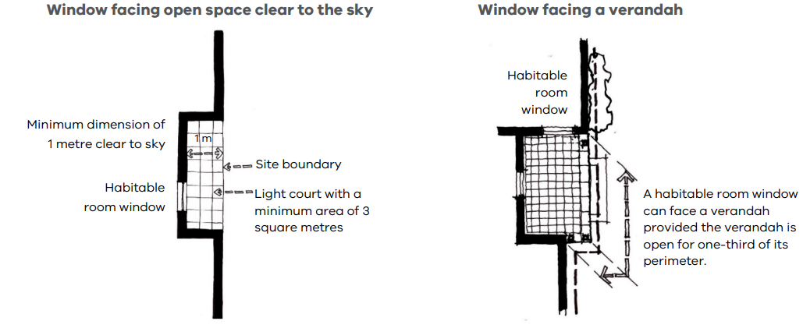
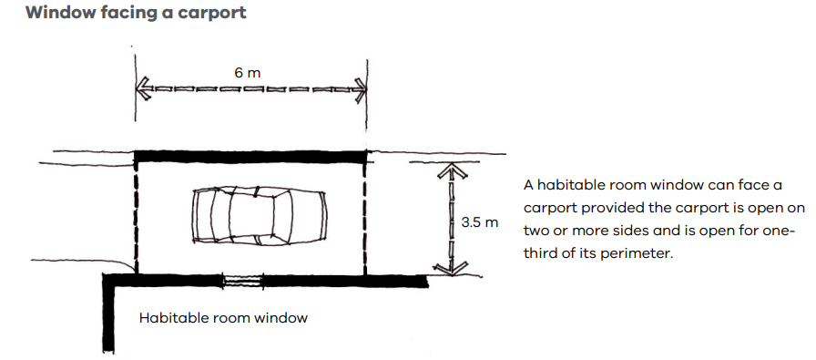

Supporting documentation
Identify widths and heights of structures adjoining habitable room windows.

Standard B3-10 Natural ventilation
Why this is important
This standard ensures occupants can effectively manage the natural ventilation of their dwellings to improve air quality, reduce the build-up of indoor pollutants and regulate indoor temperatures.
Natural ventilation objectives
To encourage natural ventilation of dwellings.
To allow occupants to effectively manage natural ventilation of dwellings.
Standard B3-10
Dwelling (other than a dwelling in or forming part of an apartment development)
Dwellings have openable windows, doors or other ventilation devices in external walls of the building that provide:
- A maximum breeze path through the dwelling of 18 metres.
- A minimum breeze path through the dwelling of 5 metres.
- Ventilation openings with approximately the same size.
The breeze path is measured between the ventilation openings on different orientations of the dwelling.
Dwelling in or forming part of an apartment development
At least 40 per cent of dwellings in or forming part of an apartment development have openable windows, doors or other ventilation devices in external walls of the building that provide:
- A maximum breeze path through the dwelling of 18 metres.
- A minimum breeze path through the dwelling of 5 metres.
- Ventilation openings with approximately the same size.
The breeze path is measured between the ventilation openings on different orientations of the dwelling.
Decision guidelines
Before deciding on an application, the responsible authority must consider:
- The design response.
- The size, orientation, slope and wind exposure of the site.

Applying the standard
A breeze path is measured as a sequence of straight line segments measured from the centreline of openings.
A minimum of one breeze path needs to be nominated.
Refer to the National Construction Code further guidance for minimum ventilation requirements.
Configure floorplates with corner or through apartments to achieve effective cross ventilation.
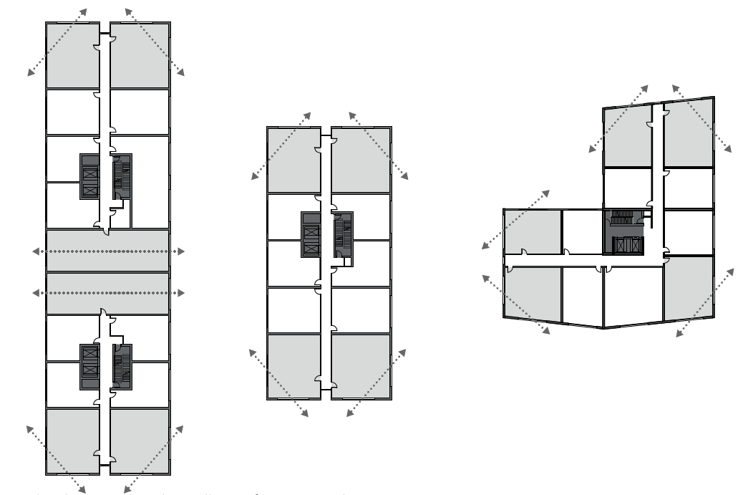
Windows must be located on different orientations of a dwelling.
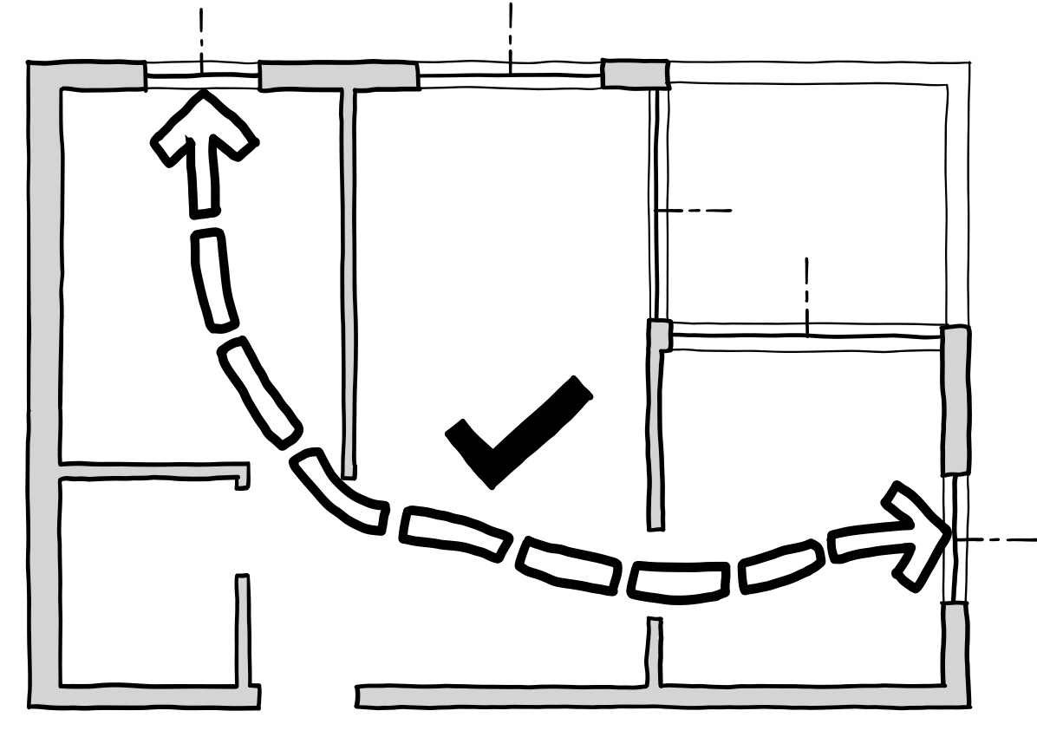This breeze path meets the standard as it measures 15 metres between the centre of similar sized windows on different orientations of the apartment. | 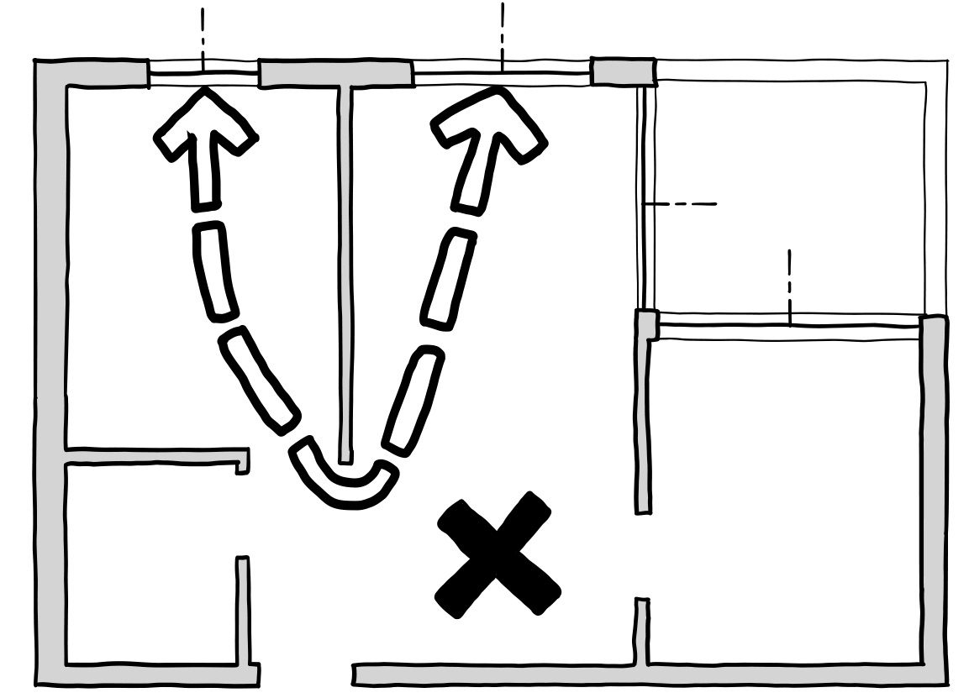  This breeze path does not meet the standard as it is between two windows on the same orientation.
Effective cross ventilation is achieved when the inlet and outlet have approximately the same area allowing air to be drawn through the apartment using opposite air pressures on each side of the building.
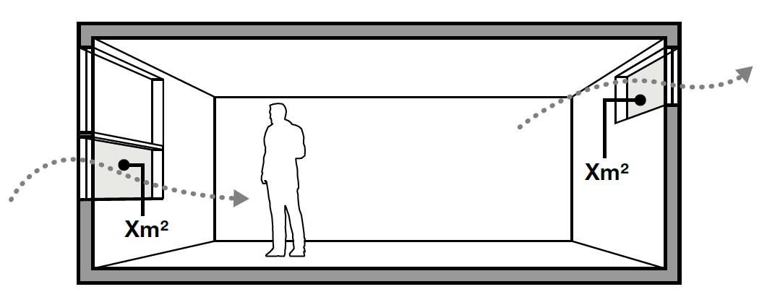
An effective breeze path should minimise the number of doors and obstructions along the breeze path.
Wherever possible, provide openable windows or doors into habitable rooms to achieve natural air flow.
Effective natural ventilation is influenced by:
- the clear openable area of varied window types
- prevailing wind conditions and air pressures
- temperature differentials
- the surrounding built environment
- the length of breeze path and number of obstructions through an apartment.
An adequately sized operable roof light in a single aspect apartment may achieve cross ventilation where adequate air flow can be demonstrated by engineering analysis.
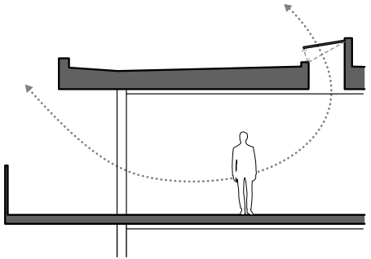
Roof lights should be designed to be weather protected, secure and maintain good thermal performance.

Supporting documentation
Nominate on a plan which dwellings are cross ventilated and illustrate the location and length of the breeze path, or provide a ventilation report for an alternative solution.

Standard B3-11 Storage
Why this is important
This standard ensures that dwellings provide adequate, usable, and functional storage space. Adequate storage promotes efficient use of space and contributes to overall comfort and convenience.
Storage objective
To provide adequate storage facilities for each dwelling.
Standard B3-11
Dwelling (other than a dwelling in or forming part of an apartment development)
Each dwelling has exclusive access to at least 6 cubic metres of externally accessible storage space.
Dwelling in or forming part of an apartment development
Each dwelling has exclusive access to storage at least the total minimum storage volume that is specified in Table B3-11.
  - Table B3-11 Storage
Dwelling type | Total minimum storage volume | Minimum storage volume within the dwelling
Studio | 8 cubic metres | 5 cubic metres
1 bedroom dwelling | 10 cubic metres | 6 cubic metres
2 bedroom dwelling | 14 cubic metres | 9 cubic metres
3 or more bedroom dwelling | 18 cubic metres | 12 cubic metres
Decision guidelines
Before deciding on an application, the responsible authority must consider:
- The design response.
- The useability, functionality and location of storage facilities provided for the dwelling.

Applying the standard
The total minimum storage volume in Table B-11 includes the minimum storage volume within a dwelling.
Whitegoods and appliances such as refrigerators, ovens, dishwashers and washing machines should have dedicated spaces and are not included in the calculation of storage.
Spaces for bicycle and car parking are additional to the storage space requirements in Table B3-11.
Provide practical arrangement of storage appropriate to each space within the dwelling.
A minimum of 1.8 metres of robe length for the main bedroom and a 1.5 metres for all other bedrooms is practical for clothes storage.
As a rule of thumb, storage volumes (m3) per linear metre of cupboards are as follows:
For 600mm deep cupboards
- 750mm bench height = 0.45m3
- 2400mm full height = 1.44m3
For 300mm deep cupboards
- 750mm overhead cupboard = 0.225m3
Long term storage provided externally to an apartment can be provided in basements and car parking areas, or in a common area convenient to the apartment.
Dedicated storage rooms can make use of areas within the floor plate which have limited access to natural light and ventilation
Locate lockable storage in locations with good informal surveillance to improve security as they are prone to theft
Dedicated storage lockers in basements are preferred as they provide easier access when compared to over car bonnet storage
Make storage enclosures a functional shape and size to suit various needs such as storing bulky items.

Examples of storage areas in typical 1 bed and 2 bed layouts
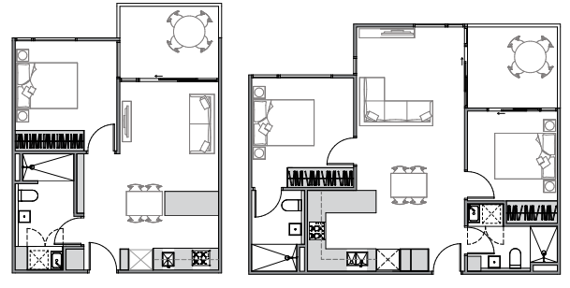
Supporting documentation
Provide a schedule with a breakdown of minimum internal and external storage provisions for each dwelling and apartment type.

  - Standard B3-12 Accessibility for apartment developments objective
Why this is important
This standard ensures the design of dwellings meets the needs of people with limited mobility, families with young children and older people to live comfortably and navigate dwellings easily and safely.
Accessibility for apartment developments objective
To ensure the design of dwellings meets the needs of people with limited mobility.
Standard B3-12
At least 50 per cent of dwellings in or forming part of an apartment development have:
- A clear opening width of at least 850mm at the entrance to the dwelling and main bedroom.
- A clear path with a minimum width of 1.2 metres that connects the dwelling entrance to the main bedroom, an adaptable bathroom and the living area.
- A main bedroom with access to an adaptable bathroom.
- At least one adaptable bathroom that meets all of the requirements of either Design A or Design B specified in Table B3-12.
Table B3-12 Bathroom design
 | Design option A | Design option B
Door opening | A clear 850mm wide door opening. | A clear 820mm wide door opening located opposite the shower.
Door design | Either:  - A slide door, or  - A door that opens outwards, or  - A door that opens inwards that is clear of the circulation area and has readily removable hinges. | Either:  - A slide door, or  - A door that opens outwards, or  - A door that opens inwards and has readily removable hinges.
Circulation area | A clear circulation area that is:  - A minimum area of 1.2 metres by 1.2 metres.  - Located in front of the shower and the toilet.  - Clear of the toilet, basin and the door swing.  - The circulation area for the toilet and shower can overlap. | A clear circulation area that is:  - A minimum width of 1 metre.  - The full length of the bathroom and a minimum length of 2.7 metres.  - Clear of the toilet and basin.  - The circulation area can include a shower area.
Path to circulation area | A clear path with a minimum width of 900mm from the door opening to the circulation area. | Not applicable.
Shower | A hobless (step-free) shower. | A hobless (step-free) shower that has a removable shower screen and is located on the furthest wall from the door opening.
Toilet | A toilet located in the corner of the room. | A toilet located closest to the door opening and clear of the circulation area.

Applying the standard
To meet the design options specified in Table B3-12 all the requirements of either option A or option B must be met.
For bathroom design option A, a corner of the bathroom is achieved where a nib wall is provided which can be fitted with a grab rail.
Locate the main bedroom with convenient access to the adaptable bathroom.
Where the main bedroom has an ensuite, it should be nominated as the adaptable bathroom.
An adaptable bathroom convenient to the larger bedroom.
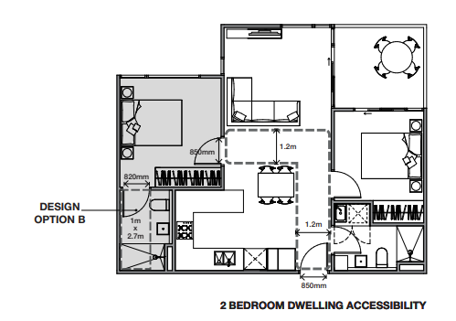

Configure spaces to achieve clear access paths while allowing for functional furniture arrangements.
Design openings and the path of travel so that turning movements into bedrooms and bathrooms are minimised.
Clear access paths between entry, living and larger bedroom.

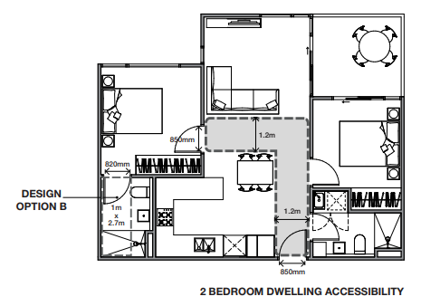

When providing an adaptable bathroom to meet either option A or option B make use of the typical configurations illustrated or demonstrate that the standard is met with an alternative layout.
A step free shower should have a maximum 5mm height level change between adjacent surfaces with a bevelled or rounded edge with falls to the waste outlet.
Typical bathroom configurations to comply with Table B3-12.
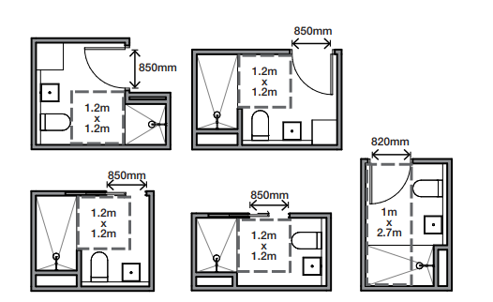

When applying bathroom design option A, if the toilet cannot be located in the corner of the room, include a nib wall adjacent to the toilet
A nib wall adjacent to a toilet needs to be 700mm long to enable future fitting of a grab rail.

A nib wall adjacent to a toilet.

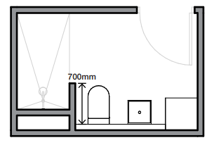

Supporting documentation
Identify apartments which have been designed to meet the accessibility requirements.
Provide dimensions for clear openings, pathways and the adaptable bathrooms.

55.04 EXTERNAL AMENITY

Standard B4-1 Daylight to existing windows
Why this is important
This standard ensures that all new dwellings provide adequate daylight to existing windows. Maximising daylight is important for energy efficiency and comfort of indoor spaces.
Daylight to existing windows objective:
To allow adequate daylight into existing habitable room windows.
Standard B4-1
Buildings opposite an existing habitable room window provide for a light court to the existing window that has a minimum area of 3 square metres and minimum dimension of 1 metre clear to the sky. The calculation of the area may include land on the abutting lot.
Walls or carports more than 3 metres in height opposite an existing habitable room window are set back from the window at least 50 per cent of the height of the new wall if the wall is within a 55 degree arc from the centre of the existing window. The arc may be swung to within 35 degrees of the plane of the wall containing the existing window.
Where the existing window is above ground floor level, the wall height is measured from the floor level of the room containing the window.
Diagram B4-1 Daylight to existing windows
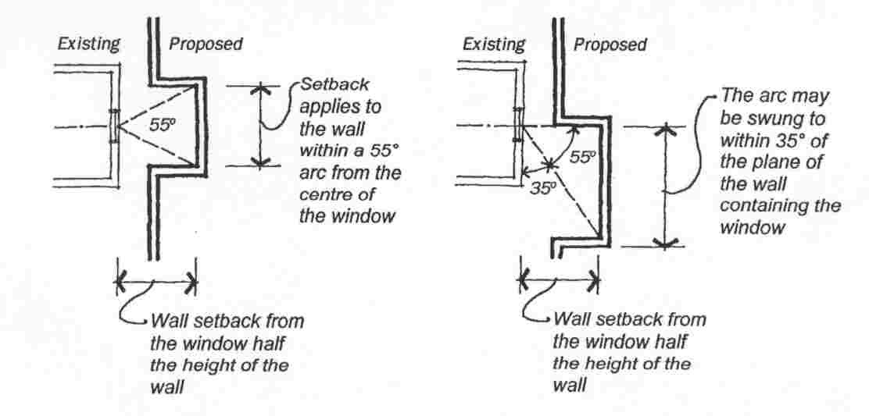

Decision guidelines
Before deciding on an application, the responsible authority must consider:
- The design response.
- The extent to which the existing dwelling or small second dwelling has provided for reasonable daylight access to its habitable rooms through the siting and orientation of its habitable room windows.
- The impact on the amenity of existing dwellings or small second dwellings.

Applying the standard
Building opposite an existing habitable room window
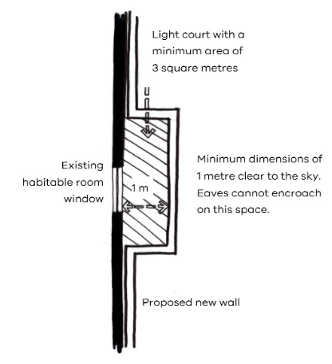
55-degree arc from centre of an existing window
- 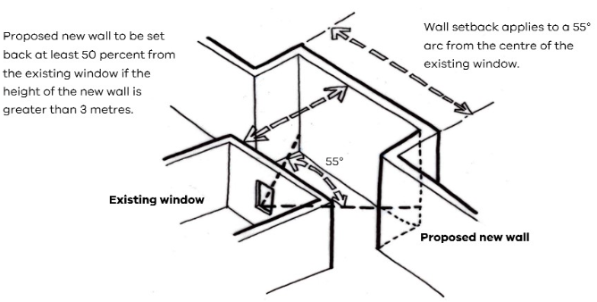

35 degree arc from plane of an existing window
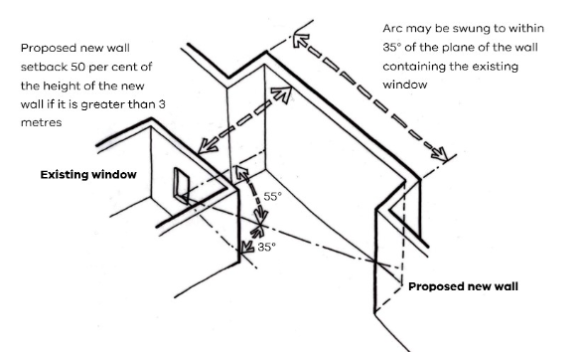

Supporting documentation
Identify widths and heights of built form proposed adjoining existing habitable room windows.

Standard B4-2 Existing north-facing windows
Why this is important
This standard protects the energy efficiency of existing dwellings or small second dwellings which use north-facing windows for passive solar heating.
Existing north-facing windows objective
To allow adequate solar access to existing north-facing habitable room windows.
Standard B4-2
Where a north-facing habitable room window of a neighbouring dwelling or small second dwelling is within 3 metres of a boundary on an abutting lot:
- A new building is to be set back from the boundary by at least 1 metre, plus 0.6 metres for every metre of height over 3.6 metres up to 6.9 metres, plus 1 metre for every metre of height over 6.9 metres. This setback is to be provided for a distance of at least 3 metres from the edge of each side of the window.
- For new buildings that meet the Standard B2-3.2 setback, the building is set back from the boundary by at least 6 metres up to a height not exceeding 11 metres and at least 9 metres for a height over 11 metres between south 30 degrees west to south 30 degrees east. This setback is to be provided for a distance of at least 3 metres from the edge of each side of the window.
For this standard a north-facing window is a window with an axis perpendicular to its surface oriented from north 20 degrees west to north 30 degrees east.
Diagram B4-2.1 North-facing windows
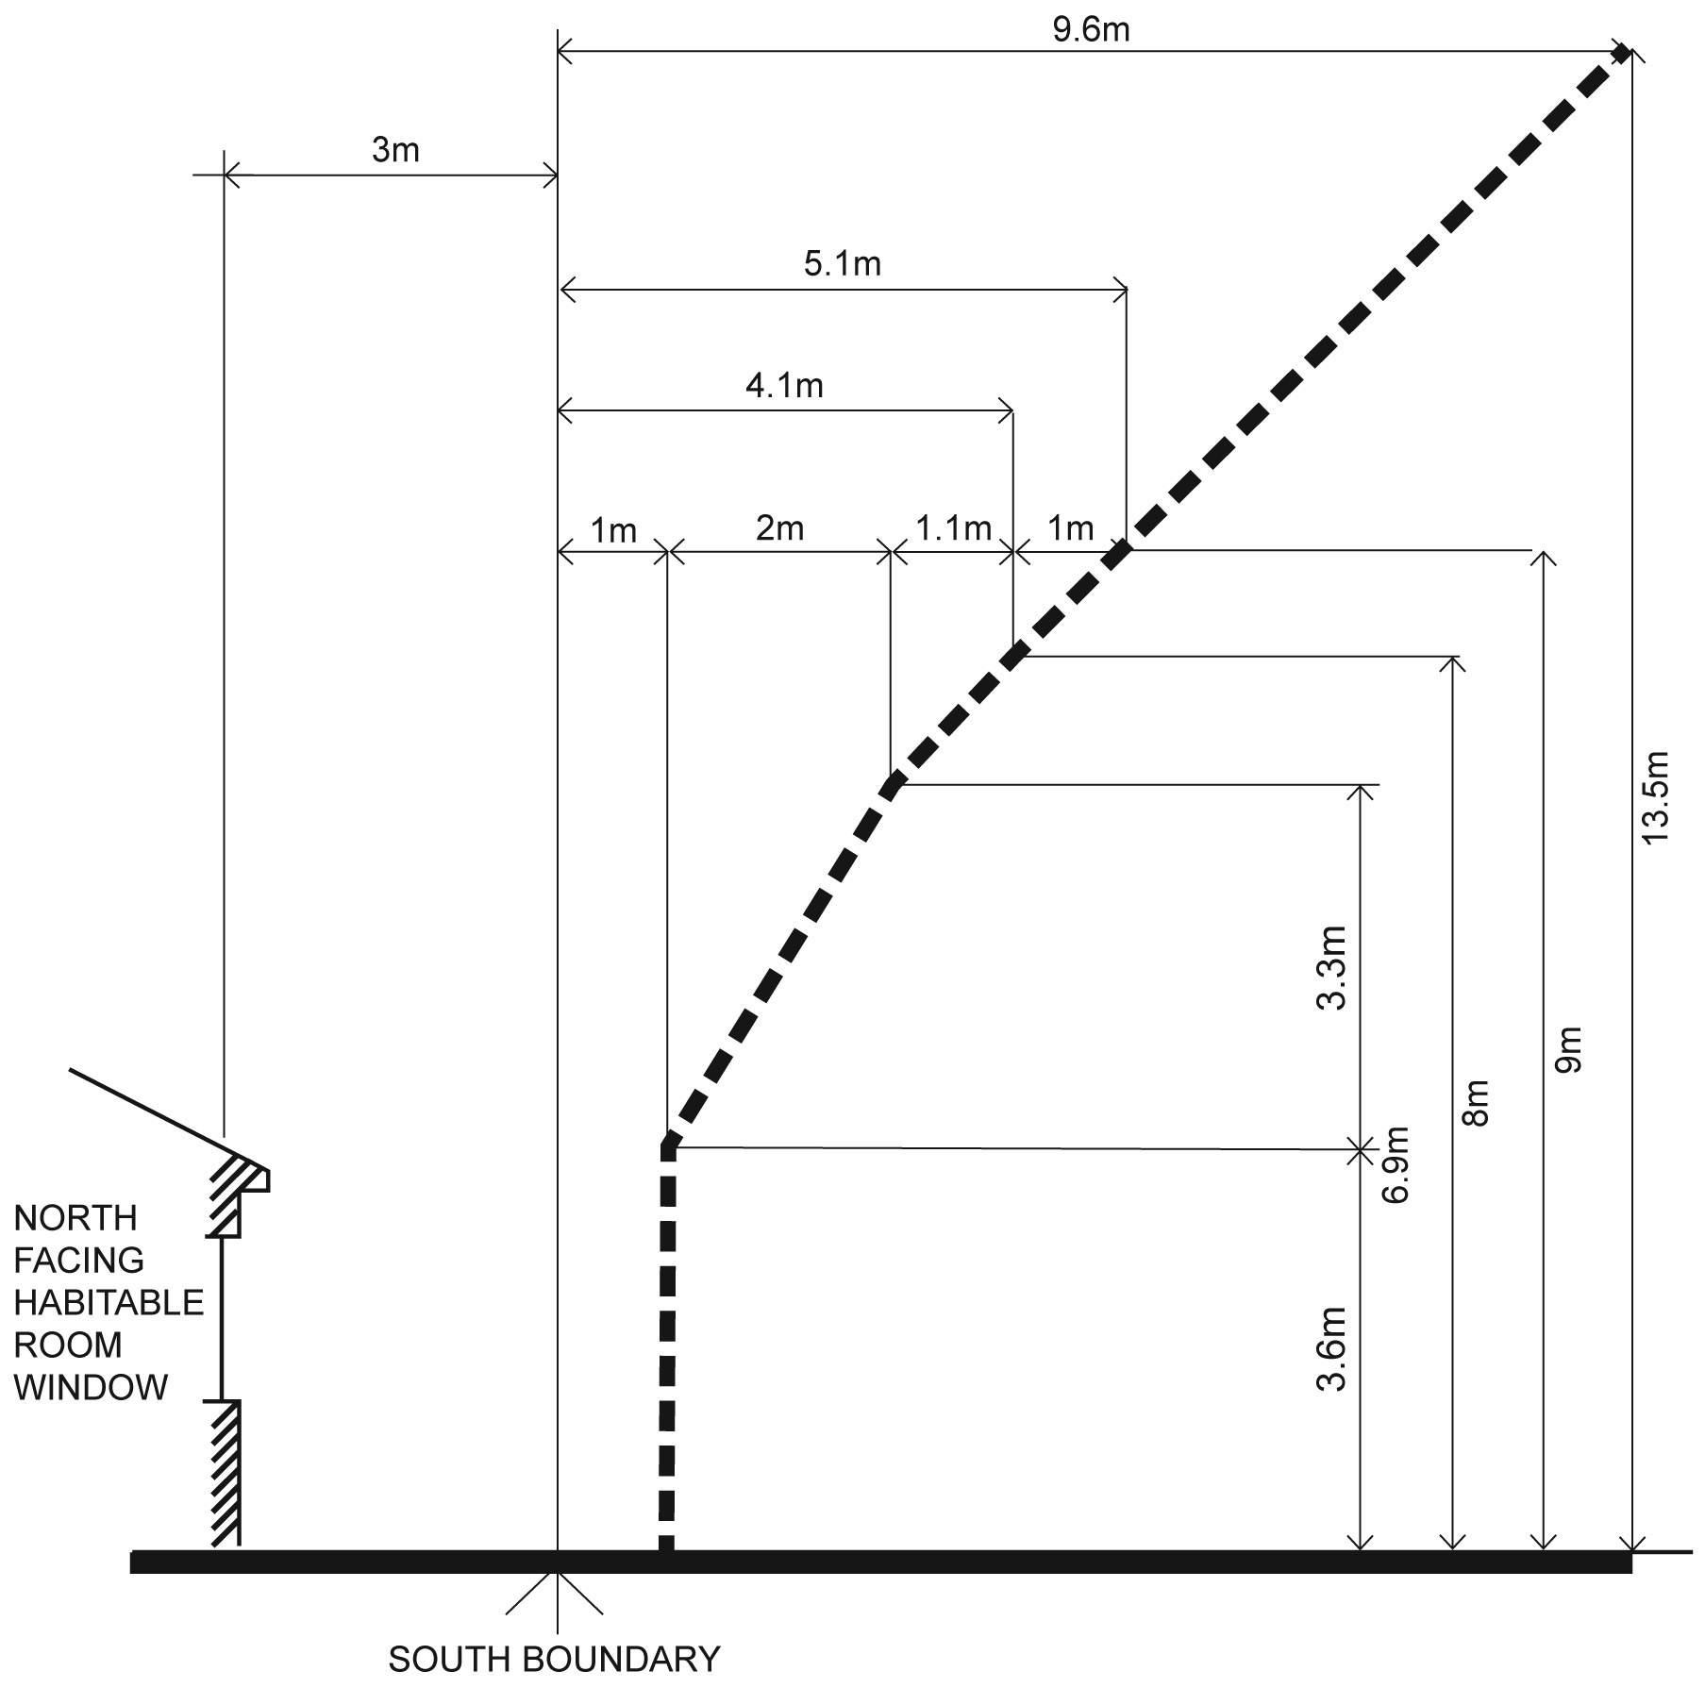
Diagram B4-2.2 North facing windows
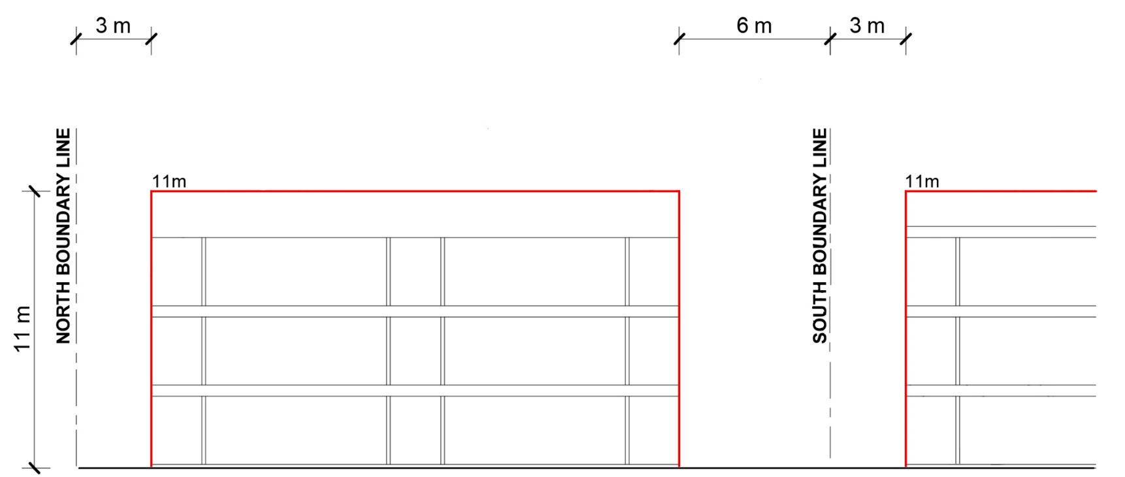

Decision guidelines
Before deciding on an application, the responsible authority must consider:
- The design response.
- Existing sunlight to the north-facing habitable room window of the existing dwelling or small second dwelling.
- The impact on the amenity of existing dwellings or small second dwellings

Applying the standard
The formula for calculating the required setback for new buildings that meet the Standard B2-3.1 where the building height is between 3.6 metres and 6.9 metres is:
1m + [0.6m x (h – 3.6m)] (h is the wall height)
If the wall height is greater than 6.9 metres, the formula is:
1m + [0.6m x (6.9m – 3.6m)] + [1m x (h – 6.9m)]
Applying the formula to the same dwelling used in the side and rear setbacks standard example above (see Standard B2-1), the upper storey will need to be set back a further 1 metre from the southern boundary to protect sunlight to north-facing windows on an existing dwelling located to the south.
1 m + [0.6 x (6.9m – 3.6m)]
= 1m + [0.6 x 3.3m]
= 1m + 1.98m
= 2.98m (rounded up to 3m) setback

Supporting documentation
Identify wall heights and setbacks on plans, elevations and setbacks.

Standard B4-3 Overshadowing secluded open space objective

Why this is important
This standard protects existing secluded private open space from overshadowing from new developments. Secluded private open space areas should receive adequate natural light for the comfort of residents and to promote the use of the space.
Overshadowing secluded open space objective
To ensure buildings do not significantly overshadow existing secluded private open space.
Standard B4-3
The area of secluded private open space that is not overshadowed by the new development is greater than 50 per cent, or 25 square metres with a minimum dimension of 3 metres, whichever is the lesser area, for a minimum of five hours between 9 am and 3 pm on 22 September.
If existing sunlight to the secluded private open space of an existing dwelling or small second dwelling is less than the requirements of this standard, the amount of sunlight will not be further reduced.
Decision guidelines
Before deciding on an application, the responsible authority must consider:
- The design response.
- The impact on the amenity of existing dwellings or small second dwellings.
- Existing sunlight penetration to the secluded private open space of the existing dwelling or small second dwelling.
- The time of day that sunlight will be available to the secluded private open space of the existing dwelling or small second dwelling.
- The effect of a reduction in sunlight on the existing use of the existing secluded private open space.

Applying the standard

Overshadowing at 9am
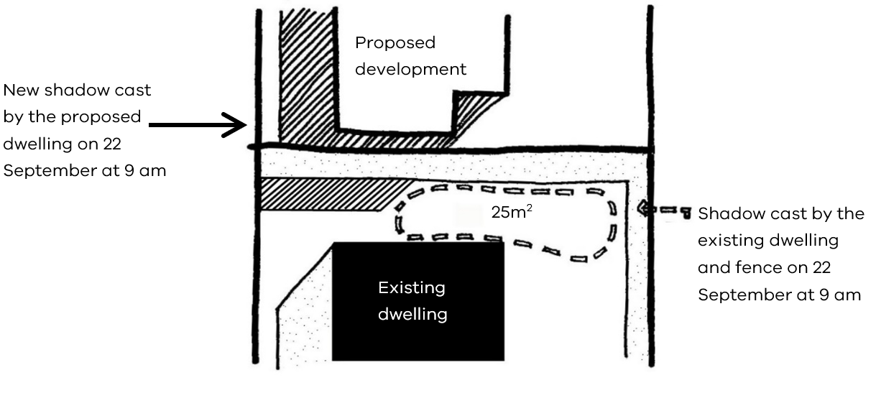

Overshadowing at 3pm
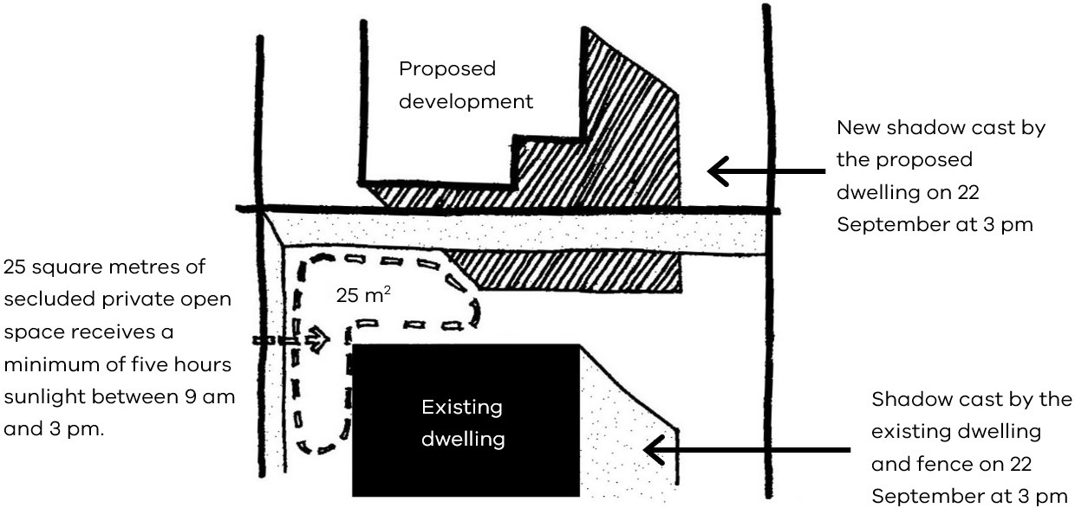

Existing overshadowing greater than allowed by the standard
In a typical inner city scenario many private open spaces have existing overshadowing greater than allowed by the requirements of this standard.
In these instances, the amount of sunlight should not be further reduced.
This example shows how Development A can be extended without further reducing the amount of sunlight to the private open space of Development B by designing for the shadow of the proposed extension to fall within the shadow of the existing fence.
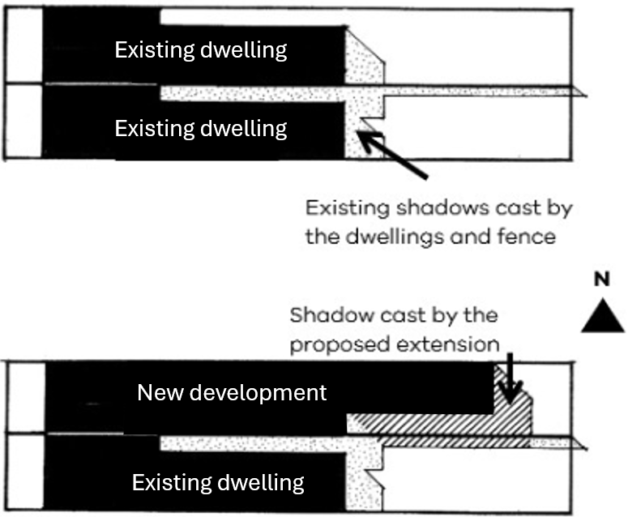
Length of shadow on 22 September
Time | Sun altitude (degrees) | Shadow length of a 1 metre high post (m)
9.00 am | 32° | 1.60
10.00 am | 41° | 1.15
11.00 am | 49° | 0.87
12.00 noon | 52° | 0.78
1.00 pm | 50° | 0.84
2.00 pm | 45° | 1.00
3.00 pm | 36° | 1.38
As a simple guide, the table above gives an indication of shadow lengths at various times of the day based on the height of a 1 metre post and assuming flat ground.
To roughly calculate the length of shadow cast by a 4.5 metre high wall at 9:00 am, you simply multiply 4.5 metres x 1.6 metres = 7.2 metres (shadow length).
Sunlight to private open space
There are a range of commercial packages available to assist in measuring and producing overshadowing diagrams.
Angle of shadow 22 September
- 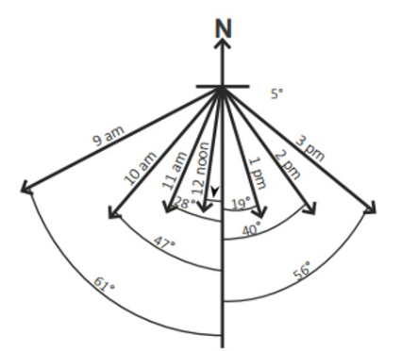

Supporting documentation
Provide existing and proposed shadow diagrams.

Standard B4-4 Overlooking
Why this is important
This standard protects existing windows and private open spaces from overlooking, ensuring privacy, security, and the overall amenity of a space for the well-being and usability of its occupants.
Overlooking objective
To limit views into existing secluded private open space and habitable room windows.
Standard B4-4
In Clause 55.04-4 a habitable room does not include a bedroom.
A habitable room window, balcony, podium, terrace, deck or patio is located and designed to avoid direct views into the secluded private open space of an existing dwelling or small second dwelling within a horizontal distance of 9 metres (measured at ground level) of the window, balcony, terrace, deck or patio. Views are measured within a 45 degree angle from the plane of the window or perimeter of the balcony, terrace, deck or patio, and from a height of 1.7 metres above floor level.
A habitable room window, balcony, terrace, deck or patio that is located with a direct view into a habitable room window of an existing dwelling or small second dwelling within a horizontal distance of 9 metres (measured at ground level) of the window, balcony, terrace, deck or patio:
- Is offset a minimum of 1.5 metres from the edge of one window to the edge of the other; or
- Has sill heights of at least 1.7 metres above floor level; or
- Has fixed, obscure glazing in any part of the window below 1.7 metre above floor level; or
- Has permanently fixed external screens to at least 1.7 metres above floor level and be no more than 25 per cent transparent; or
- Has fixed elements that prevent the direct view, such as horizontal ledges or vertical fins.
Obscure glazing in any part of the window below 1.7 metres above floor level may be openable provided that there are no direct views as specified in this standard.
Screens used to obscure a view are:
- Perforated panels or trellis with a maximum of 25 per cent openings or solid translucent panels.
- Permanent, fixed and durable.
- Designed and coloured to blend in with the development.
This standard does not apply to a new habitable room window, balcony, terrace, deck or patio which faces a property boundary where there is a visual barrier at least 1.8 metres high and the floor level of the habitable room, balcony, terrace, deck or patio is less than 0.8 metres above ground level at the boundary.

Diagram B4-4 Overlooking

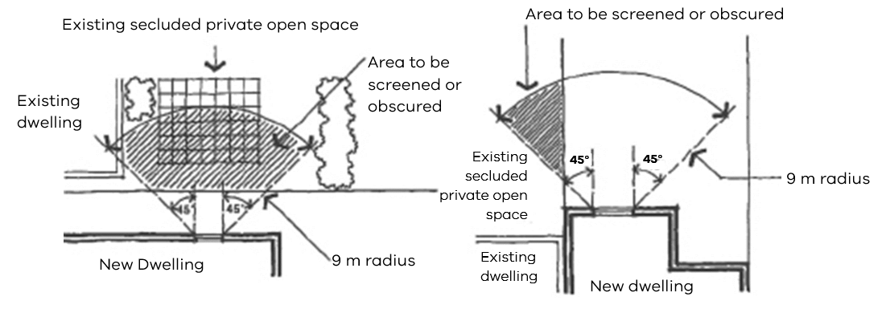

Decision guidelines
Before deciding on an application, the responsible authority must consider:
- The design response.
- The impact on the amenity of the secluded private open space or habitable room window.
- The existing extent of overlooking into the secluded private open space and habitable room windows of existing dwellings or small second dwellings.
- The internal daylight to and amenity of the proposed dwelling, residential building or small second dwelling.

Applying the standard

Overlooking into secluded private open space
You should only consider any direct line of sight within the defined area of view when considering overlooking from a proposed habitable room window into neighbouring secluded private open space.
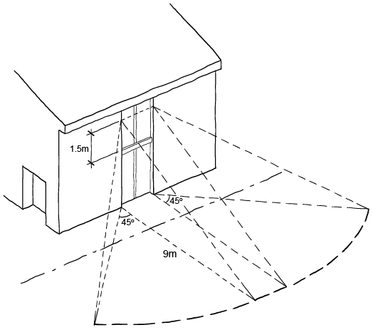

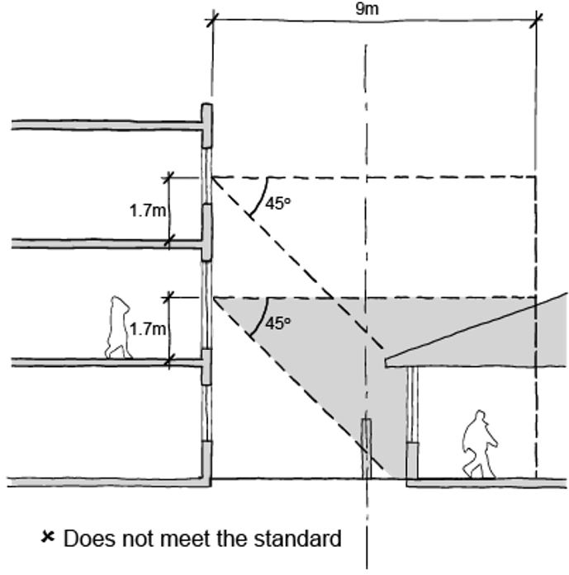 | 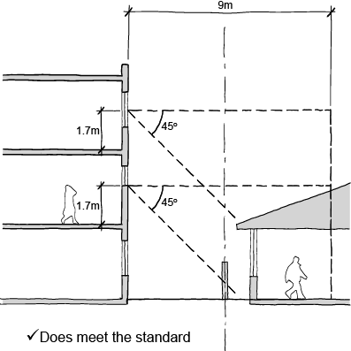
Overlooking available into neighbouring secluded private open space and habitable room windows | Windows elevated to restrict views into neighbouring secluded private open space and habitable room windows
Fixed elements that prevent direct views, such as angled vertical fins can be used to restrict views.
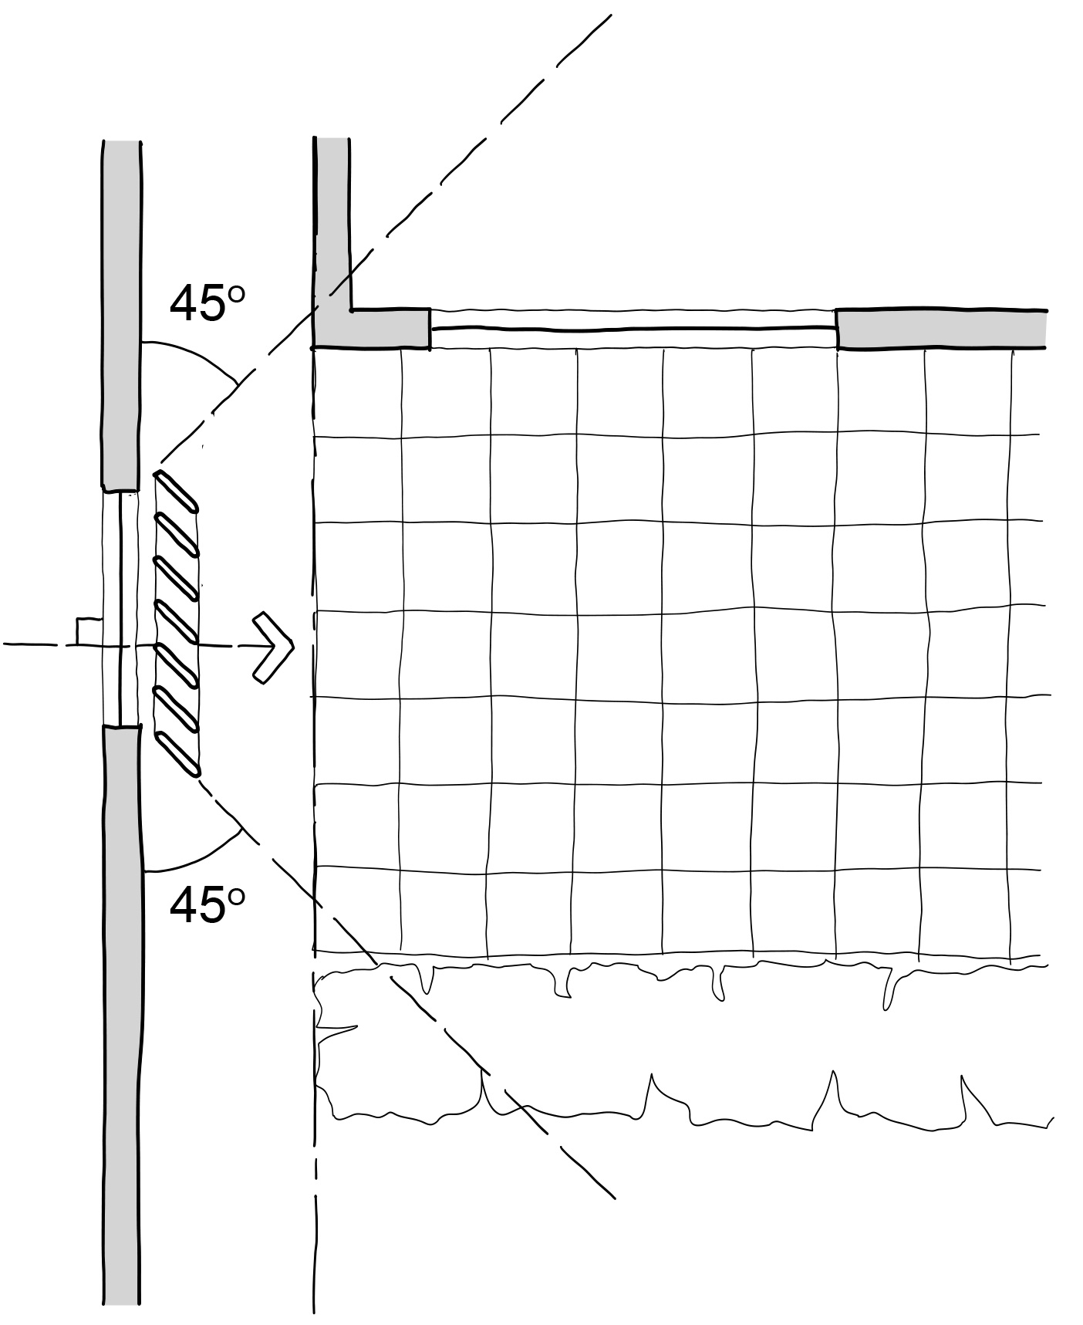

Offsetting a new window
A new habitable room window should be offset 1.5 metres from the edge of an existing window.
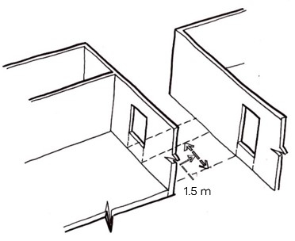

Supporting documentation
Identify existing habitable windows on site plan.
Demonstrate overlooking is mitigated in accordance with standard on plans, elevations and sections, as relevant.

Standard B4-5 Internal views
Why this is important
This standard limits views into the secluded private open spaces and habitable room windows of dwellings and residential buildings within a development to ensure privacy.
Internal views objective
To limit views into the secluded private open space and habitable room windows of dwellings and residential buildings within a development.
Standard B4-5
In Clause 55.04-5 a habitable room does not include a bedroom.
Within the development, a habitable room window, balcony, terrace, deck or patio that is located with a direct view into the secluded private open space of another dwelling:
- Is offset a minimum of 1.5 metres from the edge of the secluded private open space; or
- Has a sill height of at least 1.7 metres above floor level; or
- Has a fixed, visually obscure balustrade to at least 1.7 metre above floor level; or
- Has permanently fixed external screens to at least 1.7 metres above floor level; or.
- Has fixed elements that prevent the direct view, such as horizontal ledges or vertical fins.
Direct views are measured at a height of 1.7 metres above floor level and within:
- A 45 degree horizontal angle from the edge of the new window or balcony.
- A 45 degree angle in the downward direction.
Screens provided for overlooking are no more than 25 per cent transparent. Screens may be openable provided that this does not allow direct views as specified in this standard.

Decision guideline

Before deciding on an application, the responsible authority must consider the design response.

Applying the standard
Use building setbacks and the relationship between buildings on a site, as the primary method of limiting views into secluded private open spaces and habitable room windows of dwellings.
Adjust building form, façade shape and window locations to further limit views into secluded private open spaces and habitable room windows of dwellings while protecting access to daylight and outlook.
In addition to building setbacks, design techniques for privacy include:
- Creating oblique and controlled views such as bay windows.
- Limiting lengths of facades that direct views towards the adjoining habitable rooms and secluded private open spaces by shaping, staggering or realigning facades.
- Using sill and balustrade heights and depths to limit direct views downwards.
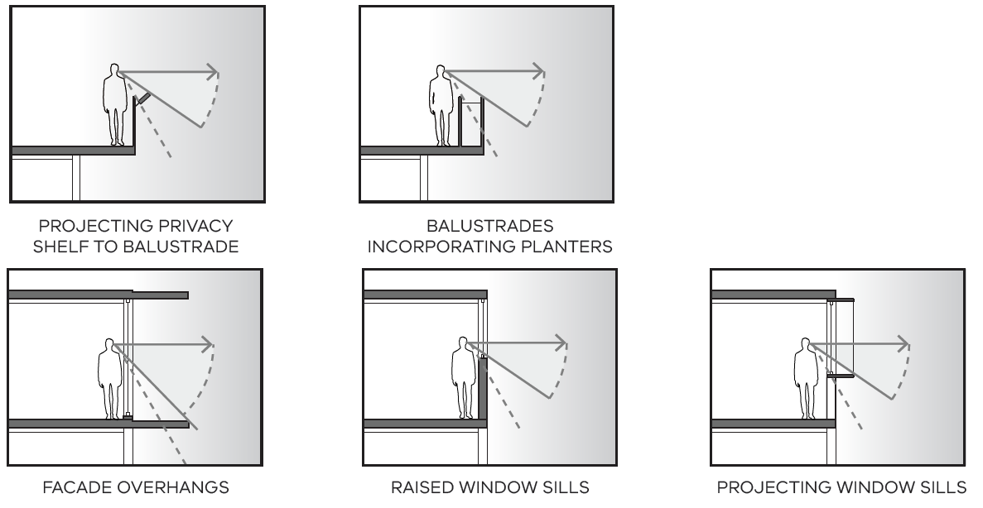
- Using pergola and shading devices to screen views to dwellings and secluded private open spaces on lower levels.
- When secluded private open spaces and habitable room windows in separate dwellings directly face each other, generally provide greater building separations than where one dwelling faces the side of another dwelling.
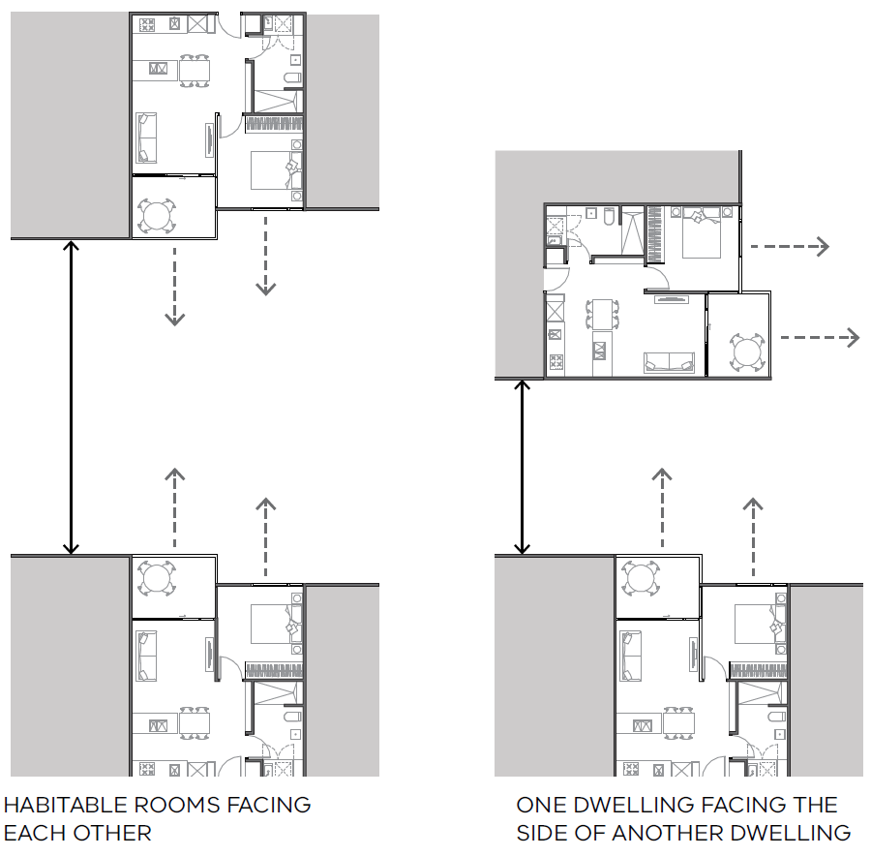

Supporting documentation
Nominate all minimum building setbacks.

55.05 SUSTAINABILITY

Standard B5-1 Permeability and stormwater management
Why this is important
This standard limits the amount of hard surfaces that can surround a new development and requires stormwater management that maximises the retention and reuse of stormwater.
These measures help to make best use of all water sources, reduce pollution of waterways, minimise the contribution of stormwater runoff to localised flooding and support cooling and greening of urban environment in the face of a changing climate.
Permeability and stormwater management objective
To reduce the impact of increased stormwater run-off on the drainage system and downstream waterways.
To facilitate on-site stormwater infiltration.
To encourage stormwater management that maximises the retention and reuse of stormwater.
To contribute to urban cooling.

Standard B5-1
The site area covered by the pervious surfaces is at least 20 percent of the site.
The development includes a stormwater management system designed to:
- Meet the best practice quantitative performance objectives for stormwater quality specified in the Urban stormwater management guidance (EPA Publication 1739.1, 2021) of:
  - Suspended solids 80% reduction in mean annual load.
  - Total phosphorus and Total Nitrogen 45% reduction in mean annual load.
  - Litter 70% reduction of mean annual load.
Note:
A certificate generated from a stormwater assessment tool including Stormwater Treatment Objective- Relative Measurement (STORM), Model for Urban Stormwater Improvement Conceptualisation (MUSIC) or an equivalent product accepted by the responsible authority may be used to demonstrate the performance objectives for stormwater quality are met.
- Direct flows of stormwater into treatment areas, garden areas, tree pits and permeable surfaces, with drainage of residual flows to the legal point of discharge.
Decision guidelines
Before deciding on an application, the responsible authority must consider:
- The design response.
- The capacity of the site to incorporate stormwater retention and reuse.
- The existing site coverage and any constraints imposed by existing development.
- The capacity of the drainage network to accommodate additional stormwater.

Applying the standard
Permeability

Permeability is calculated as the total pervious area multiplied by 100 divided by total site area.
Water cannot penetrate an impervious surface. An impervious surface includes a dwelling, a small second dwelling, a garage or carport, a verandah, a garden shed, a path, a swimming pool, outdoor paved areas, a driveway or any other sealed surface.
At least 20 per cent of the site should have surfaces that can allow penetration of water to deep soil such as garden beds, lawn and other unsealed surfaces. This can include driveways, pathways and outdoor entertaining areas, provided the materials used for their construction are pervious.
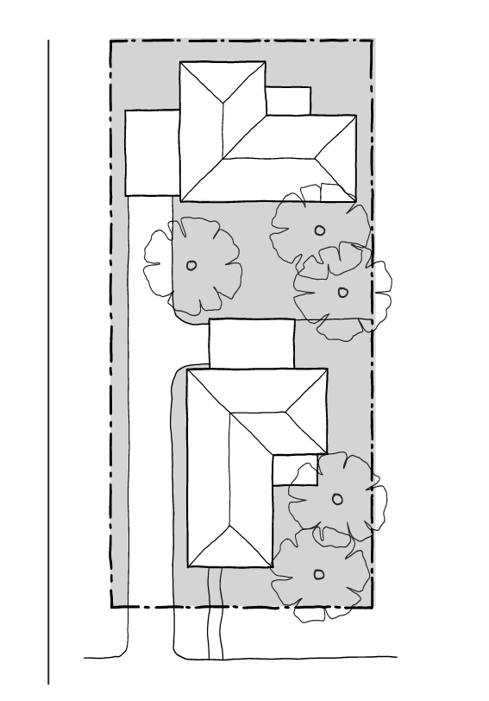
At least 20 per cent of the site should have permeable surfaces

Stormwater
Compliance with the standard can be demonstrated through a certificate generated from an industry recognised assessment tool accepted by the responsible planning authority. Larger projects which use sophisticated modelling tools such as MUSIC should be prepared by a suitably qualified consultant. Melbourne Water provides helpful advice on the use of current Stormwater assessment tools: STORM and MUSIC tools | Melbourne Water.
Details of a stormwater management system and evidence that the design features meet quantitative performance objectives for stormwater quality as set out in Standard B5-1 will typically include the following elements:

Site features and stormwater management responses | Modelling and compliance
1: Show the site boundary, dimensions, and total site area on the site layout plan.  2: Provide a site layout plan showing all building roofs and covered areas, pervious (unsealed) surface areas and impervious (sealed) surface areas with dimensions. These details must be consistent with the plans and other documents lodged with the planning application.  3: Show the legal point of discharge.  4: Specify the area draining to each downpipe, treatment and legal point of discharge – includes both impervious and pervious areas.  5: Show the location, type and surface area (sqm) of the proposed WSUD treatment systems on a plan, including how each internal catchment area to be treated will be connected to a WSUD element (e.g. roof to rainwater tank, driveway to raingarden). Show how piped connections will be made within the site and to the legal point of discharge and clearly annotate any impervious areas not being treated by a WSUD element.  6: Indicate the expected volume of on-site stormwater reuse and how this has been calculated.  7: Indicate the expected volume of on-site stormwater reuse and how this has been calculated. | 1: STORM (or approved equivalent) report with a minimum 100% rating or MUSIC (or other acceptable modelling) results that meets best practice meet quantitative performance objectives for stormwater quality (pollutant load reductions) objectives: TSS 80%; TP 45%; TN 45%; Litter 70%.  2: Summary of model input parameters, including each WSUD treatment system.  3: Screen print of model analysis (e.g. STORM report) or a schematic of the model (e.g. MUSIC).  4: If MUSIC: Check MUSIC file using the MUSIC auditor (https://www.musicaud itor.com.au/).  5: The applicant should submit a copy of the MUSIC file (.sqz) used to generate treatment performance.

Supporting documentation
Provide a site plan demonstrating permeability.
Provide a stormwater assessment.

Standard B5-2 Overshadowing domestic solar energy systems
Why this is important
This standard ensures that reasonable solar access is provided to existing domestic solar energy systems on the roofs of buildings.
Overshadowing domestic solar energy systems objective
To ensure that the height and setback of a building from a boundary allows reasonable solar access to existing domestic solar energy systems on the roofs of buildings.
Standard B5-2
Any part of a new building that will reduce the sunlight at any time between 9am and 4 pm on 22 September to an existing domestic solar energy system on the roof of a building on an adjoining lot be set back from the boundary to that lot by at least 1 metre at 3.6 metres above ground level, plus 0.3 metres for every metre of building height over 3.6 metres up to 6.9 metres, plus 1 metre for every metre of height over 6.9 metres.
This standard applies to an existing building in a Township Zone, General Residential Zone or Neighbourhood Residential Zone.
In Clause 55.05-2 domestic solar energy system means a domestic solar energy system that existed at the date the application was lodged.
Decision guidelines
Before deciding on an application, the responsible authority must consider whether the domestic solar energy system has been sited to optimise efficiency and protection from overshadowing.

Applying the standard
To comply with this standard, a new building must be designed to minimise overshadowing of any existing solar energy system on a neighbouring lot. The building should be set back from the boundary at increasing distances as its height increases.
Where the new building height is 3.6 metres above ground level, the set back from the boundary is 1 metre.
Where the new building height is between 3.6 metres and 6.9 metres, the formula is:
1 m + [0.3 m x (h – 3.6 m)]
(h = wall height)

Where the wall height is greater than 6.9 metres, the formula is:
1 m + [0.3 m x (6.9 m – 3.6 m)] + [1 m x (h – 6.9 m)]
(h = wall height)
Using the above example, if the new building height is 8.5 metres, the required setback is calculated as follows:
1 m + [0.3 x (6.9 m – 3.6 m)]
= 1 m + [0.3 x 3.3 m]
= 1 m + 0.99 m
= 1.99 m (rounded up to 2 m) plus
= 1 m x (8.5 m – 6.9 m)
= 1 m x 1.6 m
= 1.6 m
2 m + 1.6 m = 3.6 metres total setback of building height at 8.5 metres

- New building setback from the boundary of an existing domestic solar energy system on the roof of a building on an adjoining lot
- 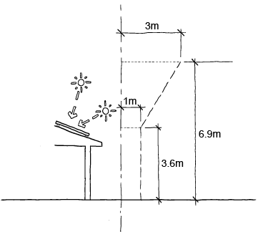

Supporting documentation
Identify existing domestic solar energy systems on the roofs of buildings on the existing context plan.
Demonstrate setbacks on plans and elevations.

Standard B5-3 Rooftop solar energy generation area
Why this is important
This standard supports the future installation of appropriately sited rooftop solar energy systems for a dwelling. Rooftop solar panels allow occupants to generate their own electricity, reducing dependence on external energy providers and decrease greenhouse gas emissions, reduce air pollution, and help combat climate change.
Rooftop solar energy generation area objective
To support the future installation of appropriately sited rooftop solar energy systems for a dwelling.
Standard B5-3
In Clause 55.05-3 rooftop solar energy area means an area provided on the roof of a dwelling to enable the future installation of a solar energy system.
An area on the roof is capable of siting a rooftop solar energy area for each dwelling which:
- Has a minimum dimension of 1.7 metres.
- Has a minimum area in accordance with Table B5-3.
- Is oriented to the north, west or east.
- Is positioned on the top two thirds of a pitched roof.
- Can be a contiguous area or multiple smaller areas.
- Is free of obstructions on the roof of the dwelling within twice the height of each obstruction (H), measured horizontally (D) from the centre point of the base of the obstruction to the nearest point of the rooftop solar energy area.
Diagram B5-3 Allowable distance between obstructions and the rooftop solar energy area

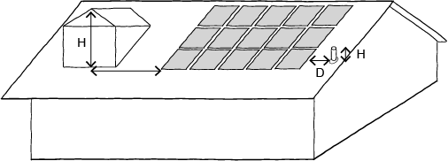

Obstructions located south of all points of the rooftop solar energy area are not subject to the horizontal distance requirements.
Table B5-3 Minimum rooftop solar energy generation area
Number of bedrooms | Minimum roof area
1 bedroom dwelling | 15 square metres
2 or 3 bedroom dwelling | 26 square metres
4 or more bedroom dwelling | 34 square metres
This standard does not apply to apartments and residential buildings.
Decision guidelines
Before deciding on an application, the responsible authority must consider:
- The design response.
- The size and orientation of the building.
- The availability of solar access to the rooftop.
- The extent to which the rooftop solar energy generation area is overshadowed by existing buildings, other permanent structures or equipment on the rooftop.

Applying the standard
A rooftop solar energy generation area must be provided with a minimum area specified in Table B5-3 and minimum dimension of 1.7 metres.
The rooftop solar energy generation area must be:
- Orientated north, west or east.
- Positioned high on the roofline.
- Free of obstructions.
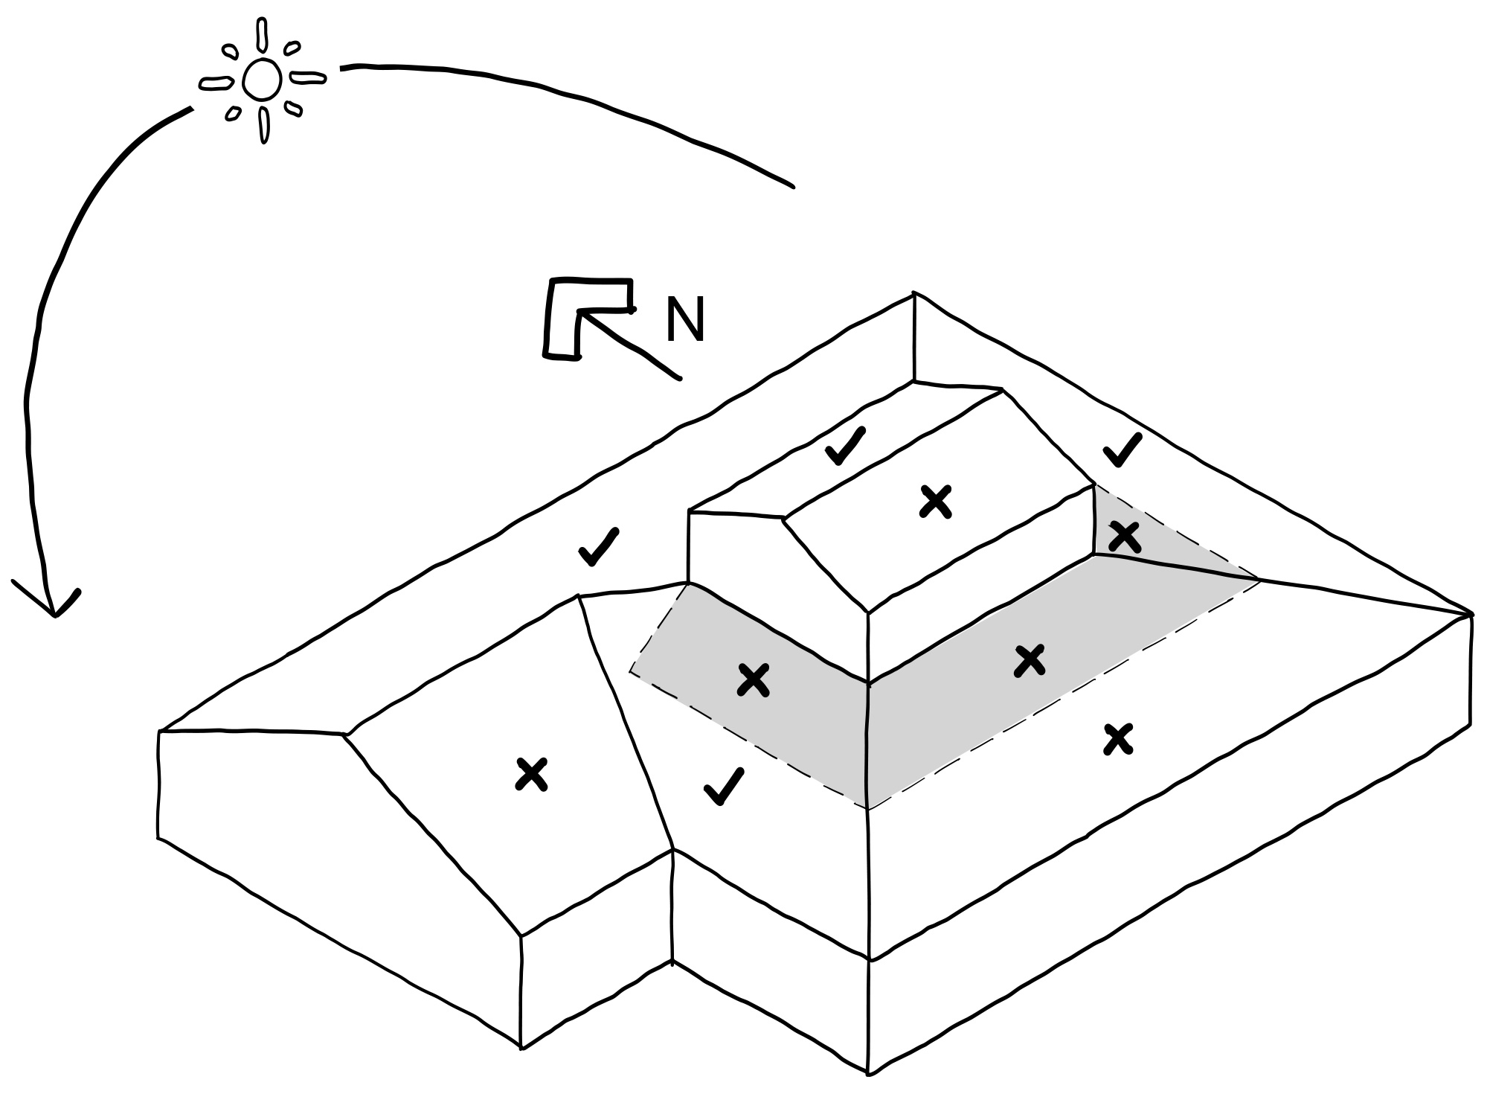
If an existing building overshadows the building from the North, the East and West will be better locations for energy generation.

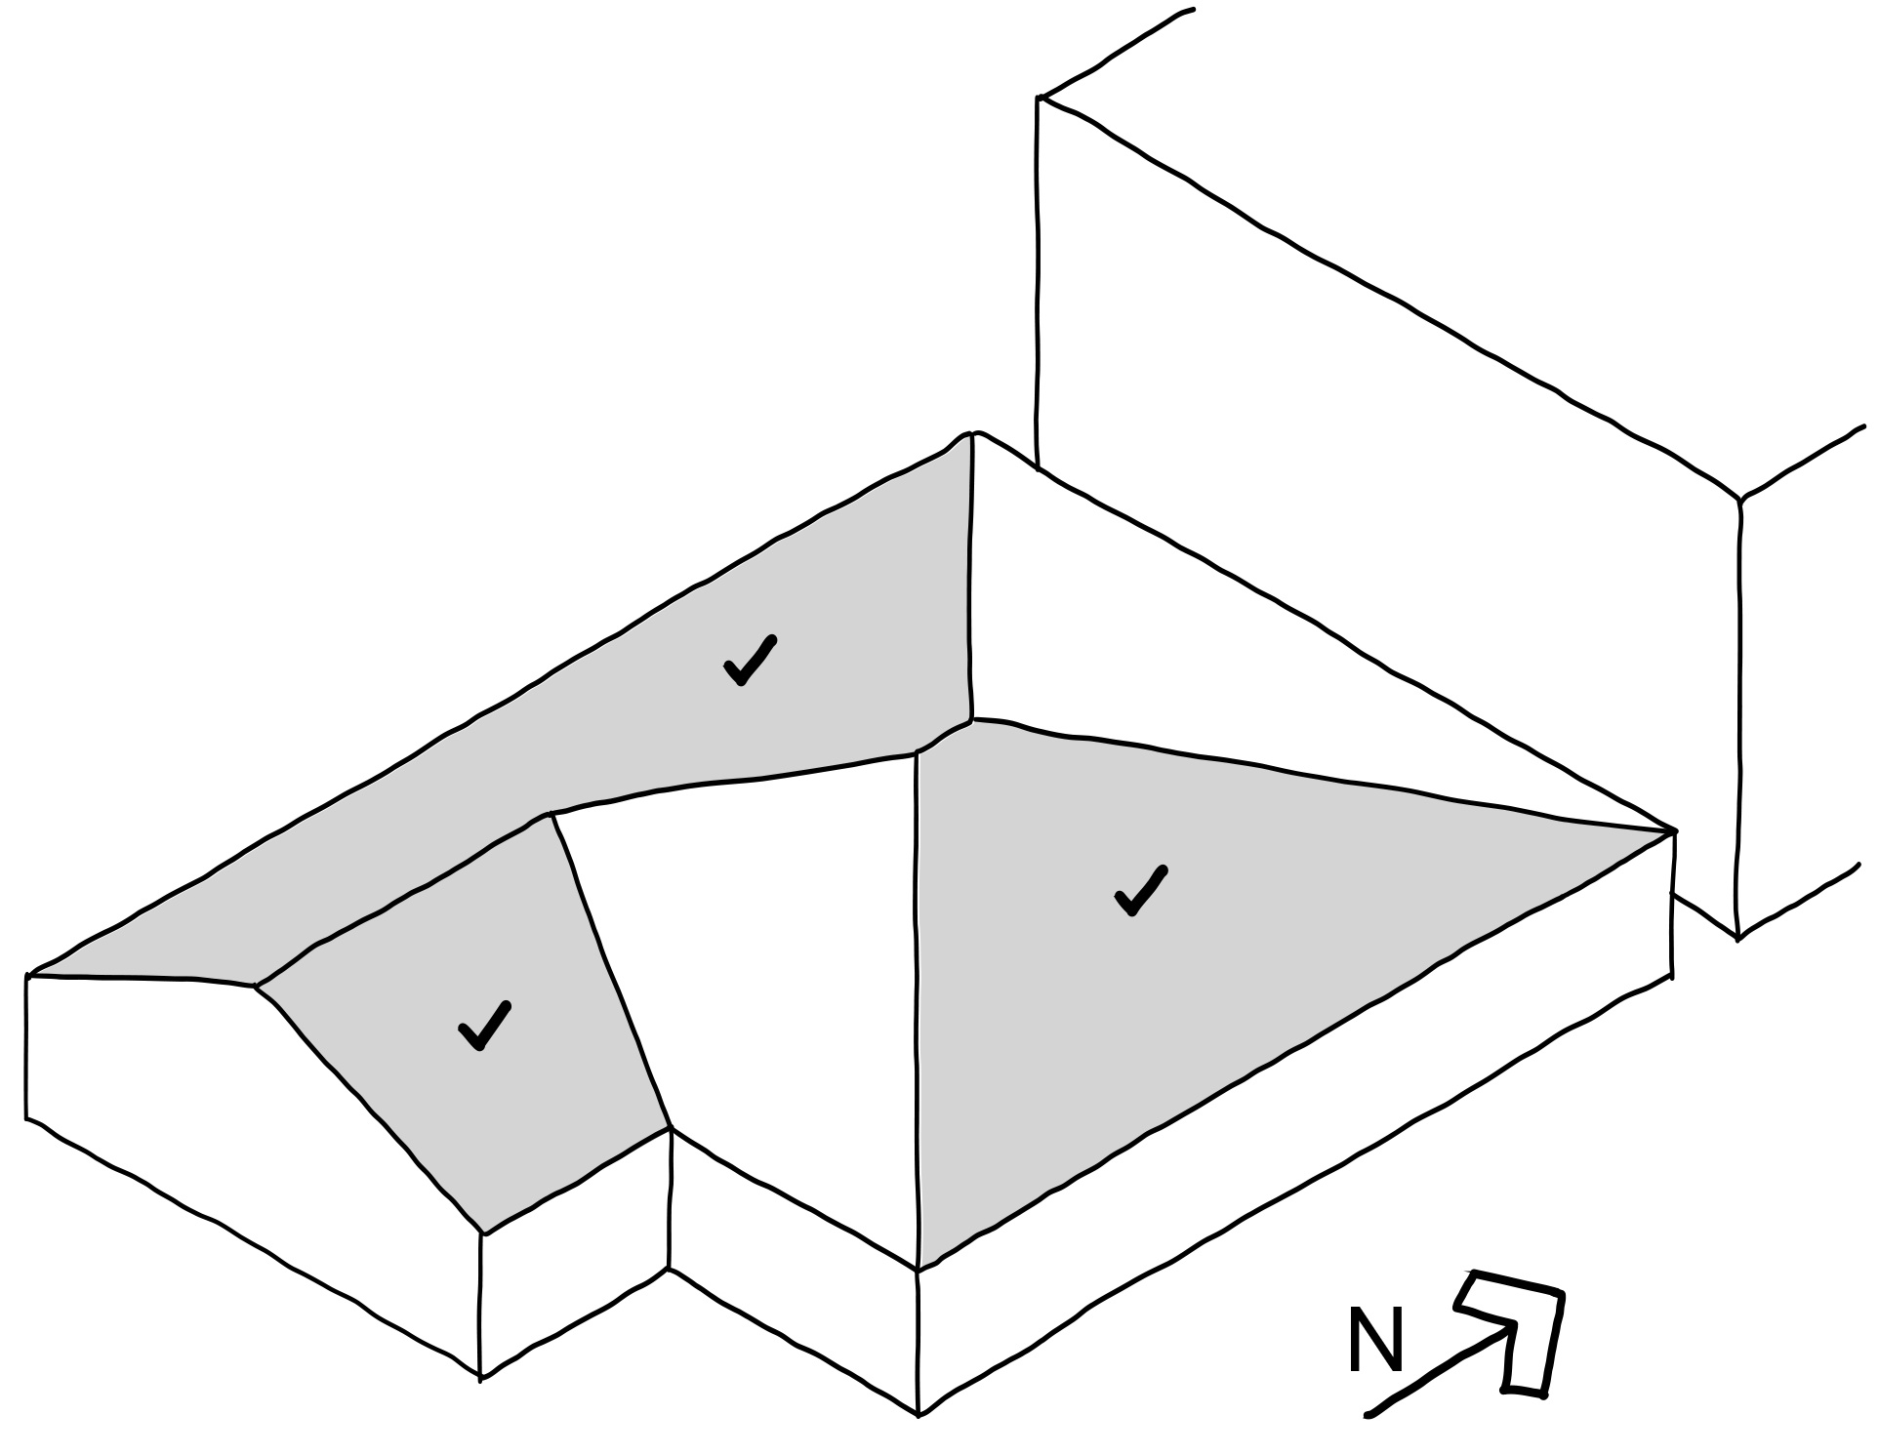

Supporting documentation
Identify location of the rooftop solar energy generation area on plans, as relevant.

Standard B5-4 Solar protection to new north-facing windows
Why this is important
This standard ensures that north facing windows are designed to optimise solar access and thermal comfort.
Solar protection to new north-facing windows objective
To encourage external shading of north facing windows to minimise summer heat gain.

Standard B5-4
North facing windows are shaded by eaves, fixed horizontal shading devices or fixed awnings with a minimum horizontal depth of 0.25 times the window height.
Decision Guidelines
Before deciding on an application, the responsible authority considers:
- The design response.
- The size and orientation of the lot.
- The type and use ability of external solar shading devices, including alternative design responses.

Applying the standard
External fixed sun shading and solar control devices should be integrated into the building design where possible.
North facing sun shading should be designed to allow winter sun and shade summer sun.
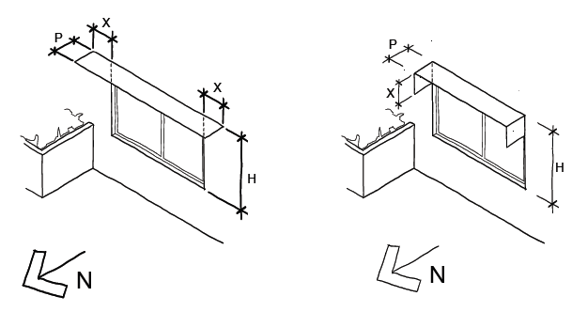
P = 0.25 x H
P = X

Supporting documentation
Show solar protection to north-facing windows on plans, elevations and sections.

Standard B5-5 Waste and recycling
Why this is important
This standard ensures that waste and recycling facilities are accessible and are of sufficient size to manage organic and general waste, and mixed and glass recycling. It ensures that dwellings facilitate waste recycling effectively. Good waste management promotes recycling, protects the environment and addresses health and safety risks. Developments with good waste management facilities minimise the impacts of waste on the health and wellbeing of occupants and the amenity of the public realm.
Waste and recycling objectives
To ensure dwellings are designed to facilitate waste recycling.
To ensure that waste and recycling facilities are accessible and are of sufficient size to manage organic and general waste, and mixed and glass recycling.
To ensure that waste and recycling facilities are designed and managed to minimise impacts on residential amenity.

Standard B5-5
Dwelling (other than a dwelling in or forming part of an apartment development)
The development includes an individual bin storage area for each dwelling, or a shared bin storage area for use by each dwelling, of at least the applicable area, depth and height specified in Table B5-5.1.
Table B5-5.1 Bin storage
Type of bin storage area | Minimum area | Minimum depth | Minimum height
Individual bin storage area for a dwelling. | 1.8 square metres | 0.8 metre | 1.8 metres
Shared bin storage area for 3 dwellings or less. | 5.4 square metres | 0.8 metre | 1.8 metres
Shared bin storage area for 4 or more dwellings. | 1 square metre per dwelling plus 4 square metres | 0.8 metres | 1.8 metres
If the development includes a shared bin storage area:
- The shared bin storage area:
  - Is located within 40 metres of a kerbside collection point.
  - Includes a tap for bin washing.
- There is a continuous path of travel free of steps and obstructions from dwellings to the bin storage area.
Where access is provided for private bin collection on the land the design of access ways must allow the vehicle to enter and exit in a forward direction.
Each dwelling includes an internal waste and recycling storage space of at least 0.07 cubic metres with a minimum depth of 250 millimetres.

Dwelling in or forming part of an apartment development
The development includes a shared bin storage area for use by each dwelling of at least the applicable area, depth and height specified in Table B5-5.2.
Table B5-5.2 Apartment bin storage
Number of dwellings | Minimum area | Minimum depth | Minimum height
15 or less dwellings | 0.7 square metres per dwelling in a shared waste storage area | 0.8 metres | 2.7 metres
16 to 55 dwellings | 0.5 square metres per dwelling, plus 5 square metres in a shared waste storage area. | 1 metre | 2.7 metres
56 or more dwellings | 0.5 square metres per dwelling in a shared waste storage area. | 1 metres | 2.7 metres
Enclosed bin storage areas are ventilated by:
- Natural ventilation openings to the external air with an area of at least 5 per cent of the area for bin storage area; or
- A mechanical exhaust ventilation system.
A tap and drain is provided to wash bins.
A continuous path of travel is provided from each dwelling to bin storage areas.
Each dwelling includes an internal waste and recycling storage space of at least 0.07 cubic metres with a minimum depth of 250 millimetres.
Decision guidelines
Before deciding on an application, the responsible authority must consider:
- The design response, including a Waste Management Plan.
- Any relevant waste and recycling objective, policy or statement set out in this planning scheme.
- The functionality and accessibility of waste and recycling facilities, including for people with limited mobility.
- Whether facilities are provided for on-site reuse or management of food and garden organics through composting or other waste recovery.
- Whether waste and recycling facilities are designed to meet the better practice design options specified in Waste management and recycling in multi-unit developments (Sustainability Victoria, 2019).

Applying the standard
For dwellings not part of an apartment development (e.g. dual-occupancy or townhouse developments), the area for bin storage must have:
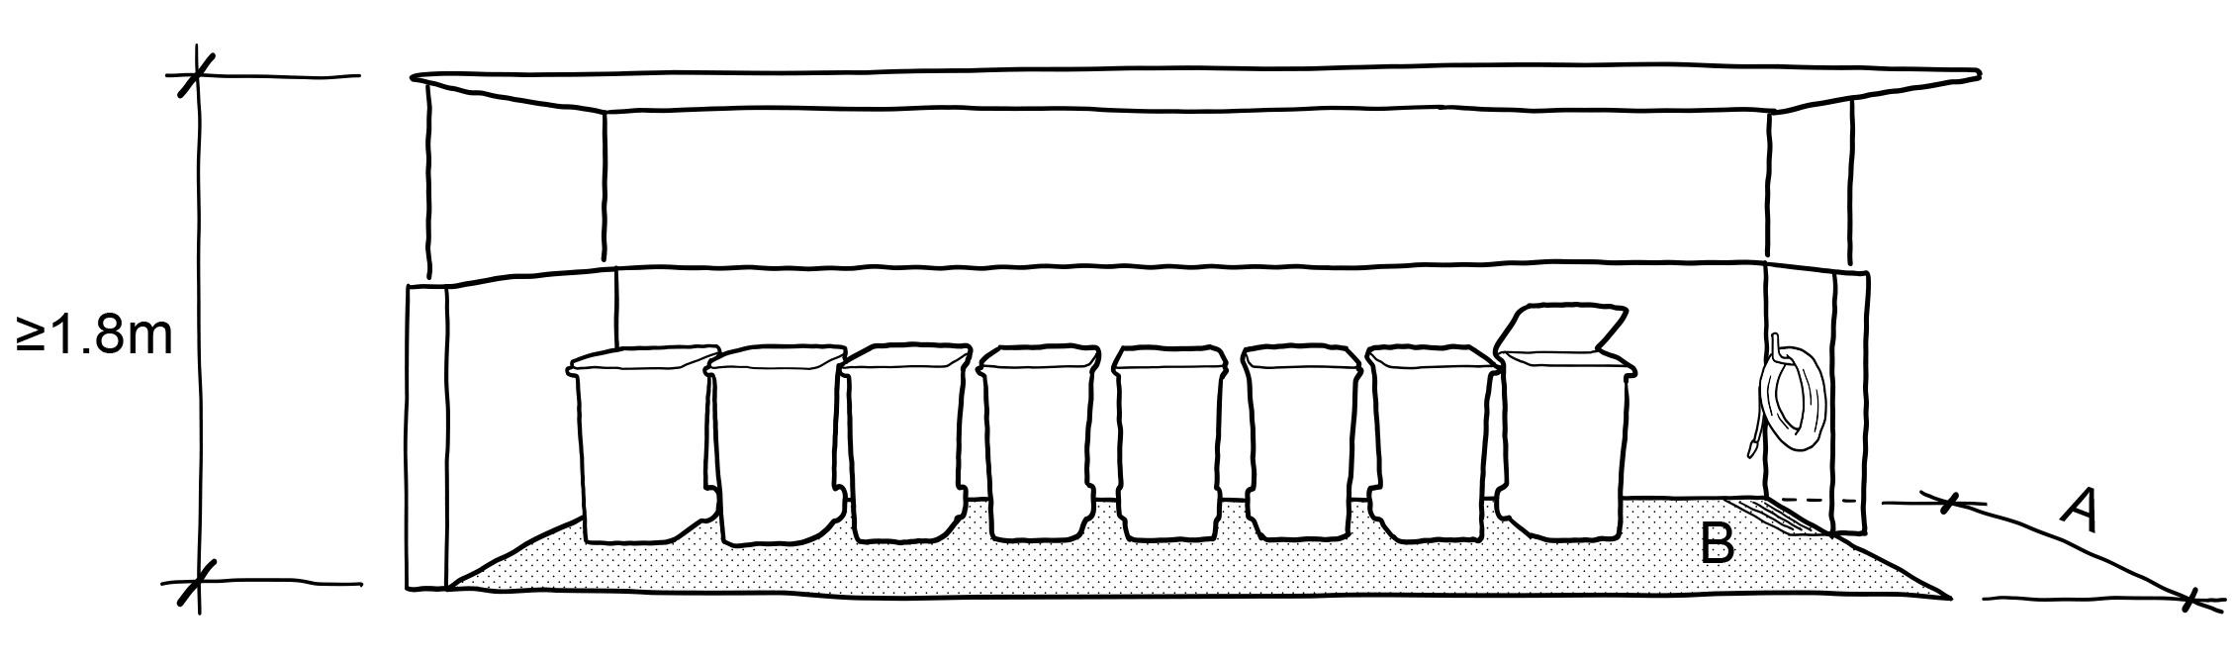
- a minimum height of 1.8 metres
- a minimum depth of 0.8 metres (A)
- a minimum area specified in Table B5-5.1 (B)

For dwellings part of an apartment development, the bin storage area must have:
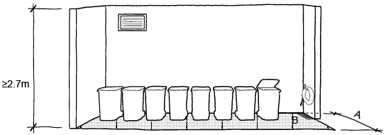
- a minimum height of 2.7 metres
- a minimum depth specified in Table B5-5.2 (A)
- a minimum area specified in Table B5-5.2 (B)

The minimum areas specified in Table B5-5.3 are based on storage containers for four waste streams. Developments with over 16 dwellings typically use larger large capacity communal receptacles.
Demonstrating compliance with the standard can be supported with a waste management plan that provides a clear method for storage, collection, and disposal of household waste and recyclables. In addition, an WMP can also incorporate management of eWaste and hard waste.
Large multi-unit developments can present greater complexity and design challenges for waste management. A waste management plan should be prepared by a suitably qualified waste consultant. The typical contents of a WMP are outlined under the supporting documentation. The Waste management plan checklist (Appendix 13) included in the Waste Management and Recycling in Multi-unit Developments – Beter Practice Guide (Sustainability Victoria, 2019) provides helpful information on suitable information to include in such plans.
Where access is provided for private bin collection use swept path analysis is helpful to determine if a design will meet the manoeuvring requirements of the collection vehicle. It will also inform design responses to limit reversing of trucks and associated noise from reversing alarms.
Adequate clearance should be provided above collection points taking into account the height of collection vehicles while lifting bins.
Providing a bin wash down area will allow bins to be cleaned will prevent the generation of odours.
Ensure drainage of a shared waste storage area (including a bin room) does not lead to stormwater pollution. Wash areas should be designed in accordance with relevant EPA requirements.
Where residents must access the basement or common storage areas to dispose of waste or recyclables, ensure that these areas are accessible for residents with limited mobility. Providing a continuous path of travel free of steps and obstructions from dwellings to the bin storage area supports this objective.
In addition, to support effective design outcomes on floors where there are apartments that comply with the accessibility standards, common storage areas for waste and recyclables should also be accessible for residents with limited mobility.
Bin rooms, waste compactors, waste chutes (where provided) waste collection points should be located to minimise noise impacts for residents and uses adjacent to the site. Use acoustic insulation as necessary to reduce noise impacts.

Supporting documentation
A Waste Management Plan prepared by a suitably qualified person.
Locate and dimension waste storage facilities on plans.

Standard B5-6 Noise impacts
Why this is important
This standard minimises the impact of mechanical plant noise located within the development by ensuring the shared mechanical plant is appropriately located. Reducing internal and external noise impacts is important to occupant wellbeing and amenity.
Noise impacts objective
To minimise the impact of mechanical plant noise located in the development.
Standard B5-6
Mechanical plant, including mechanical car storage and lift facilities are not located immediately adjacent to bedrooms of new or existing dwellings or small second dwellings, unless a solid barrier is in place to provide a line-of-sight barrier to transmission of noise and the location of all relevant bedrooms.
Decision guideline
Before deciding on an application, the responsible authority must consider:
- The design response.
- Whether the impact of potential noise sources within a development have been mitigated through design, location and siting.
- Whether an alternative design meets the relevant objectives having regard to the amenity of the dwelling or small second dwelling and the site context.

Applying the standard
Use building siting, layout and design of dwellings to reduce the impact of noise to new and existing dwellings. Design techniques to mitigate noise include:
- Locating mechanical plants (including lift cores and mechanical car storage) away from bedrooms.
- Utilising screening to external and rooftop plant and services.
- Utilising fencing or screens to provide barrier to existing dwellings external to the site.
Suitable materials for fencing or screens could include:
- A solid brick or concrete wall
- A solid high density timber fence that is at least 20 millimetres thick constructed with overlapping planks and no clearance gap at the base.
- Locating mechanical car storage in basements.
There should not be any line-of-sight exposure between an open topped enclosure to noise sensitive areas such as bedrooms.
Advice to mitigate noise impacts may be a sought from a suitably qualified person.

Supporting documentation
Plans should show the location of mechanical plant, immediately adjacent to bedrooms of new or existing dwellings or small second dwellings and the solid barrier in place to provide a line-of-sight barrier to transmission of noise and the location of all relevant bedrooms. Including details of the material and structure of the solid barrier.

Standard B5-7 Energy efficiency for apartment developments
Why this is important
This standard complements the energy efficiency provision of the National Construction Code to support energy efficiency and thermal comfort of new apartments. Dwellings that are energy efficient through passive design provide good thermal comfort and reduce energy costs. With the ongoing effects of climate change, ensuring the thermal performance of apartments over summer will become increasingly important. Reducing energy costs is important for housing affordability.
Energy efficiency for apartment developments objectives
To achieve energy efficient dwellings and buildings.
To ensure dwellings achieve adequate thermal efficiency.
Standard B5-7
Dwellings in or forming part of an apartment development located in a climate zone identified in Table B5-7 do not exceed the maximum NatHERS annual cooling load.
Table B5-7 Cooling load
NatHERS climate zone | NatHERS maximum cooling load  MJ/M² per annum
Climate zone 21 Melbourne | 30
Climate zone 22 East Sale | 22
Climate zone 27 Mildura | 69
Climate zone 60 Tullamarine | 22
Climate zone 62 Moorabbin | 21
Climate zone 63 Warrnambool | 21
Climate zone 64 Cape Otway | 19
Climate zone 66 Ballarat | 23
Note:
Refer to NatHERS zone map, Nationwide House Energy Rating Scheme (Commonwealth Department of Environment and Energy).
Decision Guidelines
Before deciding on an application, the responsible authority must consider:
- The design response.
- The size, orientation and layout of the site.
- The availability of solar access to north-facing windows on the site.
- The annual cooling load for each dwelling.

Applying the standard
From 1 May 2024, National Construction Code (NCC) 2022 changes come into effect that are different to the energy efficiency (cooling load) standards for apartment developments in planning schemes. The lower cooling load requirement (MJ/M2 per annum) in either planning or building system must be complied with.
Responsible authorities should seek to ensure that decisions on planning permit applications for apartment developments do not result in any inconsistencies with the NCC’s accessibility and cooling load requirements which could be considered non-compliant.
This means that where cooling loads in the NCC have a lower cooling load requirement (MJ/M2 per annum) for a climate zone compared to Table B5-7, the NCC cooling load figure should apply. Where the cooling load figure in Table B5-7 has a lower cooling load requirement (MJ/M2 per annum) for a climate zone compared to the NCC, that figure should apply for the purposes of lodging and assessing a planning permit application.
For further information refer to the: Fact-sheet-Minium-requirements-for-design-compliance-with-accessibility-and-energy-efficiency-provisions.pdf
The different cooling loads reflect the varied climatic contexts across Victoria. The relevant NatHERS climate zone maps are available at http://www.nathers.gov.au.

Supporting documentation
Provide the standard outputs from existing NatHERS tools. The NatHERS certificate provides verification of the cooling load performance.

Version | Date
1 | 28 March 2025 – Initial publication
2 | 5 May 2025 – Minor corrections
© The State of Victoria - Department of Transport and Planning, May 2025  This work is licensed under a Creative Commons Attribution 4.0 International licence. You are free to re-use the work under that licence, on the condition that you credit the State of Victoria as author. The licence does not apply to any images, photographs or branding, including the Victorian Coat of Arms, the Victorian Government logo and the Department of Transport and Planning (DTP) logo. To view a copy of this licence, visit http://creativecommons.org/licenses/by/4.0/  ISBN 978-0-7311-9356-1 (pdf/online/MS word)  Disclaimer  This publication may be of assistance to you but the State of Victoria and its employees do not guarantee that the publication is without flaw of any kind or is wholly appropriate for your particular purposes and therefore disclaims all liability for any error, loss or other consequence which may arise from you relying on any information in this publication. | Accessibility  If you would like to receive this publication in an alternative format, please go to planning.vic.gov.au or email planning.systems@transport.vic.gov.au



