|  |
| --- |
| Victorian Population Bulletin 2015 |

The *Victorian Population Bulletin* provides a snapshot of information on population change and the basic drivers behind that change.

The data reported here are the latest estimates and figures from the Australian Bureau of Statistics (ABS), relating to the estimated resident population (ERP) at 30 June 2014. The *Victorian Population Bulletin* provides volume and growth rates for the states and capital cities, and for the 79 Local Government Areas (LGAs) of Victoria. This issue contains revised estimates for 2013, and preliminary estimates for 2014.

Highlights of population change 2013-14

* Australia’s ERP reached 23.5 million at   
  30 June 2014, an increase of 364,900 people over the previous year. This represents a growth rate of 1.6 per cent (see Table 4).
* Victoria’s ERP at 30 June 2014 was 5.84 million, an increase of 1.9 per cent (106,700 persons) since 30 June 2013. This is higher than the estimated growth over the previous year,   
  2012-13 (102,500 persons), but lower than the recent peak growth in 2008-09   
  (115,600 persons).
* The annual growth rate of the Melbourne Greater Capital City Statistical Area was   
  2.2 per cent (see Table 5). The absolute increase for the year ending 30 June 2014 was 95,700 persons, a growth of over 1,800 persons per week.

Table 1 – LGAs with the largest population growth in Australia, 2013-14

|  |  |  |  |  |
| --- | --- | --- | --- | --- |
| **Local**  **government** | | **State** | **Growth 2013-2014 (persons)** | **Growth rate (%) 2013-2014** |
| 1 | Brisbane (C) | QLD | 16,941 | 1.5 |
| 2 | Wyndham (C) | VIC | 10,604 | 5.6 |
| 3 | Gold Coast (C) | QLD | 8,790 | 1.6 |
| 4 | Casey (C) | VIC | 8,508 | 3.1 |
| 5 | Moreton Bay (R) | QLD | 8,480 | 2.1 |
| 6 | Whittlesea (C) | VIC | 7,880 | 4.4 |
| 7 | Wanneroo (C) | WA | 7,299 | 4.1 |
| 8 | Blacktown (C) | NSW | 7,285 | 2.2 |
| 9 | Sydney (C) | NSW | 6,438 | 3.4 |
| 10 | Melbourne (C) | VIC | 5,847 | 5.0 |

Source: ABS. Regional Population Growth, Australia, 2013-14 (cat. no. 3218.0)

* The population of the rest of Victoria increased by 11,000 persons, representing a growth rate of 0.8 per cent (see Table 2 and Figure 1).
* In the metropolitan area, defined by the   
  31 Melbourne LGAs, the population increased by 94,000 persons, a rate of 2.2 per cent, and just over 1,800 people each week.
* Regional Victoria, defined by the remaining   
  48 LGAs and Unincorporated Victoria, increased its population by 12,700 at a rate of 0.9 per cent.
* There were four Victorian LGAs amongst the 10 largest growing municipalities in Australia for the year ending 30 June 2014. These were Wyndham (10,600 persons or 5.6 per cent), Casey   
  (8,500 or 3.1 per cent), Whittlesea (7,900 or 4.4 per cent) and Melbourne (5,900 or 5 per cent). All except the City of Melbourne are located on the urban fringe (see Table 1).

Regional Victoria

* For the year ending 30 June 2014, the population of regional Victoria (48 LGAs and Unincorporated Victoria) grew to 1.47 million, an increase of 12,700 persons over the previous year. This represents a growth rate of 0.9 per cent.
* Several LGAs in regional Victoria recorded small population losses in 2013-14. Many of these were located in the dryland agricultural region in the west of the state. It should be noted that in numerical terms this amounted to losses of between one and 275 persons in any LGA.
* The fastest growing LGAs in regional Victoria were generally located in peri-urban areas close

Figure 1 – Regional Victoria, change in ERP, 2013-14

*Figure 1 maps the data presented in Table 2*

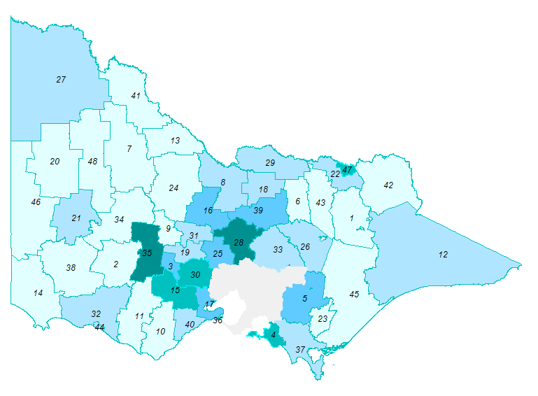Source: ABS. Regional Population Growth, Australia, 2013-14 (cat. no. 3218.0)

to Melbourne or Geelong. The highest rates recorded were in Pyrenees (3.3 per cent) and Mitchell (3.1 per cent) followed by Wodonga (2.2 per cent), Bass Coast (2.1 per cent), Golden Plains and Moorabool (2 per cent).

* In terms of absolute growth, the LGAs with regional centres recorded the highest amounts. Largely because of their size, Greater Geelong (3,600 persons), Greater Bendigo   
  (1,700) and Ballarat (1,700) recorded the highest volumes of growth. Combined, these three LGAs accounted for 55 per cent of regional Victoria’s population growth.

**\\internal.vic.gov.au\DPCD\UserDirs\Desktop\Regions_mapinfoKEY.tif**

Table 2 – Regional Victoria LGAs, ERP 2013-14

|  |  |  |  |  |  |
| --- | --- | --- | --- | --- | --- |
| **Local government** | | **2013r**  **(persons)** | **2014p**  **(persons)** | **Change 2013r-2014p** | |
| **(persons)** | **(%)** |
| 1 | Alpine (S) | 12,036 | 12,028 | -8 | -0.1 |
| 2 | Ararat (RC) | 11,222 | 11,184 | -38 | -0.3 |
| 3 | Ballarat (C) | 98,590 | 100,283 | 1,693 | 1.7 |
| 4 | Bass Coast (S) | 30,980 | 31,623 | 643 | 2.1 |
| 5 | Baw Baw (S) | 45,174 | 45,945 | 771 | 1.7 |
| 6 | Benalla (RC) | 13,689 | 13,597 | -92 | -0.7 |
| 7 | Buloke (S) | 6,216 | 6,086 | -130 | -2.1 |
| 8 | Campaspe (S) | 36,890 | 36,881 | -9 | 0.0 |
| 9 | Central Goldfields (S) | 12,617 | 12,606 | -11 | -0.1 |
| 10 | Colac-Otway (S) | 20,662 | 20,501 | -161 | -0.8 |
| 11 | Corangamite (S) | 16,113 | 15,996 | -117 | -0.7 |
| 12 | East Gippsland (S) | 43,389 | 43,772 | 383 | 0.9 |
| 13 | Gannawarra (S) | 10,314 | 10,145 | -169 | -1.6 |
| 14 | Glenelg (S) | 19,500 | 19,357 | -143 | -0.7 |
| 15 | Golden Plains (S) | 20,136 | 20,544 | 408 | 2.0 |
| 16 | Greater Bendigo (C) | 105,241 | 106,971 | 1,730 | 1.6 |
| 17 | Greater Geelong (C) | 221,355 | 224,926 | 3,571 | 1.6 |
| 18 | Greater Shepparton (C) | 62,751 | 63,269 | 518 | 0.8 |
| 19 | Hepburn (S) | 14,808 | 14,888 | 80 | 0.5 |
| 20 | Hindmarsh (S) | 5,694 | 5,644 | -50 | -0.9 |
| 21 | Horsham (RC) | 19,665 | 19,691 | 26 | 0.1 |
| 22 | Indigo (S) | 15,360 | 15,409 | 49 | 0.3 |
| 23 | Latrobe (C) | 73,771 | 73,653 | -118 | -0.2 |
| 24 | Loddon (S) | 7,425 | 7,365 | -60 | -0.8 |
| 25 | Macedon Ranges (S) | 44,067 | 44,715 | 648 | 1.5 |
| 26 | Mansfield (S) | 8,179 | 8,217 | 38 | 0.5 |
| 27 | Mildura (RC) | 52,646 | 53,036 | 390 | 0.7 |
| 28 | Mitchell (S) | 37,345 | 38,515 | 1,170 | 3.1 |
| 29 | Moira (S) | 28,653 | 28,833 | 180 | 0.6 |
| 30 | Moorabool (S) | 30,328 | 30,926 | 598 | 2.0 |
| 31 | Mount Alexander (S) | 17,977 | 18,102 | 125 | 0.7 |
| 32 | Moyne (S) | 16,302 | 16,344 | 42 | 0.3 |
| 33 | Murrindindi (S) | 13,480 | 13,595 | 115 | 0.9 |
| 34 | Northern Grampians (S) | 11,779 | 11,719 | -60 | -0.5 |
| 35 | Pyrenees (S) | 6,756 | 6,979 | 223 | 3.3 |
| 36 | Queenscliffe (B) | 3,047 | 3,027 | -20 | -0.7 |
| 37 | South Gippsland (S) | 27,931 | 27,937 | 6 | 0.0 |
| 38 | Southern Grampians (S) | 16,143 | 15,919 | -224 | -1.4 |
| 39 | Strathbogie (S) | 9,699 | 9,810 | 111 | 1.1 |
| 40 | Surf Coast (S) | 28,277 | 28,481 | 204 | 0.7 |

Table 2 – Regional Victoria LGAs, ERP 2013-14 (continued)

Source: ABS. Regional Population Growth, Australia, 2013-14 (cat. no. 3218.0)

Note: Estimates for 2013 are revised (r) and estimates for 2014 are preliminary (p)

|  |  |  |  |  |  |
| --- | --- | --- | --- | --- | --- |
| **Local government** | | **2013r**  **(persons)** | **2014p**  **(persons)** | **Change 2013r-2014p** | |
| **(persons)** | **(%)** |
| 41 | Swan Hill (RC) | 20,855 | 20,580 | -275 | -1.3 |
| 42 | Towong (S) | 5,885 | 5,797 | -88 | -1.5 |
| 43 | Wangaratta (RC) | 27,176 | 27,117 | -59 | -0.2 |
| 44 | Warrnambool (C) | 33,244 | 33,501 | 257 | 0.8 |
| 45 | Wellington (S) | 42,279 | 42,220 | -59 | -0.1 |
| 46 | West Wimmera (S) | 4,086 | 3,982 | -104 | -2.5 |
| 47 | Wodonga (RC) | 37,317 | 38,131 | 814 | 2.2 |
| 48 | Yarriambiack (S) | 7,028 | 6,892 | -136 | -1.9 |
|  | Unincorporated Victoria | 758 | 757 | -1 | -0.1 |
|  | **All regional LGAs** | **1,454,835** | **1,467,496** | **12,661** | **0.9** |

Metropolitan Melbourne

* For the year ending 30 June 2014, the population of the 31 Metropolitan LGAs grew to 4.37 million persons. This represented an increase of 94,000 persons or 2.2 per cent.
* All LGAs in metropolitan Melbourne recorded population growth in the year ending   
  30 June 2014.
* Within the ”top 5” LGAs in terms of growth, the City of Melbourne experienced the fourth largest and second fastest growth: 5,900 persons and 5 per cent.
* The other four LGAs with the largest volumes of growth were all on the urban fringe: Wyndham (10,600 persons), Casey (8,500), Whittlesea (7,900), and Hume (5,700).
* The other four LGAs with the highest growth rates in Victoria were also located on the urban fringe: Wyndham (5.6 per cent), Whittlesea   
  (4.4 per cent), Melton (4 per cent) and Cardinia (3.6 per cent).

Table 3 – Metropolitan Melbourne LGAs, ERP 2013-14

|  |  |  |  |  |  |
| --- | --- | --- | --- | --- | --- |
| **Local government** | | **2013r**  **(persons)** | **2014p**  **(persons)** | **Change 2013r-2014p** | |
| **(persons)** | **(%)** |
| 1 | Banyule (C) | 124,382 | 125,503 | 1,121 | 0.9 |
| 2 | Bayside (C) | 98,295 | 99,947 | 1,652 | 1.7 |
| 3 | Boroondara (C) | 170,424 | 172,612 | 2,188 | 1.3 |
| 4 | Brimbank (C) | 195,322 | 197,701 | 2,379 | 1.2 |
| 5 | Cardinia (S) | 83,997 | 87,008 | 3,011 | 3.6 |
| 6 | Casey (C) | 274,907 | 283,415 | 8,508 | 3.1 |
| 7 | Darebin (C) | 146,687 | 148,728 | 2,041 | 1.4 |
| 8 | Frankston (C) | 133,459 | 135,243 | 1,784 | 1.3 |
| 9 | Glen Eira (C) | 141,413 | 144,059 | 2,646 | 1.9 |
| 10 | Greater Dandenong (C) | 146,615 | 149,518 | 2,903 | 2.0 |
| 11 | Hobsons Bay (C) | 89,406 | 91,148 | 1,742 | 1.9 |
| 12 | Hume (C) | 183,124 | 188,832 | 5,708 | 3.1 |
| 13 | Kingston (C) | 151,571 | 153,079 | 1,508 | 1.0 |
| 14 | Knox (C) | 154,797 | 155,508 | 711 | 0.5 |
| 15 | Manningham (C) | 117,435 | 118,521 | 1,086 | 0.9 |
| 16 | Maribyrnong (C) | 79,242 | 81,859 | 2,617 | 3.3 |
| 17 | Maroondah (C) | 109,493 | 111,223 | 1,730 | 1.6 |
| 18 | Melbourne (C) | 116,360 | 122,207 | 5,847 | 5.0 |
| 19 | Melton (C) | 122,817 | 127,677 | 4,860 | 4.0 |
| 20 | Monash (C) | 182,348 | 185,037 | 2,689 | 1.5 |
| 21 | Moonee Valley (C) | 115,009 | 117,337 | 2,328 | 2.0 |
| 22 | Moreland (C) | 159,909 | 163,488 | 3,579 | 2.2 |
| 23 | Mornington Peninsula (S) | 152,145 | 153,800 | 1,655 | 1.1 |
| 24 | Nillumbik (S) | 62,676 | 62,872 | 196 | 0.3 |
| 25 | Port Phillip (C) | 102,422 | 104,846 | 2,424 | 2.4 |
| 26 | Stonnington (C) | 103,110 | 105,981 | 2,871 | 2.8 |
| 27 | Whitehorse (C) | 161,602 | 163,697 | 2,095 | 1.3 |
| 28 | Whittlesea (C) | 179,126 | 187,006 | 7,880 | 4.4 |
| 29 | Wyndham (C) | 189,111 | 199,715 | 10,604 | 5.6 |
| 30 | Yarra (C) | 83,530 | 86,506 | 2,976 | 3.6 |
| 31 | Yarra Ranges (S) | 149,438 | 150,098 | 660 | 0.4 |
|  | **Metropolitan LGAs** | **4,280,172** | **4,374,171** | **93,999** | **2.2** |

Source: ABS. Regional Population Growth, Australia, 2013-14 (cat. no. 3218.0)

Note: Estimates for 2013 are revised (r) and estimates for 2014 are preliminary (p)

Figure 2 – Metropolitan Melbourne, change in ERP, 2013-14

*Figure 2 maps the data presented in Table 3*

Source: ABS. Regional Population Growth, Australia, 2013-14 (cat. no. 3218.0).

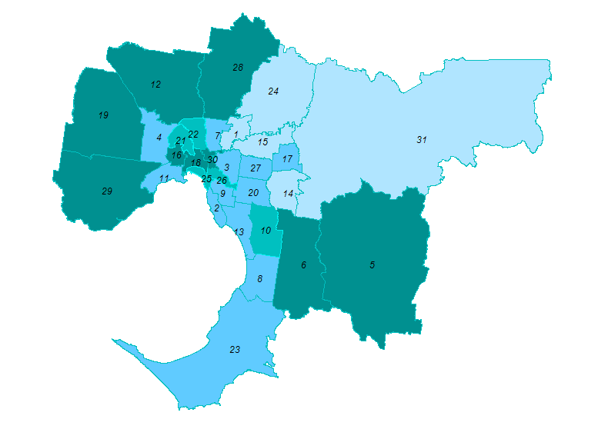

**\\internal.vic.gov.au\DPCD\UserDirs\Desktop\Regions_mapinfoKEY.tif**

National, State and Territory Population Change

* For the year ending 30 June 2014, Australia’s population was 23.49 million. This was a growth of 365,900 or 1.6 per cent.
* Western Australia (2.2 per cent) recorded the fastest population growth of all states and territories, but trends associated with the minerals boom are abating. Victoria recorded the second fastest growth (1.9 per cent). The populations of Queensland and New South Wales increased by 1.5 per cent.

|  |  |  |  |  |
| --- | --- | --- | --- | --- |
|  | **ERP at 30 June** | | **Change**  **2013r-2014p** | |
| **2013r** | **2014p** |
| **(persons)** | **(persons)** | **(persons)** | **(%)** |
| New South Wales | 7,409,337 | 7,518,472 | 109,135 | 1.5 |
| Victoria | 5,735,007 | 5,841,667 | 106,660 | 1.9 |
| Queensland | 4,651,912 | 4,722,447 | 70,535 | 1.5 |
| South Australia | 1,670,498 | 1,685,714 | 15,216 | 0.9 |
| Western Australia | 2,519,007 | 2,573,389 | 54,382 | 2.2 |
| Tasmania | 513,100 | 514,762 | 1,662 | 0.3 |
| Northern Territory | 242,541 | 245,079 | 2,538 | 1.0 |
| Australian Capital Territory | 381,291 | 385,996 | 4,705 | 1.2 |
| Other Territories | 3,175 | 3,210 | 35 | 1.1 |
| **Australia** | **23,125,868** | **23,490,736** | **364,868** | **1.6** |

Table 4 – Australian States and Territories,

ERP 2013-14

Source: ABS. Regional Population Growth, Australia, 2013-14 (cat. no. 3218.0)

Note: Estimates for 2013 are revised (r) and estimates for 2014 are preliminary (p)

* In terms of absolute numbers, New South Wales recorded the largest growth (109,100 persons), followed by Victoria (106,700), Queensland (70,500) and Western Australia (54,400).
* Victoria recorded the largest gain in interstate migration (8,800 persons), ahead of Queensland (5,800) and Western Australia (1,000). The other states and territories recorded losses: New South Wales (loss of 6,900 persons), Northern Territory (3,300), South Australia (3,000), the Australian Capital Territory (1,200) and Tasmania (1,200). (Source: Australian Demographic Statistics, September Quarter 2014, cat. no. 3101.0).

Figure 3 – Australian States and Territories, change in ERP, 2013-14

*Figure 3 maps the data presented in Table 4*

Source: ABS. Regional Population Growth, Australia, 2013-14 (cat. no. 3218.0).

0.3%%

0.3%%

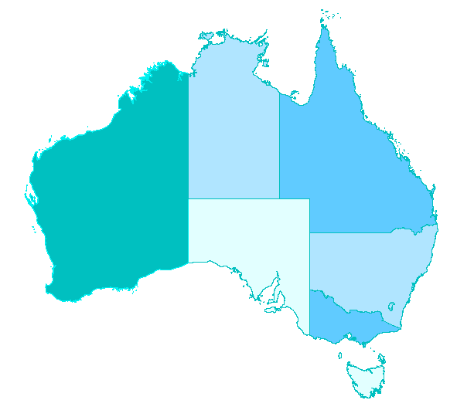

**1.0%**

**1.5%**

**2.2%%**

**0.9%%**

**1.5%**

**1.2%%**

**1.9%%**

**0.3%%**

Capital City Population Change

* The majority of Australia’s population lives in the state and territory capital cities and their associated socioeconomic areas. At   
  30 June 2014, 15.63 million people or 66 per cent of the Australian population lived in the seven Greater Capital City Statistical Areas and the Australian Capital Territory.
* The bulk of each state or territory’s population growth also occurred in the capital cities – with the exception of Queensland and Tasmania.

Table 5 – Greater Capital City Statistical Areas,

ERP 2013-14

|  |  |  |  |  |  |
| --- | --- | --- | --- | --- | --- |
| **Capital City Statistical Area** | **Population 30 June 2014 (p)** | **Share of State (%)** | **Change 2013-14** | **Growth Rate (%)** | **Share of State's growth (%)** |
| Greater Sydney | 4,840,628 | 64.4 | 84,230 | 1.8 | 77.2 |
| Greater Melbourne | 4,440,328 | 76.0 | 95,655 | 2.2 | 89.7 |
| Greater Brisbane | 2,274,560 | 48.2 | 38,516 | 1.7 | 54.6 |
| Greater Adelaide | 1,304,631 | 77.4 | 13,254 | 1.0 | 87.1 |
| Greater Perth | 2,021,203 | 78.5 | 48,354 | 2.5 | 88.9 |
| Greater Hobart | 219,243 | 42.6 | 1,247 | 0.6 | 75.0 |
| Greater Darwin | 140,386 | 57.3 | 3,033 | 2.2 | 119.5 |
| Australian Capital Territory | 385,996 | 100.0 | 4,705 | 1.2 | 100.0 |
| **All Capital Cities** | **15,626,975** | **66.5** | **288,994** | **1.9** | **79.2** |

Source: ABS. Regional Population Growth, Australia, 2013-14 (cat. no. 3218.0)

Note: Estimates for 2013 are revised (r) and estimates for 2014 are preliminary (p)

|  |  |
| --- | --- |
| © The State of Victoria Department of Environment, Land, Water and  Planning 2015  by  This work is licensed under a Creative Commons Attribution 3.0 Australia licence. You are free to re-use the work under that licence, on the condition that you credit the State of Victoria as author. The licence does not apply to any images, photographs or branding, including the Victorian Coat of Arms, the Victorian Government logo and the Department of Environment, Land, Water and Planning logo. To view a copy of this licence, visit <http://creativecommons.org/licenses/by/3.0/au/deed.en> | **Accessibility** If you would like to receive this publication in an alternative format, please telephone DELWP Customer Service Centre 136 186, email [customer.service@delwp.vic.gov.au](mailto:customer.service@delwp.vic.gov.au), via the National Relay Service on 133 677 [www.relayservice.com.au](http://www.relayservice.com.au).   **Disclaimer** This publication may be of assistance to you but the State of Victoria and its employees do not guarantee that the publication is without flaw of any kind or is wholly appropriate for your particular purposes and therefore disclaims all liability for any error, loss or other consequence which may arise from you relying on any information in this publication. |

* Queensland has strong growth in areas adjoining Brisbane (the Sunshine and Gold Coasts), leading to the capital accounting for only 55 per cent of the population growth in the year to   
  30 June 2014.
* Greater Perth was the fastest growing state capital, increasing by 2.5 per cent, or 48,400 persons. However, the volume of growth was largest in Greater Melbourne (95,700) and Greater Sydney (84,200).