Victorian Population Bulletin 2014
ISSN 1834-6650

The Victorian Population Bulletin provides a valuable snapshot of information on population change and the basic drivers behind that change. The data reported here are the latest estimates and figures from the Australian Bureau of Statistics (ABS), relating to the estimated resident population (ERP) at 30 June 2013. The Victorian Population Bulletin provides volume and growth rates for the states and capital cities, and for the 79 Local Government Areas (LGAs) of Victoria. This issue contains revised estimates for 2012, and preliminary estimates for 2013.

Highlights of population change 2012-13

- Australia’s ERP reached 23.1 million at 30 June 2013, an increase of 407,000 people over the previous year. This represents a growth rate of 1.8 per cent (see Table 4).
- Victoria’s ERP at 30 June 2013 was 5.74 million, an increase of 1.9 per cent (106,800 persons) since 30 June 2012. This is higher than the estimated growth over the previous year, 2011-12 (94,700 persons), but lower than the growth in 2008-09 (115,600 persons).
- The annual growth rate of the Melbourne Greater Capital City Statistical Area was 2.2 per cent (see Table 5). The absolute increase for the year ending 30 June 2013 was 95,500 persons, a growth of approximately 1,800 persons per week.
- The population of the rest of Victoria increased by 11,300 persons, representing a growth rate of 0.8 per cent (see Figure 1).
- In the metropolitan area, defined by the 31 Melbourne LGAs, the population increased by 93,400 persons, a rate of 2.2 per cent, and just under 1,800 people each week.
- Regional Victoria, defined by the remaining 48 LGAs plus unincorporated Victoria, increased its population by 13,400 at a rate of 0.9 percent.
- There were four Victorian LGAs amongst the 10 largest growing municipalities in Australia for the year ending 30 June 2013. These were Melbourne (up 11,000 or 10.5 per cent), Wyndham (up 10,750 or 6 per cent), Whittlesea (up 9,300 or 5.5 per cent) and Casey (up 7,500 persons or 2.8 per cent). All except the City of Melbourne are located on the urban fringe (see Table 1 below).

Table 1 LGAs with the largest population growth in Australia, 2012-13
 | Local government | State | Growth 2012–13 (persons) | Growth rate 2012-13 (%)
1 | Brisbane (C) | QLD | 20,859 | 1.9
2 | Melbourne (C) | VIC | 11,029 | 10.5
3 | Gold Coast (C) | QLD | 11,028 | 2.1
4 | Wyndham (C) | VIC | 10,759 | 6.0
5 | Whittlesea (C) | VIC | 9306 | 5.5
6 | Wanneroo (C) | WA | 8625 | 5.1
7 | Moreton Bay (R) | QLD | 8581 | 2.1
8 | Casey (C) | VIC | 7476 | 2.8
9 | Blacktown (C) | NSW | 7147 | 2.2
10 | Stirling (C) | WA | 6585 | 3.0
Source: ABS. Regional Population Growth, Australia, 2012-13 (cat. no. 3218.0)

Regional Victoria

- For the year ending 30 June 2013, the population of regional Victoria (48 LGAs plus unincorporated) grew to 1,455,936, an increase of 13,446 persons over the previous year, or 0.9 per cent.
- Several LGAs in regional Victoria recorded small population losses in 2012-13. Many of these were located in the dryland agricultural region in the west of the state. It should be noted that in numerical terms this amounted to losses of between one and 250 persons in any LGA.
- The fastest growing LGAs in regional Victoria were generally located in peri-urban areas close to Melbourne or Geelong. The highest rate recorded was in Golden Plains (3.5 per cent), Mitchell (3.4 per cent) and Moorabool (3.3 per cent), on the north and westerns edges of Melbourne. Surf Coast (2.9 per cent), Baw Baw and Wodonga (2.1 per cent) also experienced growth rates higher than the Victorian average.
- In terms of absolute growth, the LGAs with regional centres recorded the highest amounts. Largely because of their size, Greater Geelong (up 3,390 persons), Ballarat (up 1,749) and Greater Bendigo (up 1,727) recorded the highest volumes of growth. Combined, these three LGAs accounted for 51 per cent of regional Victoria’s population growth.

Figure 1 Regional Victoria, Change in ERP, LGAs, 2012-13
[Figure 1 shows on a map the data presented in Table 2]
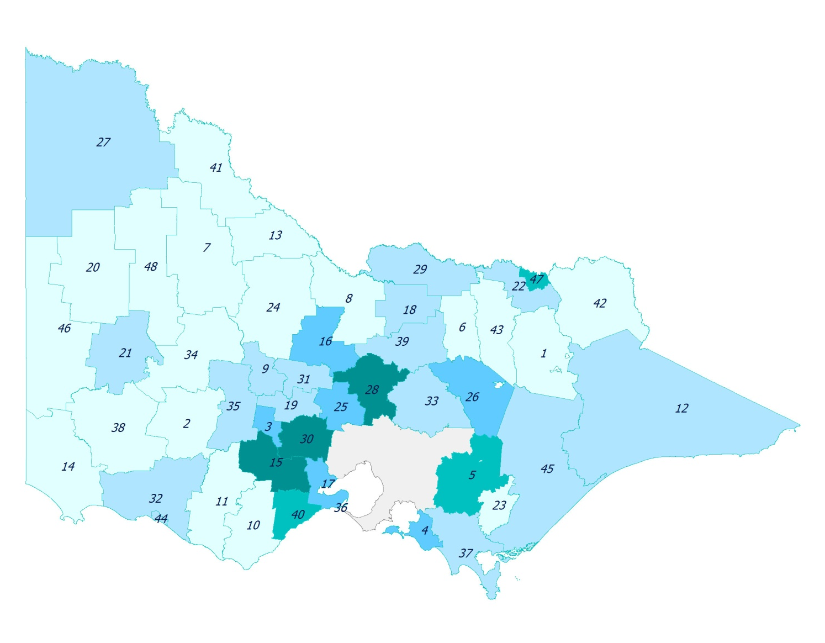
Source: ABS. Regional Population Growth, Australia, 2012-13 (cat. no. 3218.0)

Table 2 Regional Victoria ERP, LGAs, 2012-13
Local government |  | 2012r  (persons) | 2013p  (persons) | Change 2012r-2013p
 |  |  |  | (persons) | (%)
1 | Alpine (S) | 12,109 | 12,044 | -65 | -0.5
2 | Ararat (RC) | 11,335 | 11,207 | -128 | -1.1
3 | Ballarat (C) | 96,935 | 98,684 | 1,749 | 1.8
4 | Bass Coast (S) | 30,616 | 31,010 | 394 | 1.3
5 | Baw Baw (S) | 44,296 | 45,205 | 909 | 2.1
6 | Benalla (RC) | 13,731 | 13,719 | -12 | -0.1
7 | Buloke (S) | 6,355 | 6,221 | -134 | -2.1
8 | Campaspe (S) | 36,967 | 36,919 | -48 | -0.1
9 | Central Goldfields (S) | 12,581 | 12,602 | 21 | 0.2
10 | Colac-Otway (S) | 20,767 | 20,694 | -73 | -0.4
11 | Corangamite (S) | 16,387 | 16,137 | -250 | -1.5
12 | East Gippsland (S) | 43,160 | 43,413 | 253 | 0.6
13 | Gannawarra (S) | 10,376 | 10,326 | -50 | -0.5
14 | Glenelg (S) | 19,758 | 19,521 | -237 | -1.2
15 | Golden Plains (S) | 19,470 | 20,151 | 681 | 3.5
16 | Greater Bendigo (C) | 103,605 | 105,332 | 1,727 | 1.7
17 | Greater Geelong (C) | 218,125 | 221,515 | 3,390 | 1.6
18 | Greater Shepparton (C) | 62,379 | 62,784 | 405 | 0.6
19 | Hepburn (S) | 14,728 | 14,843 | 115 | 0.8
20 | Hindmarsh (S) | 5,781 | 5,695 | -86 | -1.5
21 | Horsham (RC) | 19,631 | 19,687 | 56 | 0.3
22 | Indigo (S) | 15,373 | 15,372 | -1 | 0.0
23 | Latrobe (C) | 74,001 | 73,846 | -155 | -0.2
24 | Loddon (S) | 7,506 | 7,443 | -63 | -0.8
25 | Macedon Ranges (S) | 43,517 | 44,098 | 581 | 1.3
26 | Mansfield (S) | 8,052 | 8,185 | 133 | 1.7
27 | Mildura (RC) | 52,197 | 52,685 | 488 | 0.9
28 | Mitchell (S) | 36,143 | 37,366 | 1,223 | 3.4
29 | Moira (S) | 28,647 | 28,675 | 28 | 0.1
30 | Moorabool (S) | 29,347 | 30,320 | 973 | 3.3
31 | Mount Alexander (S) | 17,896 | 17,994 | 98 | 0.5
32 | Moyne (S) | 16,226 | 16,277 | 51 | 0.3
33 | Murrindindi (S) | 13,423 | 13,494 | 71 | 0.5
34 | Northern Grampians (S) | 11,945 | 11,799 | -146 | -1.2
35 | Pyrenees (S) | 6,746 | 6,770 | 24 | 0.4
36 | Queenscliffe (B) | 3,085 | 3,058 | -27 | -0.9
37 | South Gippsland (S) | 27,756 | 27,930 | 174 | 0.6
38 | Southern Grampians (S) | 16,372 | 16,145 | -227 | -1.4
39 | Strathbogie (S) | 9,666 | 9,706 | 40 | 0.4
40 | Surf Coast (S) | 27,474 | 28,282 | 808 | 2.9
41 | Swan Hill (RC) | 20,950 | 20,867 | -83 | -0.4
42 | Towong (S) | 5,910 | 5,889 | -21 | -0.4
43 | Wangaratta (RC) | 27,221 | 27,197 | -24 | -0.1
44 | Warrnambool (C) | 33,004 | 33,300 | 296 | 0.9
45 | Wellington (S) | 42,294 | 42,319 | 25 | 0.1
46 | West Wimmera (S) | 4,195 | 4,089 | -106 | -2.5
47 | Wodonga (RC) | 36,576 | 37,345 | 769 | 2.1
48 | Yarriambiack (S) | 7,102 | 7,018 | -84 | -1.2
 | Unincorporated Victoria | 774 | 758 | -16 | -2.1
 | All regional LGAs | 1,442,490 | 1,455,936 | 13,446 | 0.9
Source: ABS. Regional Population Growth, Australia, 2012-13 (cat. no. 3218.0)
Note: Estimates for 2012 are revised (r) and estimates for 2013 are preliminary (p)

Metropolitan Melbourne

- For the year ending 30 June 2013, the population of the 31 Metropolitan LGAs grew to nearly 4.3 million persons (4,283,405). This represented an increase of 93,374 persons or 2.2 per cent.
- All but one LGA in metropolitan Melbourne recorded population growth in the year ending 30 June 2013.
- After the City of Melbourne, the LGAs with the largest volumes of growth were all on the urban fringe: Wyndham (10,759), Whittlesea (9,306), Casey (7,476) and Hume (5,229).
- The City of Melbourne experienced the largest and fastest growth: 11,029 persons and 10.5 per cent. It is the fastest growth of any LGA in Australia. The four LGAs with the next highest growth rates in Victoria were located on the urban fringe: Wyndham (6 per cent), Whittlesea (5.5 per cent), Cardinia (4.8 per cent) and Melton (4.3 per cent).
- Nillumbik experienced a small loss of population (less than 30 persons).

Figure 2 Metropolitan Melbourne, Change in ERP, LGAs, 2012-13
[Figure 2 shows on a map the data presented in Table 3]
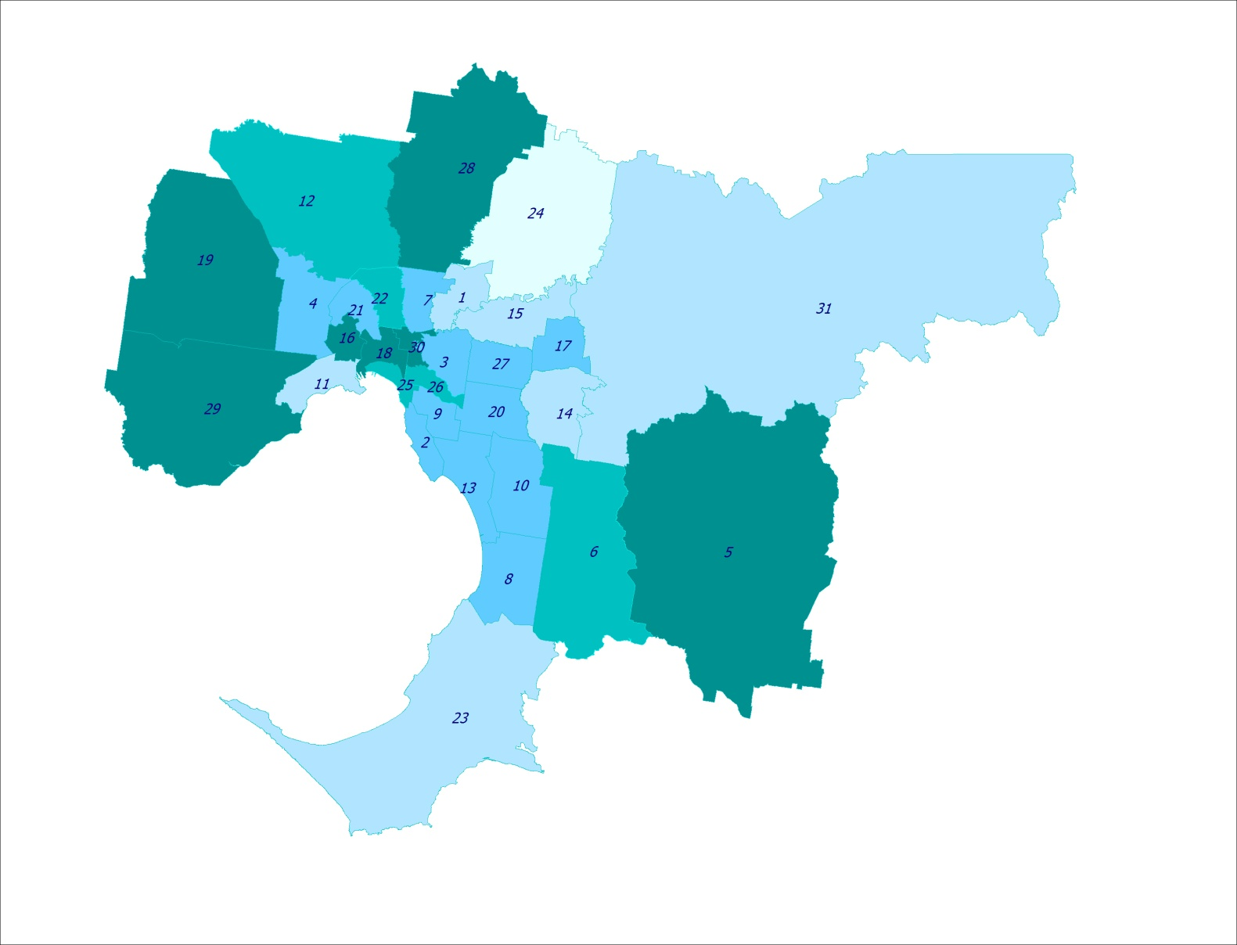
Source: ABS. Regional Population Growth, Australia, 2012-13 (cat. no. 3218.0)

Table 3 Metropolitan Melbourne ERP, LGAs, 2012-13
Local government |  | 2012r | 2013p | Change 2012r-2013p
 |  | (persons) | (persons) | (persons) | (%)
1 | Banyule (C) | 123,600 | 124,475 | 875 | 0.7
2 | Bayside (C) | 96,992 | 98,368 | 1,376 | 1.4
3 | Boroondara (C) | 168,458 | 170,553 | 2,095 | 1.2
4 | Brimbank (C) | 193,334 | 195,469 | 2,135 | 1.1
5 | Cardinia (S) | 80,188 | 84,065 | 3,877 | 4.8
6 | Casey (C) | 267,640 | 275,116 | 7,476 | 2.8
7 | Darebin (C) | 144,641 | 146,797 | 2,156 | 1.5
8 | Frankston (C) | 131,754 | 133,560 | 1,806 | 1.4
9 | Glen Eira (C) | 139,242 | 141,519 | 2,277 | 1.6
10 | Greater Dandenong (C) | 144,312 | 146,727 | 2,415 | 1.7
11 | Hobsons Bay (C) | 88,275 | 89,111 | 836 | 0.9
12 | Hume (C) | 178,034 | 183,263 | 5,229 | 2.9
13 | Kingston (C) | 150,014 | 151,686 | 1,672 | 1.1
14 | Knox (C) | 154,583 | 154,909 | 326 | 0.2
15 | Manningham (C) | 117,036 | 117,537 | 501 | 0.4
16 | Maribyrnong (C) | 76,866 | 79,302 | 2,436 | 3.2
17 | Maroondah (C) | 108,168 | 109,575 | 1,407 | 1.3
18 | Melbourne (C) | 105,418 | 116,447 | 11,029 | 10.5
19 | Melton (C) | 117,881 | 122,909 | 5,028 | 4.3
20 | Monash (C) | 179,931 | 182,485 | 2,554 | 1.4
21 | Moonee Valley (C) | 113,513 | 115,097 | 1,584 | 1.4
22 | Moreland (C) | 156,657 | 160,029 | 3,372 | 2.2
23 | Mornington Peninsula (S) | 150,830 | 152,260 | 1,430 | 0.9
24 | Nillumbik (S) | 62,751 | 62,724 | -27 | -0.0
25 | Port Phillip (C) | 100,394 | 102,501 | 2,107 | 2.1
26 | Stonnington (C) | 101,187 | 103,187 | 2,000 | 2.0
27 | Whitehorse (C) | 159,296 | 161,724 | 2,428 | 1.5
28 | Whittlesea (C) | 169,955 | 179,261 | 9,306 | 5.5
29 | Wyndham (C) | 178,859 | 189,618 | 10,759 | 6.0
30 | Yarra (C) | 80,987 | 83,593 | 2,606 | 3.2
31 | Yarra Ranges (S) | 149,235 | 149,538 | 303 | 0.2
 | Metropolitan LGAs | 4,190,031 | 4,283,405 | 93,374 | 2.2
Source: ABS. Regional Population Growth, Australia, 2012-13 (cat. no. 3218.0)
Note: Estimates for 2012 are revised (r) and estimates for 2013 are preliminary (p)

National, state and territory population growth

- For the year ending 30 June 2013, Australia’s population reached 23,135,281 persons. This was a growth of 407,027 or 1.8 per cent.
- Western Australia (3.3 per cent) recorded the fastest population growth of all states and territories, continuing trends associated with the minerals boom. The population of the Northern Territory increased by 2.1 per cent. Queensland and Victoria also grew strongly, at a rate of 1.9 per cent, followed by the Australian Capital Territory at 1.7 per cent.
- In terms of absolute numbers, Victoria recorded the largest growth (106,820 persons), followed by New South Wales (up 103,216), Queensland (up 88,598) and Western Australia (up 81,327).
- Western Australia recorded the largest gain in interstate migration (8,333 persons), ahead of Queensland (8,196) and Victoria (5,443). The other states and territories recorded losses; New South Wales (14,463 persons), South Australia (3,973 persons), Tasmania (1,942 persons), the Northern Territory (1,220 persons) and the Australian Capital Territory (374 persons). (Source: Australian Demographic Statistics, September Quarter 2013, cat. no. 3101.0)

Table 4 Australian states and territories ERP, 2012-13
 | ERP at 30 June |  | Change  2012r-2013p
 | 2012r | 2013p
 | (persons) | (persons) | (persons) | (%)
New South Wales | 7,307,183 | 7,410,399 | 103,216 | 1.4
Victoria | 5,632,521 | 5,739,341 | 106,820 | 1.9
Queensland | 4,568,205 | 4,656,803 | 88,598 | 1.9
South Australia | 1,656,035 | 1,670,827 | 14,792 | 0.9
Western Australia | 2,437,994 | 2,519,321 | 81,327 | 3.3
Tasmania | 512,106 | 513,159 | 1,053 | 0.2
Northern Territory | 235,881 | 240,759 | 4,878 | 2.1
Australian Capital Territory | 375,183 | 381,488 | 6,305 | 1.7
Other Territories | 3,146 | 3,184 | 38 | 1.2
Australia | 22,728,254 | 23,135,281 | 407,027 | 1.8
Source: ABS. Regional Population Growth, Australia, 2012-13 (cat. no. 3218.0).
Note: Estimates for 2012 are revised (r) and estimates for 2013 are preliminary (p).

Figure 3 Australian states and territories, Growth in ERP, 2012-13
[Figure 3 shows on a map the data presented in Table 4]

Source: ABS. Regional Population Growth, Australia, 2012-13 (cat. no. 3218.0).
Capital city population growth

- The majority of Australia’s population lives in the state and territory capital cities and their associated socioeconomic areas. At 30 June 2013, 15.3 million people or 66 per cent of the Australian population lived in the seven Greater Capital City Statistical Areas and the Australian Capital Territory.
- The bulk of each state or territory’s population growth also occurred in the capital cities - with the exception of Queensland.
- Queensland has strong growth in other areas adjoining Brisbane (the Sunshine and Gold Coasts), leading to the capital accounting for only 51 per cent of the population growth in the year to 30 June 2013.
- Greater Perth was the fastest growing state capital, increasing by 3.5 per cent, or 67,500 persons. However, the volume of growth was largest in Greater Melbourne (95,497 persons) and Greater Sydney (80,965 persons).

Table 5 Estimated Resident Population, Greater Capital City Statistical Areas , 2012-13
 | Population 30 June 2013p | Share of State (%) | Change 2012r-13p | Growth Rate (%) | Share of State's growth (%)
Greater Sydney | 4,757,083 | 64.2 | 80,965 | 1.7 | 78.4
Greater Melbourne | 4,347,955 | 75.8 | 95,497 | 2.2 | 89.4
Greater Brisbane | 2,238,394 | 48.1 | 45,078 | 2.1 | 50.9
Greater Adelaide | 1,291,666 | 77.3 | 13,066 | 1.0 | 88.3
Greater Perth | 1,972,358 | 78.3 | 67,500 | 3.5 | 83.0
Greater Hobart | 217,973 | 42.5 | 1,052 | 0.5 | 99.9
Greater Darwin | 136,245 | 56.6 | 3,924 | 3.0 | 80.4
Australian Capital Territory | 381,488 | 100.0 | 6,305 | 1.7 | 100.0
All Capital Cities | 15,343,162 | 66.3 | 313,387 | 2.1 | 77.0
Source: ABS. Regional Population Growth, Australia, 2012-13 (cat. no. 3218.0).
Note: Estimates for 2012 are revised (r) and estimates for 2013 are preliminary (p)

Authorised and published by the Victorian Government
1 Treasury Place

June 2014

spatialanalysis.research@dtpli.vic.gov.au
www.dtpli.vic.gov.au/victorian-population-bulletin

Unless indicated otherwise, this work is made available under the terms of the Creative Commons Attribution 3.0 Australia licence. To view a copy of this licence, visit creativecommons.org/licenses/by/3.0/au

It is a condition of this Creative Commons Attribution 3.0 Licence that you must give credit to the original author who is the State of Victoria.
This publication may be of assistance to you, but the State of Victoria and its employees do not guarantee that the publication is without flaw of any kind or is wholly appropriate for your particular purposes and therefore disclaims all liability for any error, loss or other consequences which may arise from you relying on any information in this publication.

