This version of Planning for golf in Victoria Discussion Paper has been prepared for use with screen reader software. The printed publication contains various photographs, captions and design features that have been necessarily omitted from this version. In other respects this document contains identical text to that in the PDF version of the document which is available at www.planning.vic.gov.au
Planning for golf in Victoria

Discussion Paper

JUNE 2017

Planning Victoria’s golf future
Golf generates multiple social, economic and environmental benefits for Victorians.
This Discussion Paper identifies the key challenges and opportunities for golf in Victoria, short and long term.
It seeks feedback and input to help develop a long term plan for golf in Victoria that supports local clubs, communities and the golf industry and delivers benefits and value to Victorians.

Background
Many golf clubs across Victoria are experiencing financial difficulties and some have merged, closed or relocated in recent years. Others are considering their long-term futures. There are others like the Sandbelt private golf courses in a strong financial position and healthy club memberships.
Golf courses are a major land use and important to Melbourne’s culture. They are recognised as part of what makes Melbourne a distinctive and liveable city in the metropolitan planning strategy, Plan Melbourne 2017-2050, which sets the Victorian Government’s priorities and goals to guide the city’s long-term growth.
A refreshed Plan Melbourne 2017-2050 was released in March 2017 following extensive public consultation. Plan Melbourne 2017-2050 includes an Implementation Plan with short, medium and long-term actions so that Melbourne maintains its productivity, sustainability and liveability as the population grows.
Action 67 of the Implementation Plan is:
Golf state-wide facilities plan: Work with the golf industry and local government to develop a strategic metropolitan-wide facilities plan that will meet the future needs of the sport, given the increasing pressures for some golf courses to be rezoned for residential use.

This Discussion Paper
This Discussion Paper is the first step in developing a state-wide golf facilities plan.
The Discussion Paper was developed by the Department of Environment, Water, Land and Planning (DELWP) together with the Department of Health and Human Services and Golf Victoria. It follows extensive research and consultation with the golf industry, and with guidance from the Planning for golf in Victoria Task Force.
See Appendix A for more details on the methodology for this Discussion Paper and for members of the Task Force.
This Discussion Paper is not a statement of the views of the Task Force nor any other parties. It identifies the challenges and opportunities for golf, sets out ideas and options to respond to them, and seeks opinions and suggestions from others.

Have your say
Community groups and golf clubs and organisations, local governments, businesses and interested individuals are encouraged to make submissions on this Discussion Paper. They can respond to all, some or just one of the questions it asks.
Submissions must be made in writing and can be submitted via the Engage Victoria webpage or posted to:
Planning for Golf in Victoria,
L14, 8 Nicholson Street,
East Melbourne, Victoria, 3002
Submissions are sought by 14 August 2017.

Next steps
The Planning for golf in Victoria Task Force will consider submissions to this Discussion Paper.
A subsequent Stage 2 Engagement Findings Report will be developed reporting on land use and development issues and opportunities relating to golf. It will propose strategic directions for the future work of the Task Force. The Engagement Findings Report will be delivered in September 2017.
Stage 3 is the preparation of a Recommendations Report by November 2017 and submitted to the Minister for Planning.
The Recommendation Report will identify ways to support the long-term growth and sustainability of golf in Victoria while maximising public value.

Stage 1: DISCUSSION PAPER, 2nd Quarter 2017
- Prepare a Discussion Paper and seek public comment.
- Submissions close on 31 July 2017.

Stage 2: ENGAGEMENT FINDINGS REPORT, 3rd Quarter 2017
- Summarise findings from engagement process.

Stage 3: RECOMMENDATIONS REPORT, 4th Quarter 2017
- Prepare a recommendation and planning decision framework.
- Provide for Government response.
The changing golf landscape
Golf clubs are being challenged by changing demographics, participation trends and land pressures.

Golf in Victoria
Golf is one of Victoria’s most popular organised sports with over 300,000 participants with a wide spread of age groups.
It generates health and wellbeing benefits and supports regular and enduring social interactions across different age groups.
Golf also makes an important economic contribution to Victoria. A 2016 study commissioned by Golf Victoria (2015 Australian Golf Landscape Research, Australian Golf Industry Council, 2015) found that golf contributes $883.6 million in economic and health benefits for the state each year. It generates $849.7 million in economic activity, supports 6,900 full-time jobs and generates $33.8 million of health contributions.
Victoria’s golf clubs generate $152 million through golf tourism each year, attracting domestic and international visitors. Melbourne’s famous sandbelt courses are highly regarded internationally, with four courses appearing on the list of the ‘World’s 100 Greatest Golf Courses’ compiled by Golf Digest Magazine. Regional Victoria and Metropolitan interface municipalities also offers quality golfing destinations, from the Mornington Peninsula and Bellarine Peninsula, to the new Yarra Valley and to Australia’s most visited golf destination, the Murray River region. As Australia’s events capital, Melbourne has also hosted world-class golf events including the Presidents Cup, The Australian Masters and the Women’s Australian Open.
Golf supports local businesses and jobs. It also provides opportunities to preserve green spaces and contribute to biodiversity values.

The changing landscape
Victoria’s golf courses have historically developed on opportunity rather than demand.
Melbourne’s first golf courses were carved from vacant paddocks and scrubland in the 1890s. Many new courses opened in the 1920s and again during the post World War II years. Land for these courses was mostly gifted by local councils and their construction was supported by community volunteers.
The Murray River golf destination was established in the 1970s and features various resorts based around distinctive golf courses. Most of these courses are located on the NSW border of the Murray River.
Since 2000 around over 10 new golf courses have been established as the centrepiece of high-end residential developments in Victoria.
This trend appears to be short lived. As an industry, golf clubs are currently experiencing a lengthy period of transition. Social golf participation remains popular but club memberships are declining and local clubs must manage multiple challenges. Casual players and tourism has become more important. These include changing leisure patterns, an ageing player demographic and increasing costs including higher rates, operating and infrastructure costs.
Many Victorian public and second tier private golf clubs are in financial difficulty. In 2012, Golf Victoria reported that almost half of metropolitan Melbourne clubs were experiencing ﬁnancial stress (2012 Golf Victoria Governance and Structural Review, Golf Victoria). A number have needed to merge and some have closed. Unless declining membership is addressed, this is likely to continue. Clubs are now seeking new ways to attract participants and to increase their long term sustainability.
Today’s golfer is increasingly a social player without a membership who prefers to participate in an unstructured way. They have budget constraints and limits on their time. Clubs must balance delivering the entitlements that club members pay for with the demands of social players. Low levels of innovation and the exclusive nature of many clubs in the past has exacerbated membership decline. Golf’s traditional slower-paced game and strict conservative dress codes and course rules are barriers for younger people to play golf or join a club.

There are many opportunities for golf
A 2015 national research report commissioned by the Australian Golf Industry Council (2015 National Golf Industry Report) found that 6.91 million Australians said they had never played golf but were interested to (see Figure 1). When compared with the 1.15 million people who actually played a round of golf in Australia that year, this represents substantial opportunity to grow participation in the sport.
The 2015 report also identified that club members and social players were attracted to golf for its fun and enjoyment, the opportunity to connect with the outdoors, and to socialise.
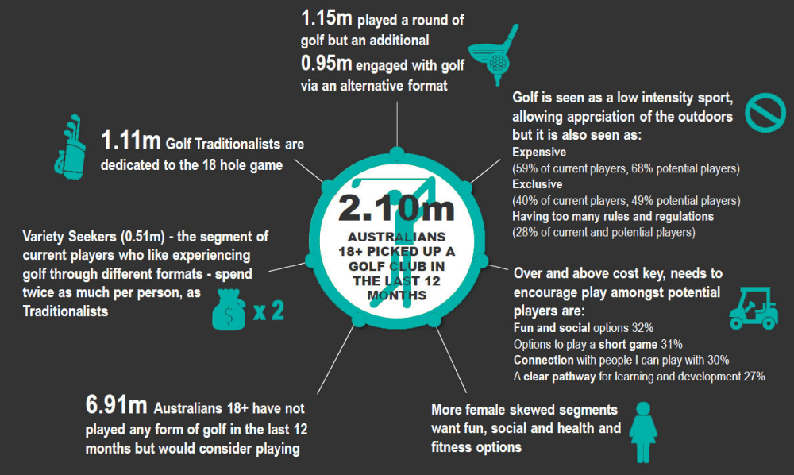
Figure 1: Australian golf landscape key highlights (Source: 2015 Australian Golf Landscape Research, Australian Golf Industry Council.

Land pressures
Residential developers have been attracted to golf clubs, which are often located in scenic, high-value areas. Many clubs experiencing financial difficulties have merged or closed, creating a surplus of land and golf facilities.
Several Melbourne golf courses have also merged or relocated to outside the Urban Growth Boundary into green wedge areas to create better courses and facilities. Green wedge areas are low-density non urban areas which form a ring around the city and feature development controls to protect important biodiversity, agricultural and other values (see Figure 2).
The number of golf courses inside the Urban Growth Boundary in Melbourne’s south east exceeds demand. A number may be suited to repurposing for other sports, community facilities or open space serving active recreation. Some clubs are keen to be rezoned for residential development but constraints on the land, unsuitable location and other considerations may limit how much land is suitable for rezoning.
Some areas to the north and west of metropolitan Melbourne have fewer golf courses than may be justified by projected future population.
Some privately-owned golf courses outside the Urban Growth Boundary are campaigning for their land to be rezoned to allow greater development that enables them to build a sustainable club and business with innovative programs and commercial strategies like providing hospitality for conferencing and events.
This may not be a good planning outcome or be consistent with Plan Melbourne 2017-2050.
Open spaces such as golf courses add value to residential areas, particularly for properties that can take advantage of the green space and aesthetic appeal that courses offer.
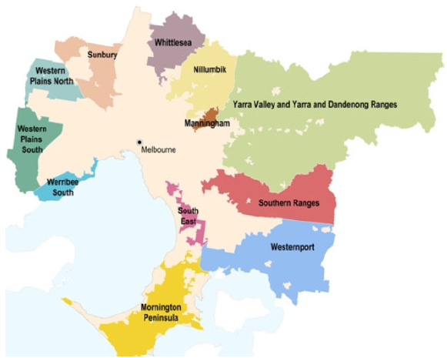
Figure 2: Melbourne’s green wedge areas.

Alternative land uses
Melbourne’s population is projected to almost double over the next few decades, from 4.5 million in 2015 to 7.9 million by 2051 (see Figure 3). Greater housing density has added pressure on community infrastructure and services. These include parks, trails and sports facilities, schools and child care centres, hospitals and aged care facilities, social housing and transport links.
Plan Melbourne 2017-2050 prioritises where this growth should occur. It identifies golf courses as being important to the open space network of communities and to biodiversity, environmental and heritage values. They contribute to the network of parks, bushland and waterways that act as the lungs to our city and public amenity value to a region.
Whilst construction of new golf courses in Melbourne’s green wedges on the urban fringe may have reduced the availability of high-quality agricultural land, it may also have regenerated green wedge land and strengthened biodiversity values. The use of fertilisers needs to be managed to minimise impacts on the ecosystems of nearby streams.
When considering the future of golf course land, an assessment of all land use values and alternative uses is important.
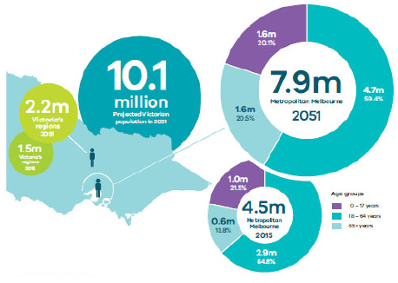
Figure 3: Victoria’s projected population growth. Source: Victoria in Future 2016
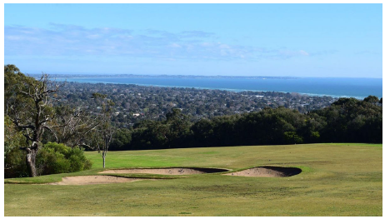
Some golf courses provide scenic views of Melbourne and Port Phillip Bay.
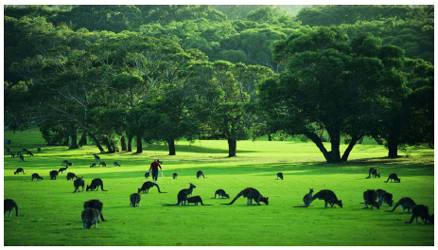
Some golf courses in green wedge areas support significant wildlife populations.

How do we navigate these hazards?

PARTICIPATION HAZARD
- 300,000 Victorians play golf.
- Social golf is on the rise.
- New participation programs and golf business products aim to broaden the audience of golf.
- Golf contributes $859 million in social and economic contributions to Victoria.
- Social reasons are the main reason for participation.
- Golf participation is extended through people watching on television, however this sometimes doesn’t translate into playing.

MEMBERSHIP HAZARD
- 110,000 registered club members in Victoria.
- Club membership declined by 1.3% in Victoria.
- Only 3% of total club memberships are juniors and 20% females.
- Time and cost pressures are major barriers to being an active member.

DEMAND & SUPPLY HAZARD
- Victoria has the highest ratio of golf courses per capita in Australia.
- Locational misalignment between supply and demand.
- Most golf courses are the same. 70% of golf courses are 18 holes.
- Golf courses vary in quality but most considered in poor to fair condition and with club memberships of less than 100.

GOVERNANCE HAZARD
- Nearly half of golf clubs are experiencing financial stress.
- Societal issues are impacting attendance at events and recruitment of volunteers.
- Clubs are struggling to balance access to current members and providing social access.
- Attracting new participation groups, diversifying membership and becoming family friendly environments are key to future club success.

LAND USE HAZARD
- Metropolitan Melbourne is under constant pressure from urban development and competing land use demands.
- 290 ha of golf land has been sold to developers in recent years.
- Golf courses provide social, environmental and cultural heritage values. 139 golf courses located adjacent parks and 69 with waterways.
- 52 golf courses are within an area short of public open space.
- Government policy informs regional demand for sport and recreation facilities and land use objectives.
Participation challenge
People have more choices for active pursuits than ever before.
How will golf adapt and attract new participants?

The current state of play
There is great potential to grow the number of golf participants in Victoria and the proportion who hold club memberships.
Of the 300,000 people who play at Victoria’s 374 golf courses each year, only about a third (110,000) are registered club members.
A 2015 Australian Golf Industry Council report (2015 Australian Golf Landscape Research, Australian Golf Industry Council, 2015 identified potential to almost double the national golf market from 1.15 million to 2.1 million participants.)
The report recommended making golf more accessible to a broader audience and attracting people currently participating socially into a club environment.
Population and demographic trends can support greater golf participation. Golf clubs can target specific population groups by tailoring programs that motivate people to ‘have a go’, and transfer this participation into memberships. For example, there is potential to encourage and grow the low proportion of young people who play golf (see Figure 4).

Figure 4: Golf participation by age, Australia.
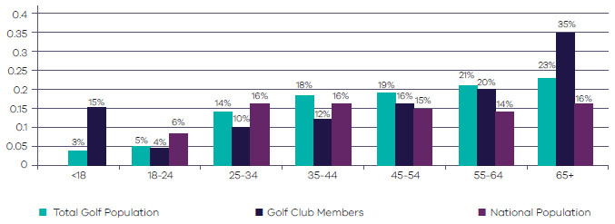
Source: ASC, Golf Australia Database, Golflink, ABS Cat. 32350
Industry research highlights that social reasons are the main driver for playing golf, so this should underpin new program development.
Peak golf sporting bodies (Golf Victoria and Golf Australia) and the golf industry have heavily researched participation and trends to inform current strategic plans for increasing participation and creating sustainable golf clubs.
In 2013, The Australian Sports Commission commissioned the CSIRO to research future sports trends, including the impact of megatrends – patterns of social, economic or environmental changes that influence sports participation (Future of Australian Sport: Megatrends shaping the sports sector over the coming decades, Australian Sports Commission, 2013). The research found while golf participation rates per capita have declined in recent years, golf remains one of Australia’s top 10 sport and recreational activities.
The key megatrends profiling the types of participant identified in the Australian Sports Commission’s The Future of Australian Sport report that can support greater participation in golf included:
- A perfect fit – personalised sport for health and fitness
- More than a sport – achieving health, community and overseas aid objectives via sport
- Everybody’s game – sports that respond to demographic, generational and cultural change.
- The 2015 The Australian Golf Landscape Research report (2015 Australian Golf Landscape Research, Australian Golf Industry Council, 2015) established segments for existing and potential golf markets:
- Golf traditionalists (current) – Dedicated to the pure form of golf. Represent 40 per cent of the total playing group and 40 per cent of industry spending.
- Variety seekers (current) – Frequent golfers but like to experience other golf formats. Represents 20 per cent of the total playing group and 39 per cent of industry spend.
- Incidental and infrequent (current) – Represents 24 per cent of total playing group and 16 per cent of industry spending.
- Alternatives (current) – Prefer other forms like mini golf with little interest in the pure form of golf. Represents 11 per cent of total playing group and 5 per cent of industry spending.
- Get me started (potential) – Have a strong interest in golf but don’t know where to begin. Represents 66 per cent of the potential market.
- Health and fitness (potential) – Focus on general health and wellbeing activities. Represents 34 per cent of the potential market.
New programs such as Golf Australia’s PlayGolf, My Golf and Swing Fit respond to these market trends and segments. Their targets include juniors and schools, females, people interested in health and fitness and beginners.
In addition, new golf business and products are being developed to respond to mega trends and segments. Examples include Big Hole Golf, which features bigger holes and simplified games for faster rounds and less putts, and Top Golf, which has the world’s largest golfing online community and provides golf facilities aimed at attracting all ages and abilities for fun and entertainment.
Major global trends shaping golf participation today are:
- Golf’s popularity in Asia is growing rapidly. There is a boom in children playing in China and India, and Asia is already recognised as the centre of the women’s professional game.
- Females represent much of the growth in golf participation. This is changing expectations of facilities for members and participants and platforms for golf as a family game.
- Golf apps are increasingly providing caddy advice, with software that help golfers make better choices.
Golf Victoria’s Community Impact of Golf Report (2016) found that in Victoria, golf contributes $859 million in economic contribution, $33 million in health benefits and employs 6,900 people.
A recent Golf Tourism in Australia Report found that golf generates significant travel in and out of Australia with 29 per cent of people travelling interstate and 12 per cent of people heading overseas to play. It is a popular lifestyle sport and harnessing this interest into Victorian golf courses (both public and private) will strengthen Melbourne’s status as the most liveable city.
Victoria’s golf regions are: Murray River, Mornington Peninsula, Melbourne Sandbelt, Bellarine Peninsula and the emerging Yarra Valley.

Golf Australia participation programs.

What do we want in the future?
Golf participation in Victoria will be broader, more flexible, accessible and engaging, driving sustainable golf participation growth.

How can we get there?

Idea 1 Train local clubs to deliver participation and inclusion programs
Roll out a training program to skill local clubs in delivering programs that increase participation and make golf courses more inclusive to everyone.
Set a target of 100 per cent increase in the number of participants in Golf Victoria’s MyGolf, SwingFit and PlayGolf programs across rural, regional Victoria and metropolitan Melbourne by 2020.

Idea 2 Partner new initiatives and embrace new technology in local golf courses
Develop a Big Hole Golf and Par 3 competition and new venues to play across Victoria.
Promote the use of on-course technology and encourage interactivity with venue and online forums.

Idea 3 Support new golf business on golf course land
Attract TopGolf and similar golf business ventures aimed at attracting new participation to Melbourne and regional centres.
Do you agree or disagree with the ideas?
How can we attract golf participation for all?

New golf businesses and products.
Membership challenge
Club membership is declining and operational costs are rising. How will golf reverse this trend?

The current state of play
A key to a golf clubs future success will be to offer broader and more flexible, accessible, diverse and engaging family environments and participation opportunities.
Total golf club memberships in Victoria declined 1.3 per cent in Victoria from 2013 to 2014 (2014 National Golf Participation Report, Golf Australia). Figure 5 shows membership changes in different regions.
Of Victoria’s 374 golf courses, 188 clubs in 2013-14 were operating with less than 200 members and 145 had less than 100 members. Only 21 clubs had more than 1,000 members and they made up 25 per cent of Victoria’s total members. The median membership in Victoria today is 117.
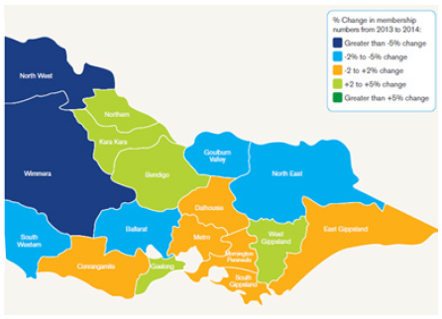
Figure 5: Percentage change in golf membership across Victoria (Source: 2014 National Golf Participation report, Golf Australia)
This declining trend is of great concern for a club’s sustainability as membership funds are their main revenue source, and operational and maintenance costs of golf courses are increasing. Council rates are also increasing as land prices escalate.

How do we reverse this trend?
Golf clubs are well positioned to grow participation and memberships. The golf age profiles the Victorian population and demographic trends of an ageing population. The 2015 The Australian Golf Landscape Research report states that 2.1 million people picked up a golf club or said they were interested in playing (Australian Golf Landscape Research, Australian Golf Industry Council 2015). Golf clubs must do better to attract the social club and non-traditional members.
In Victoria, only 3.5 per cent of total club members are junior-aged players (under 18 years). Only 20 per cent are females. Attracting more junior and women players to golf will be key to strengthening future participation in golf (Australian Golf Landscape Research, Australian Golf Industry Council 2015).

Why are they not joining a golf club?
According to a 2015 report in The Economist (Why golf is in decline in America, The Economist, 2015), there are three main reasons for declining golf club membership in America, which can be applied to Australia:
- Time – players can no longer afford to set aside 4 hours to play a full round of 18 holes and the game is not ‘compatible’ with modern family obligations.
- Cost – membership fees are no longer affordable to most people, particularly low to middle income earners who face additional pressures of increasing costs of housing, education, technology and transport.
- Difficulty – golf courses have been designed to be harder, longer and tougher since the 1990s to challenge players and equipment. Rules are also difficult to understand for many golfers.
Golf administrators are tackling these issues. For example, the R&A and the USGA (governing bodies for rules) have recently proposed more than 50 new or modified rules to simplify and speed up play. Proposals include players being able to putt on greens with the flag still in the cup; golfers not being penalised for accidentally moving their ball; the time allowed to find a lost ball reduced from 5 to 3 minutes; ball drops from one (1) inch above ground rather than from hip height; prompt play and ‘ready golf’ (playing golf out of turn) is encouraged.
Golf Victoria programs are designed to attract a broader range of participants. The success of these programs may rest on delivering to golf clubs across Victoria.
The success of golf clubs could very well rely on successful delivery of these new programs, and also embracing new forms of golf, technology and making clubs more accessible and family friendly.

What do we want in the future?
A sustainable and accessible network of golf courses across Victoria that each attract 200+ members, social golfers and public use.

How can we get there?

Idea 1 Adopt a regional approach to providing golf membership and programs
The regional approach would involve a Regional Development Officers working with clubs in the region. They would focus on regional membership models (that go beyond reciprocal rights) and building club capacity to deliver Golf Victoria programs.
Set a target of 80 per cent of all golf clubs in Victoria to partner regionally to deliver the Golf Victoria programs MyGolf, SwingFit and PlayGolf.

Idea 2 Improve usage data on golf courses
Support Public Golf Courses Australia in the collection of data to establish benchmarks on use (membership and casual).
Set a target of 80 per cent of all golf clubs in Victoria completing the club health check, with Golf Victoria monitoring and analysing trends to inform decisions on club support.

Idea 3 Open up golf courses to everyone
Fund initiatives aimed at providing family friendly environments and making a golf club more accessible, including by embracing technology.
Open up golf courses to make them more accessible to the public for active recreation and enjoyment of the golf course environs and landscapes.
Support the implementation of R&A rule changes aimed at making rounds faster and easier to complete to make golf more accessible and friendly to all types of golfers through a club leader education program.
Do you agree or disagree with the ideas?
How can we increase club membership?
Demand and supply challenge
Victoria has more golf courses per capita than the rest of Australia. How do we best provide for golf courses in the future?

The current state of play
Victoria has one golf course to 13,200 residents, with golf courses in metropolitan Melbourne (1 course to 38,000 residents) and rural Victoria (1 course to 4,900 residents) recording a lower than national average ratio (Issues and Challenges for Golf Clubs in Victoria, Ernst and Young, 2004).
Of the 35 new courses that opened between 1998 and 2004 in Australia, 13 (40 per cent) were in Victoria. With more new courses underway or planned, Victoria will remain the most densely populated state in Australia in terms of golf courses per capita.
Golf courses have not traditionally been developed on a demand basis. Most have been developed on land gifted by local councils or more recently, as the centrepiece of high-end residential estates. This has created an environment where courses are not necessarily located where demand exists and there are multiple clubs in a region competing for memberships.
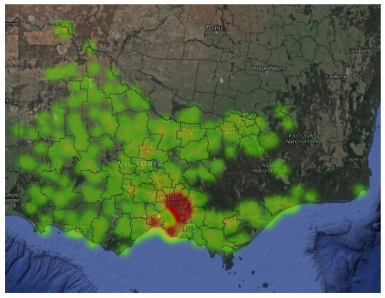
Figure 10: Heat map of golf facilities in Victoria
In metropolitan Melbourne, there is an oversupply of golf courses in the southern and eastern regions and an undersupply in the northern and western regions.
The locational misalignment between supply and demand is further exacerbated in Melbourne’s northern and western growth areas. This issue is set to continue if not addressed, with a further 17 new suburbs planned for metropolitan Melbourne to support the demand for housing as our population continues to grow.
In general, there is an oversupply of golf courses in regional and rural Victoria. Regional cities have more than three golf courses servicing populations of 150,000 and many of Victoria’s rural towns have a golf course. These golf courses and facilities vary in quality with most considered in poor to fair condition and with memberships less than 100 people.
There are 374 golf courses and 35 driving ranges in Victoria. Of the golf courses, 268 (72 per cent) are 18 hole courses. Most public courses and facilities are managed by the club (volunteers) or local council and are ageing and generally in average condition. Meeting this infrastructure challenge must be guided by contemporary design standards for golf courses, universal design principles and female-friendly guidelines.
In regional Victoria, similar golf facilities are offering the same membership models and are often located in the same catchment area. This is spreading the ‘sport loyalists’ thin and clubs are not offering programs and facilities attractive to a broader audience.
A major global trend shaping demand and supply is increasing time pressures and space shortages in cities. This demands a shorter format golf game that can be played more quickly. Courses are being designed with options to play 3 and 6 holes – France’s winning Ryder Cup 2018 bid committed to building hundreds of short urban courses. Improved simulator technology will also increase opportunities for virtual games in the heart of cities. It is predicted that broadcasters will create a high-profile, short form professional competition like Twenty20 cricket.

National Home of Golf Case Study
The Victorian Government has provided $10 million in the 2017/18 Budget towards building the National ‘Home of Golf’ and Centre of Excellence. This facility will serve the entire industry and support all players, from beginners to elite. It will provide a home for Golf Victoria and world class research, training and educational facilities for national and local organisations including a driving range and short course facility. The project represents a renewed and collective focus across the Australian golf industry on growing participation and giving Australia’s golfing talent the best chance to succeed in the future.

What do we want in the future?
A network of sustainable golf courses that supports future demand for golf in Victoria.

How can we get there?

Idea 1 Adopt a regional, strategic and partnership approach to providing golf facilities
The regional approach would focus on understanding the capacity of golf courses, diversifying facilities and regional membership models and building club capacity to deliver Golf Victoria programs.
A regional golf facilities strategy would be developed, similar to those currently being developed for AFL Victoria.

Idea 2 Golf Victoria lead a regional approach with local clubs and local councils to offer varied golf course types
Golf Victoria would host conversations with regional local clubs with support from the Victorian Government and local councils. The conversation would discuss club issues and opportunities for golf, with a focus on different types of golf facilities that may be required to drive participation and club membership.
A focus on public golf courses and the transformation of these facilities into shorter forms and different types of golf facilities including 3 and 6-hole circuits, Big Hole and Footgolf courses, driving range, mini golf and virtual golf and a mix of hospitality and social family and fun play environments.

Idea 3 Develop Facility Design Guidelines to inform development and management of golf courses
A new Facility Design Guidelines may support the development of a diverse mix of golf facilities within a regional catchment to support participation programs and targets of Golf Victoria to help achieve club sustainability.
The guidelines would identify levels of service in terms of facility distribution, type, quality and maintenance demands.
The guidelines could also support the development of golf courses in new growth areas.
Do you agree or disagree with the ideas?
Would you like to see more short form golf facilities?
Land use challenge
Victoria is faced with a range of land use challenges. Golf course land presents one way to help meet these challenges.

The current state of play
Victoria’s 374 golf courses occupy over 18,750 hectares of land.
These golf courses hold a range of community and environmental values. They are an important part of metropolitan Melbourne’s green wedges and open spaces that act as the lungs to the city. Research shows that an area of 180m² of turf grasses, grasslands and trees produce oxygen to support one person per year (Sustainable Golf Course Design, Society of Australian Golf Course Architects 2016). This means that Victorian golf courses provide oxygen for approximately 1.42 million people per year.
Research into the economic social and health benefits generated by golf commissioned by Golf Victoria (2016) reported (The Community Impact of Golf in Victoria Report, Golf Victoria 2016) that golf contributes $33.8 million in health benefits to the state. Golf has unique physical, mental and social strengths including: a lifelong reduction on the healthcare burden; the growth and maintenance of strong social capital (personal networks); regular and enduring social interaction; a culture based on respect, etiquette and self discipline; and a sanctuary (both physically and mentally) from the hustle of modern life.
Golf courses offer a buffer from the urban areas and often support remnant Indigenous vegetation. Sixty-five per cent of most golf courses provide a rich ecology and diverse habitat for native birdlife and animals, mostly in the rough, natural grasses, trees and non playable areas.
Thirty-five per cent (130) of Victoria’s golf courses were established over 75 years ago and feature sites of Aboriginal and European cultural heritage significance. Almost a quarter of Victoria’s courses (99) are located within 200 metres of a waterway or have a heritage site protected in the planning scheme. Many golf courses abut watercourses and are, at least in part, subject to inundation.
Metropolitan Melbourne is under constant pressure from urban development and competing land use demands. Demand for housing and pressure on local parks and sports reserves, education and health facilities and transport networks is projected to continue, with the Victorian population projected to almost double from 4.5 million in 2015 to 7.9 million in 2050 (Victoria in Future, Victorian Government, 2016).
Developers are now directing their interest to golf course land across metropolitan Melbourne, on its urban fringes and in regional cities. In some regions, golf courses are in oversupply or are in financial difficulty. This presents an opportunity for developers to consider the development of large amounts of land within urban areas to meet continuing high demand for housing.
A 2016 article (From Fairways into Laneways: Developers Gobbling up Melbourne’s Golf Courses, https//www.
commercialrealestate.com.au/news/from-fairways-into-laneways-developers-gobbling-up-
melbournes-golf-courses/) reported that more than 290 hectares of golf course land in metropolitan Melbourne has been sold to developers in recent years for houses, offices and shops. Eight former golf courses in metropolitan Melbourne are presently being redeveloped. These include Kingston Links golf course, Kingswood golf course and Keysborough golf course.
The Victorian Government made an election commitment to protect the city’s green wedges by maintaining the existing Urban Growth Boundary. There are 23 golf courses abutting and outside the Urban Growth Boundary. Some submissions to the government’s 2016 refresh of the metropolitan planning strategy, Plan Melbourne 2017-2050, related to golf courses on the urban fringe, seeking to have that land included inside the Urban Growth Boundary to enable residential development. This would allow clubs to sell their land and reinvest in less expensive land outside the Urban Growth Boundary to provide a more diverse golf and hospitality experience on a larger site.
Victoria’s policy makers also highlight alternative land use objectives for surplus golf course land such as sport, community facilities and open space.
The Victorian Planning Authority (VPA) recently consulted across the Victorian Government and with local governments, and consolidated data and categorised open space in metropolitan Melbourne. The VPA has also launched the Metropolitan Open Space Portal that includes walkable catchment maps. There are 54 golf courses in metropolitan Melbourne identified within an area short of public open space.
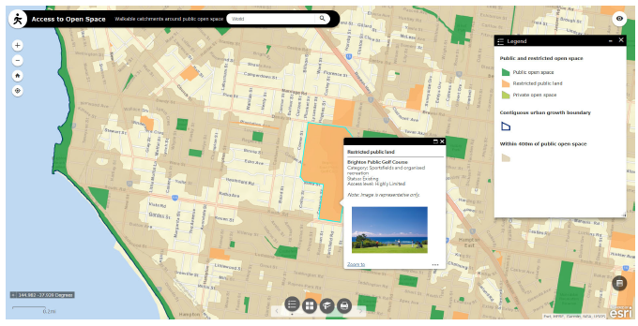
Figure 11: Brighton area map showing golf course within an area outside a 400-metre walkable distance from public open space (Source: Melbourne Open Space Portal, VPA, 2016.
The Victorian Government’s research into future demand for community sport and recreation facilities shows that unprecedented population growth in the inner and middle suburbs and Melbourne’s’ growth areas and the explosion of women’s sport participation is placing pressure on our sports grounds, indoor and outdoor sports courts and aquatic facilities and leisure centres across Victoria. Whilst in rural Victoria, improving the quality and maintenance of existing sport and recreation facilities was of high need.
The following examples capture the demand for sport and recreation facilities today:
- Victoria has over 300 new girls and women’s football teams and 150 new girls and women’s cricket teams in 2016/2017. Demand for sports grounds to accommodate this growth exceed supply in inner city and middle suburbs, Melbourne’s growth areas and Victoria’s ten (10) regional cities. In 2016, it was calculated that an investment of over $450 million would be required to meet demand for community multi-sport indoor courts for high ball sports like basketball, netball and volleyball and other indoor social sport programs like futsal (indoor soccer) over the next four (4) years (Indoor Sports Facilities Needs Assessment, Sport and Recreation Victoria, 2016)
- Extending the demand for new sport and recreation facilities is a plan to create 17 new suburbs and the urban renewal of Fisherman Bend in metropolitan Melbourne. New sport and recreation facilities will be required in these locations to provide for the projected 5.5 million new people in metropolitan Melbourne by 2051. Eight (8) hectares of land is required to provide for a multi-sport infrastructure.
The Victorian Government is also currently developing a State Sporting Facilities Strategy to identify what state-level facilities we may need in the future.
Local government and land managers recreation and open space strategies and management plans that support these state-wide reviews into sport and open space. These plans consider the future recreation facility and open space demand of a local (and regional) population area.
The refreshed Plan Melbourne 2017-2050 has been included in the Victoria Planning Provisions and all planning schemes through the approval of Amendment VC134.
A new Melbourne Open Space Strategy is a recommendation of Plan Melbourne 2017-2050. The strategy will consider how Melbourne’s growing population will enjoy access to diverse and quality open spaces. Also, there are 76 golf courses that are within an area relating to an action such as improving significant tourism destination and creating the Great Yarra River Parkland. Golf course land development proposals will need to consider these recommendations.
Regional growth and land use plans for Geelong, Bendigo and Ballarat also identify land use planning strategies that potentially impact golf.
Planning zones applied to golf courses support the existing golf course use. When planning zones were applied to golf courses, the purpose of the zones on adjoining land zoning was considered and if it supports golf course use, the same zone was generally applied. A Special Use Zone was applied to golf courses where the purposes of the adjoining land zones, overlays and local policies cannot support golf course use or the site adjoins more than one zone and the strategic intent of the site is not known.
Planning overlays are well applied to provide good coverage of protection of environmental, landscape and other site values. The most common planning zones and overlays that govern the use and development and protect the values of golf course land are:
- Public Park and Recreation Zone – 122 golf courses
- Special Use Zone – 77 golf courses
- Farming Zone – 74 golf courses
- Environmental Significance Overlay / Significant Landscape Overlay and Vegetation Protection Overlay – 157 golf courses
- Flood Overlay / Land Subject to Inundation – 87 golf courses.
A Comprehensive Development Zone (CDZ) has been applied to new golf courses with other uses like resort golf courses, residential golf course estates and golf courses with hospitality and conference venues. The CDZ is designed to allow more complex developments in accordance with a comprehensive development plan incorporated in the planning scheme. A description of these planning zones and overlays are referenced in Appendix B. The planning scheme controls are supported by Victorian and Commonwealth legislation. Legislation relevant to golf courses include:
- Planning and Environment Act 1987 (Vic)
- Environmental Protection Biodiversity and Conservation Act 1999 (Cwth)
- Environmental Effects Act 1978 (Vic)
- Environmental Protections Act 1970 (Vic)
- Aboriginal Heritage Act 2006 (Vic)
- Crown Land Reserves Act 1978 (Vic)
- Cultural and Recreation Lands Act 1963 (Vic)
- State Environment Protection Policies.
There is a good level of coverage of legislation, regulation and supporting assessment tools to govern and support sustainable development of golf course land.
Relevant planning panel reports concerning rezoning golf course land or golf course development identify these tools and a set of principles relevant to a planning decision framework for golf course land development proposals. These are:
- The planning scheme amendments should be assessed having regard to net community benefit, the planning issues relevant to the site and principles of environmental and sustainable development.
- Environmental Management Plan, Landscape Management Plan, Cultural Heritage Management Plan and Comprehensive Development Plan should support a planning application.
- Planning for urban growth should consider: opportunities for consolidation, redevelopment and intensification of existing urban areas; neighbourhood character and landscape considerations; the limits of land capability and natural hazards and environmental quality; service limitations and the costs of providing infrastructure.
The Society of Australian Golf Course Architects released a resource promoting environmentally responsible and sustainable golf course design principles. The resource is considered best practice for golf course design and highlights the value of well designed golf courses to the community and environment. A ‘total environment’ approach to golf course management is taken. A set of design principles shows how golf course designers and land managers can conserve and manage the natural resources and meet the increasing operational demands resulting from environmental pressures.
The principles identified are:
- Provide a recreational resource promoting physical and mental wellbeing
- Promote indigenous flora and fauna and the Australian landscape experience
- Provide wildlife sanctuaries
- Preserve open space and remnant vegetation within urban environments
- Minimise and treat water resources such as sewage and urban runoff
- Protect valuable water resources
- Rehabilitate degraded landscapes
- Improve air quality and reduce heat
- Protect topsoil from degradation.
- Beautify the environment and aid community education on environmental issues.

Olinda Golf Course Repurposing Case Study
The Victorian Government is funding the transformation of the old Olinda Golf Course site to a community sport and recreation facility. Parks Victoria and Yarra Ranges Shire Council adopted a place making approach and invited the community to develop a precinct plan for the future of the golf course site. The new park features an Olinda green, a space for community events and gatherings and a nature-based playspace. A new informal playing field will be an overflow sports field for training and a designated area provided for off-lead dog walking. Improved trails throughout the park and connecting with other Olinda community places and the township will encourage walking, running and riding. A new, more visible entrance for the National Rhododendron Gardens will support the many visitors each year.

What do we want in the future?
Sustainable development of golf course land that supports the land use and infrastructure objectives for Victoria and its local areas.
Design and maintain environmentally responsible and sustainable golf courses that enhance the open space, environmental and landscape values.

How can we get there?

Idea 1 Establish a framework for golf course land development proposals to be considered
Golf course land within the Urban Growth Boundary can be considered for rezoning, subject to all the overlays and issues being investigated and resolved.
Rezoning land outside of the Urban Growth Boundary involves an authorisation process requiring approval by the Minister and ratification by both Houses of Parliament in accordance with the Planning and Environment Act 1987.The Victorian Government made an election commitment to maintain the Urban Growth Boundary which was reflected in Plan Melbourne 2017-2050.
The planning decision framework for golf course land development proposals would capture the following key planning steps:
- Any future development proposals must have a net community benefit and achieve a high level of sustainability.
- Consideration is given to the history of how the land was originally provided for a golf course.
- A response is developed to the Planning and Environment Act 1987 and other relevant Victorian and Commonwealth legislation and regulations including the Environmental Protection Biodiversity and Conservation Act (EPBC) 1999, Environmental Effects Act 1978, and Aboriginal Heritage Act 2006.
- A voluntary Cultural Heritage Management Plan is recommended for golf course land.
- A recreation and open space assessment is completed. The assessment should consider: local and regional sport and open space planning strategies; the VPA Metropolitan Open Space Portal to see whether the golf course is within an area short of open space; and the demand for sport and recreation facilities identified in the Community Sport and Recreation Futures Paper¹⁷.
- An assessment is conducted against relevant Plan Melbourne 2017-50 or regional growth and land use plan actions including for community, education, health and legal services.
- A place-making approach applying the Creating Places for People (Creating Places for People, Australian Sustainable Built Environment Council, 2011) and Healthy by Design Guidelines (Healthy by Design Guidelines, National Heart Foundation, 2012) to design future development proposals.
Net community benefit could be defined by providing:
- Open space that is substantially greater to that which has been lost and provides open access to public benefit
- The value of public open space contribution for the golf course land lost is directed to improve or develop regional and local sport and open space as per regional or municipal open space strategies
- A substantially higher public open space provision in new housing development on golf course land due to its proximity and landscape amenity value to existing residential and environs
- New golf course developments support other / alternative state, regional or local public policy objectives. For example, social housing, crisis accommodation, libraries, education precincts, health or legal services.

Idea 2 Rationalise golf courses with overlapping membership catchments; and assess alternative use for surplus golf course land
Golf courses deemed surplus to a regional catchment would be identified and an assessment on future use conducted. The assessment would prioritise sport, recreation and open space needs for a regional catchment as a priority. A review of alternative land uses in line with Plan Melbourne 2017-2050, regional growth and land use plans and local policy objectives including to address housing affordability, access to education, health, legal or community services would also be considered.
The Victorian Government partner with Golf Victoria and local councils in regional conversations where rationalisation of golf courses is likely. Discussions would focus on club mergers, planning processes and local community engagement on development proposals.

Idea 3 Adopt the SAGCA Sustainable Golf Course Design resource as Practice Guidelines for golf course design and management
The Practice Guidelines are the overarching guidelines for golf courses, supporting environmentally responsible and sustainable design and management practices.
The guidelines would support the enhancement of environmental, biodiversity or landscape attributes to those 139 Victorian golf courses located in or adjacent to other open spaces and bushlands and the 69 golf courses with a waterway.
Do you agree or disagree with the ideas?
How can we create a sustainable network of golf courses in Victoria?
Governance challenge
Golf club administrators must address multiple challenges and increasing responsibilities as office bearers.

The current state of play
Of Australia’s 1,600 affiliated golf clubs, approximately 430 employ managers and approximately 600 clubs are serviced by a PGA member. Over 1,000 clubs are managed by volunteers with no professional support. It is also noted that golf relies heavily on volunteers to service the game (Golf Club Participation Report, Golf Australia. 2015).
Golf Victoria commissioned a Governance and Structure Review in 2012 which informed subsequent changes to its operations and included an overall health check survey of its 31 country districts and 44 of its 48 member clubs. The findings of the report were telling. They showed:
- Demographic changes, busier lives and rising living costs are influencing the overall number of people playing golf and when and where they play.
- Less players are participating in golf club events and there is a view there are too many clubs and events.
- Many clubs share overlapping catchments which means they compete for members. Reducing membership prices is their major competitive strategy. This raises concerns about their long-term sustainability. Many districts suggested two to three clubs were merging or closing.
- Nearly half (42%) of Victorian golf clubs were experiencing some level of financial stress (2012).
- Small clubs are relying heavily on volunteers to remain open and keep their course playable.
- Recruiting new volunteers is a challenge and succession planning is a major concern.
- Clubs are struggling to balance the entitlements of members with increasing numbers of social players.
- Golf doesn’t generally appeal to youth and traditional membership offers.
- The administration burden for clubs is increasing, with a greater need for club support and more knowledge sharing.
A presentation by a recognised golf business consultancy at the 2016 Parks and Leisure National Conference identified the following key areas that golf clubs should focus on:
- Respond to mega trends and be market-focused to stay relevant
- Attract new groups, add diversity to membership and become a family-friendly place
- Be flexible and embrace short game formats and social play to make golf more entertaining
- Explore all new golf business models and programs to increase visitation and revenue
- Actively engage and be customer focused
- Market the golf club and invest in telling people what it offers.
Golf Victoria and Golf Australia support this view and are slowly working to change the mindset of golf clubs.
A National Participation Advisory Group and National Club Development Advisory Group are being established by Golf Austrlaia. A Workplace Development Plan is to be developed to build the capacity of the golf workforce and a focus on support of volunteer managed clubs.
A national regional structure has been developed for golf by Golf Australia to guide future resource allocation and planning. The regional structure also enables golf trends to be compared with the resident population and performance. There are 17 regions in Victoria and six regional officers coordinating Golf Victoria programs and events.
There are now providers of club development training and support in the sport sector. Partnering with these providers that have the resources, skills and online platforms represent an opportunity for Golf Victoria and local governments to support clubs and volunteers.

Curlewis Golf Club Case Study
Curlewis Golf Club on Victoria’s Bellarine Peninsula has recently recorded the fastest membership growth in Australia. This has been achieved with quality management and a contemporary marketing campaign appealing particularly to younger people. The club is trialling new initiatives to speed up play such as golf boards and golf formats. To continue to broaden the participation base and connect with non golfers, the golf course is planning a new café and function centre to accommodate 300 patrons. It also plans to create the peninsula’s first large-scale 18 bay driving range and provide a new pedestrian and cyclist access connecting it to the rail trail so users of the rail trail can stop for refreshment.

What do we want in the future?
A skilled golf workforce that works collaboratively and in partnership to achieve regional success.

How can we get there?

Idea 1 Deliver a state-wide training and club support program for golf clubs
Golf Victoria would partner with a training and club support provider and offer an annual program across the 17 golf regions. The program would skill existing and future office bearers and administrators of clubs to support succession planning.
The service would provide year-round support of clubs through online resources and a call for advice service.

Idea 2 Regional golf forums between Golf Victoria districts, clubs and local government
A regional forum would offer a platform for golf’s stakeholders including local governments to come together and discuss issues and strategy to improve golf course sustainability and share knowledge on issues faced by golf courses.
The forum combined with a regional strategic plan would facilitate regional partnerships and open up communication channels between golf and government at a local, regional and state level.
A local government reference group may also strengthen the partnership and relationship between golf and local government in tackling local and regional golf course issues.

Idea 3 Develop the national home of golf and centre of excellence
Provide a ‘one golf’ model for growing participation and supporting club development.
Do you agree or disagree with the ideas?
How can we support the golf workforce?
Appendix A: Methodology and Golf Task Force

Methodology
DEWLP has developed this Discussion Paper with desktop research and consultation with local governments, Golf Victoria, Sport and Recreation Victoria, clubs and others. This has involved:
- A review of the strategic directions of Golf Australia and Golf Victoria and other relevant golf bodies in terms of the future direction of the sport and facility needs.
- A review of Australian local and state government policies and strategies related to golf.
- Analysis of current and predicted participation rates in golf across Victoria, with a focus on the changing demographics and the way that people now want to participate in golf. Consider how golf can become more accessible to more diverse participants at an affordable rate.
- An audit and spatial GIS analysis of current and proposed golf facilities across Victoria, including location, facility type, condition, ownership, membership and land use zone and applicable overlays.

Golf Task Force
The Minister for Planning has appointed a Task Force to provide expert advice into decisions and to monitor and report on the project.
The Task Force consists of:
- Richard Allen – Independent Member and Chair
- Kate Roffey – Independent Member
- Fiona Telford – Golf Victoria
- Fiona dePreu – Planning Implementation, Department of Environment, Land, Water and Planning
- Justin Burney – Sport and Recreation Victoria, Department of Health and Human Services
- Ben Bainbridge – Project Manager, Department of Environment, Land, Water and Planning.
Appendix B: Planning provisions glossary

Planning scheme zones and overlays applied to Victorian golf courses
Please refer to the Planning Schemes Online webpage for an understanding of the Victoria Planning Provisions relevant to your local golf course.
The most common planning zones and overlays that govern the use and development and protect the values of golf course land are:
- Public Park and Recreation Zone – This is the main zone recognising public recreation and open space areas
- Special Use Zone – This zone provides for the use of land for specific purposes. The purpose and the land use requirements are specified in a schedule to the zone
- Farming Zone – This is the main zone for the use of land for agricultural purpose
- Environmental Significance Overlay – Environmental significance is intended to be interpreted widely and may include issues such as noise effects or industrial buffer areas in addition to issues related to the natural environment. This overlay identifies areas where the development of land may be affected by environmental constraints
- Floodway Overlay / Land Subject to Inundation – These overlays are applied to land in either rural or urban areas which is subject to flood inundation. Floodway overlays form part of the active floodway of an area.
Appendix C: Maps

Map 1: Statewide golf club membership compared with population by municipal boundaries
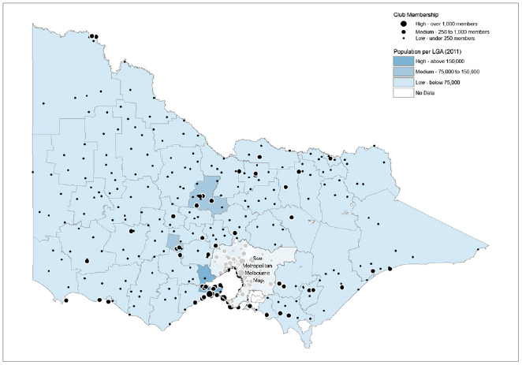

Map 2: Metropolitan Melbourne golf club membership compared with population by municipal boundaries
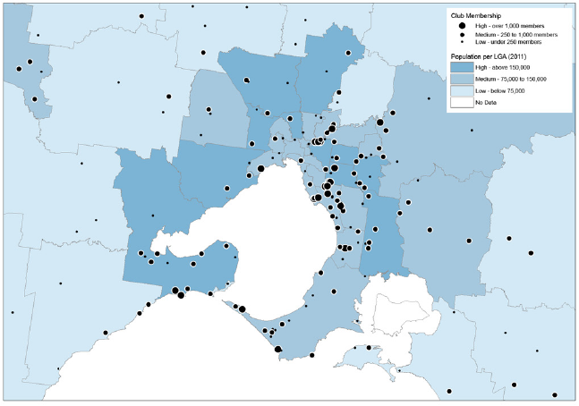

Map 3: Statewide golf club catchment compared with population growth or decline by municipal boundaries
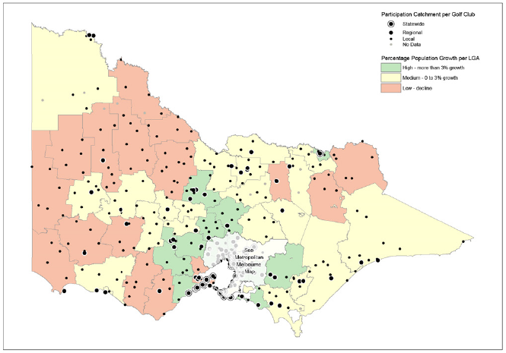

Map 4: Metropolitan Melbourne golf course catchment compared with population growth or decline by municipal boundaries
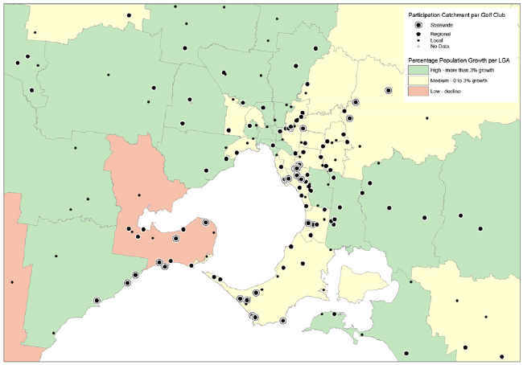

Map 5: Statewide golf courses per head of population

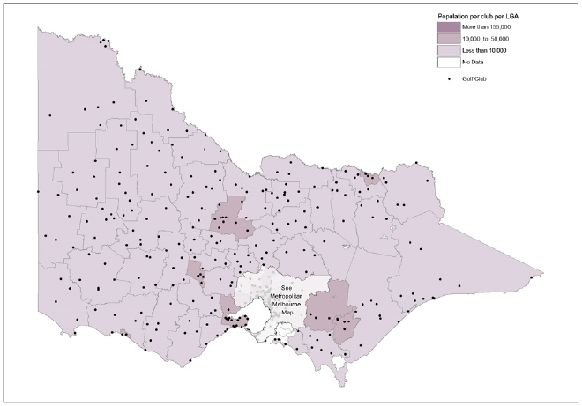

Map 6: Metropolitan Melbourne golf courses per head of population
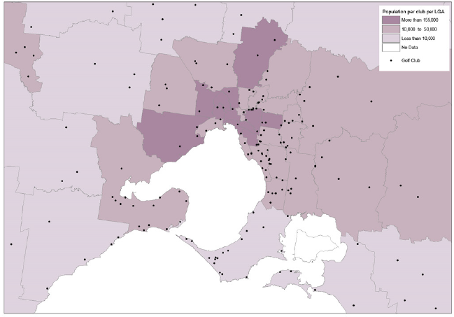

Acknowledgements
Planning for Golf in Victoria Task Force
Department of Environment, Land, Water and Planning
Department of Health and Human Services
Golf Victoria
Golf Australia

Author
Ben Bainbridge, Project Manager, Planning Implementation
Department of Environment, Land, Water and Planning
L14, 8 Nicholson Street, East Melbourne, Victoria, 3002
Telephone: +61 3 8392 5564
Email: benjamin.bainbridge@delwp.vic.gov.au

Photo credits
Visit Victoria

© The State of Victoria Department of Environment, Land, Water and Planning 2017
This work is licensed under a Creative Commons Attribution 4.0 International licence. You are free to re-use the work under that licence, on the condition that you credit the State of Victoria as author. The licence does not apply to any images, photographs or branding, including the Victorian Coat of Arms, the Victorian Government logo and the Department of Environment, Land, Water and Planning (DELWP) logo. To view a copy of this licence, visit http://creativecommons.org/licenses/by/4.0/
ISBN 978-1-76047-609-0 (pdf/online)
Disclaimer
This publication may be of assistance to you but the State of Victoria and its employees do not guarantee that the publication is without flaw of any kind or is wholly appropriate for your particular purposes and therefore disclaims all liability for any error, loss or other consequence which may arise from you relying on any information in this publication.
Accessibility
If you would like to receive this publication in an alternative format, please telephone DELWP Customer Service Centre 136 186, email customer.service@delwp.vic.gov.au, via the National Relay Service on 133 677 www.relayservice.com.au .
This document is also available in Portable Document Format at www.delwp.vic.gov.au/planning

DOCUMENT ENDS

