**Environment Effects Act 1978**

ORDER UNDER SECTION 3(1)

The Minister for Planning, being satisfied that works proposed in relation to the Western Distributor Project could reasonably be considered to have or be capable of having a significant effect on the environment, hereby declares the works proposed to be undertaken by the Department of Economic Development, Jobs, Transport and Resources for the purposes of the Western Distributor Project to be public works for the purposes of the *Environment Effects Act 1978*.

The "public works” to which the Order relates broadly comprise the following:

* Widening of the existing West Gate Freeway by two lanes in each direction to provide overall capacity of six lanes each way generally between Williamstown Road and M80, collector-distributor carriageways, elevated ramps, structures and surface road connections including a new connection generally in the vicinity of Hyde Street;
* Two bored tunnels ultimately catering for three traffic lanes in both directions, with the southern portal generally located on the north side of the West Gate Freeway in the vicinity of Beverley and Hyde Streets, and the northern portal generally in the vicinity east of Whitehall Street, north of Somerville Road and west of the Maribyrnong River;
* Bridge works across Maribyrnong River connecting the tunnel and Footscray Road, with two viaducts in both directions above Footscray Road providing direct access to the Port of Melbourne generally in the vicinity Mackenzie Road and Appleton Dock Road; and
* Connections to CityLink generally via the existing Dynon Road ramps, and access to Docklands, West Melbourne and central or inner City generally via ramps onto Footscray Road with additional connections to Dynon Road and Wurundjeri Way through construction of a new CBD Bypass road generally between Wurundjeri Way and Dynon Road;

Figure 1 is a schematic diagram of key Project components.

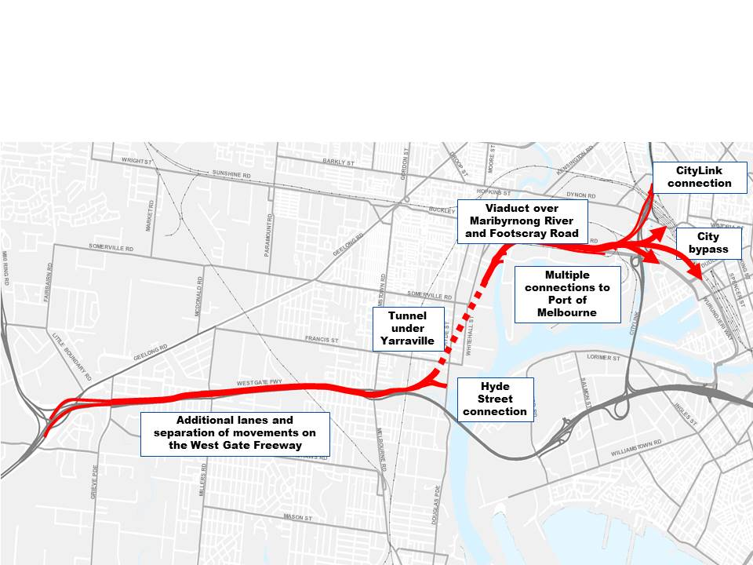

**Section 3(3) of the Environment Effects Act:specified procedures and requirements**

The following procedures and requirements under the guidelines are to apply to the Environment Effects Statement (EES) for the works.

1. The EES is to document investigations of potential environmental effects of the proposed works, including the feasibility of design alternatives and associated environmental mitigation and management measures, in particular for:
   1. potential effects of construction works on noise, dust and vibration levels, and hydrology and quality of groundwater and surface water;
   2. potential effects arising from disturbance of contaminated soils or groundwater, acid sulfate soils or geophysical conditions, including risks related to land and river bank or bed stability;
   3. potential effects on amenity and environmental quality of the adjacent residential areas from the works’ operation, in particular air emissions from the proposed ventilation stacks and increased noise levels;
   4. potential effects on visual, landscape, recreational values of areas in the vicinity of the proposed works;
   5. potential effects on native vegetation and biodiversity, in particular listed flora and fauna species and communities;
   6. potential effects on Aboriginal and cultural heritage values;
   7. potential effects on existing land uses, (including Crown Land) and community and business activities, including with respect to acquisitions, services, connectivity and social impacts;
   8. potential temporary and permanent effects on transport network and services, both for residents and businesses located in the vicinity of the proposed and related works and for the broader community; and
   9. other effects on land uses and the community.
2. The matters to be investigated and documented in the EES will be set out in more details in the scoping requirements. Draft scoping requirements will be exhibited for 15 business days for public comment, before final scoping requirements are endorsed by the Minister for Planning.
3. The proponent may prepare and submit to the Department of Environment, Land, Water and Planning (DELWP) a draft EES study program to inform the preparation of scoping requirements.
4. The level of detail of investigation for the EES studies should be consistent with the approach set out in the scoping requirements and be adequate to inform an assessment of the significance and acceptability of the potential environmental effects of the proposed works, in the context of the guidelines.
5. DELWP will convene an inter-agency Technical Reference Group (TRG) to advise the Department and the proponent, as appropriate, during the preparation of the EES, on the scoping requirements, the design and adequacy of the EES studies, and coordination with statutory approval processes.
6. The proponent is to prepare and implement an EES Consultation Plan for informing the public and consulting with stakeholders during the preparation of the EES, having regard to advice from DELWP and the TRG.

(vii) The proponent is also to prepare and submit to DELWP its proposed schedule for the completion of studies, preparation and exhibition of the EES, which may be amended following endorsement of the scoping requirements. This schedule is intended to facilitate the alignment of the proponent’s and DELWP’s timeframes, including for TRG review of technical studies for the EES and the main EES documentation.

(viii) The proponent is to apply appropriate peer review where necessary and quality management procedures to enable the completion of EES studies to a satisfactory standard.

(ix) The EES is to be exhibited for a period of 30 business days for public comment, unless the exhibition period spans the Christmas–New Year period, in which case 40 business days will apply.

(x) An inquiry will be appointed under the **Environment Effects Act 1978** to consider environmental effects of the proposal.

Excluded works

The works specified in Schedule 1 hereof are excluded from the declaration of “public works”.

**Hon Richard Wynne MP**

**Minister for Planning**

**Date:**

**SCHEDULE 1**

**Excluded works**

The following preliminary works:

1. Design and investigation activities and works associated with designing the Project and assessing its impacts through the Environment Effects Statement process.