This version of Better Apartments Design Standards has been prepared for use with screen reader software. The printed publication contains various design features that have been necessarily omitted from this version. In other respects this document contains identical text to that in the PDF version of the document which is available at www.delwp.vic.gov.au/planning

Better Apartments Design Standards

New apartment design standards for Victoria

December 2016

Overview
The Victoria Planning Provisions and all planning schemes will be amended in March 2017 to introduce the Better Apartments Design Standards.
The Better Apartments Design Standards will apply to all apartment developments in Victoria.
Apartment developments up to four storeys in a residential zone will be assessed against existing Clause 55 standards as well as the Better Apartments Design Standards to ensure that development respects existing or preferred neighbourhood character.
Apartment developments of five or more storeys in a residential zone will be assessed against selected Clause 55 standards as well as the Better Apartments Design Standards to ensure that development reflects the existing or preferred urban context. All apartment developments in other zones will also be assessed in this manner.
The Better Apartments Design Standards are detailed on pages 3 to 25.

Application of the Better Apartments Design Standards
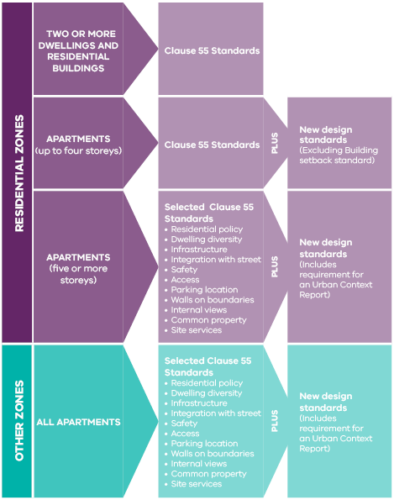

Operation of the new planning provisions

Performance based approach
The Better Apartments Design Standards will adopt the same performance based approach currently used to assess residential development in the Victoria Planning Provisions.
The new apartment provisions will contain Objectives, Standards and Decision guidelines.
Objectives describe the desired outcomes to be achieved in the completed development.
A Standard contains the requirements to meet the objective. A standard should normally be met. However, if the responsible authority is satisfied that an alternative design solution meets the objective, the alternative design solution may be considered.
Decision guidelines set out the matters that the responsible authority must consider before deciding if an application meets the objectives. When an alternative design solution is proposed, the effect of the design solution on the achievement of other objectives should be considered.

Operation with other provisions
Overlays will continue to operate to respond to specific built form issues such as neighbourhood character, heritage, environment, and other local planning objectives.
Where an overlay specifies a requirement that is different from a requirement set out in the new provisions, the requirement of the overlay must be met.

Transitional arrangements
Transitional arrangements will be included in the new provisions to ensure that applications lodged prior to the introduction of the new apartment provisions will be assessed under the planning scheme requirements that existed before the new apartment provisions came into operation.

The Better Apartments Design Standards

Building setback

Objectives
To ensure the setback of a building from a boundary appropriately responds to the urban context.
To allow adequate daylight into new dwellings.
To limit views into habitable room windows and private open space of new and existing dwellings.
To provide a reasonable outlook from dwellings.
To ensure the building setbacks provide appropriate internal amenity to meet the needs of residents.

Standard
The built form of the development must be appropriate to the urban context and the site.
A building should be setback a reasonable distance from side and rear boundaries, and other buildings within the site to:
- Ensure adequate daylight into new habitable room windows.
- Avoid direct views into habitable room windows and private open space of new and existing dwellings. Developments should avoid relying on screening to reduce views.
- Provide an outlook from dwellings that creates a reasonable visual connection to the external environment.
- Ensure the dwellings are designed to meet other internal amenity objectives of the new apartment provisions.

Decision Guidelines
Before deciding on an application, the responsible authority must consider:
- The purpose of the zone or overlay that applies to the land.
- Any relevant urban design objective, policy or statement set out in this scheme.
- The urban context report and site description.
- The design response.
- The relationship between the proposed building setback and the building setbacks of existing adjacent buildings, including the interface with laneways.
- The extent to which the proposed dwellings are provided with reasonable daylight access through the layout of rooms and the number, size, location and orientation of windows.
- The impact of overlooking on the amenity of existing and proposed dwellings.
- The existing extent of overlooking into existing dwellings and private open space.
- Whether the development meets other internal amenity objectives of the new apartment provisions.

Function layout

Objectives
To encourage dwellings that provide functional areas that meet the needs of residents.
To provide dwellings that can be adapted to meet the changing needs of residents.

Standard
A dwelling should have bedrooms that meet the minimum internal room dimensions specified in Table 1.
All bedrooms should provide an area in addition to the minimum internal room dimensions to accommodate a wardrobe.

Table 1 Bedroom dimensions
Bedroom type  Main bedroom | Minimum width  3 metres | Minimum depth  3.4 metres
Bedroom type  All other bedrooms | Minimum width  3 metres | Minimum depth  3 metres

A dwelling should have a living area (excluding dining and kitchen areas) that meets the minimum internal room dimensions specified in Table 2.

Table 2 Living area dimensions
Dwelling type  Studio and 1 bedroom dwelling | Minimum width  3.3 metres | Minimum area  10 sqm
Dwelling type  2 or more bedroom dwelling | Minimum width  3.6 metres | Minimum area  12 sqm

Decision Guidelines
Before deciding on an application, the responsible authority must consider:
- The design response.
- The useability, functionality and amenity of habitable rooms.

Minimum room dimensions
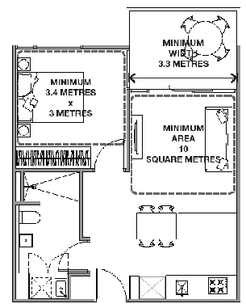
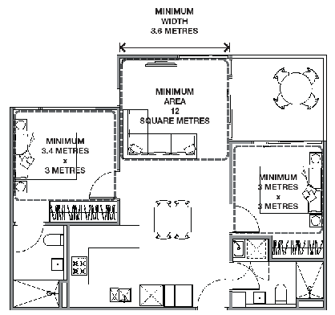

Room depth

Objective
To ensure that single aspect habitable rooms allow for adequate daylight.

Standard
A single aspect habitable room should not exceed a room depth of 2.5 times the ceiling height.
A single aspect open plan habitable room depth may be increased to 9 metres provided the following requirements are met:
- The room combines the living area, dining area and kitchen.
- The kitchen is located furthest from the window.
- The ceiling height is at least 2.7 metres measured from finished floor level to finished ceiling level, except where services are provided above the kitchen.
The room depth is measured from the external surface of the habitable room window to the rear wall.

Decision Guidelines
Before deciding on an application, the responsible authority must consider:
- The design response.
- The extent to which the habitable room is provided with reasonable daylight access through the number, size, location and orientation of windows.
- The useability, functionality and amenity of the dwelling based on layout, siting, size and orientation of habitable rooms.
- Any overhang above habitable room windows that limits daylight access.

Room depth and ceiling height dimensions
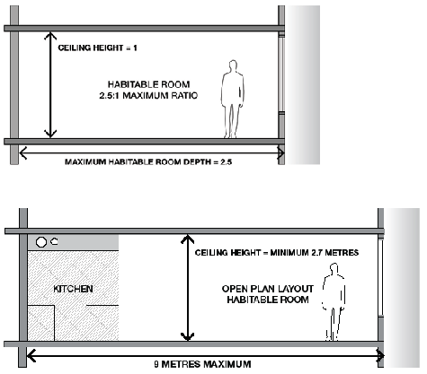

Windows

Objective
To allow adequate daylight into new habitable room windows.

Standard
A window in a habitable room should be located in an external wall.
A window may provide daylight to a bedroom from a smaller area within the room, where:
- The area is at least:
  - A minimum width of 1.2 metres.
  - A maximum depth of 1.5 times the width, measured from the external surface of the window.
- The window is clear to the sky.

Decision Guidelines
Before deciding on an application, the responsible authority must consider:
- The design response.
- The extent to which the habitable room is provided with reasonable daylight access through the number, size, location and orientation of windows.
- The useability and amenity of the dwelling based on the layout, siting, size and orientation of habitable rooms.

Window location and layout
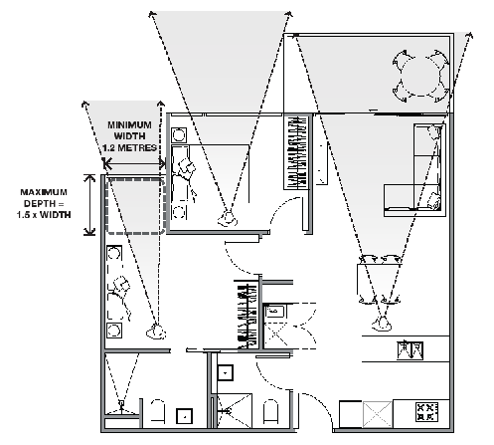

Storage

Objective
To provide adequate storage facilities for each dwelling.

Standard
Each dwelling should have convenient access to usable and secure storage space.
The total minimum storage space (including kitchen, bathroom and bedroom storage) should meet the requirements specified in Table 1.

Table 1 Storage
Dwelling type  Studio | Total minimum storage volume  8 cubic metres | Minimum storage volume within the dwelling  5 cubic metres
Dwelling type  1 bedroom dwelling | Total minimum storage volume  10 cubic metres | Minimum storage volume within the dwelling  6 cubic metres
Dwelling type  2 bedroom dwelling | Total minimum storage volume  14 cubic metres | Minimum storage volume within the dwelling  9 cubic metres
Dwelling type  3 or more bedroom dwelling | Total minimum storage volume  18 cubic metres | Minimum storage volume within the dwelling  12 cubic metres

Decision Guidelines
Before deciding on an application, the responsible authority must consider:
- The design response.
- The useability, functionality and location of storage facilities provided for the dwelling.

External storage layout
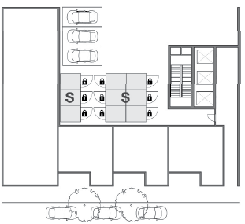

Internal storage layout
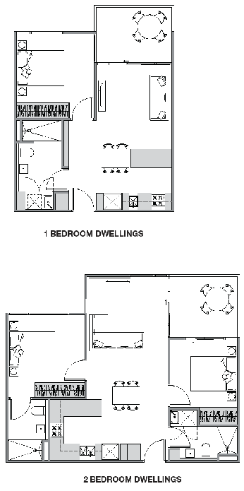

Noise impacts

Objectives
To contain noise sources in developments that may affect existing dwellings.
To protect residents from external and internal noise sources.

Standard
The layout of new dwellings and buildings should minimise noise transmission within the site.
The location of noise sensitive rooms (such as living area and bedrooms) and private open space should take account of:
- The layout of adjoining dwellings, and
- The location of mechanical plants, lifts, building services, non-residential uses, car parking, and communal areas.
Noise sources, such as mechanical plants should not be located near bedrooms of immediately adjacent existing dwellings..
New dwellings should be designed and constructed to include acoustic attenuation measures to reduce noise levels from off-site noise sources.
A building within a noise influence area specified in Table 1 should be designed and constructed to achieve the following noise levels:
- Not greater than 35dB(A) for bedrooms, assessed as an LAeq,8h from 10pm to 6am.
- Not greater than 40dB(A) for living areas, assessed LAeq,16h from 6am to 10pm.
This does not apply to a building, or part of a building that is obstructed by an existing solid building or works or the natural topography of the land.
Noise levels should be measured in an unfurnished and finished floor with the windows closed.

Table 1 Noise influence area
Noise source  Zone interface  Industrial zone 1, 2 & 3 | Noise influence area  300m to the zone boundary
Noise source  Road  Freeways and tollways | Noise influence area  300m
Noise source  Road  Other roads | Noise influence area  300m and carrying 40,000 Annual Average Daily Traffic Volume
Noise source  Railway  Railway servicing passengers in Victoria | Noise influence area  80m
Noise source  Railway  Railway servicing freight in non Metropolitan Melbourne | Noise influence area  80m
Noise source  Railway  Railway servicing freight in Metropolitan Melbourne | Noise influence area  135m

Decision guidelines
Before deciding on an application, the responsible authority must consider:
- The design response.
- An acoustic report by a suitably qualified consultant submitted with the application or demonstration that the design treatment incorporated into the development meets the noise levels.
- Whether the impact of potential noise sources within a development have been mitigated through design, location and siting.
- Whether the layout of rooms within a dwelling mitigates noise transfer within and between dwellings.
- Whether an alternative design meets the relevant objectives having regard to the amenity of the dwelling and the site context.

Internal noise sources
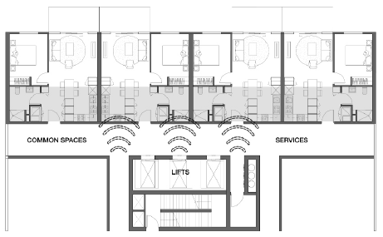

External noise sources
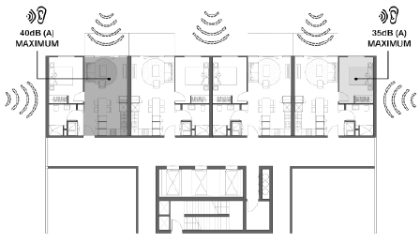

Energy efficiency

Objectives
To achieve and protect energy efficient dwellings and buildings.
To ensure the orientation and layout of development reduce fossil fuel energy use and make appropriate use of daylight and solar energy.
To ensure dwellings achieve adequate thermal efficiency.

Standard
Buildings should be:
- Oriented to make appropriate use of solar energy.
- Sited and designed to ensure that the energy efficiency of existing dwellings on adjoining lots is not unreasonably reduced.
Living areas and private open space should be located on the north side of the development, if practicable.
Developments should be designed so that solar access to north-facing windows is optimised.
A dwelling located in a climate zone identified in Table 1 should not exceed the specified maximum NatHERS annual cooling load.

Table 1 Cooling load
NatHERS CLIMATE ZONE  Melbourne Central (Climate Zone 21 Melbourne) | NatHERS MAXIMUM COOLING LOAD MJ/M2 PER ANNUM  30
NatHERS CLIMATE ZONE  Melbourne North and West (Climate Zone 60 Tullamarine) | NatHERS MAXIMUM COOLING LOAD MJ/M2 PER ANNUM  22
NatHERS CLIMATE ZONE  Melbourne South and East (Climate Zone 62 Moorabbin) | NatHERS MAXIMUM COOLING LOAD MJ/M2 PER ANNUM  21

Note: Refer to NatHERS zone map, Nationwide House Energy Rating Scheme (Commonwealth Department of Environment and Energy). Maximum cooling load levels are currently being prepared for all relevant Victorian climate zones.

Decision Guidelines
Before deciding on an application, the responsible authority must consider:
- The design response.
- The size, orientation and layout of the site.
- The existing amount of solar access to abutting properties.
- The availability of solar access to north-facing windows on the site.

Solar access to communal open space

Objective
To allow adequate solar access into communal outdoor open space.

Standard
The communal outdoor open space should be located on the north side of a building, if appropriate.
At least 50 percent or 125 square metres, whichever is the lesser, of the primary communal outdoor open space area used by occupants should receive a minimum of two hours of sunlight between 9am and 3pm on 21 June.

Decision Guidelines
Before deciding on an application, the responsible authority must consider:
- The design response.
- The useability and amenity of the primary communal outdoor open space areas based on the urban context, the orientation of the building, the layout of dwellings and the sunlight it will receive.

Minimum sunlight access
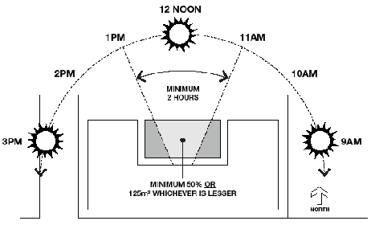

Natural ventilation

Objectives
To encourage natural ventilation of dwellings.
To allow occupants to effectively manage natural ventilation of dwellings.

Standards
The design and layout of dwellings should maximise openable windows, doors or other devices in an external wall of the building, where appropriate.
At least 40% of dwellings should achieve effective cross ventilation. Effective cross ventilation is achieved where:
- There is a maximum breeze path through the dwelling of 18 metres.
- There is a minimum breeze path through the dwelling of 5 metres.
- The ventilation openings have approximately the same area.
- The breeze path is measured between the ventilation openings on different orientations of the dwelling.

Decision Guidelines
Before deciding on an application, the responsible authority must consider:
- The design response.
- The size, orientation, slope and wind exposure of the site.
- The extent to which the orientation of the building and the layout of dwellings maximises opportunities for cross ventilation.
- Whether an alternative design meets the relevant objectives having regard to the amenity of the dwelling and the site context.

Effective cross ventilation layout
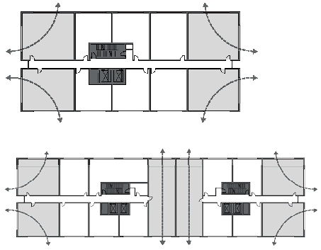

Breeze path layout
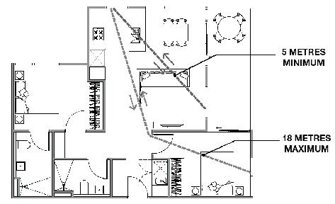

Private open space

Objective
To provide adequate private open space for the reasonable recreation and service needs of residents.

Standard
A dwelling should have private open space consisting of:
- An area of 25 square metres, with a minimum dimension of 3 metres at natural ground floor level and convenient access from a living room, or
- An area of 15 square metres, with a minimum dimension of 3 metres at a podium or other similar base and convenient access from a living room, or
- A balcony with a minimum area and dimension specified in Table 1 and convenient access from a living room, or
- A roof-top area of 10 square metres with a minimum dimension of 2 metres and convenient access from a living room.
If an air conditioning/heating/condenser unit is located on a balcony, the balcony must be an additional 1.5 square metre in area.

Table 1 Balcony size
Dwelling Type  Studio or 1 bedroom dwelling | Minimum Area  8 square metres | Minimum Dimension  1.8 metres
Dwelling Type  2 bedroom dwelling | Minimum Area  8 square metres | Minimum Dimension  2 metres
Dwelling Type  3 or more bedroom dwelling | Minimum Area  12 square metres | Minimum Dimension  2.4 metres

Decision Guidelines
Before deciding on an application, the responsible authority must consider:
- The design response.
- The useability, accessibility and functionality of the private open space.
- The amenity of the private open space based on the orientation of the lot, the wind conditions and the sunlight it receives.
- The availability of and access to public or communal open space.

Minimum private open space dimensions
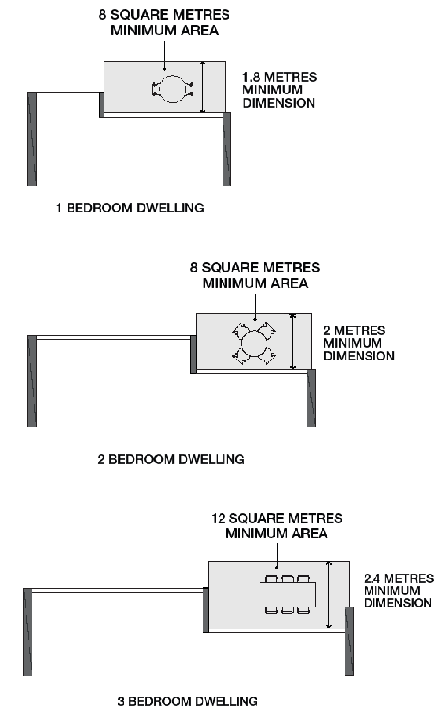

Communal open space

Objectives
To provide adequate and useable communal open space for the benefit of residents.
To integrate the layout of development with communal open space provided in the development.

Standard
Developments with 40 or more dwellings should provide a minimum area of communal open space of 2.5 square metres per dwelling or 250 square metres, which ever is lesser.
Communal open space should:
- Be located to:
  - Provide passive surveillance opportunities, where appropriate.
  - Provide outlook for as many dwellings as practicable.
  - Avoid overlooking into habitable rooms and private open space of new dwellings.
  - Minimise noise impacts to new and existing dwellings.
- Be designed to protect any natural features on the site.
- Maximise landscaping opportunities.
- Be accessible and useable.

Decision guidelines
Before deciding on an application, the responsible authority must consider:
- Any relevant urban design objective, policy or statement set out in this scheme.
- The design response.
- The amenity of the communal space based on the orientation of the lot, the wind conditions and the sunlight it receives.
- The useability of the communal open space based on its size, accessibility and reasonable recreation needs of residents.
- The availability of and access to public open space.

Landscaping

Objectives
To encourage development that respects the landscape character of the neighbourhood.
To encourage development that maintains and enhances habitat for plants and animals in locations of habitat importance.
To provide appropriate landscaping.
To encourage the retention of mature vegetation on the site.
To promote climate responsive landscape design and water management in developments that supports thermal comfort and reduces the urban heat island effect.

Standard
The landscape layout and design should:
- Be responsive to the site context and protect any predominant landscape features of the neighbourhood.
- Provide a safe, attractive and functional environment for residents.
- Consider landscaping opportunities such as green walls, green roofs and roof top gardens to reduce heat absorption and improve storm water management.
- Maximise opportunities for deep soil area to allow for planting of canopy trees.
- Take into account the soil type and drainage patterns of the site and integrate planting and water management.
- Allow for intended vegetation growth and structural protection of buildings.
- In locations of habitat importance, maintain existing habitat and provide for new habitat for plants and animals.
Development should provide for the retention or planting of trees, where these are part of the character of the neighbourhood and the local context.
Development should provide for the replacement of any significant trees that have been removed in the 12 months prior to the application being made.
The landscape design should specify landscape themes, vegetation (location and species), paving and lighting.
A development should achieve the minimum deep soil areas specified in Table 1.
If the development cannot achieve the deep soil areas specified in Table 1, an equivalent canopy cover should be achieved by providing either:
- Canopy trees or climbers (over a pergola) with planter pits sized appropriately for the mature tree soil volume requirements.
- Vegetated planters, green roofs or green facades.

Table 1 Deep soil areas
Site Area (Square Metres)  Deep soil areas (% of site area) | 750-1000  5% (minimum dimension of 3 metres) | 1001-1500  7.5% (minimum dimension of 3 metres) | 1501-2500  10% (minimum dimension of 6 metres) | >2500  15% (minimum dimension of 6 metres)
Site Area (Square Metres)  Minimum tree provision (number and size of trees per area of deep soil) | 750-1000  1 small tree (6-8 metres) per 30 square metres deep soil | 1001-1500  1 medium tree (8-12 metres) per 50 square metres deep soil  Or  1 large tree per 90 square metres deep soil | 1501-2500  1 large tree (Over 12 metres ) per 90 square metres deep soil  Or  2 medium trees per 90 square metres deep soil | >2500  1 large tree per 90 square metres deep soil  Or  2 medium trees per 90 square metres deep soil
Site Area (Square Metres)  Existing canopy tree | This cell is intentionally blank. | 1001-1500  If an existing canopy tree over 8 metres can be retained without damage during the construction period the minimum deep soil requirement is 7% of the site area. | 1501-2500  If an existing canopy tree over 8 metres can be retained without damage during the construction period the minimum deep soil requirement is 7% of the site area. | >2500  If an existing canopy tree over 8 metres can be retained without damage during the construction period the minimum deep soil requirement is 7% of the site area.

Decision Guidelines
Before deciding on an application, the responsible authority must consider:
- Any relevant landscape character objective, policy or statement set out in this scheme.
- Any relevant plan or policy for landscape design in the State Planning Policy Framework and Local Planning Policy Framework, including the Municipal Strategic Statement and local planning policies.
- The design response.
- The location and size of gardens and the predominant plant types in the neighbourhood.
- The health of any trees to be removed.
- Whether a tree was removed to gain a development advantage.
- The suitability of the proposed location and soil depth for canopy trees.
- The ongoing management of landscaping within a development.
- The soil type and drainage patterns of the site.

Minimum deep soil areas
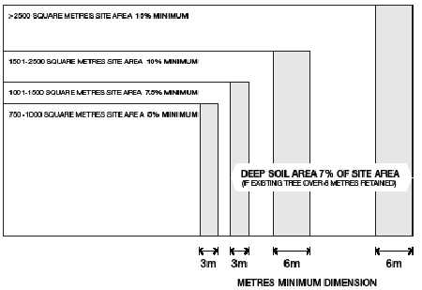

Minimum tree provision
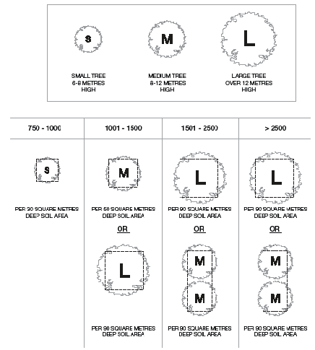

Deep soil locations
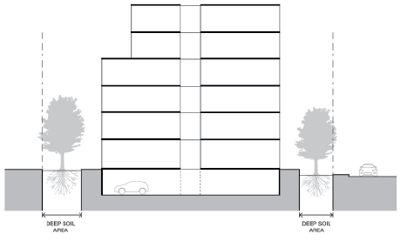

Accessibility

Objective
To ensure the design of dwellings meets the needs of people with limited mobility.

Standard
At least 50% of dwellings should comply with all of the following requirements:
- A clear opening width of at least 850mm at the entrance to the dwelling and main bedroom.
- A clear path with a minimum width of 1.2 metres that connects the dwelling entrance to the main bedroom, an adaptable bathroom and the living area.
- At least one adaptable bathroom that meets one of the design options specified in Table 1:

Table 1 Bathroom design
Clear door opening | Design option A  850 mm | Design option B  820mm
Door Design | Design option A  A slide door, a door that opens outwards, or a door that opens inwards that is clear of the circulation area and has readily removable hinges. | Design option B  A slide door, a door that opens outwards, or door that opens inwards and has readily removable hinges.
Circulation area | Design option A  A minimum clear circulation area in front of the shower and the toilet of 1.2 metres by 1.2 metres.  The circulation area for the toilet and shower can overlap.  The circulation area must be clear of the toilet, basin and the door swing. | Design option B  A minimum clear circulation area of 1 metre wide and 2.7 metres deep.  The circulation area can include a shower area with a removable shower screen.  The circulation area must be clear of the toilet and basin.
Path to circulation area | Design option A  A clear path with a minimum width of 900mm from the door opening to the circulation area. | This cell is left blank intentionally.
Shower | A hobless (step-free) shower. | Design option B  A hobless (step-free) shower with a removable shower screen located on the furthest wall from the door opening.
Toilet | A toilet located in the corner of the room. | Design option B  A toilet located closest to the door opening and clear of the circulation area.

Minimum accessible room dimensions
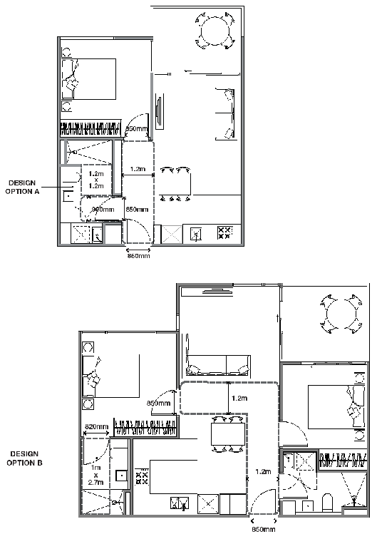

Minimum accessible bathroom dimensions
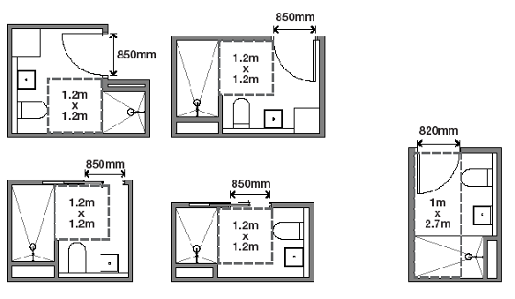

Building entry and circulation

Objectives
To provide each dwelling and building with its own sense of identity.
To ensure the internal layout of buildings provides for the safe, functional and efficient movement of residents.
To ensure internal communal areas provide adequate access to daylight and natural ventilation.

Standard
Entries to dwellings and buildings should:
- Be visible and easily identifiable.
- Provide shelter, a sense of personal address and a transitional space around the entry.
The layout and design of buildings should:
- Clearly distinguish entrances to residential and non-residential areas.
- Provide windows to building entrances and lobbies, including open stairs and lift areas.
- Provide common areas and corridors that:
  - Include at least one source of natural light and natural ventilation.
  - Avoid obstruction from building services.
  - Maintain clear sight lines.

Decision Guidelines
Before deciding on an application, the responsible authority must consider:
- The design response.
- The useability and amenity of internal communal areas based on daylight access and the natural ventilation it will receive.

Building entry layout
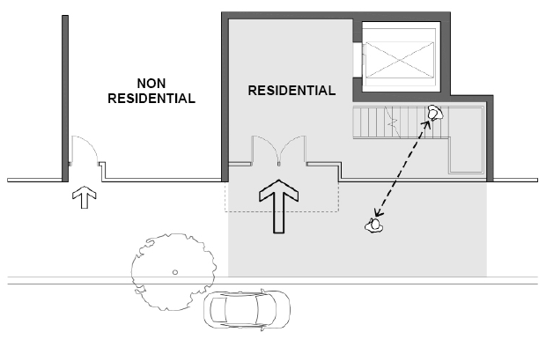

Internal building layout
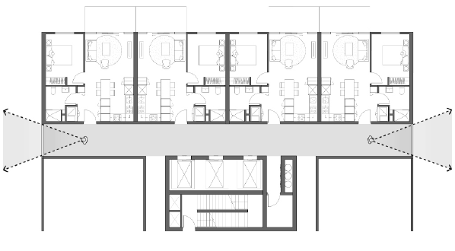

Waste and recycling

Objectives
To ensure dwellings are designed to encourage waste recycling.
To ensure that waste and recycling facilities are accessible, adequate and attractive.
To ensure that waste and recycling facilities are designed and managed to minimise impacts on residential amenity, health and the public realm.

Standard
The development should include dedicated areas for:
- Bin and recycling enclosures which are adequate in size, durable, waterproof and blend in with the development. These areas should be adequately ventilated.
- Bin and recycling enclosures that are located and designed for convenient access by residents and made easily accessible to people with limited mobility.
- Adequate area and facilities for bin washing. These areas should be adequately ventilated.
- Collection, separation and storage of general waste and recyclables, including where appropriate opportunities for on-site management of food waste through composting or other waste recovery as appropriate.
- Collection, storage and reuse of garden waste, including opportunities for on-site treatment (where appropriate), or offsite removal for reprocessing.
- Adequate circulation area for waste collection vehicles that allows waste vehicles to enter and leave the site without reversing.
- Adequate internal storage space within each dwelling to enable the separation of recyclables, residual waste and where appropriate food waste.
Waste and recycling management facilities should:
- Be designed to meet the best practice waste and recycling management guidelines for residential development adopted by Sustainability Victoria.
- Protect public health and amenity of occupants and adjoining premises from the impacts of odour, noise and waste collection vehicle movements.
- Be maintained in accordance with a Waste Management Plan approved by the responsible authority.

Decision Guidelines
Before deciding on an application, the responsible authority must consider:
- The design response.
- Any relevant waste and recycling objective, policy or statement set out in this scheme.

Waste and recycling management
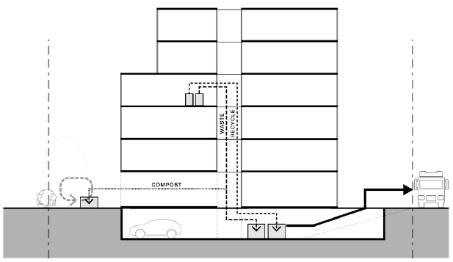

Integrated water and stormwater management

Objectives
To encourage the use of alternative water sources such as rainwater, stormwater and recycled water.
To facilitate on-site stormwater collection, utilisation and infiltration within the development.
To encourage measures to filter sediment and waste from stormwater prior to its discharge from the site.

Standards
Buildings should be designed to collect rainwater for non-drinking purposes such as flushing toilets, laundry appliances and garden use.
Dwellings should be connected to a non-potable dual pipe reticulated water supply, where available from the water authority.
The stormwater management system should be:
- Designed to meet the current best practice performance objectives for stormwater quality as contained in the Urban Stormwater – Best Practice Environmental Management Guidelines (Victorian Stormwater Committee 1999) as amended.
- Designed to maximise infiltration of stormwater, water and drainage of residual flows into permeable surfaces, tree pits and treatment areas.

Decision Guidelines
Before deciding on an application, the responsible authority must consider:
- Any relevant water and stormwater management objective, policy or statement set out in this scheme.
- The design response.
- Whether the stormwater discharge from the site will adversely affect water quality entering the drainage system.
- Whether the stormwater treatment areas can be effectively maintained.

© The State of Victoria Department of Environment, Land, Water & Planning 2016
This work is licensed under a Creative Commons Attribution 4.0 International licence. You are free to re-use the work under that licence, on the condition that you credit the State of Victoria as author. The licence does not apply to any images, photographs or branding, including the Victorian Coat of Arms, the Victorian Government logo and the Department of Environment, Land, Water and Planning (DELWP) logo. To view a copy of this licence, visit http://creativecommons.org/licenses/by/4.0/
ISBN 978-1-76047-407-2 (Print)
ISBN 978-1-76047-408-9 (pdf/online)
Accessibility
If you would like to receive this publication in an alternative format, please telephone the DELWP Customer Service Centre on 136186, email customer.service@delwp.vic.gov.au (or relevant address), or via the National Relay Service on 133 677 www.relayservice.com.au. This document is also available on the internet at www.delwp.vic.gov.au
Disclaimer
This publication may be of assistance to you but the State of Victoria and its employees do not guarantee that the publication is without flaw of any kind or is wholly appropriate for your particular purposes and therefore disclaims all liability for any error, loss or other consequence which may arise from you relying on any information in this publication.
Cover: Collins and Queen (Rothelowman). Photography by Scott Burrows.
DOCUMENT ENDS

